**DATA MODELLING TEAM**

**Muhammad Arshad : Deputy Director SoP**

**Dr. Ather Ashraf : Consultant**

**Muhammad Adrees : Consultant**

**ACKNOWLEDGMENTS**

*I would like to express my special thanks of gratitude to Board of Revenue Directorates / Stakeholders for co-operation and SOP team for sharing their experience and knowledge.*

Contents

Chapter 1 : TENTATIVE DATA MODEL DEVELOPED BY SOP 1

Data Model: 1

Levels of Abstraction in Data Modelling for Cadaster Database: 1

Data Collection (Methods of data input): 1

Data Transformation: 2

Testing and Validation: 2

Modeling and Designing Database 3

Methodology for System Design and Development: 3

System Specification: based on requirement analysis 4

Tasking and Progress: 5

Unified Cadastral system 6

Main Objectives: 6

Unified and Integrated Cadaster System: 6

Data Model and Database Schema: 7

Scale and Tolerance: 8

Spatial reference system /Coordinate System: 9

Quality Check (QC): 9

Requirement of Geometric and Attribute Accuracy: 9

Consistency: 11

Cadastral Model: Detailed Description 12

Cadastral 12

Cadastral diagram 12

BoundaryTypeV 12

CadastralZoningTab 12

Control 16

ControlType 17

LandUseType 20

OwnershipType 25

Parcel 26

RecordOfRightsTab 32

ResidentialZoneType 35

RevenueLandType 37

ShajraNasabTab 39

TaxTable 42

Chapter 2 the Services(TERM OF REFERENCES) 45

Terms of references /tasks 45

CONTRACT FOR HIRING CONSULTANCY SERVICES (For Data Modelling) Cadastral Mapping Project 46

Chapter 3 Cadastre Data Model 50

Introduction 50

Issues and Problems in the Current System 50

Institutional Issues 50

Technical Issues 51

Land Data Model 52

Type of Land Records 52

Layout of Registers 54

Cadaster Data Model 111

Territory ID Structure 132

Measurements of land 133

Measure of length and areas 133

Land Business process Model 137

Land Process 137

Process Modelling 138

As-Is of Land processes 138

To-Be Land Processes 159

Proposed Land Architecture 179

Spatial Databases: 179

Development of work flow Engine 180

Development of COGO and Spatial Data Pipeline 180

Application interface and Information Dissemination 180

Communication through Email & SMS 181

Information Sharing on Different Platforms For Future Research 181

Prototype Application for Spatial data mangmaent 182

Home Page 182

Companies Data Management 183

2. Map Module 185

3. Pivot Table analysis 192

List of figures

Figure 1:Conceptual flow of data 2

Figure 2: Conceptual Model for Unified Cadaster System 7

Figure 3:Tentative Database Schema 8

Figure 4: Receipt for the collection of Land-Revenue ,rates and cases 55

Figure 5: Preliminay Proceeding (Robkar Ibtedai) 56

Figure 6: Shajra Nasab 57

Figure 7: Index Survey / Khasra Numbers 57

Figure 8: Alphabetical Index of Owners and Mortgagees 57

Figure 9: Alphabetical Index of Owners and Mortgagees 58

Figure 10: Register Haqdaran Nakhlistan (Date Trees) 59

Figure 11: Statement of Rights in Wells and Tube-Wells 60

Figure 12: Statement of Distribution of Water 61

Figure 13: Statement of Rights in Water Mills 61

Figure 14: Field Book 62

Figure 15: Title Page Register Haqdaran Zamin 63

Figure 16: Supplementary Map (Tatimma Shajra) 64

Figure 17: Fard Badar 64

Figure 18: Final Attestation Certificate of Register Haqdaran Zamin for the Year 65

Figure 19: Statement Showing the Checking and Attestation Work of Records of Rights and Periodical Records 66

Figure 20: Memorandum Regarding Transfer of Rights 67

Figure 21: Statement Showing the Mutations Pending over Three Months, for the Month Ending 67

Figure 22: Roznamcha Waqiati of Patwari Circle 69

Figure 23: Acknowledgement Under Section 47 (2) of the West Pakistan Land Revenue Act 69

Figure 24: Register showing the applications for grant of certified copies or extracts of records in possession of Patwari received in the office of Collector of the Sub-Division and disposed 70

Figure 25: Receipt of fee for the inspection of records of patwari and grant of certified copies or 71

Figure 26: Acknowledgement of the receipt of application for the supply of copies of records of Patwaris 71

Figure 27: Register of fees for the Preparation of Produce Statement and Five-yearly Abstract of yield. 72

Figure 28: Crop Inspection Register (Register Girdawari) 74

Figure 29: Register Taghayyurat-e-Kasht 75

Figure 30: Statement of Kharaba 76

Figure 31: Dhal Bachh Malia Mustaqil 77

Figure 32: Dhal Bachh Malia Ghair Mustaqil 78

Figure 33: Bill of Assessment 79

Figure 34: Arz Irsal 79

Figure 35: Payment Receipt 80

Figure 36: Security Bond 81

Figure 37: Register of Securities 82

Figure 38:Notice of Demand Under Section Of the West Pakistan Land Revenue Act, 1967 83

Figure 39:Demarcation of land RULE 67-A (4)(a) 84

Figure 40: Demarcation of land RULE 67-A (4)(c) 85

Figure 41:Notice of Eviction Rule 67-B (4)) 85

Figure 42:Warrant of Eviction 86

Figure 43: Register Haqdaran Zamin (Record of Rights/ Periodical Record) 87

Figure 44:Mutation Form (Dakhil Kharij Form 88

Figure 45: Application for Mutation 89

Figure 46:Statement of Customs (Wajib-Ul-Arz) 90

Figure 47:Requisition for Information or Document Under Section 47(1) of the West Pakistan Land Revenue Act, 1967 91

Figure 48:Holding Slip (Parcha Khatauni) 93

Figure 49:Interrogatory (Band Sawal) 94

Figure 50: Register of Miscellaneous Land Revenue 95

Figure 51:Warrant of Arrest Under Section 82(1) of the West Pakistan Land Revenue Act, 1967 95

Figure 52: Warrant of Committal of Defaulter to Civil Jail Under Section 82(5) of the West Pakistan Land Revenue Act, 1967 96

Figure 53:Order for the Release of a Defaulter Under Section 82(8) of the West Pakistan Land Revenue Act, 1967 96

Figure 54:Warrant of Distraint Under Section 83 of the West Pakistan Land Revenue Act, 1967 97

Figure 55: Warrant for Sale of Movable Property Under Section 83 of the West Pakistan Land Revenue Act, 1967 97

Figure 56: Warrant of Transfer of Holding In Respect of Which an Arrear of Revenue Is Due Under Section 84 of the West Pakistan Land Revenue Act, 1967 98

Figure 57: Warrant for Attachment of an Estate or Holding Under Section 85 of the West Pakistan Land Revenue Act, 1967 98

Figure 58: Proclamation of Sale Under Section 92 of the West Pakistan Land Revenue Act, 1967 99

Figure 59: Certificate of Sale Under Section 107 of the West Pakistan Land Revenue Act, 1967 99

Figure 60: Instrument of Partition Under Section 145 of the West Pakistan Land Revenue Act, 1967 100

Figure 61:Register Showing the Amount of Fee Realized by Patwari for Inspection of Records and Grant of Certified Copies Therefrom 101

Figure 62: Register Showing the Amount pf Fee Realized by Patwari for Inspection of Records and Grant of Certified Copies Therefrom 102

Figure 63: Register of Records in the Custody of Patwari 103

Figure 64: Statement Showing the Condition of Survey and Boundary Marks 103

Figure 65: Register of Patwari Circles 104

Figure 66: Work-Book (Roznamcha-Karguzari) for Patwaris 105

Figure 67: Work-Book (Roznamcha-Karguzari) for Kanungos 105

Figure 68: Work-Book (Roznamcha-Karguzari) For Tehsildars and Naib-Tehsildars / Head Munshis 106

Figure 69: List of Mortgages with Possession 106

Figure 70: List of Rents 107

Figure 71: List of Khatauni Totals 107

Figure 72: Day Book 108

Figure 73: Ledger of Demands and Collections 108

Figure 74: Balance Sheet 109

Figure 75: Register of Demands and Recoveries of Water-Course Expenses 110

Figure 76: Register of Area and Assessment of Cultivation in Unsurvey Land 111

Figure 77: Area Calculation based on Euclidean geometry 134

Figure 78: Polygon area Calculation based on Analytical geometry 134

Figure 79: Consolidation Procedure 139

Figure 80: Mutation Procedure 143

Figure 81: Error Correction Procedure 151

Figure 82: Ownership Procedure 156

Figure 83: TO-BE LAND PROCESSES 160

Figure 84: Consolidation Procedure To Be 162

Figure 85: Mutation Procedure To Be 167

Figure 86: Error Correction Procedure To Be 170

Figure 87: Ownership Procedure To Be 174

Figure 88: Digitization of Land Parcels and Features Process 177

Figure 89: Proposed Land Architecture 179

Figure 90: Application homepage 182

Figure 91: Application Login Page 183

Figure 92: Company Data Management 184

Figure 93: Spatial data upload 184

Figure 94: Non- Spatial Data upload 185

Figure 95: Data View 185

Figure 96: Layer Designer 186

Figure 97: Meta data 186

Figure 98: Layer Styling 187

Figure 99: Attribute Table 187

Figure 100: Upload Document 188

Figure 101: Share Layer Info Through SMS 188

Figure 102: Layer Switcher 190

Figure 103: Layers Data 190

Figure 104:Graph Functionality 193

List of Tables

Table 1: tbl_agriculture_tax 111

Table 2: tbl_arz_irsal 112

Table 3: tbl_bill_of_assessments 112

Table 4: tbl_cast 113

Table 5: tbl_crop_inspection 113

Table 6: tbl_crop_season 113

Table 7: tbl_crop_types 113

Table 8: tbl_dhal_bachh_malia_ghair_mustaqil 113

Table 9: tbl_dhal_bachh_malia_mustaqil 114

Table 10: tbl_district 115

Table 11:tbl_division 115

Table 12: tbl_family 115

Table 13: tbl_fard_asiab 115

Table 14: tbl_fard_badar 116

Table 15: tbl_fard_taqseem_ab 116

Table 16: tbl_field_book 116

Table 17: tbl_final_attestation_certificate 117

Table 18: tbl_forest 117

Table 19: tbl_forest_category 118

Table 20: tbl_forest_type 118

Table 21: tbl_gcps 118

Table 22: tbl_gcps_type 118

Table 23: tbl_gender 118

Table 24: tbl_haqdaran_nakhlistan 118

Table 25: tbl_index_khasra_no 119

Table 26: tbl_inteqal_type 119

Table 27: tbl_interrogatory_band_sawal 119

Table 28: tbl_irrigation_source 120

Table 29: tbl_kharaba_statement 120

Table 30: tbl_khasra_numbers 120

Table 31: tbl_khatuni 121

Table 32: tbl_khewat 121

Table 33: tbl_land_type 121

Table 34: tbl_landuse_subtype 121

Table 35: tbl_landuse_type 121

Table 36: tbl_mauza 121

Table 37: tbl_measurement_type 122

Table 38: tbl_measurement_units 122

Table 39: tbl_mutations 122

Table 40: tbl_naqsha_haquq_chahat_wa_nul_chahat 124

Table 41: tbl_ownership_type 125

Table 42: tbl_parcel_landuse 125

Table 43: tbl_parcels 125

Table 44: tbl_parcels_info 125

Table 45: tbl_patwar_circle 126

Table 46: tbl_pending_muations 126

Table 47: tbl_possession 126

Table 48: tbl_possession_type 126

Table 49:tbl_province 127

Table 50: tbl_qanoongo_halqa 127

Table 51: tbl_radeefwar_malikan 127

Table 52: tbl_radeefwar_murtahinan 127

Table 53: tbl_record_of_rights 127

Table 54: tbl_religion 128

Table 55: tbl_revenue_terminology 128

Table 56: tbl_robkar_ibtdai 129

Table 57: tbl_roznamcha_karguzari_patwari 129

Table 58: tbl_roznamcha_karguzari_qanoongo 129

Table 59: tbl_roznamcha_karguzari_thesildar 130

Table 60: tbl_roznamcha_waqiati 130

Table 61: tbl_sect 130

Table 62: tbl_shajrah_nasab 130

Table 63: tbl_soil_type 131

Table 64: tbl_source_of_irrigation 131

Table 65: tbl_sub_cast 131

Table 66: tbl_tatimma_shajrah 131

Table 67: tbl_tax 132

Table 68: tbl_tehsil 132

Table 69: tbl_territory 132

Table 70: tbl_unit_conversion 132

# : TENTATIVE DATA MODEL DEVELOPED BY SOP

## Data Model:

“data models” in terms of the ways in which geographic data can best be structured in a GIS. Data model ensures the appropriate way in which database management systems are structured in order to optimize the data handling. The Modelling team has developed a tentative conceptual model for designing a geo-database. Its refinement is a continuous process, however, the provided geo-database design shared with the directorates is readily enough for collection/preparation of data usable for GIS purpose. The data developed based on the provided template will be validated, refined, transformed into the final geo-database.

In order to create digital maps that will be used in any GIS, it is critically important that a data modeling process has been undertaken. Data modeling provides the set of rules on how spatial information can be intelligently structured as the basis for map production in a GIS.

## Levels of Abstraction in Data Modelling for Cadaster Database:

**First level:** Understanding the existing system

**Second level:** Conceptual model

**Third level:** Logical model / Data structure

**Fourth level:** Physical model / Acute file structure

**Fifth level:** Creation of digital maps

If data modeling has been done well, these maps should have the necessary intelligence to be optimally used for GIS purposes.

## Data Collection (Methods of data input):

* Scanning
* Georeferencing
* Digitizing
* Field Work
* Keyboard data entry
* Data Validation

After the preparation of GIS data adopting the proposed mythology for mapping in urban areas and state land, the next stage is to assemble the GIS data into a GIS-based cadaster database to support the existing lrmis system.

The conceptual flow of data from its actual collection and preparation towards GIS-based cadaster database is as shown: -

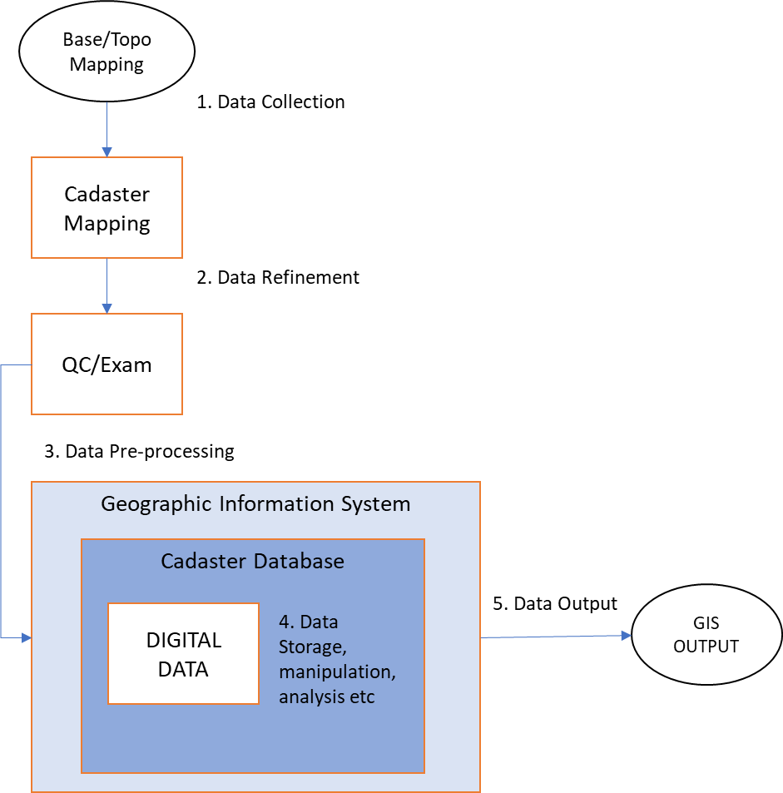

Figure 1:Conceptual flow of data

## Data Transformation:

1. After the collection of data and preparation of the topo-based cadaster map into digital format (shapefile), it must be ensured that the collected data is UpToDate and accurate.
2. Then the data would need to be transformed /stored into an organized form (database designed based on prepared data model).
3. Data refinement will include validating, editing, and correcting the data, and may also require other manipulations such as data transformations or reclassifications. i.e. that may be necessary to transform data so that the data can be used for specific GIS-based Cadaster Management System.
4. The GIS data would be examined for typical topological errors caused during the map digitizing process like overshoots, undershoots, loops or knots, duplicate lines, etc.

## Testing and Validation:

System testing, validation, and removal of any deficiency.

1. The System testing, and implementation will be an iterative process that will be continued till the completion /after of the project for ensuring its sustainability.
2. After the completion of the project, data will also be held in the SoP datacenter therefore, the development of a support system will also be planned for ensuring its sustainability.
3. include the development of a procedure to integrate the existing cadastral system with the newly developed system
4. Technical and support documents will also be drafted.
5. Technical guidelines for managing data in the SoP data center be developed.

## Modeling and Designing Database

The team employed on the task of developing conceptual model and designing geo-database has already been working on the given task since the preliminary preparation phase of the project. The following tasks has been planned / are being carried out during the execution of the project.

### Methodology for System Design and Development:

#### Requirement analysis:

* Review of the current system Cadaster database/system to comprehend the **business process**
* Assess the user needs of a digital Cadaster database
* Analyze issues related to the existing Manual System

##### Present Status:

1. Review of the current system Cadaster database/system that will be continuous study and the regional directorates are expected to provide assistance for coordination with the relevant stakeholders in all province including AJ&K.
2. The SoP’s team also intends to meet and discuss with the technical teams of PLRA and other data custodians preferably database users for detailed requirement analysis in order to understand their data requirements, and the functional requirements including user-defined operations or transaction like division, merging and registration of the Parcels, record retrievals, updates, etc., that are to be applied on the database.
3. With the in-depth study of existing digital system being run or under plan in all the provinces will be utilized for modelling the system for its re-designing and re-engineering as per international standards and practices to make it compatible with GIS data (Cadaster maps).
4. The team is being studying and assessing the user needs of a digital Cadaster database for finalizing the deliverable to be shared with stakeholders including revenue authorities.

### System Specification: based on requirement analysis

#### System Development:

* Undertake systems re-designing and re-engineering as per international standards and practices
* UML (Enterprise Architect)
* XML Schemas
* Development of a prototype and its evaluation

#### Present Status

1. During the pilot projects undertaken by DPO/NO, 08 party, a prototype based conceptual model has already been developed and all the data prepared in the pilot projects are based on the geo-database template provided by the team.
2. The GIS data prepared on the draft template in G-6 Sector is implemented on developing Digital Cadastre by converting it into Cadastre using parcel Fabrics (ArcGIS platform). The Cadastre data will be handled at SoP using ArcGIS /ArcSDE platform. The final data will be handed over/shared with the stakeholders in the shape of geo-database designed on the SoP developed Model and the stakeholders will have to decide on their own either to use already developed tools or customized tools for handling the Cadastre data and integrating it into their existing LRMIS.
3. The base geo-database template will be provided by the team to start work on data received from stakeholders. The data developed based on the provided template will be validated after its submission to the project secretariat.

#### System Implementation:

1. The tentative Cadastral Conceptual Schema, Basic Data Model and geo-database design has been framed is ready to share with the directorates.
2. The base data developed in the provided geo-database after verification be submitted to the Project Secretariat there in it will be converted into usable Cadaster database before handing over the same to the partner users.

#### Testing and validation:

System testing, validation and removal of any deficiency.

1. The System testing and implementation will be an iterative process that will be continued till the completion /after of the project for ensuring its sustainability.
2. After the completion of the project, data will also be held in the SoP datacenter therefore, the development of a support system will also be planned for ensuring its sustainability.
3. include the development of a procedure to integrate the existing cadastral system with the newly developed system
4. Technical and support documents will also be drafted.
5. Technical guidelines for managing data in the SoP data center be developed

## Tasking and Progress:

|  |  |  |
| --- | --- | --- |
| Sr. No | Task | Plan & progress |
| 1. | Initial Study | Completed |
| 2. | Tentative Model (to start with) | Completed |
| 3. | Meeting with Land Record Authorities and BOR, Lahore, Karachi, | Completed |
| 4. | Analysis of the existing database systems of the Punjab | Completed |
| 5. | Meeting with Land Record Authorities and BOR, Other Provinces | Planned in 3rd week of Nov |
| 6. | Analysis of the database systems of other provinces | -do- |
| 7. | Modification of model to integrate all existing LRMIS | -do- |
| 8. | Validation of model | Procurement of GIS Validation Tools |
| 9. | Modification of the model to tackle real time issues (if any) | After validation and implementation |
| 10. | Re-validation of the modified model | -do- |
| 11. | Documentation | Continued |
| 12. | Data Development, Population and Monitoring | -do- |

## Unified Cadastral system

The lack of interoperability (i.e. combining of cadaster information data from various stakeholders in a consistent way without involving any effort) and quality of cadaster data is a great challenge. In order to solve these problems it is necessary to take measures of coordination between the stakeholders of cadaster system. The Directive of the honorable Prime Minister (PM) is to establish an infrastructure for unified cadaster system.

The unified cadaster system will be based on already developed analog provincial cadaster system. To ensure cadaster data quality and interoperability, method and rules addressing these challenges of the infrastructure are being specified.

The participation of stakeholders is very crucial for improvement and implementation of the tentative cadaster model. For this reason, to reach on consensus Survey of Pakistan team met with various stakeholders.

### Main Objectives:

1. To promote and facilitate sharing, exchange, dissemination and use of cadaster information among stakeholders
2. To ensure accuracy, correctness and consistency of cadaster information

### Unified and Integrated Cadaster System:

To integrate cadaster information number of aspects to be care of particularly:

* 1. Data Model and Database Schema

1. Data Model
2. Scale
3. Database Schema/ Structure
   1. Spatial Reference System (Coordinate System)
   2. Quality Check
4. Accuracy
5. Consistency



Figure 2: Conceptual Model for Unified Cadaster System

### Data Model and Database Schema:

The tentative Database consist of the following table and feature classes:

1. Parcel Feature Class: represents parcel of any village, the land type field represents the type according to revenue records and the land classification field represents land classification according to land cover and land use.
2. Control Feature Class: represents reference control point e.g. Bench Mark(BM)
3. Cadastral Zone Table: represents the province, district, tehsil, mauza etc.
4. Parcel Info. Table: represents information related to streets, block, house no. etc.
5. Record of Right Table: represents information related to owner, tenant, previous owner etc.
6. Shajra Nasb Table: represents information about owner family, profession etc.
7. Tax Table: The tax table represent tax to be collected from a person



Figure 3:Tentative Database Schema

### Scale and Tolerance:

|  |  |  |  |
| --- | --- | --- | --- |
|  | **Scale** | **Distance Tolerance** | **Area Accuracy** |
| **Rural Areas** | 1:500 up to 1:1000 | 8cm to 16cm | 0.5 m2 |
| **Urban Area** | 1:500 | 8cm | 0.2 m2 |

### Spatial reference system /Coordinate System:

UTM projection coordinate system should be used for unified cadaster system

### Quality Check (QC):

To get the required data the QC has very crucial role, it ensures accuracy and consistency of the data populated in the system

Two important component of the QC is as follow:

1. Accuracy
2. Geometric Accuracy
3. Attribute Accuracy
4. Consistency

### Requirement of Geometric and Attribute Accuracy:

#### Georeferencing of Massavi (Cadastral Map):

Digitize parcel accuracy is influenced by Georeferencing RMS (Root Mean Square) error therefore the RMS error should be less than the tolerance distance.

#### Digitization of Parcel on the Imagery or Massavi:

1. Digitization of satellite imagery shall be performed as database schema with attribute information related to the parcel of land. While storing the attribute information, the textual details on the plan shall be converted into English language and stored in the GIS database.
2. Digitize all the features present on plan i.e. parcel, roads, water channels, graveyards, and other similar features.
3. Parcels should be properly digitizes, e.g., while digitization line segments centerline of feature should be digitize
4. Parcel segment must be larger than the tolerance distance

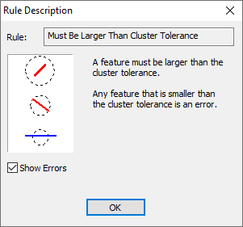

1. There should be no any gaps between parcels;

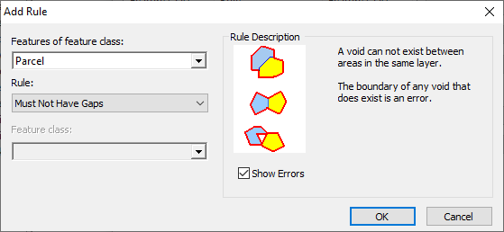

1. Parcels must not overlap

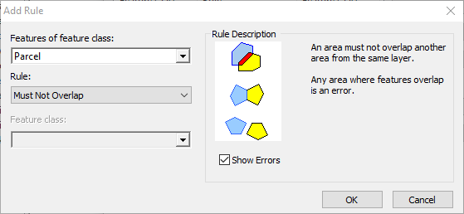

1. While parcel digitization unwanted Back loop and spike must not occur



1. The attribute should be properly entered

### Consistency:

The geometry and attributes should be consistent with respect to the other parcel and massavis.

## Cadastral Model: Detailed Description

### Cadastral

Package «applicationSchema» in package 'Cadastral Parcels Consolidated UML Model'

-- Name --

Cadastral

-- Definition --

The application schema CadastralParcels contains the feature types CadastralParcel

Cadastral

Version 1.0 Phase 1.0 Proposed

### Cadastral diagram

Class diagram in package 'Cadastral'

Cadastral

Version 1.0

### BoundaryTypeV

Class «codeList» in package 'Cadastral'

-- Name --

boundaryTypeV

-- Definition --

Identifies the classification of the boundary.

BoundaryTypeV

Version 1.0 Phase 1.0 Proposed

### CadastralZoningTab

Class «featureType» in package 'Cadastral'

-- Name --

CadastralZoningTab (Cadastral Zoning Table)

-- Definition --

represents administrative area zones

CadastralZoningTab

Version 1.0 Phase 1.0 Proposed

| ATTRIBUTES |
| --- |
| cantonment : string Public  Multiplicity: ( [0..1], Allow duplicates: 0, Is ordered: False )  -- Name --  cantonment  -- Definition --  Represents the cantonment name.  [ Is static False. Containment is Not Specified. ] |
| description : string Public  -- Name --  description  -- Definition --  Represents any additional description  [ Is static False. Containment is Not Specified. ] |
| district : string Public  -- Name --  district  -- Definition --  Represents the district name.  [ Is static False. Containment is Not Specified. ] |
| massaviNumber : string Public  Multiplicity: ( [0..1], Allow duplicates: 0, Is ordered: False )  -- Name --  massaviNumber  -- Definition --  Represents the unique massavi number of massavi map  [ Is static False. Containment is Not Specified. ] |
| masterPlan : string Public  Multiplicity: ( [0..1], Allow duplicates: 0, Is ordered: False )  -- Name --  masterPlan  -- Definition --  Represents the master plan name like malir master plan  [ Stereotype is «voidable». Is static False. Containment is Not Specified. ] |
| mauza : string Public  -- Name --  mauza  -- Definition --  Represents the mauza/ village name .  [ Is static False. Containment is Not Specified. ] |
| patwarCircle : string Public  -- Name --  patwarCircle  -- Definition --  Represents the patwar circle.  [ Is static False. Containment is Not Specified. ] |
| province : string Public  -- Name --  province  -- Definition --  Represents the province name.  [ Is static False. Containment is Not Specified. ] |
| qanungoi : string Public  -- Name --  qanungoi  -- Definition --  Represents the qanungoi name.  [ Is static False. Containment is Not Specified. ] |
| tahsil : string Public  -- Name --  tahsil  -- Definition --  Represents the tahsil name.  [ Is static False. Containment is Not Specified. ] |
| town : string Public  Multiplicity: ( [0..1], Allow duplicates: 0, Is ordered: False )  -- Name --  town  -- Definition --  Represents the town name.  [ Is static False. Containment is Not Specified. ] |
| validFrom : DateTime Public  Multiplicity: ( [0..1], Allow duplicates: 0, Is ordered: False )  -- Name --  validFrom  -- Definition --  Official date and time the parcel zone was/will be legally established.  -- Description --  NOTE This is the date and time the parcel zone reference can be used in legal acts.  [ Stereotype is «voidable». Is static False. Containment is Not Specified. ] |
| validTo : DateTime Public  Multiplicity: ( [0..1], Allow duplicates: 0, Is ordered: False )  -- Name --  validTo  -- Definition --  Date and time at which the parcel zone legally ceased/will cease to be used.  -- Description --  NOTE This is the date and time the parcel zone reference can no longer be used in legal acts.  [ Stereotype is «voidable». Is static False. Containment is Not Specified. ] |
| zoneID : string Public  -- Name --  zoneID  -- Definition --  zoneID represents the unique identification of the parcel zone.  [ Is static False. Containment is Not Specified. ] |

| ASSOCIATIONS | |
| --- | --- |
| Association (direction: Bi-Directional) | |
| Source: Public zone_ID (Class) Parcel «featureType» | Target: Public zone_ID (Class) CadastralZoningTab «featureType» |

### Control

Class «featureType» in package 'Cadastral'

-- Name --

Control

-- Definition --

represents vertical and horizontal control points. Control points are used for the basis of the topographic survey measurements

Control

Version 1.0 Phase 1.0 Proposed

| ATTRIBUTES |
| --- |
| controlPoint_ID : string Public  -- Name --  controlPoint_ID (control Point ID)  -- Definition --  controlPoint_ID represents the unique identification of the control point feature.  [ Is static False. Containment is Not Specified. ] |
| description : string Public  -- Name --  description  -- Definition --  Represents any additional description of the spatial object  [ Is static False. Containment is Not Specified. ] |
| elevation : double Public  -- Name --  elevation  -- Definition --  represents the elevation of the control  [ Is static False. Containment is Not Specified. ] |
| geom : GM_Point Public  -- Name --  geom: (geometry)  -- Definition --  represents geometry of spatial object to be represented  [ Is static False. Containment is Not Specified. ] |
| name : string Public  -- Name --  name  -- Definition --  Represents the name of the topographic feature  [ Is static False. Containment is Not Specified. ] |
| type : ControlType Public  -- Name --  type  -- Definition --  represents the specific type of control feature.  [ Is static False. Containment is Not Specified. ] |

| ASSOCIATIONS | |
| --- | --- |
| Association (direction: Source -> Destination) | |
| Source: Public controlPoint_ID (Class) Parcel «featureType» | Target: Public referencePoint (Class) Control «featureType» |

### ControlType

Class «codeList» in package 'Cadastral'

-- Name --

ControlType

-- Definition --

represents the possible values of control features.

ControlType

Version 1.0 Phase 1.0 Proposed

| ATTRIBUTES |
| --- |
|  |
| benchmark : string Public  -- Name --  benchmark (Benchmark (BM))  -- Definition --  a permanent marker (usually a bronze disk) at a point of determined location (elevation and possibly horizontal coordinates). In a less formal sense, it is a point of fixed location (such as a mark on a bridge abutment, a foundation, or a rock face). It can be used as a reference point for surveys in its locality.  [ Is static False. Containment is Not Specified. ] |
| boundaryPillar : string Public  -- Name --  boundaryPillar (boundary pillar)  -- Definition --  a robust physical marker that identifies the start of a land boundary or the change in a boundary, especially a change in direction of a boundary.  [ Is static False. Containment is Not Specified. ] |
| canalBenchmark : string Public  -- Name --  canalBenchmark (canal benchmark)  -- Definition --  it is fixed point of reference with known elevation  [ Is static False. Containment is Not Specified. ] |
| distanceStone : string Public  -- Name --  distanceStone (distance stone)  -- Definition --  is one of a series of numbered markers placed along a road or railway at particular intervals  [ Is static False. Containment is Not Specified. ] |
| distanceStoneCanal : string Public  -- Name --  distanceStoneCanal (distance stone canal)  -- Definition --  is one of a series of numbered markers placed along a canal at particular intervals  [ Is static False. Containment is Not Specified. ] |
| gtBenchmark : string Public  -- Name --  gtBenchmark (G.T Benchmark)  -- Definition --  the high precision benchmarks established during the great trigonometrical survey.  [ Is static False. Containment is Not Specified. ] |
| other : string Public  -- Name --  other  -- Definition --  control type which is not listed  [ Is static False. Containment is Not Specified. ] |
| spotHeight : string Public  -- Name --  spotHeight (Spot Height)  -- Definition --  represents height of spots.  [ Is static False. Containment is Not Specified. ] |
| standardBenchmark : string Public  -- Name --  Standard Benchmark (SBM)  -- Definition --  it is a ground planed monument built for stability to minimized the probability of disturbance. The SBM are established within the precise leveling network to provide a stable benchmark system that will control the leveling network.  [ Is static False. Containment is Not Specified. ] |
| traverseStation : string Public  -- Name --  traverseStation (Traverse Station)  -- Definition --  a geodetic point whose position on the earth's surface within a given system of coordinates is determined by the method of traversing. It may be stabilized by a large concrete monument set into the ground or by a geodetic beacon erected on the surface.  [ Is static False. Containment is Not Specified. ] |
| trigonometricIP : string Public  -- Name --  trigonometricIP  -- Definition --  represents trigonometric intersected point  [ Is static False. Containment is Not Specified. ] |
| trigonometricStation : string Public  -- Name --  trigonometricStation (trig station)  -- Definition --  is a fixed surveying station with known coordinates, established through trigonometric instruments and methods.  [ Is static False. Containment is Not Specified. ] |

### LandUseType

Class «codeList» in package 'Cadastral'

-- Name --

LandUseType

-- Definition --

Land use type for graphical visualization of land classification.

LandUseType

Version 1.0 Phase 1.0 Proposed

| ATTRIBUTES |
| --- |
| agriculture : string Public  -- Name --  agriculture  -- Definition --  Agricultural areas including cultivated areas and areas for grazing livestock  [ Is static False. Containment is Not Specified. ] |
| campingSite : string Public  -- Name --  campingSite  -- Definition --  Permanent camping area with service buildings, cabins etc  [ Is static False. Containment is Not Specified. ] |
| coalfield : string Public  -- Name --  coalfield  -- Definition --  an area which is rich in coal, and where coal is mined  [ Is static False. Containment is Not Specified. ] |
| constructionSite : string Public  -- Name --  constructionSite  -- Definition --  Area with ongoing construction activity  [ Is static False. Containment is Not Specified. ] |
| desert : string Public  -- Name --  desert  -- Definition --  arid land with little or no vegetation  [ Is static False. Containment is Not Specified. ] |
| disposalArea : string Public  -- Name --  disposalArea  -- Definition --  Municipal landfill and waste disposal  [ Is static False. Containment is Not Specified. ] |
| forest : string Public  -- Name --  forest  -- Definition --  Forest areas both natural and cultivated  [ Is static False. Containment is Not Specified. ] |
| gasField : string Public  -- Name --  gasField (Gas Field)  -- Definition --  a gas field is an area of natural gas underground, produced by decay of organic material.  [ Is static False. Containment is Not Specified. ] |
| goldfield : string Public  -- Name --  goldfield  -- Definition --  an area which is rich in gold, and where gold is mined  [ Is static False. Containment is Not Specified. ] |
| graveyard : string Public  -- Name --  graveyard  -- Definition --  Area for burial  [ Is static False. Containment is Not Specified. ] |
| industrialArea : string Public  -- Name --  industrialArea  -- Definition --  Area with or without buildings for industrial purposes  [ Is static False. Containment is Not Specified. ] |
| lake : string Public  -- Name --  lake  -- Definition --  A natural stream comparatively smaller than river, which carries water to another lake, a river or the sea.  [ Is static False. Containment is Not Specified. ] |
| mountainArea : string Public  -- Name --  mountainArea  -- Definition --  Mountainous areas with bare bedrock, scree, moraine, avalanche material etc.  [ Is static False. Containment is Not Specified. ] |
| oilfield : string Public  -- Name --  oilfield  -- Definition --  an area of land or seabed underlain by strata yielding petroleum, especially in amounts that justify commercial exploitation.  [ Is static False. Containment is Not Specified. ] |
| other : string Public  -- Name --  other  -- Definition --  Areas with no clear connection to the specified Land Use categories  [ Is static False. Containment is Not Specified. ] |
| park : string Public  -- Name --  park  -- Definition --  Green-areas in cities and densely populated areas facilitated for recreational use. Characterized by lawns, benches, walkways, planting, water fountains etc.  [ Is static False. Containment is Not Specified. ] |
| quarry : string Public  -- Name --  quarry  -- Definition --  a place where rocks, sand, or minerals are extracted from the surface of the Earth. A quarry is a type of mine called an open-pit mine, because it is open to the Earth's surface.  [ Is static False. Containment is Not Specified. ] |
| residentialArea : string Public  -- Name --  residentialArea  -- Definition --  Area with high degree of residential development, also including areas with functions connected to residential areas  [ Is static False. Containment is Not Specified. ] |
| river : string Public  -- Name --  river  -- Definition --  a major natural stream which carries water to another river, a lake or the sea.  [ Is static False. Containment is Not Specified. ] |
| saltpan : string Public  -- Name --  saltpan  -- Definition --  a shallow container or depression in the ground in which salt water evaporates to leave a deposit of salt.  [ Is static False. Containment is Not Specified. ] |
| sandGravelPit : string Public  -- Name --  sandGravelPit  -- Definition --  Area with industrial excavation of sand, gravel and rocks  [ Is static False. Containment is Not Specified. ] |
| sportComplex : string Public  -- Name --  sportComplex  -- Definition --  Area for sport activities  [ Is static False. Containment is Not Specified. ] |
| transportArea : string Public  -- Name --  transportArea  -- Definition --  Areas used for transportation including road, railway etc.  [ Is static False. Containment is Not Specified. ] |
| waterReservoir : string Public  -- Name --  waterReservoir  -- Definition --  Areas used for water reservation including lake, dam, ocean etc.  [ Is static False. Containment is Not Specified. ] |
| wetland : string Public  -- Name --  wetland  -- Definition --  Marsh and peat areas  [ Is static False. Containment is Not Specified. ] |

### OwnershipType

Class «codeList» in package 'Cadastral'

-- Name --

ownershipType

-- Definition --

represents the ownerships type e.g., state owned, individual , or shamilat-e-deh

OwnershipType

Version 1.0 Phase 1.0 Proposed

| ATTRIBUTES |  |  |
| --- | --- | --- |
| other : string Public  -- Name --  other  -- Definition --  ownership type which is not listed  [ Is static False. Containment is Not Specified. ] | | |
| private : string Public  -- Name --  private  -- Definition --  parcel owned by the country citizen  [ Is static False. Containment is Not Specified. ] | | |
| shamilat-e-deh : string Public  -- Name --  shamilat-e-deh  -- Definition --  land in a village held for the common purposes of the village, i.e. graveyards, grazing grounds, community buildings,places of worship, schools, dispensaries, playgrounds, wells etc.  [ Is static False. Containment is Not Specified. ] | | |
| state : string Public  -- Name --  state  -- Definition --  state owned parcel  [ Is static False. Containment is Not Specified. ] | | |

### Parcel

Class «featureType» in package 'Cadastral'

-- Name --

Parcel

-- Definition --

Represents a parcel/ khasra of a village of the Pakistan

Parcel

Version 1.0 Phase 1.0 Proposed

| ATTRIBUTES |
| --- |
| description : string Public  Multiplicity: ( [0..1], Allow duplicates: 0, Is ordered: False )  -- Name --  description  -- Definition --  Represents any additional description of the Parcel.  [ Is static False. Containment is Not Specified. ] |
| geom : GM_Polygon Public  -- Name --  geom (Geometry)  -- Definition --  represents the geometry of the parcel.  [ Is static False. Containment is Not Specified. ] |
| khasra : string Public  -- Name --  khasra_Number  -- Definition --  represents the unique khasra number in the village.  [ Is static False. Containment is Not Specified. ] |
| landUse : LandUseType Public  -- Name --  LandUse  -- Definition --  Land use area for graphical visualization of land classification.  [ Is static False. Containment is Not Specified. ] |
| parcel_ID : string Public  -- Name --  Parcel_ID  -- Definition --  represents the unique id of a parcel in the Pakistan.  [ Is static False. Containment is Not Specified. ] |
| referencePoint : string Public  Multiplicity: ( [0..M], Allow duplicates: 0, Is ordered: False )  -- Definition --  A point within the cadastral parcel.  -- Description --  EXAMPLE The centroid of the cadastral parcel geometry.  [ Stereotype is «voidable». Is static False. Containment is Not Specified. ] |
| revenueLandType : RevenueLandType Public  -- Name --  land_Type  -- Definition --  represents the type of land  [ Is static False. Containment is Not Specified. ] |
| sub_khasra : string Public  [ Is static False. Containment is Not Specified. ] |
| validFrom : DateTime Public  Multiplicity: ( [0..1], Allow duplicates: 0, Is ordered: False )  -- Definition --  Official date and time the cadastral parcel was/will be legally established.  -- Description --  NOTE This is the date and time the national cadastral reference can be used in legal acts.  [ Stereotype is «voidable». Is static False. Containment is Not Specified. ] |
| validTo : DateTime Public  Multiplicity: ( [0..1], Allow duplicates: 0, Is ordered: False )  -- Definition --  Date and time at which the cadastral parcel legally ceased/will cease to be used.  -- Description --  NOTE This is the date and time the national cadastral reference can no longer be used in legal acts.  [ Stereotype is «voidable». Is static False. Containment is Not Specified. ] |
| zone_ID : string Public  [ Is static False. Containment is Not Specified. ] |

| ASSOCIATIONS | |
| --- | --- |
| Association (direction: Bi-Directional) | |
| Source: Public zone_ID (Class) Parcel «featureType» | Target: Public zone_ID (Class) CadastralZoningTab «featureType» |
| Association (direction: Bi-Directional) | |
| Source: Public parcel_ID (Class) Parcel «featureType» | Target: Public parcel_ID (Class) Parcel_InfoTab «featureType» |
| Association (direction: Source -> Destination) | |
| Source: Public controlPoint_ID (Class) Parcel «featureType» | Target: Public referencePoint (Class) Control «featureType» |
| Association (direction: Bi-Directional) | |
| Source: Public parcel_ID (Class) TaxTable «featureType» | Target: Public parcel_ID (Class) Parcel «featureType» |
| Association (direction: Bi-Directional) | |
| Source: Public parcel_ID (Class) RecordOfRightsTab «featureType» | Target: Public parcel_ID (Class) Parcel «featureType» |

#### Parcel_InfoTab

Class «featureType» in package 'Cadastral'

-- Name --

Parcel_InfoTab

-- Definition --

Represents parcel specific information

Parcel_InfoTab

Version 1.0 Phase 1.0 Proposed

| ATTRIBUTES |
| --- |
| block : string Public  Multiplicity: ( [0..1], Allow duplicates: 0, Is ordered: False )  -- Name --  block  -- Definition --  represents the block number/ name  [ Stereotype is «voidable». Is static False. Containment is Not Specified. ] |
| buidlingNo : string Public  Multiplicity: ( [0..1], Allow duplicates: 0, Is ordered: False )  -- Name --  buidlingNo  -- Definition --  represents the building number  [ Stereotype is «voidable». Is static False. Containment is Not Specified. ] |
| description : string Public  Multiplicity: ( [0..1], Allow duplicates: 0, Is ordered: False )  -- Name --  description  -- Definition --  Represents additional description  [ Is static False. Containment is Not Specified. ] |
| floorNo : string Public  Multiplicity: ( [0..1], Allow duplicates: 0, Is ordered: False )  -- Name --  floorNo  -- Definition --  represents the floor number  [ Stereotype is «voidable». Is static False. Containment is Not Specified. ] |
| houseNo : string Public  Multiplicity: ( [0..1], Allow duplicates: 0, Is ordered: False )  -- Name --  houseNo  -- Definition --  Represents the house number  [ Is static False. Containment is Not Specified. ] |
| housingSociety : string Public  Multiplicity: ( [0..1], Allow duplicates: 0, Is ordered: False )  -- Name --  housingSociety  -- Definition --  Housing society is a membership based legal entity made of one or more residential buildings.  [ Stereotype is «voidable». Is static False. Containment is Not Specified. ] |
| infoID : string Public  -- Name --  infoID  -- Definition --  represents the unique id of a parcel information record .  [ Is static False. Containment is Not Specified. ] |
| parcel_ID : string Public  -- Name --  Parcel_ID  -- Definition --  represents the unique id of a parcel in the Pakistan.  [ Is static False. Containment is Not Specified. ] |
| propertyNo : string Public  Multiplicity: ( [0..1], Allow duplicates: 0, Is ordered: False )  -- Name --  propertyNo  -- Definition --  represents the property number  [ Stereotype is «voidable». Is static False. Containment is Not Specified. ] |
| residentialZone : ResidentialZoneType Public  Multiplicity: ( [0..1], Allow duplicates: 0, Is ordered: False )  -- Name --  residentialZone  -- Definition --  Residential zones with a high degree of residential development, also including areas with functions connected to residential areas  [ Is static False. Containment is Not Specified. ] |
| sector : string Public  Multiplicity: ( [0..1], Allow duplicates: 0, Is ordered: False )  -- Name --  sector  -- Definition --  represents the sector number/ name  [ Stereotype is «voidable». Is static False. Containment is Not Specified. ] |
| street : string Public  Multiplicity: ( [0..1], Allow duplicates: 0, Is ordered: False )  -- Name --  street  -- Definition --  represents the street number/ name  [ Is static False. Containment is Not Specified. ] |

| ASSOCIATIONS | |
| --- | --- |
| Association (direction: Bi-Directional) | |
| Source: Public parcel_ID (Class) Parcel «featureType» | Target: Public parcel_ID (Class) Parcel_InfoTab «featureType» |

### RecordOfRightsTab

Class «featureType» in package 'Cadastral'

-- Name --

RecordOfRightsTab (Record of Rights Table)

-- Definition --

represents the ownership of the parcel.

RecordOfRightsTab

Version 1.0 Phase 1.0 Proposed

| ATTRIBUTES |
| --- |
| organization : string Public  Multiplicity: ( [0..1], Allow duplicates: 0, Is ordered: False )  -- Name --  organization  -- Definition --  the organization which owned/ use the parcel  [ Is static False. Containment is Not Specified. ] |
| ownershipEndDate : DateTime Public  Multiplicity: ( [0..1], Allow duplicates: 0, Is ordered: False )  -- Name --  ownershipEndDate  -- Definition --  The official Date and time when the ownership is transferred to someone else  [ Stereotype is «voidable». Is static False. Containment is Not Specified. ] |
| ownershipStartDate : DateTime Public  Multiplicity: ( [0..1], Allow duplicates: 0, Is ordered: False )  -- Name --  ownershipStartDate  -- Definition --  the official ownership establishment date  [ Stereotype is «voidable». Is static False. Containment is Not Specified. ] |
| ownershipType : OwnershipType Public  -- Name --  ownershipType  -- Definition --  represents the ownerships type e.g., state owned, individual , or shamilat-e-deh  [ Is static False. Containment is Not Specified. ] |
| parcel_ID : string Public  -- Name --  Parcel_ID  -- Definition --  represents the unique id of a parcel in the Pakistan.  [ Is static False. Containment is Not Specified. ] |
| personID : string Public  -- Name --  Person_ID (Personal ID)  -- Definition --  represents the NIC/ form B number.  [ Is static False. Containment is Not Specified. ] |
| prevOwner_ID : string Public  Multiplicity: ( [0..1], Allow duplicates: 0, Is ordered: False )  -- Name --  prevOwner_ID (Previous Owner ID)  -- Definition --  represents the NIC number of previous owner  [ Is static False. Containment is Not Specified. ] |
| sharingPercentage : double Public  -- Name --  sharingPercentage (Sharing Percentage)  -- Definition --  represents ownership share in percentage  [ Stereotype is «voidable». Is static False. Containment is Not Specified. ] |
| tenant_ID : string Public  Multiplicity: ( [0..1], Allow duplicates: 0, Is ordered: False )  -- Name --  tenant_ID  -- Definition --  tenant unique id i.e. person id  [ Stereotype is «voidable». Is static False. Containment is Not Specified. ] |

| ASSOCIATIONS | |
| --- | --- |
| Association (direction: Bi-Directional) | |
| Source: Public person_ID (Class) RecordOfRightsTab «featureType» | Target: Public person_ID (Class) ShajraNasabTab «featureType» |
| Association (direction: Unspecified) | |
| Source: Public personID (Class) RecordOfRightsTab «featureType» | Target: Public prevOwner_ID (Class) RecordOfRightsTab «featureType» |
| Association (direction: Bi-Directional) | |
| Source: Public parcel_ID (Class) RecordOfRightsTab «featureType» | Target: Public parcel_ID (Class) Parcel «featureType» |
| Association (direction: Source -> Destination) | |
| Source: Public person_ID (Class) RecordOfRightsTab «featureType» | Target: Public tenant_ID (Class) ShajraNasabTab «featureType» |
| Association (direction: Unspecified) | |
| Source: Public personID (Class) RecordOfRightsTab «featureType» | Target: Public prevOwner_ID (Class) RecordOfRightsTab «featureType» |

### ResidentialZoneType

Class «codeList» in package 'Cadastral'

-- Name --

ResidentialZoneType

-- Definition --

Represents the possible values of a residential zone

ResidentialZoneType

Version 1.0 Phase 1.0 Proposed

| ATTRIBUTES |
| --- |
| commercial : string Public  -- Name --  commercial  -- Definition --  A commercial building/ area mainly used for profit business, such as shopping mall, restaurant, office complexes and service stations  [ Is static False. Containment is Not Specified. ] |
| educational : string Public  -- Name --  educational  -- Definition --  A building/ area mainly used for educational purpose.  [ Is static False. Containment is Not Specified. ] |
| emergencyService : string Public  -- Name --  emergencyService  -- Definition --  A building/ area used rescue and emergency services  [ Is static False. Containment is Not Specified. ] |
| healthService : string Public  -- Name --  healthService  -- Definition --  A building/ area used for providing medical care  [ Is static False. Containment is Not Specified. ] |
| lawEnforcementAgency : string Public  -- Name --  lawEnforcementAgency  -- Definition --  Office of an agency responsible for law enforcement  [ Is static False. Containment is Not Specified. ] |
| other : string Public  -- Name --  other  -- Definition --  A Building/ areas with no clear connection to the specified residential zone categories  [ Is static False. Containment is Not Specified. ] |
| religiousPlace : string Public  -- Name --  religiousPlace  -- Definition --  A place designated for worship  [ Is static False. Containment is Not Specified. ] |

### RevenueLandType

Class «codeList» in package 'Cadastral'

-- Name --

RevenueLandType

-- Definition --

represents land type used in analog revenue system

RevenueLandType

Version 1.0 Phase 1.0 Proposed

| ATTRIBUTES |
| --- |
| aabi : string Public  -- Name --  aabi  -- Definition --  Land irrigated with means other than canal or well.  [ Is static False. Containment is Not Specified. ] |
| abadiDeh : string Public  -- Name --  abadiDeh (Abadi Deh)  -- Definition --  inhabited area of a village.  [ Is static False. Containment is Not Specified. ] |
| banjar : string Public  -- Name --  banjar  -- Definition --  Uncultivable land.  [ Is static False. Containment is Not Specified. ] |
| banjarJadid : string Public  -- Name --  banjarJadid (Banjar Jadid)  -- Definition --  new fallow. Land not cultivated for continuous four harvests though it was cultivated earlier.  [ Is static False. Containment is Not Specified. ] |
| banjarKadim : string Public  -- Name --  banjarKadim (Banjar Kadim)  -- Definition --  old fallow. Land not cultivated for continuous eight harvests though it was cultivated earlier.  [ Is static False. Containment is Not Specified. ] |
| barani : string Public  -- Name --  barani  -- Definition --  dependent on rainfall.  [ Is static False. Containment is Not Specified. ] |
| chahi : string Public  -- Name --  chahi  -- Definition --  irrigated from well.  [ Is static False. Containment is Not Specified. ] |
| chahiMustar : string Public  -- Name --  chahiMustar (chahi Mustar)  -- Definition --  irrigated from purchased water.  [ Is static False. Containment is Not Specified. ] |
| chahiNahri : string Public  -- Name --  chahiNahri (chahi Nahri)  -- Definition --  irrigated partly from a well and partly from canal.  [ Is static False. Containment is Not Specified. ] |
| nahri : string Public  -- Name --  nahri  -- Definition --  Irrigated from canal.  [ Is static False. Containment is Not Specified. ] |
| other : string Public  -- Name --  other  -- Definition --  Areas with no clear connection to the specified revenue land type  [ Is static False. Containment is Not Specified. ] |

### ShajraNasabTab

Class «featureType» in package 'Cadastral'

-- Name --

ShajraNasabTab (Shajra Nasab Table)

-- Definition --

represents personal and family information of owners/ farmers

ShajraNasabTab

Version 1.0 Phase 1.0 Proposed

| ATTRIBUTES |
| --- |
| description : string Public  Multiplicity: ( [0..1], Allow duplicates: 0, Is ordered: False )  -- Name --  description  -- Definition --  represents any additional description about the person.  [ Is static False. Containment is Not Specified. ] |
| family : string Public  -- Name --  family  -- Definition --  represents family of the owner/ farmer.  [ Is static False. Containment is Not Specified. ] |
| father_Name : string Public  -- Name --  Father_Name  -- Definition --  represents the father name of the owner/ farmer.  [ Is static False. Containment is Not Specified. ] |
| father_NIC : string Public  -- Name --  Father_NIC  -- Definition --  represents the father NIC number of the owner/ farmer.  [ Is static False. Containment is Not Specified. ] |
| husband_Name : string Public  Multiplicity: ( [0..1], Allow duplicates: 0, Is ordered: False )  -- Name --  Husband_Name  -- Definition --  represents name of the husband of owner/ farmer.  [ Is static False. Containment is Not Specified. ] |
| husband_NIC : string Public  Multiplicity: ( [0..1], Allow duplicates: 0, Is ordered: False )  -- Name --  Husband_NIC  -- Definition --  represents NIC number of the husband of owner/ farmer.  [ Is static False. Containment is Not Specified. ] |
| name : string Public  -- Name --  Name  -- Definition --  represents the name of the owner/ farmer.  [ Is static False. Containment is Not Specified. ] |
| person_ID : string Public  -- Name --  Person_ID (Personal ID)  -- Definition --  represents the NIC number/ form B number.  [ Is static False. Containment is Not Specified. ] |
| profession : string Public  -- Name --  profession  -- Definition --  represents profession of the owner/ farmer.  [ Is static False. Containment is Not Specified. ] |
| religion : string Public  -- Name --  religion  -- Definition --  represents religion of the owner/ farmer.  [ Is static False. Containment is Not Specified. ] |
| sect : string Public  -- Name --  sect  -- Definition --  represents sect of the owner/ farmer.  [ Is static False. Containment is Not Specified. ] |

| ASSOCIATIONS | |
| --- | --- |
| Association (direction: Bi-Directional) | |
| Source: Public person_ID (Class) RecordOfRightsTab «featureType» | Target: Public person_ID (Class) ShajraNasabTab «featureType» |
| Association (direction: Source -> Destination) | |
| Source: Public person_ID (Class) TaxTable «featureType» | Target: Public farmerID (Class) ShajraNasabTab «featureType» |
| Association (direction: Source -> Destination) | |
| Source: Public person_ID (Class) RecordOfRightsTab «featureType» | Target: Public tenant_ID (Class) ShajraNasabTab «featureType» |

### TaxTable

Class «featureType» in package 'Cadastral'

-- Name --

TaxTable

-- Definition --

represents the tax of the parcel

TaxTable

Version 1.0 Phase 1.0 Proposed

| ATTRIBUTES | | |
| --- | --- | --- |
| areaValue : double Public  Multiplicity: ( [0..1], Allow duplicates: 0, Is ordered: False )  -- Name --  areaValue  -- Definition --  Registered area value giving quantification of the area.  [ Stereotype is «voidable». Is static False. Containment is Not Specified. ] | | |
| cropType : string Public  -- Name --  cropType  -- Definition --  represents the cultivated crops.  [ Is static False. Containment is Not Specified. ] | | |
| description : string Public  Multiplicity: ( [0..1], Allow duplicates: 0, Is ordered: False )  -- Name --  description  -- Definition --  Represents any additional description of the parcel.  [ Is static False. Containment is Not Specified. ] | | |
| farmerID : string Public  -- Name --  farmerID  -- Definition --  represents the NIC of farmer  [ Is static False. Containment is Not Specified. ] | | |
| parcel_ID : string Public  -- Name --  Parcel_ID  -- Definition --  represents the unique id of a parcel in the Pakistan.  [ Is static False. Containment is Not Specified. ] | | |
| tax : double Public  -- Name --  tax  -- Definition --  represents tax of parcel  [ Is static False. Containment is Not Specified. ] | | |
| taxPeriodFrom : DateTime Public  Multiplicity: ( [0..1], Allow duplicates: 0, Is ordered: False )  -- Name --  taxPeriodFrom  -- Definition --  represents the date from which tax due.  [ Stereotype is «voidable». Is static False. Containment is Not Specified. ] | | |
| taxPeriodTo : DateTime Public  Multiplicity: ( [0..1], Allow duplicates: 0, Is ordered: False )  -- Name --  taxPeriodTo  -- Definition --  represents the date up to which tax due.  [ Stereotype is «voidable». Is static False. Containment is Not Specified. ] | | |
| ASSOCIATIONS | | |
| Association (direction: Source -> Destination) | | |
| Source: Public person_ID (Class) TaxTable «featureType» | Target: Public farmerID (Class) ShajraNasabTab «featureType» | |
| Association (direction: Bi-Directional) | | |
| Source: Public parcel_ID (Class) TaxTable «featureType» | Target: Public parcel_ID (Class) Parcel «featureType» | |

* XML Schema for Cadastral Database has been attached as an annexure

# the Services(TERM OF REFERENCES)

## Terms of references /tasks

1. Designing of the conceptual model
2. Validation of model Database developed for managing cadastral data and
3. Development of integrated land record information system prototype

Purpose: The unified data model at the national level for adaptation/integration of the Land Record Management System (LRMIS) of provinces with the newly developed cadastre database

1. Requirements and Deliverables: The qualified team will be responsible for carrying out the following key activities:

|  |  |
| --- | --- |
| **Sr. No.** | **Description** |
| **i** | Review of the current Cadastre system exiting in any form (Analogue or Manual or old) of all provinces |
| **ii** | Detailed user requirement analysis for assessing the user needs for Digital Cadastral database |
| **iii** | Undertake systems designing or re-designing and engineering or re-engineering as per international standards and practices |
| **iv.** | Development of a prototype for evaluation |
| **v.** | System testing and implementation |
| **vi.** | Development of a procedure to integrate the existing cadastral system with the newly developed system |
| **vii.** | Platform independent UML modelling and its XML schema for the designed and development of data model |
| **viii.** | Technical guidelines for managing data developed in the data centre |
| **ix.** | The database schema should also compatible with renowned DBMS platforms i.e. ArcGIS, Oracle, Postgres, and SQL Server, etc. |
| **x.** | Development of technical documents and conceptual reports related to the above stated |

1. Progress Monitoring and Evaluation:The periodic meetings for sharing progress monitoring, evaluation, and validation

### CONTRACT FOR HIRING CONSULTANCY SERVICES (For Data Modelling) Cadastral Mapping Project

|  |  |  |
| --- | --- | --- |
| 1. | Services | The Consultant shall perform the services specified in Terms of Reference, which is made an integral part of this Contract (“the Services”). |
| 2. | Term of Engagement | The Consultant shall be engaged by the Client pursuant to the Agreement till such time as the Consultant shall have completed the Services, however, the period during which the Consultant shall be so engaged shall not, except as the parties may otherwise mutually agree, exceed one month (“Term”) from the Commencement Date. Furthermore, either party may terminate the Agreement by engaging the other party a one (02) weeks advance notice. |
| 3. | Commencement of Engagement | The Agreement shall be deemed to have entered into with effect from March 20, 2021 ("Commencement Date”) |
| 4. | Payment | Ceiling  The Client shall pay the Consultant remuneration/ fee, in accordance with the Services, as provided in the Appendix-B.  Payment Conditions  Payment shall be made in *PKR* not later than 30 days following submission of invoices by the Consultant in duplicate to the Project Coordinator designated in paragraph 6 and as per payment conditions specified in Appendix-B. |
| 5. | Taxation | The Consultant shall be responsible for and pay such taxes, duties, fees and any other impositions as may be levied on his income under the Agreement in accordance with the laws of Pakistan :  The Client may withhold tax in accordance with the Government of Pakistan Rules and deposit the same with the Income Tax Department under intimation to the Consultant. |
| 6. | Project Administration | Coordinator  The Client designates Major Muhammad Tanvir, Director / Project Coordinator, Survey of Pakistan as Client’s Coordinator. The Coordinator will be responsible for the coordination of activities under this Contract, for acceptance and approval of the reports and of other deliverables on behalf of the Client and for receiving and approving invoices for the payment.  Reports  The reports listed, as deliverable as listed in ToRs, shall be submitted vide in hard copy form and email in editable format in the course of the assignment, and will constitute the basis of the payments to be made under this Contract. |
| 7. | Performance Standards | The Consultant undertakes to perform the Services with the highest standards of professional and ethical competence and integrity. |
| 8. | Confidentiality | The Consultant shall not, disclose any proprietary or confidential information relating to the Services under this Contract or the Client’s business or operations without the prior written consent of the Client. |
| 9. | Ownership of Material | Any studies, reports or other material, graphic, software or otherwise, prepared by the Consultant for the Client under the Contract shall belong to and remain the property of the Client. The Consultant may not retain a copy of such documents. |
| 10. | Consultant Not to be Engaged in Certain Activities | The Consultant agrees that, during the term of this Contract and after its termination, the Consultant and any entity affiliated with the Consultant, shall be disqualified from providing goods, works or services (other than the Services and any continuation thereof) for any project resulting from or closely related to the Services. |
| 11. | Insurance | The Consultant will be responsible for taking out any appropriate insurance coverage. |
| 12. | Assignment | The Consultant shall not assign this Contract or sub- contract any portion of it without the Client’s prior written consent. |
| 13. | Law Governing Contract and Language | The Contract shall be governed by the laws of Pakistan, and the language of the Contract shall be English. |
| 14. | Dispute Resolution | This Contract shall be governed by the laws of the Islamic Republic of Pakistan and in case of any dispute, only court of jurisdiction at Rawalpindi shall have the jurisdiction to decide the matter.  Any claims, demands, cause of action, controversies, dispute(s) in relation to any matter connected with or arising out of the Contract including any question regarding its existence, breach, validity or termination and not amicably settled between the parties themselves shall be referred to grievance committee for arbitration. The arbitration shall be governed by the Arbitration Act 1940 and as per PPRA Rules, as modified or re-enacted. The venue of arbitration shall be at Rawalpindi. |
| 15. | Effectiveness | The Agreement shall become effective upon execution by the Client and Consultant. |
| 16. | CONTRACT AMENDMENTS: | No variation in or modification of the terms of Contract shall be made except by written amendment signed by the parties.  Modification of the terms and conditions of this Contract, including any modification of the scope of the Services or of the Contract Price, may only be made in writing, which shall be signed by both the Parties. |

# Cadastre Data Model

## Introduction

The current land administration system in Pakistan aims at land revenue assessment and tax collection for the fiscal purposes. This system is organized or structured on the traditional land registers and cadastral maps in paper formats, and their maintenance is mainly dependent on the hard works of the local land administrator, called “Tapedar” (in Sindh) and “Patwari” (rest of the Provinces), at the grass-root level within his jurisdiction. Although, the local administrator reports all changes on land rights and boundaries of land parcels to the higher level of government authorities, the maintenance and quality of the land registers and cadastral maps kept at national level are always questionable. The experience shows that limited accessibility and reliability to these records have restricted the operational and legal usefulness for securing land ownership as well as for carrying out the reliable planning and development activities.

Land administration is the regulatory framework, institutional arrangements, systems and processes that encompass the determination, allocation, administration and information concerning land. It includes the determination and conditions of approved uses of land, the adjudication of rights and their registration via titling, the recording of land transaction and the estimation of value and taxes based on land and property. There are three components of land administration i.e.

* The land rights registration and management
* The land use allocation and management
* The land valuation and taxation

A land administration system is comprised of textual records that define rights and/or information and spatial records that define the extent over which these rights and/or any information apply. In most jurisdictions land administration has evolved from separate systems to manage private rights in land and manage public land. In this way, land administration is a system implemented by the State to record and manages rights in land for carrying out land related activities. Land administration systems are usually operated within distinct social/cultural norms and values. Therefore, it is important to develop a framework that considers institutional, including organizational and technical aspects, for implementing land administration systems in the context of land policy development. It is generally accepted that there is no standard Cadaster since the social, cultural, economic, legal and institutional needs of all countries are different. It is also essential to gain a detailed understanding of the existing conditions and then make comparisons with other systems to gain a full understanding of the system and its strengths and weaknesses and options for improvement, prior to recommending solutions.

## Issues and Problems in the Current System

Although the Land record system in Pakistan is time tested and has remained functional for more than two hundred years, presently there are several concerns due to changes in societal needs particularly the user’s views. Few are highlighted below.

### Institutional Issues

* Land record system is fiscal in nature. It is mainly used for tax collection and is used as a means of generating revenue. The land records show information on who the tax payer is, how much the tax value is, how much the land (cost and size) is and where the location is. It doesn’t clearly define the nature of rights in land for land owners. This means that legal security on land rights is not guaranteed.
* There is room for corruption and unofficial changes in the land records due to heavy dependency on Patwaris for land transaction and other processes which affect the efficiency and effectiveness of the present system.
* All clients said that inaccuracy and complex nature of the present system exacerbates land related disputes. This creates doubts about tenure security in land owner’s minds due to which they cannot use their property for any mortgage and loan from banks.
* Land transactions are relatively expensive and disputes about the correctness of land rights are caused among others by an inefficient and dispersed land record system
* Official procedures in the present LAS are so complicated that these always lead to delays in court decisions that affects the land market directly or indirectly both at local and national level. Moreover, Lack of credible information and insufficient cooperation of land administration officials during land disputes generate considerable delays in resolving pending cases in courts.

### Technical Issues

* The present land records are in paper format. These land records are quite outdated and there is a lack of updated geographical information data.
* There is no latitude/ longitude information on cadastral maps which creates gaps between maps and registers to present reality on the ground.
* Information about the record-of-rights is originally established on the basis of a detailed field survey and includes a map of each village showing the position and boundary of each parcel. All this graphical information is intended to be updated every 25-35 years which is not in accordance with the rapid changes in developmental works in the society.
* The agricultural land in many areas is still recorded in the name of a person who passed away long ago and whose legal successors are the owners, but their names are not entered in the land records.
* Record-of-rights are updated once every four years which affects the efficiency of the LAS and slows down land transaction business in the land market. In fact, land records should be maintained at every instant of a land transaction.
* Delays in most of the land disputes are due to insufficient knowledge and information about the land.
* No effort is carried out to publish any printed information for public awareness about land related procedures, basic steps, and rules for land transactions. Thus, the public is not aware of who must be approached for an appeal or who is responsible for what at different levels of the land administration agency.
* The “Burjiyan” (bench-marks) have been displaced from their original position which leads to in accurate measurements.
* The units used for measurement are not according to standard. The units used are called “Karam” which is an approximately 5.5 feet.

## Land Data Model

### Type of Land Records

The land record data is maintained at Tehsil offices whereby record sets are developed at the time of settlement. For maintenance of records, the Patwari has to maintain the following maps and registers:

#### Mussavi (Cadastre Map)

A cadastral map of a village called ‘Mussavi’, it shows all the fields, duly measured and numbered in a village. This is basically a surveyed paper map at different scales depending upon village area, normally at a scale of 1″=40 Karam (about 1:2500 scale or so according to parcel sizes in the village). The yard-stick of measuring a field is called Karam which is 5.5 feet in length. Land parcels are labeled with their Khasra Number (parcel identification number) and dimension of each side. Each Khasra Number is owned by an owner. Mussavi is developed at the time of settlement. No changes can be made in this record-set till next settlement which is normally carried out after every 30-35 years. Subdivision lines break up an irregular land parcel in different regular geometrical shapes. The subdivision lines are generally represented with dotted line and defined for the area calculation on the map.

#### Field Book

This contains the details of measurement of each field e.g. its length, breadth, diagonal detail, and worked out total area.

#### Shajra Kishtwar

All the Mussavis of a village are drawn up conjointly on a cloth (Lattha) for day-to-day use by the Patwari which is called Shajra Kishtwar.

#### Register Haqdaran-e-Zamin (Jammabandi)

This is the most important register containing necessary particulars about ownership, tenancy, khasra number and its classification, source of irrigation, land revenue, and Rent (Lagan).

#### Register of Mutation

It contains particulars of all transactions which are entered by the Patwari and decided by the Revenue Officer.

#### Lal Kitab (Village Note Book)

This book has details about statistics of a village lands e.g. total area, area sown, assessment of land revenue, number of entered and attested mutations, notes about changes in cultivation, and ownership for the last four years. It also shows the population of a village and the approximate number of livestock. It is a statistical book of a village.

#### Fard Bach

It contains the details of the demand of land revenue thereon recoverable from each land owner in a village.

#### Roznamcha Waqiati

All the happenings about land affairs are recorded in this diary. For instance, hailstorm, severe rains, the reports of all transactions of land, encroachments on State Land, tours conducted by various revenue officers, and all other matters connected with land are entered in it. In addition, there are another nineteen registers which are maintained by a Patwari but are not of much significance.

#### The 24 registers carried in a Patwari’s Basta include:

|  |  |  |  |
| --- | --- | --- | --- |
| **1.** | **Register Haqdaraan-e-Zamin** | **19** | **Roznamcha Service Center (Service Center Register)** |
| **2.** | **Shajrah-e-Nasab** | **20** | **Reporting & Printing Shajra Nasab** |
| **3.** | **Wajib-Ul-Arz** |  | * **Complete Register** |
| **4.** | **Index Survey / Khasra Number** |  | * **Single Family** |
| **5** | **Index Radeef-Var-Malikan** | **21** | **Reporting & Printing Haqdaran-e-Zamin** |
| **6.** | **Fard Badr** |  | * **Complete Register** |
| **7.** | **Note Partaal Kanungo** |  | * **Fard Mukamal Khewat** |
| **8.** | **Note Partaal Revenue Officer** |  | * **Fard Juzwi Khewat** |
| **9.** | **Certificate last Attestation** |  | * **Fard Wahid Malik Wahid Khewat** |
| **10.** | **Register Intiqaalat** |  | * **Fard Wahid Malik Mukamal Mauza** |
| **11.** | **Register Gardawari** |  | * **Fard Wahid Malik Juzwi Hissa** |
| **12.** | **Register Tagayarat-e-Kasht** |  | * **Mukamal Malik Mukamal Hissa** |
| **13.** | **Field Book** |  | * **Mukamal Malik Juzwi Hissa** |
| **14.** | **Roznamcha Waqaati** | **22** | **Reporting & Printing Intiqaalat** |
| **15.** | **Roznamcha Karguzari** |  | * **Complete Register** |
| **16.** | **Roznamcha Hidayati** |  | * **Copy of Intiqaal** |
| **17.** | **Roznamcha Partal** | **23** | **Reporting & Printing Wajb ul Arz** |
|  |  |  | * **Complete Mauza** |
| **18.** | **Reporting & Printing Gardawari** |  | * **Specific Serial number** |
|  | * **Complete Register** | **24** | **Reporting & Printing Field Bk** |
|  | * **Specific Khasra Number** |  | * **Complete Mauza** |
|  |  |  | * **Specific Khasra** |

### Layout of Registers

In this section the layout and pattern of BOR registers and forms has been given. It includes all kind of land record, and land transition processes registers, forms and letters.

1. **Form I: Receipt for the collection of Land-Revenue ,rates and cases, etc.**

All payments of land revenue, rates and cesses shall be made to the Tapedar concerned, who shall issue receipts in Form I to the land-owners in token of having received the Government dues, from them. The Tapedar shall deposit the amount in the Treasury on Form XXX, which shall be checked and signed by the Revenue Accountant and the Mukhtiarkar, or Head Munshi.

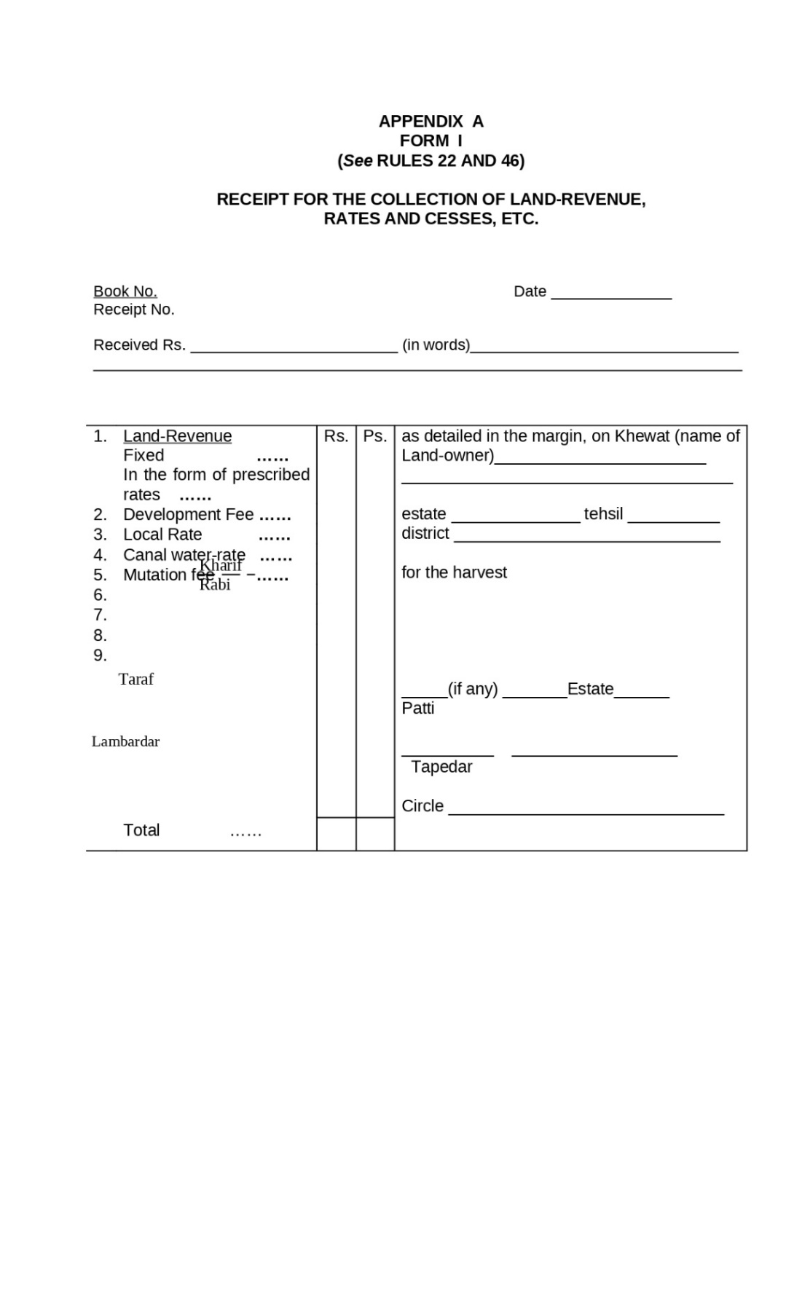

Figure : Receipt for the collection of Land-Revenue ,rates and cases

1. **Form I : Preliminay Proceeding (Robkar Ibtedai)**

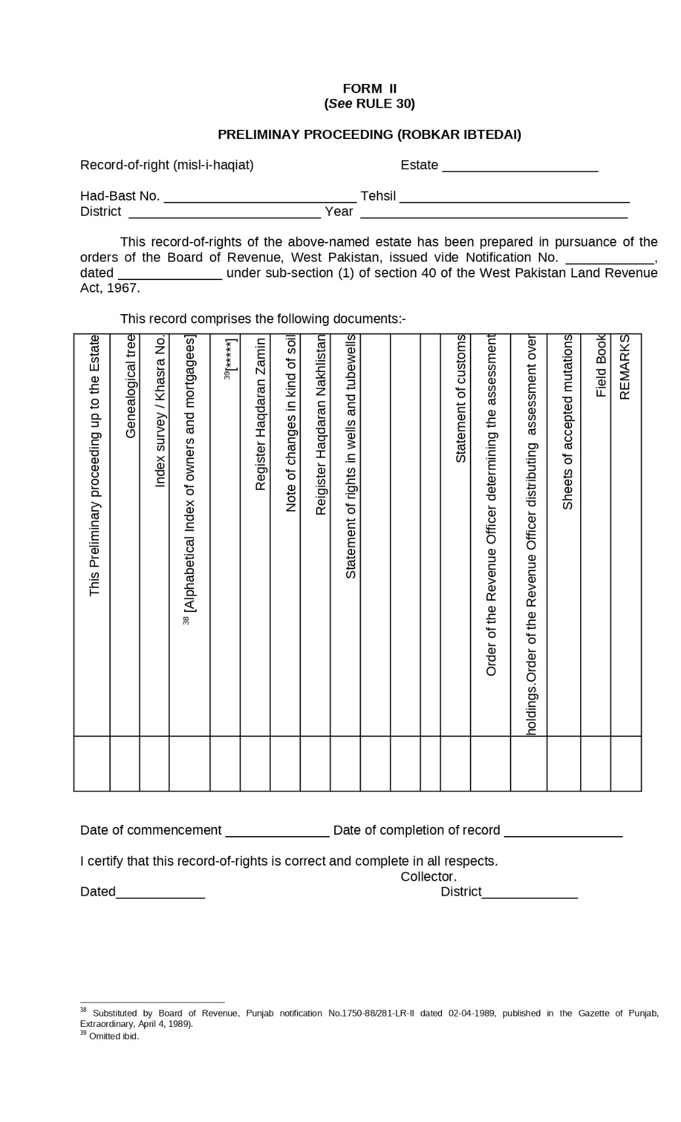

Figure : Preliminay Proceeding (Robkar Ibtedai)

1. **Form III: Shajra Nasab Genealogical tree (Shajra Nasab) of Owners**

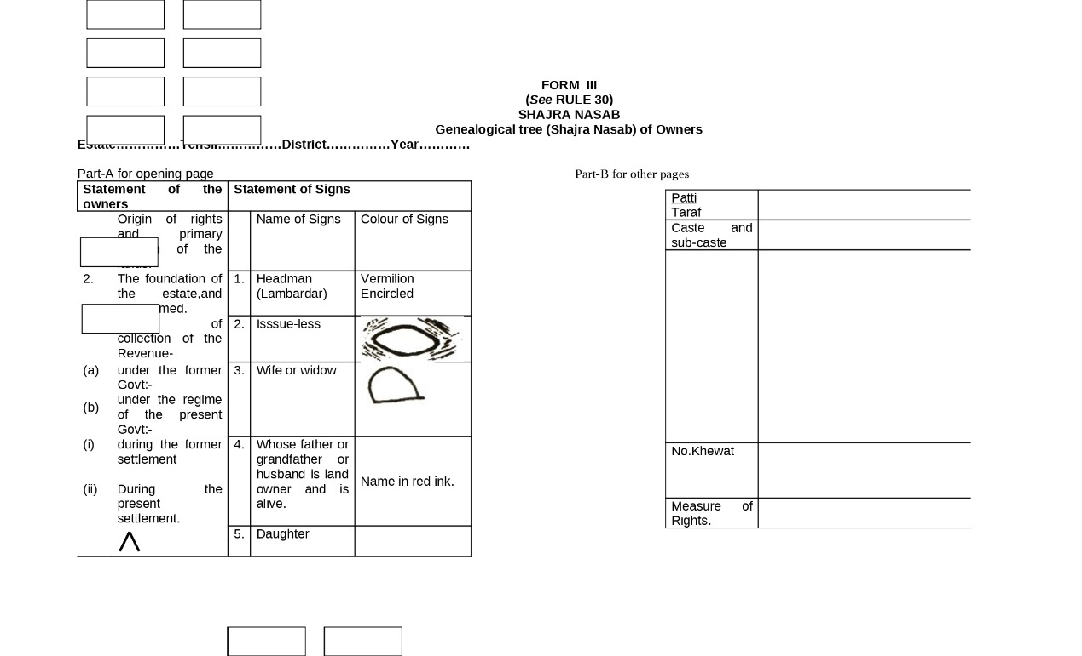

Figure : Shajra Nasab

1. **Form IV: Index Survey / Khasra Numbers**

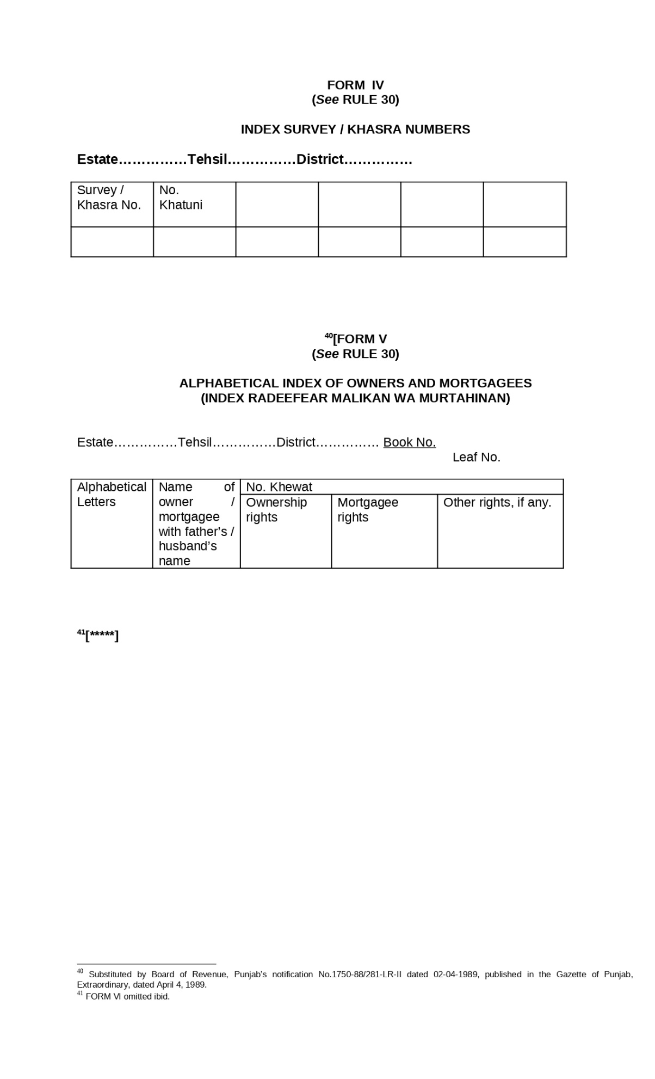

Figure : Index Survey / Khasra Numbers

1. **Form V: Alphabetical Index of Owners and Mortgagees (Index Radeefear Malikan Wa Murtahinan)**

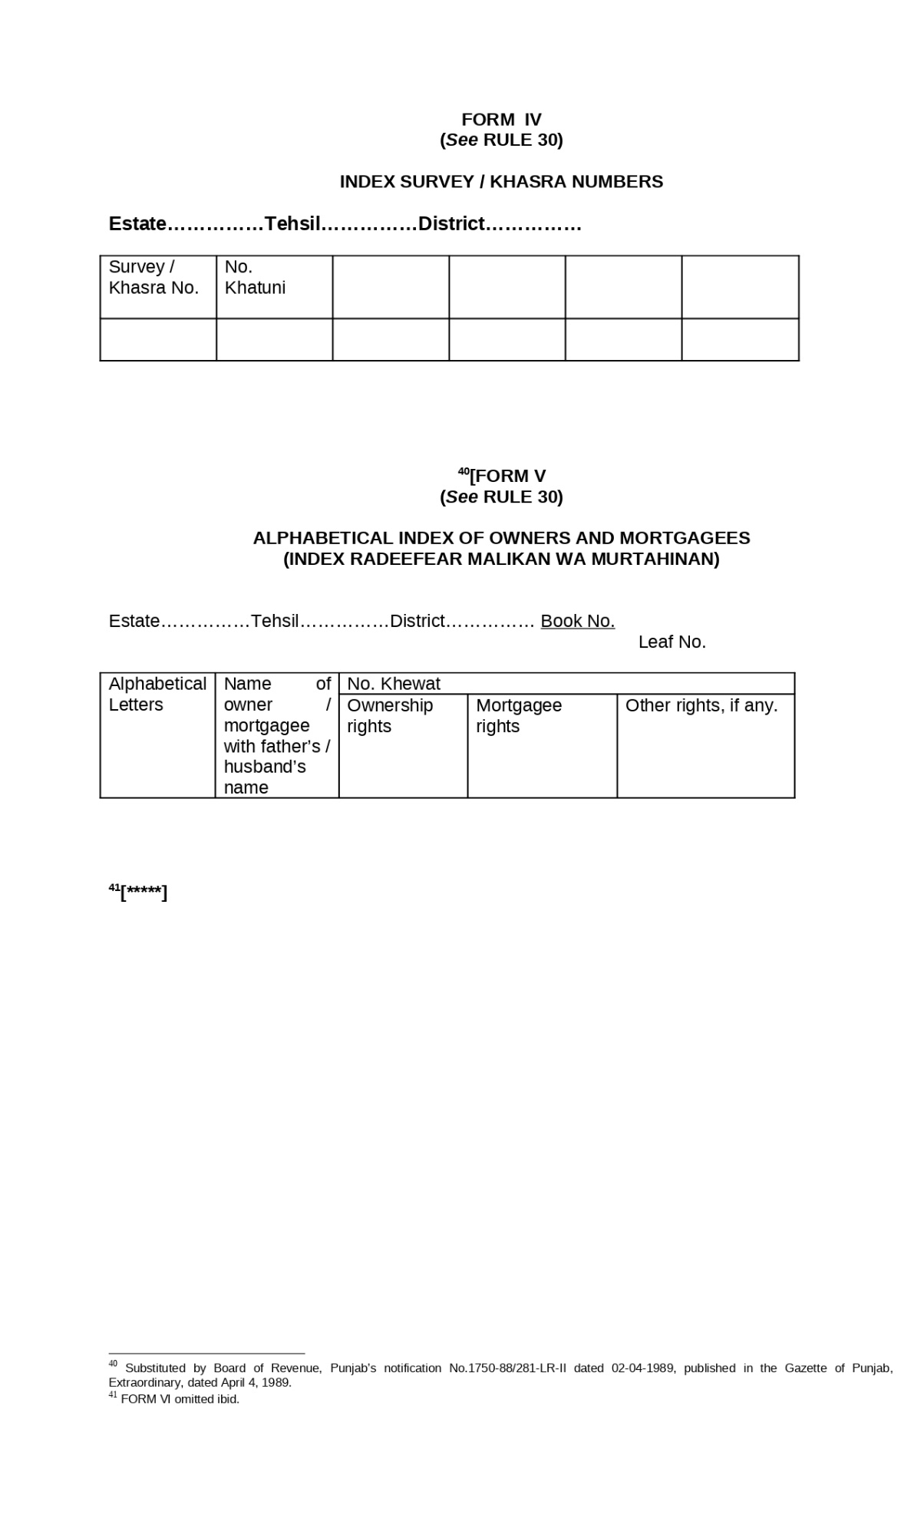

Figure : Alphabetical Index of Owners and Mortgagees

1. **Form VII: NOTE OF CHANGES IN KIND OF SOIL**

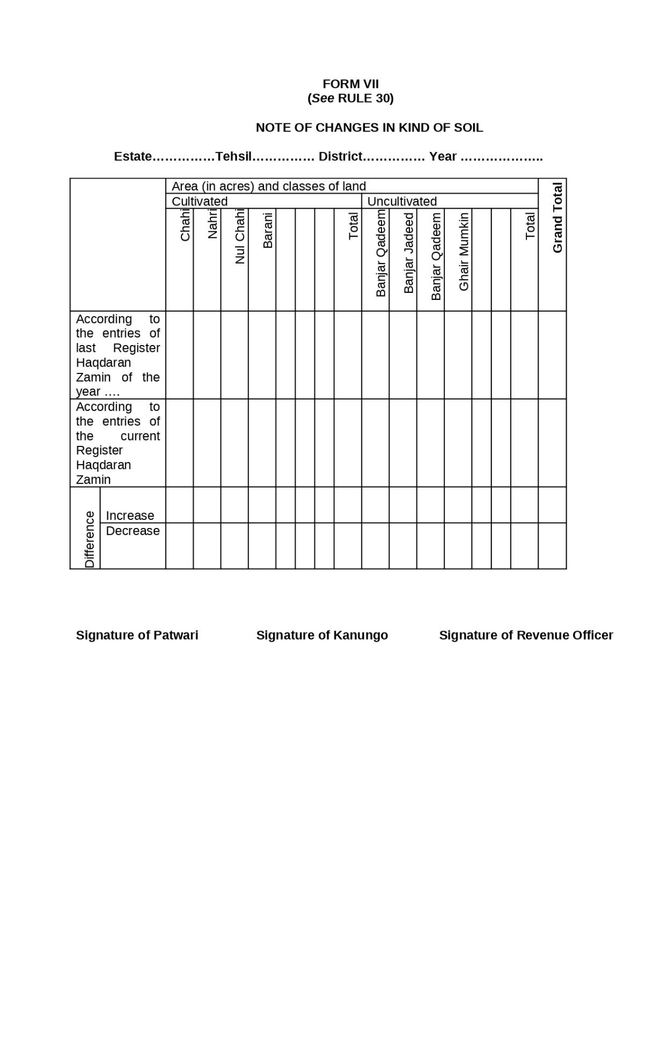

Figure : Alphabetical Index of Owners and Mortgagees

1. **Form VIII: Register Haqdaran Nakhlistan (Date Trees)**

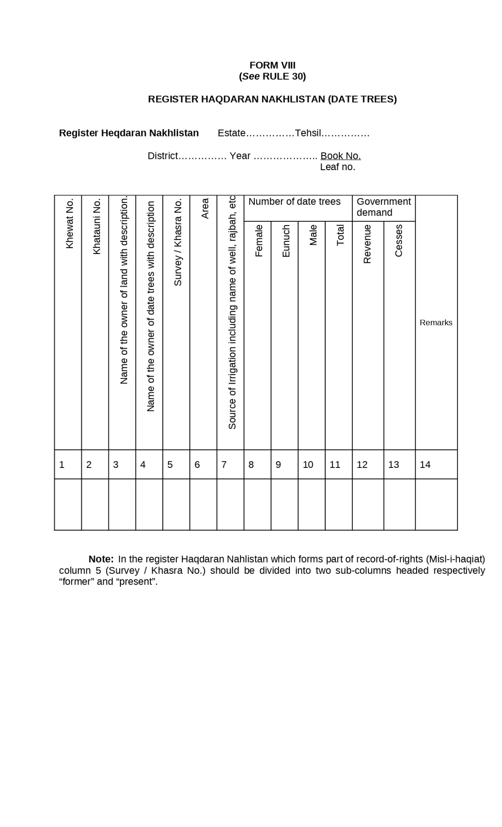

Figure : Register Haqdaran Nakhlistan (Date Trees)

1. **Form IX:** **Statement of Rights in Wells and Tube-Wells (Naqsha Haquq Chahat Wa Nul-Chahat)**

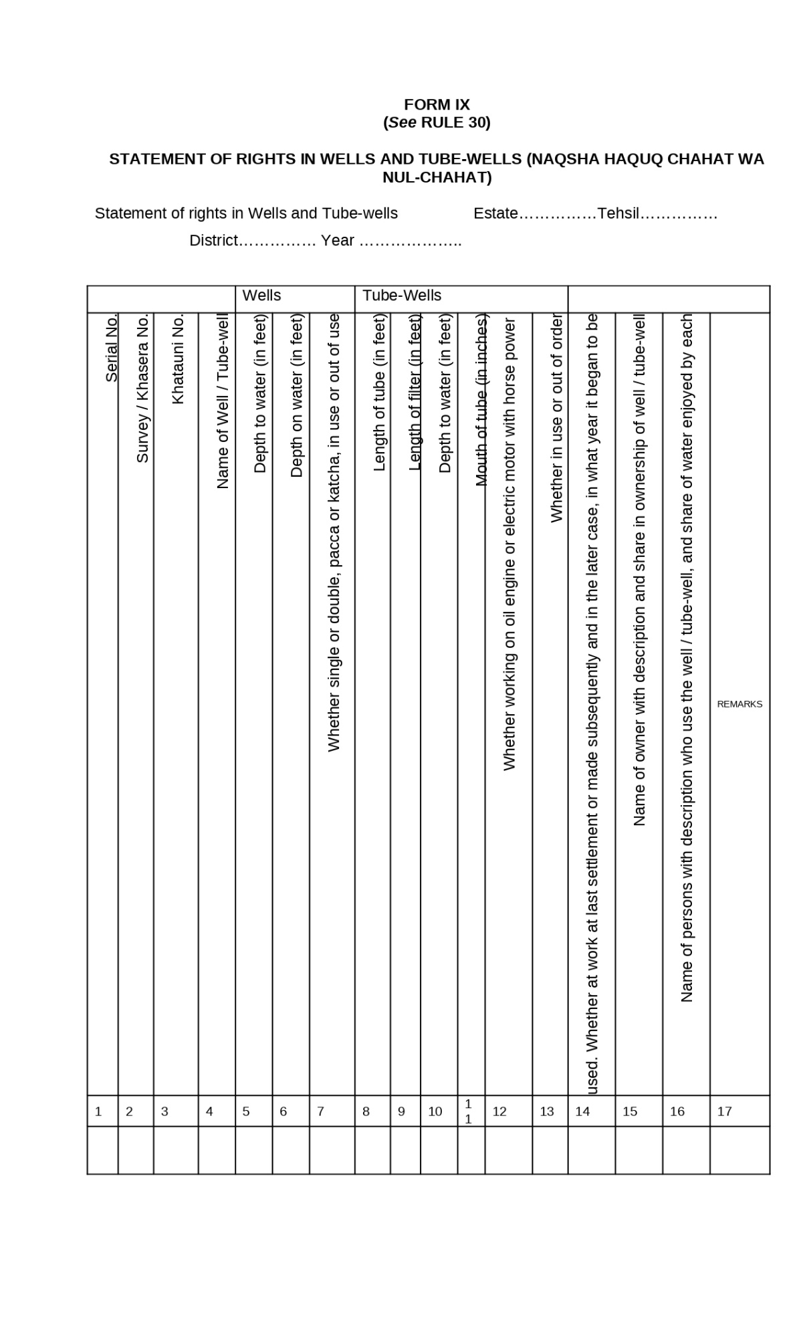

Figure : Statement of Rights in Wells and Tube-Wells

1. **Form X: Statement of Distribution of Water (Fard Taqseem Ab)**

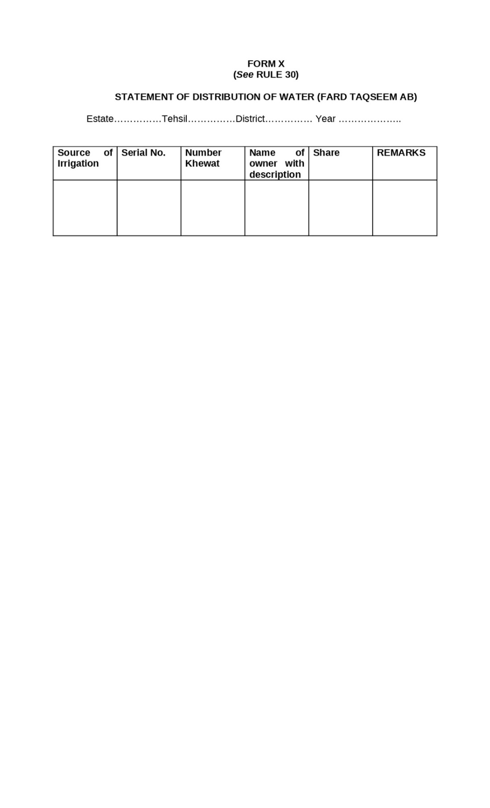

Figure : Statement of Distribution of Water

1. **Form XI: Statement of Rights in Water Mills (Naqsha Haquq Panchakiat)**

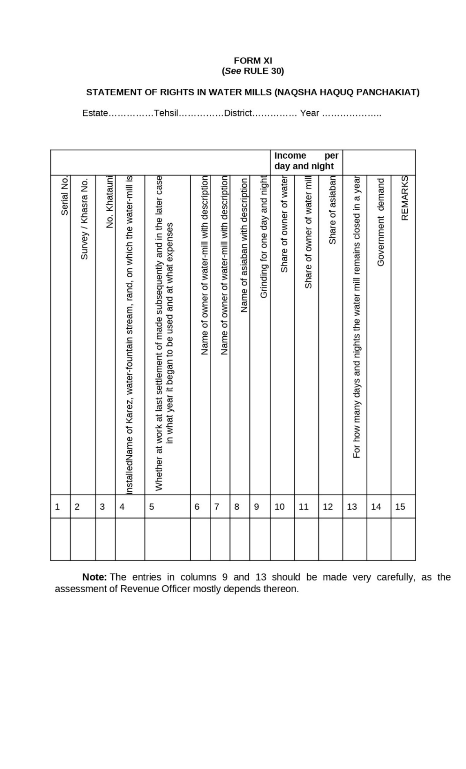

Figure : Statement of Rights in Water Mills

1. **Form XII: Field Book**

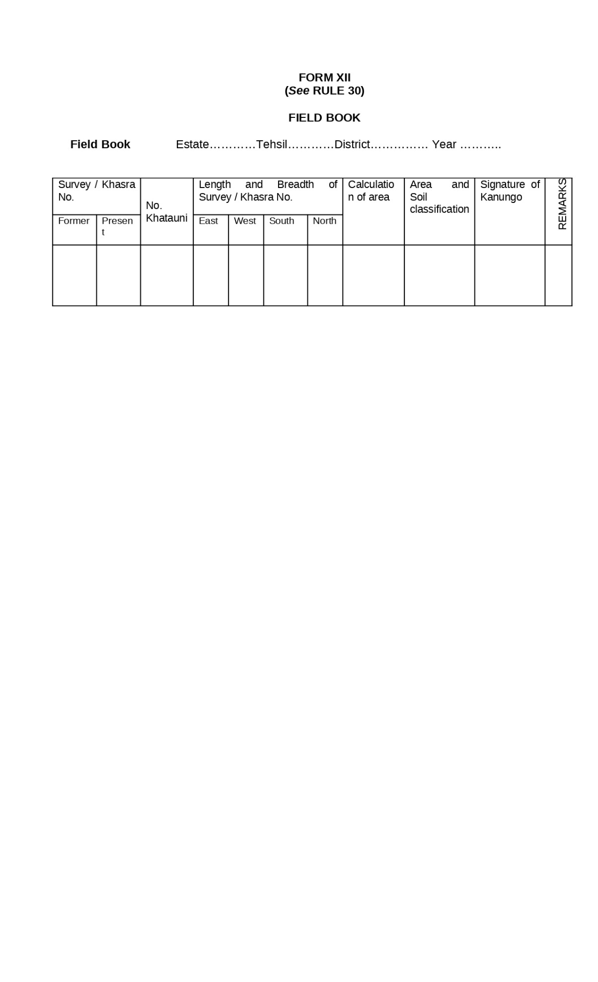

Figure : Field Book

1. **Form XIII: Title Page Register Haqdaran Zamin**

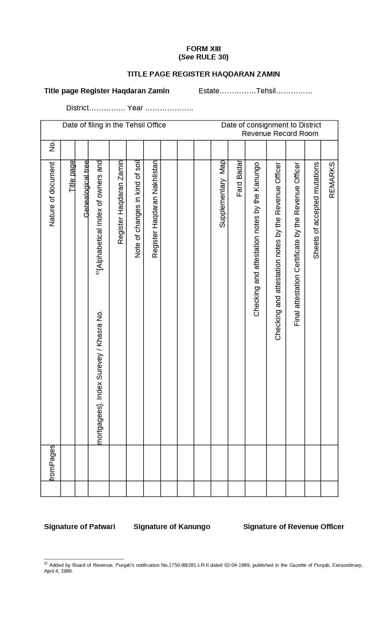

Figure : Title Page Register Haqdaran Zamin

1. **Form XIV: Supplementary Map (Tatimma Shajra)**

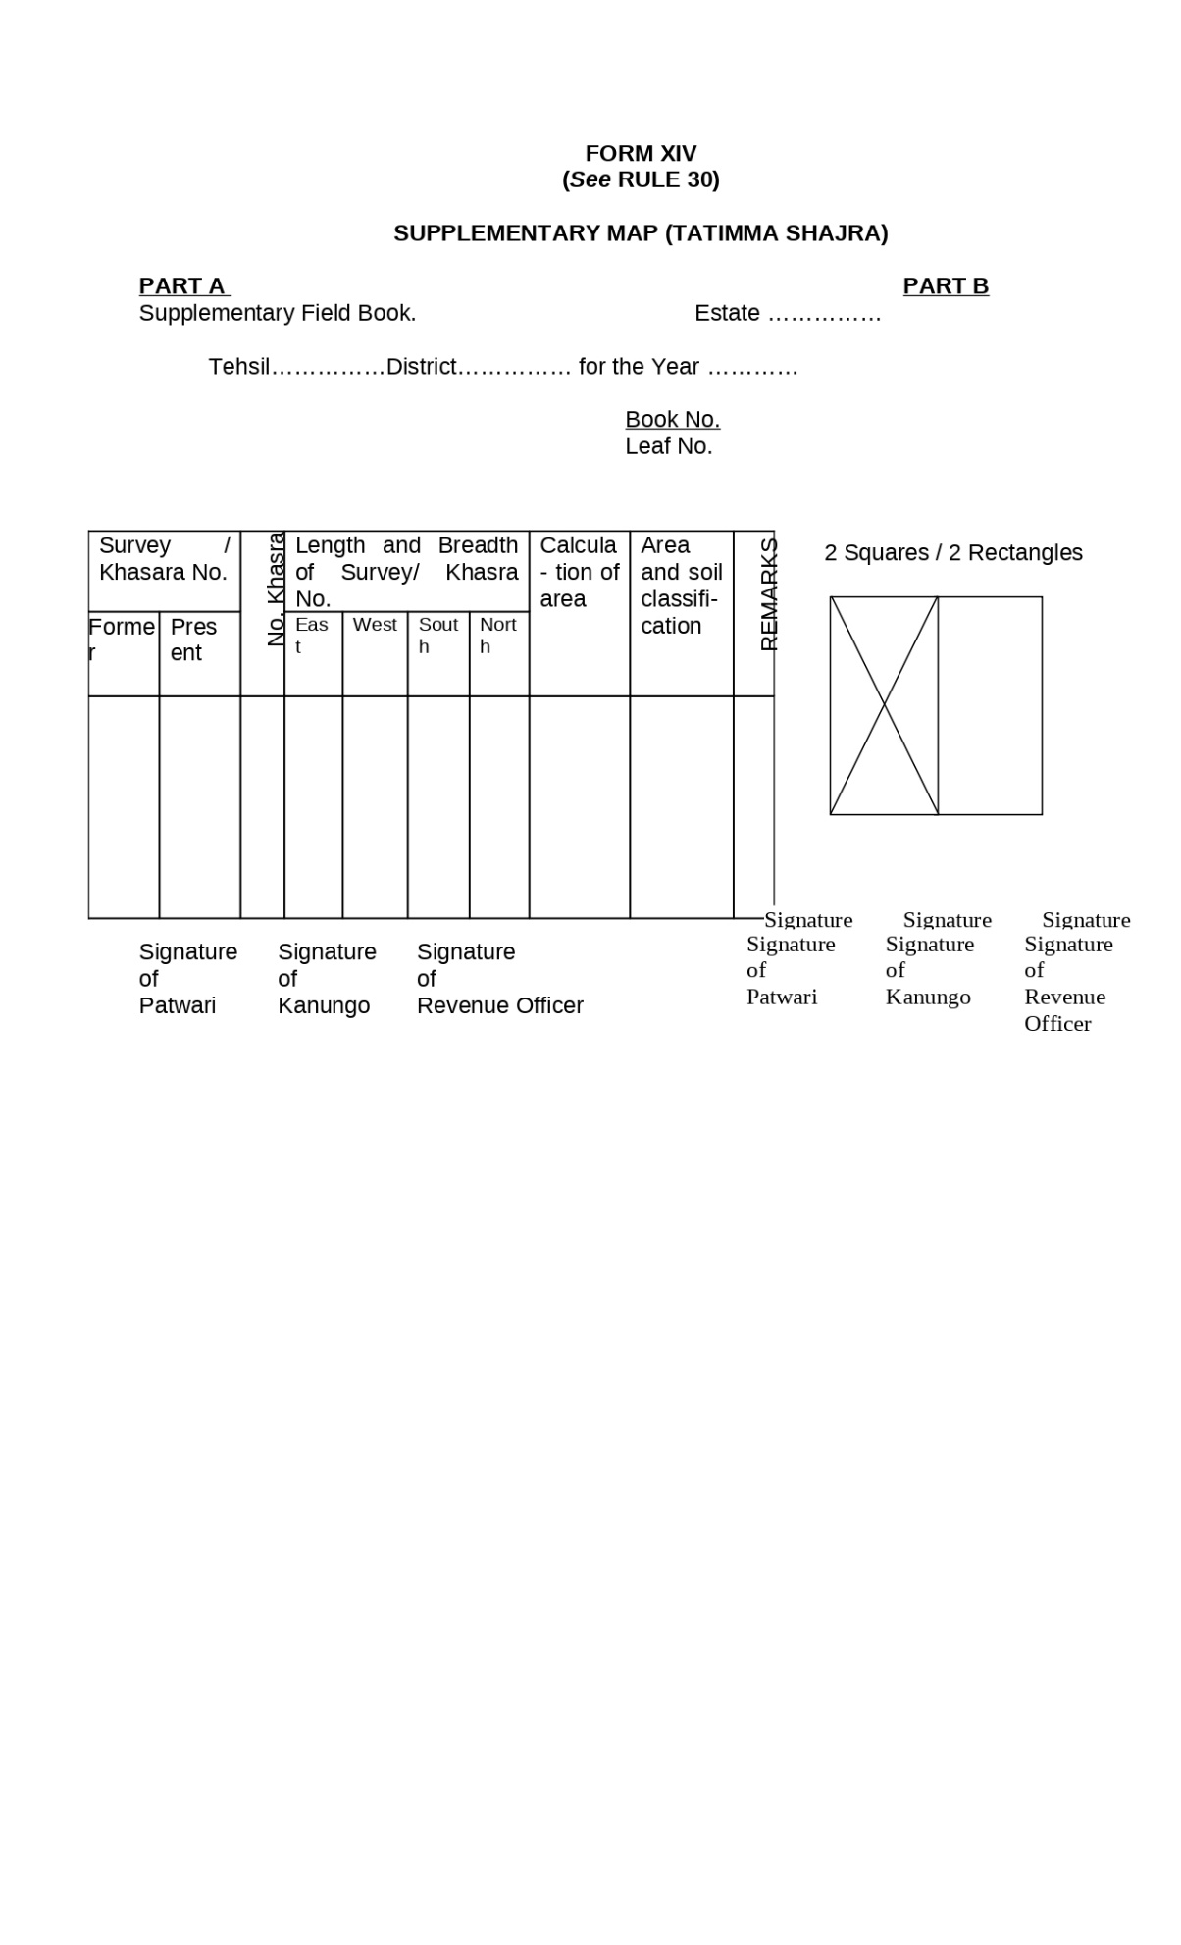

Figure : Supplementary Map (Tatimma Shajra)

1. **Form XV:** **Fard Badar (Statement of Correction of Clerical Mistakes)**

A statement for the correction of clerical mistakes, which has been made in copying the entries of the Register Haqdaran Zamin into another or in incorporating a mutation in a Register Haqdaran Zamin and the correction of which does not involve the alteration of any mutation order shall be recorded in the form set forth below, to be known as Fard Badar:-

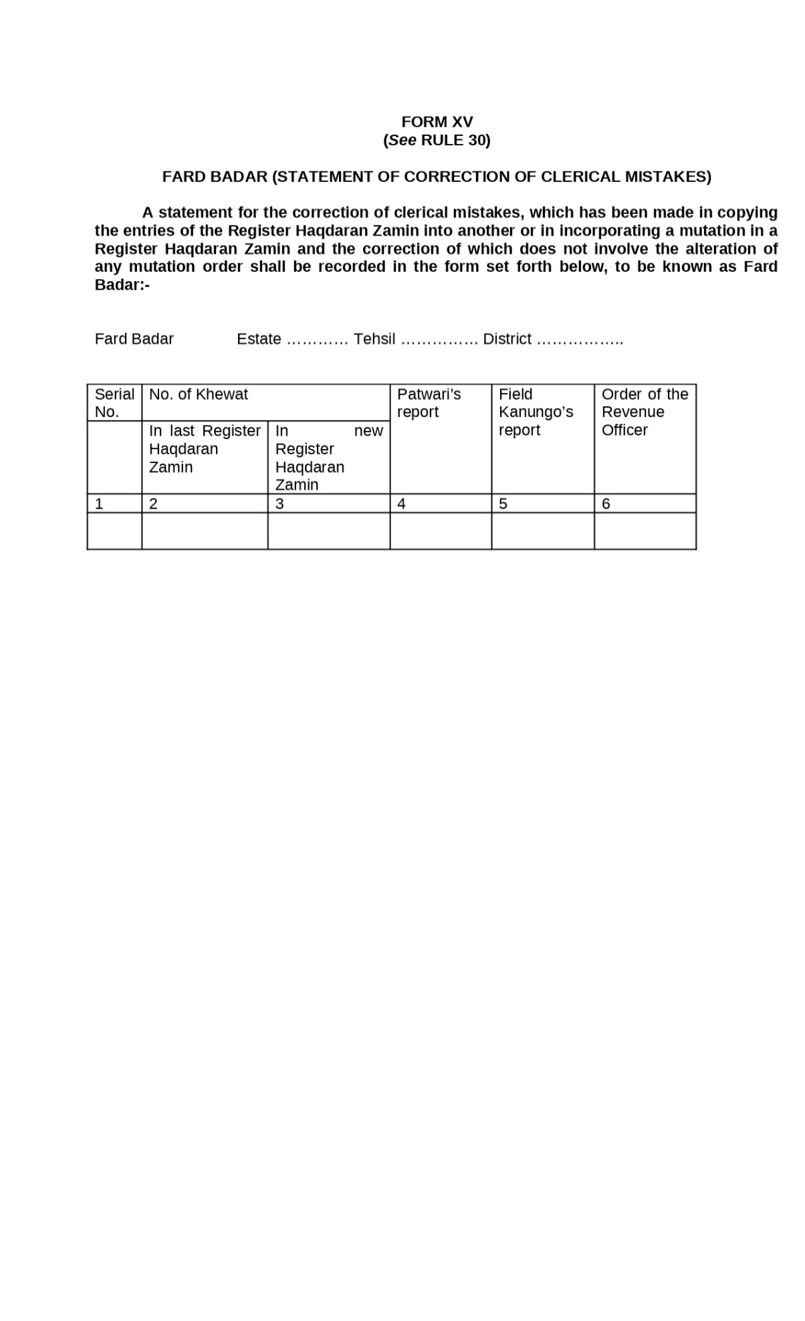

Figure : Fard Badar

1. **Form XVI:Final Attestation Certificate of Register Haqdaran Zamin for the Year**

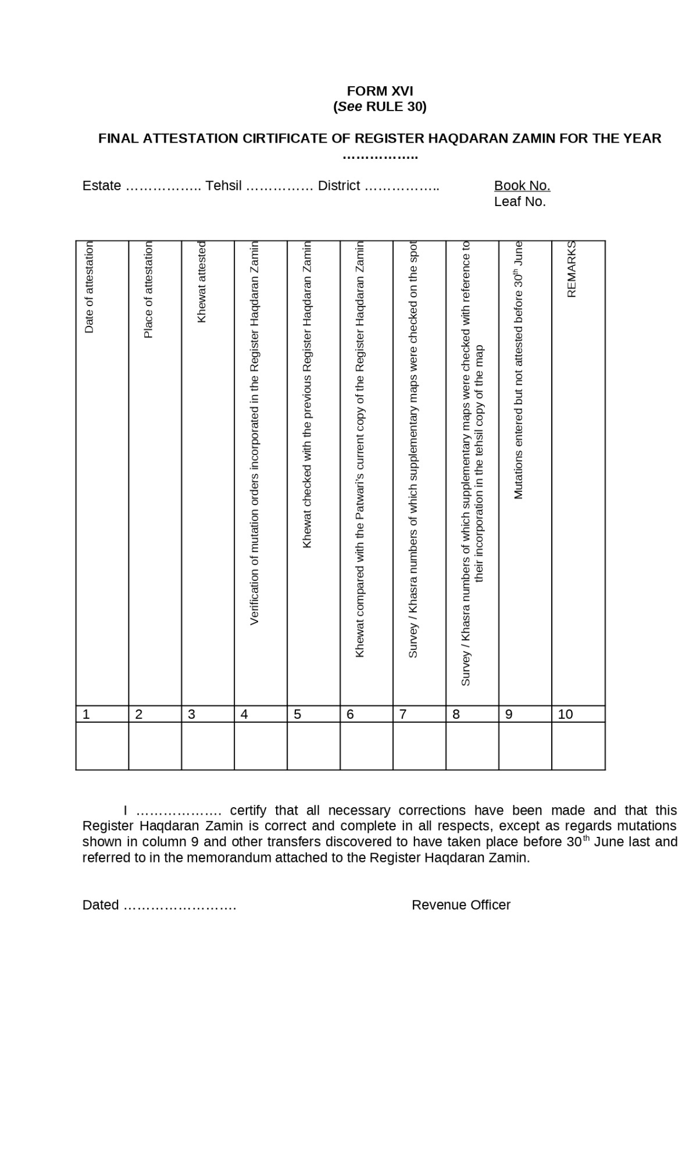

Figure : Final Attestation Certificate of Register Haqdaran Zamin for the Year

1. **Form XVII: Statement Showing the Checking and Attestation Work of Records of Rights and Periodical Records Rule 31(6)**

Manner in which the Record-of-Rights prepared, signed and attested.- A statement in Form XVII with regard to checking and attestation carried out under sub-rules (2) to (5), for each month, shall be submitted by the Tehsildar to the Collector through the Revenue Assistant, Sub-Divisional Officer concerned and the Collector shall submit all such statements in a consolidated form to the Commissioner and to the Director of Land Records.

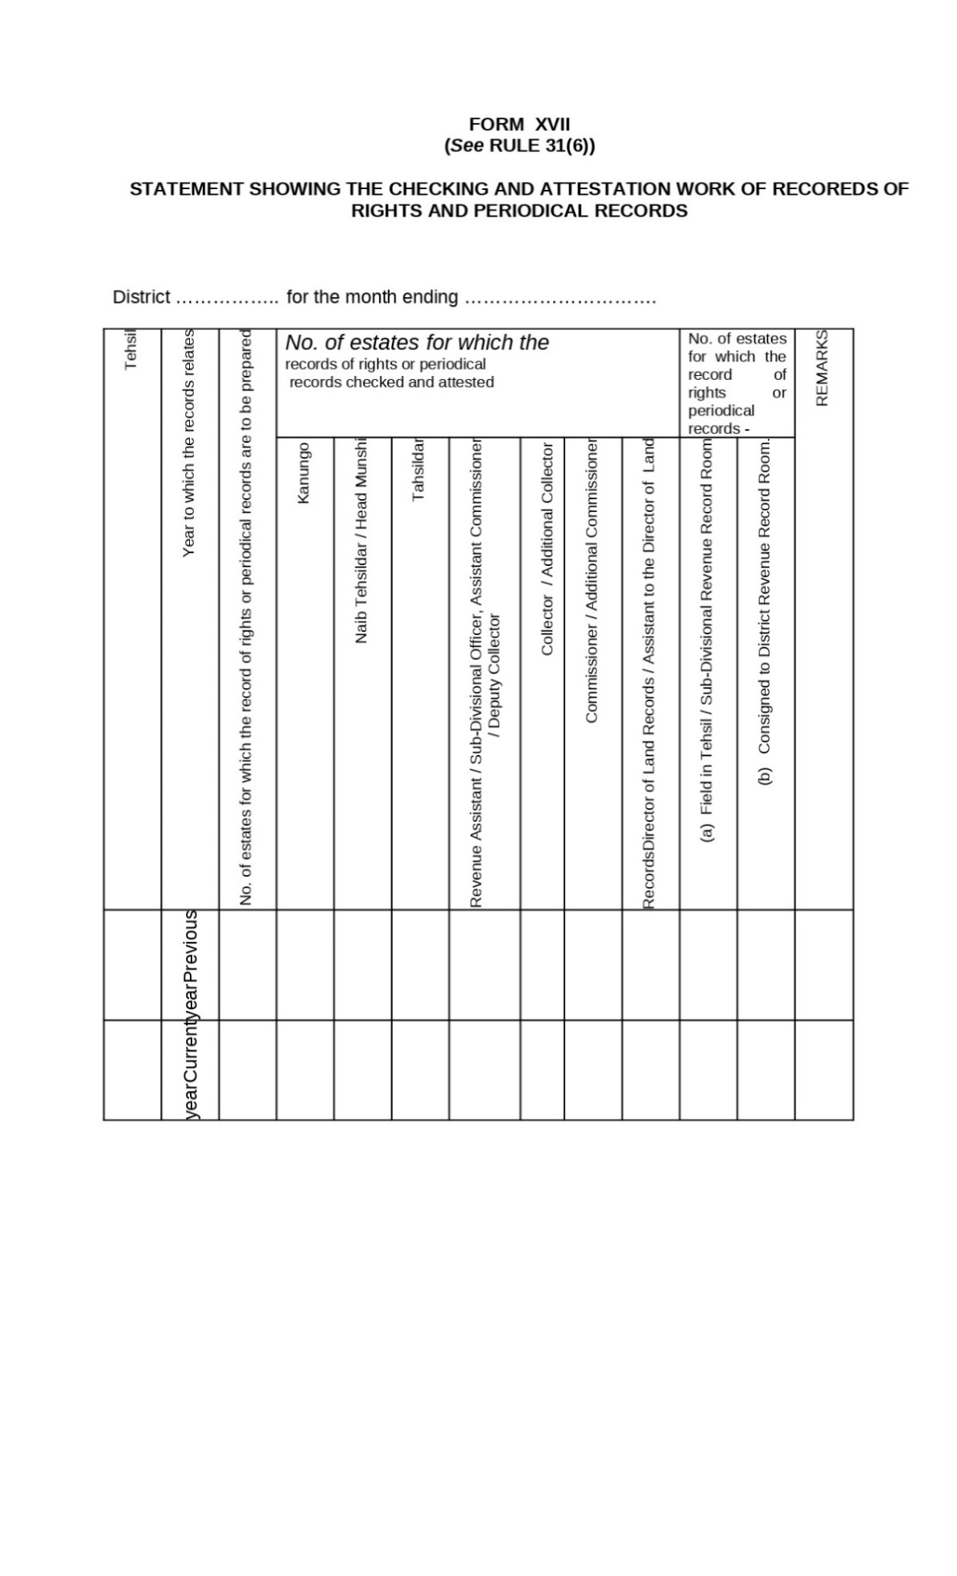

Figure : Statement Showing the Checking and Attestation Work of Records of Rights and Periodical Records

1. **Form XVIII: Memorandum Regarding Transfer of Rights RULE 32**

Gist of the order of mutation.- When a mutation is decided by a Revenue Officer, a gist of the order, shall be sent, in Form XVIII to the 22[Secretary of the Union Committee, Town Committee or the Union Council, as the case may be], in which the estate is situated and to the person whose right has been transferred.

Explanation.- In case of mutation of inheritance, the copy of the gist of the order shall be sent to the heir(s) of the deceased.

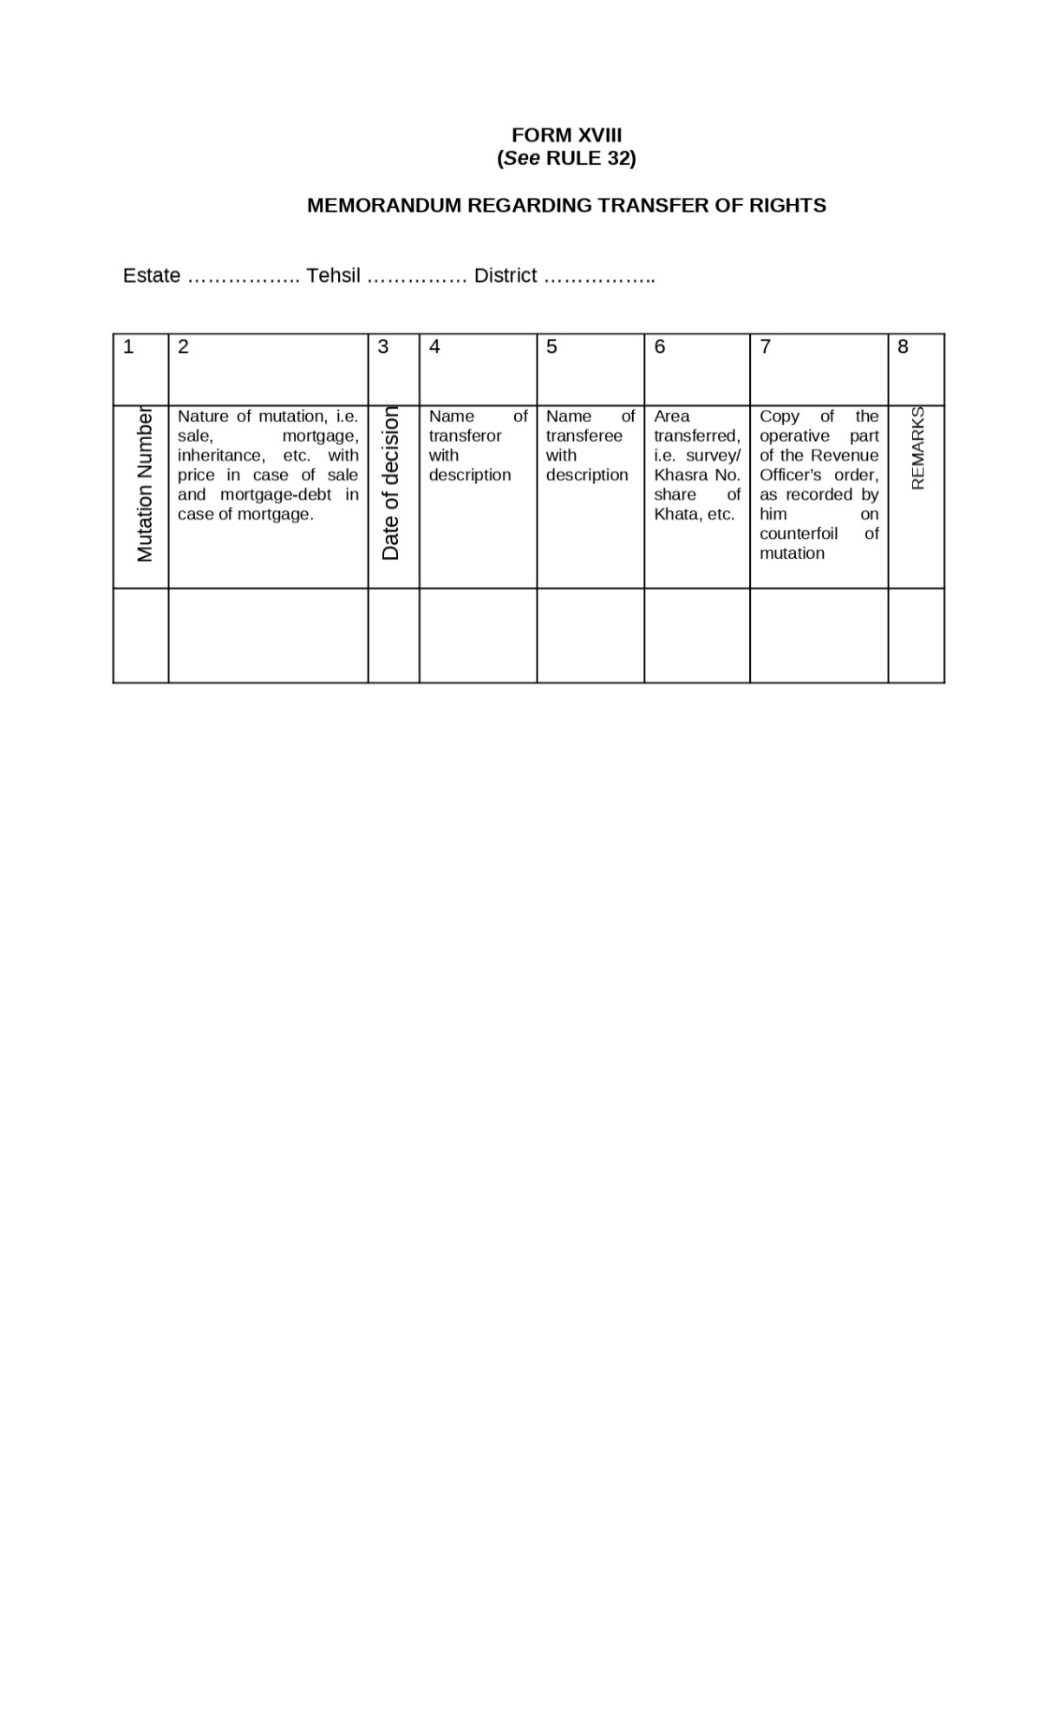

Figure : Memorandum Regarding Transfer of Rights

1. **Form XIX: Statement Showing the Mutations Pending over Three Months, for the Month Ending** **RULE 33**

Report regarding cause of delay in mutation cases.- In respect of all mutations, pending over three months, the Revenue Officer shall submit to the Collector, through the Revenue Assistant or the Sub-Divisional Officer concerned, a report in Form XIX.

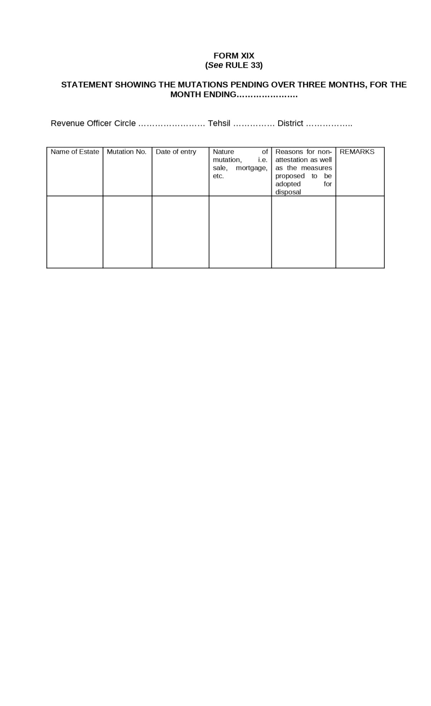

Figure : Statement Showing the Mutations Pending over Three Months, for the Month Ending

**Form XX:** **Roznamcha Waqiati of Patwari Circle RULE 34**

Roznamcha Waqiati to be maintained by the Patwari.-

1. The Roznamcha Waqiati (Daily Diary) to be maintained by the Patwari, under clause (a) of sub section of section 42, shall be in the Form XX.
2. The pages of Roznamcha shall be stitched in a volume and each page shall bear the book number and page number in print.
3. The Patwari shall prefix to every entry, in the Roznamcha a separate serial number, in large and clear figures. Every entry shall be closed by an asterisk, and no blank line shall be left between two consecutive entries. Such orders and instructions as relate to rules of practice, shall be entered in red ink. The date of each day's entries shall be given according to the official calendar.
4. In addition to the events to be entered in Roznamcha according to the instructions which may be issued by the Commissioner from time to time, the following occurrences shall be entered in the Roznamcha of the day on which they come to the Patwari's notice, and the manner in which they come to his knowledge.
5. Any epidemic disease among human beings or livestock, or any calamity affecting crops, including crop pests.
6. All alluvion, or diluvion, with approximate areas and details so far as known at that time.
7. Falls of rain and their duration, and whether slight, medium or heavy and the damage or benefit to the standing crops as a result.
8. The dates on which canals or Rajbahas began or ceased to run, and on which there was any marked change in the supply of canal water.
9. Deaths of land-owners, village officers and pensioners.
10. The ejectment, absconding, or settling of cultivators or right-holders, and the relinquishment, change or renewal of any tenure.
11. The execution of any decree of Court affecting the land, its rent, or its produce.
12. Taccavi advances made by Government and repayments of the same; as also notes of the progress or completion of works for which taccavi has been granted.
13. Orders of Revenue Officers or Kanungos received by the Patwari or executed in the circle.
14. Attachment proceedings affecting the land, its cultivation, or its produce, or cattle.
15. Any encroachment on or damage to Nazul or Government Property or roads.
16. Any suspensions or remissions of revenue, and any alteration of the rate of cesses.
17. The cultivation of land occupied by groves held free of revenue. 22 Now “Union Administration”
18. The erection, destruction or decay of survey marks or boundary marks and the alteration of village boundaries.
19. The visit of any Government official to the circle.
20. Any fact relating to land or its revenue or rent specially reported to the Patwari by a person interested therein, with a request that it be entered in his Roznamcha or which the Patwari may think of importance.
21. Any alteration in the ownership, cultivating possession or rent of land, which may have been recorded in the crop-inspection register.
22. The receipt of any registration Memos. received in respect of item (xvii).
23. Any case of rick-burning, and, when it is suspected that the crime is due to incendiarism, this should be specified.
24. Any cases of increase of mortgage money, with details of the amount, parties and village.
25. Distribution of Dhal Bachhes to headmen and bills of assessment to landowners.
26. The signature or thumb-impression of the headman or member of the Union Committee, Town Committee or Union Council concerned, shall also be obtained at the time of making entries, relating to changes in revenue records.
27. A copy of the report, recorded by the Patwari, in the Roznamcha under sub sections (1) to (3) of section 42, shall be exhibited at the Patwari's office for a period of one month, from the date of its recording and shall be made available to the public for inspection during office hours, without any fee.



Figure : Roznamcha Waqiati of Patwari Circle

**Form XXI: Acknowledgement Under Section 47 (2) of the West Pakistan Land Revenue Act, 1967 RULE 35**

Production of documents or furnishing of information under section 47.-

1. When any information is furnished to the Revenue Officer or Patwari, or any document is produced before him, under the provisions of section 47, the Revenue Officer or the Patwari concerned, as the case may be, shall give a written acknowledgement thereof, to the person furnishing the information or producing the document, in Form XXI.
2. Any document so requisitioned and produced shall be returned in original, after inspection, to the person who produced it, with an endorsement by the Revenue Officer or the Patwari, as the case maybe, under his signature. 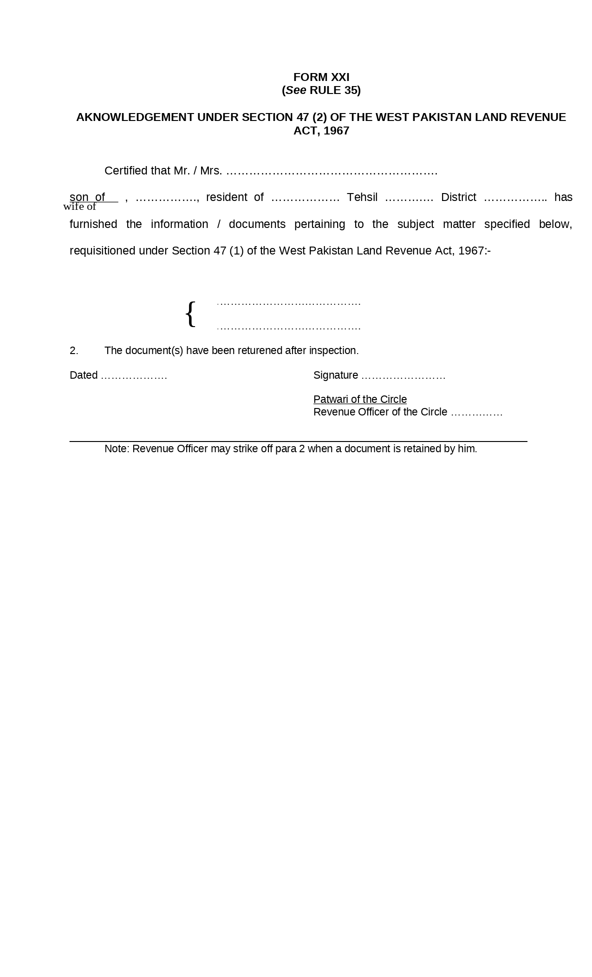

Figure : Acknowledgement Under Section 47 (2) of the West Pakistan Land Revenue Act

**Form XXI-A: Register showing the applications for grant of certified copies or extracts of records in possession of Patwari received in the office of Collector of the Sub-Division and disposed of RULE 36**

Inspection of Records of Patwaris and grant of certified copies or extracts therefrom.-

1. The Patwari shall allow any one interested to inspect his records and to take notes therefrom, in pencil, in his presence, during office hours, on all working days. He shall give to the applicants certified copies or extracts therefrom and enter in his diary, a note, of the inspections allowed and copies or extracts given.
2. Such copies or extracts shall be given by the Patwari, to the applicants, within three days from the receipt of the application. 24[(2-A) A person who desires to obtain a certified copy of revenue record in possession of a Patwari may apply to the Collector of the Sub-Division on all working days except Sundays giving necessary particulars of the record of which a copy is required. All such applications will be entered in a register in Form XXI-A. The applicant shall be given a date to receive the said copy within a week from the receipt of the application: Provided that if so required the copy shall be provided on payment of urgent fee within 24 hours].
3. The charges shall be made, as detailed in Schedule in Appendix B.

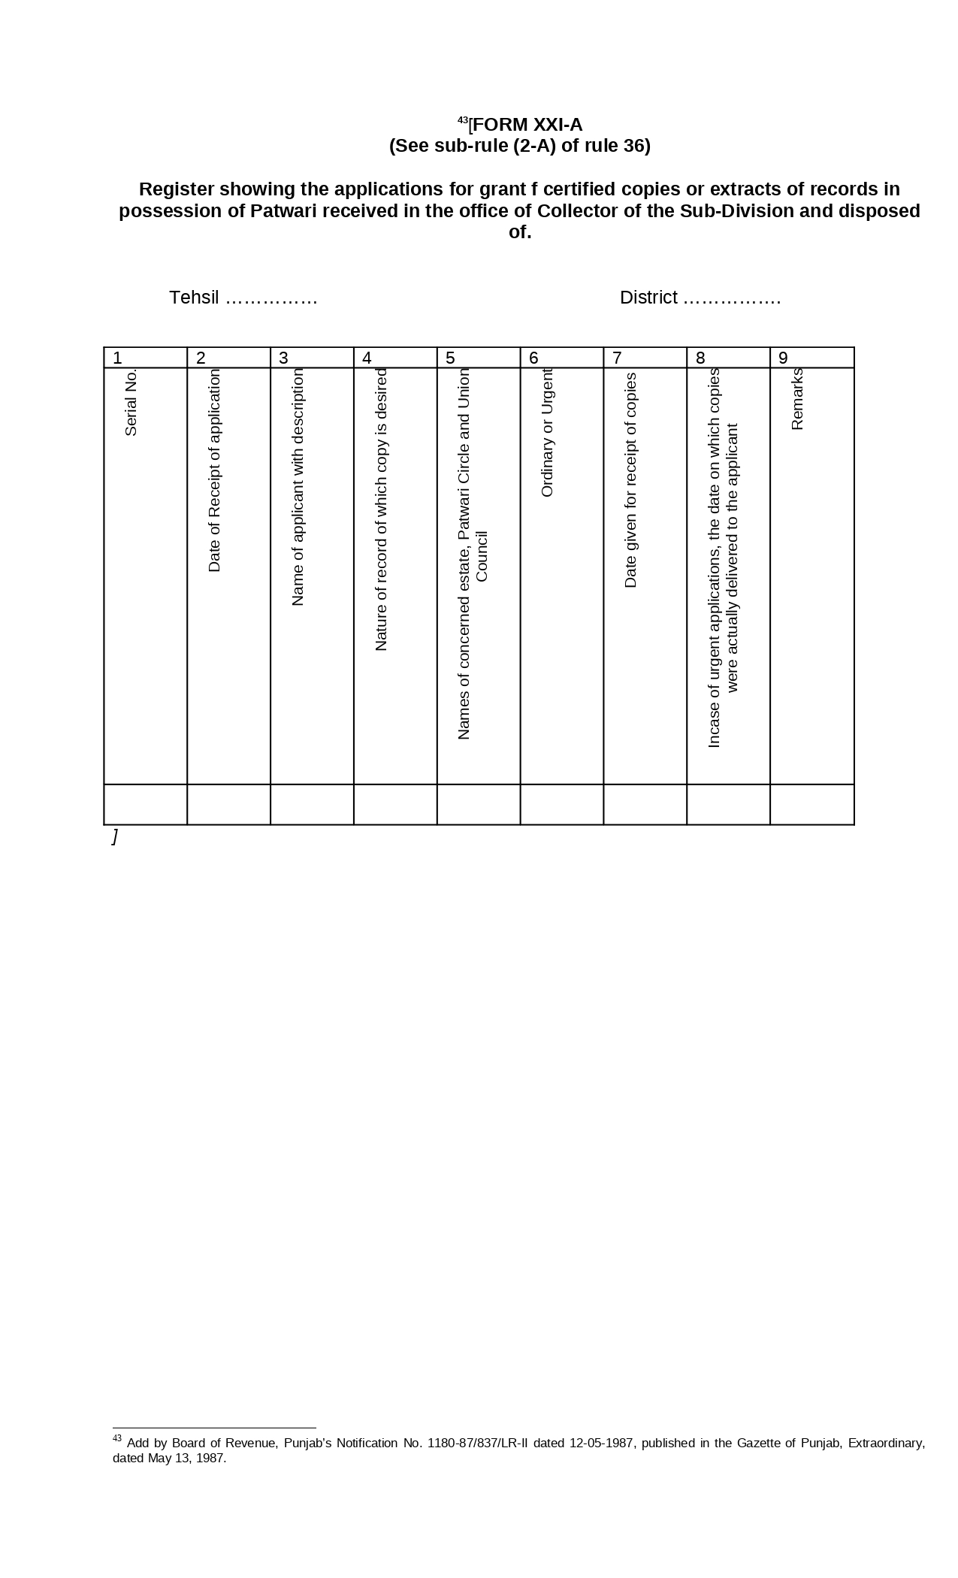

Figure : Register showing the applications for grant of certified copies or extracts of records in possession of Patwari received in the office of Collector of the Sub-Division and disposed

**Form XXII:** **Receipt of fee for the inspection of records of patwari and grant of certified copies or**

**extracts therefrom RULE 36(3)**

The charges shall be made, as detailed in Schedule in Appendix B.

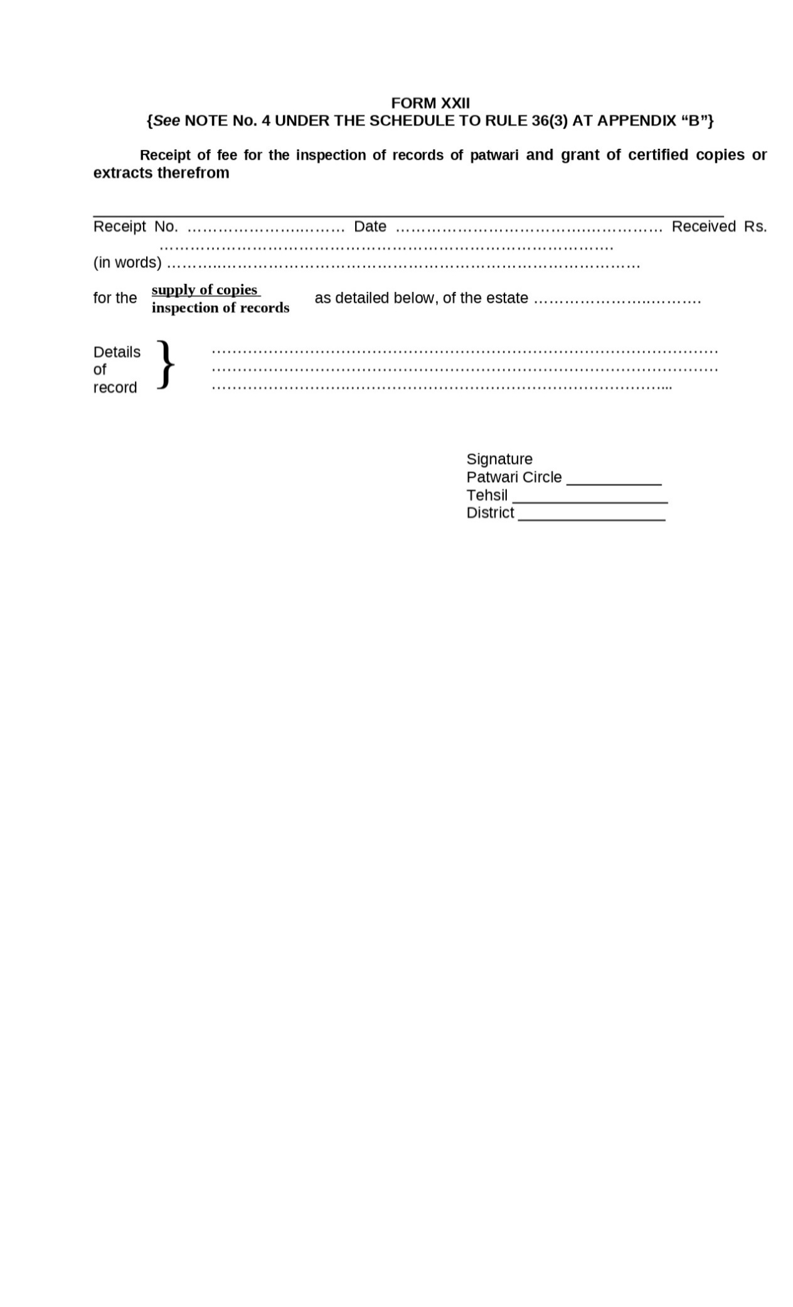

Figure : Receipt of fee for the inspection of records of patwari and grant of certified copies or

**Form XXIII:** **Acknowledgement of the receipt of application for the supply of copies of records of Patwaris**

**under Rule 36 of the West Pakistan Land Revenue Rules 36(3).**

The charges shall be made, as detailed in Schedule in Appendix B.



Figure : Acknowledgement of the receipt of application for the supply of copies of records of Patwaris

**Form XXIII-A: Register of fees for the Preparation of Produce Statement and Five-yearly Abstract of yield. RULE 37-A(6)**

Preparation of produce statements and five-yearly abstracts of yield.- The particulars of all such requisitions and the amount of fee chargeable shall be entered in the register maintained in the Land Records Office of the District or Tehsil, as the case may be in Form XXIII-A].

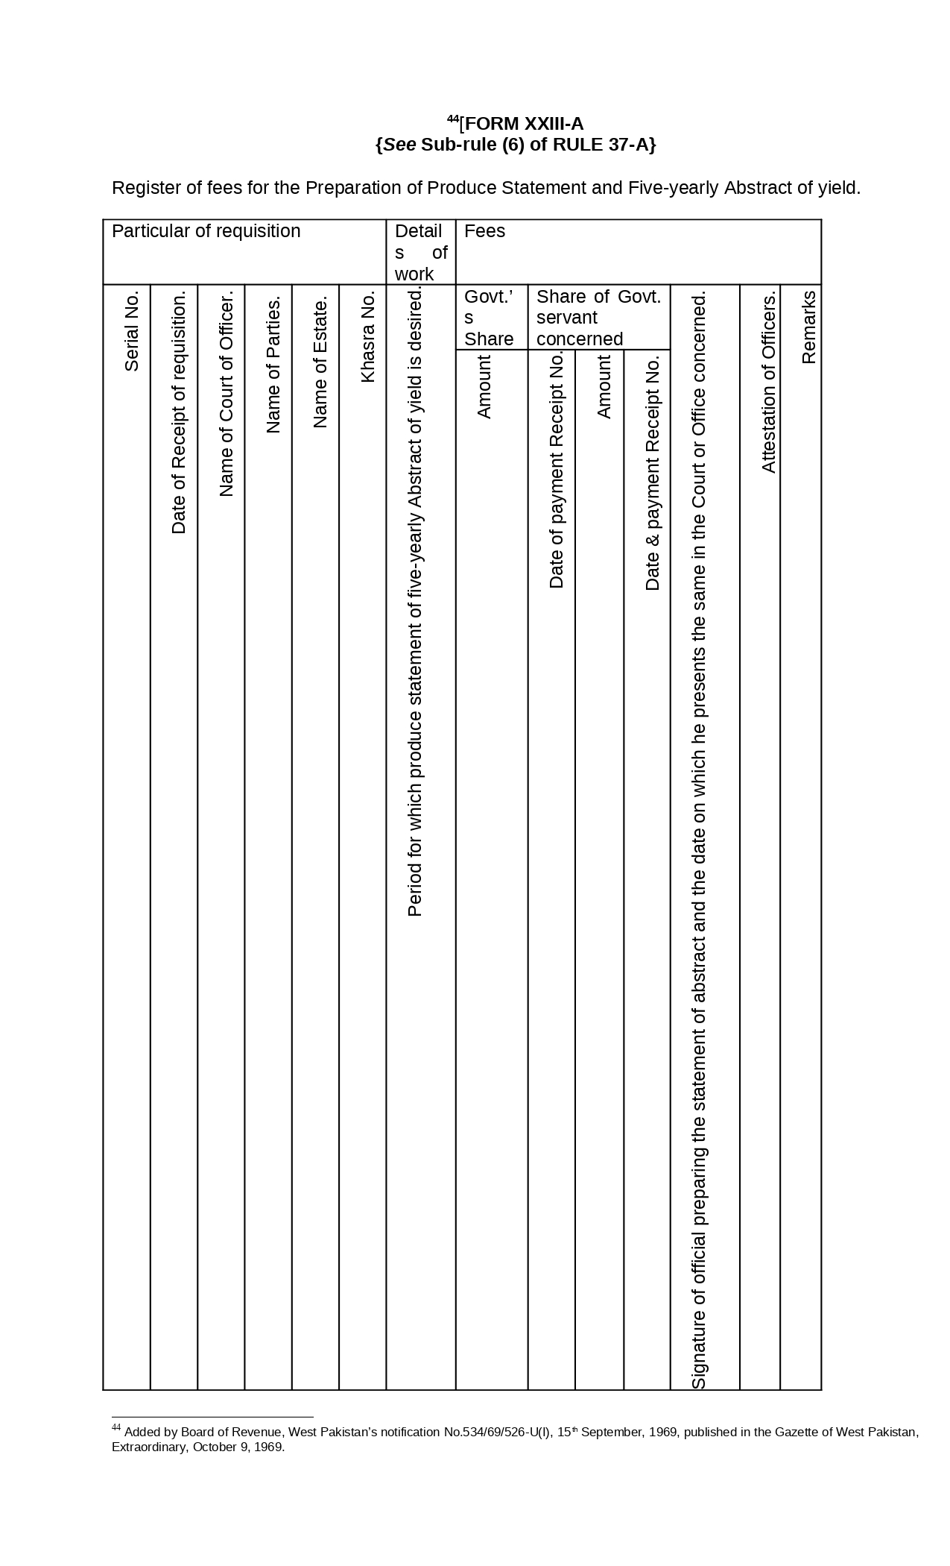

Figure : Register of fees for the Preparation of Produce Statement and Five-yearly Abstract of yield.

**Form XXIV: Crop Inspection Register (Register Girdawari) RULE 39**

Crop Inspection Register.-

1. For each estate, a crop inspection register (Girdawari) shall be maintained, in Form XXIV.
2. For each estate, a register of changes in cultivations, possession and rent to be known as the “Register Taghayyurat-e-Kasht” shall also be maintained by the Patwari in Form XXIV-A in which he will enter such harvest-wise changes as are not disputed and will incorporate the same in the Register Girdawari after due checking and attestation thereof by the Field Kanungo and the Circle Revenue Officer.
3. After the date specified by the Board of Revenue under sub-section (2) of section 41-A of the Act, the Patwari shall, within fifteen calendar days of completion of girdawari of Rabi/Khareef each year, submit the register Taghayyurat-e-Kasht (Form XXIV-A), duly verified by the field Kanungo and the Circle Revenue Officer to the Service Centre In-charge of the estate who shall cause it to be immediately scanned, saved in the computerized record and returned to the Patwari.
4. The Service Centre In-charge shall cause the Service Centre Official to update the computerized record of the estate on the basis of variations recorded in the register Taghayyurate-Kasht and the entries made as such shall be presented to the Service Centre Revenue Officer for his approval through his electronic signatures, and after his approval, the changes shall become a part of the computerized register Haqdaran Zamin of the estate.

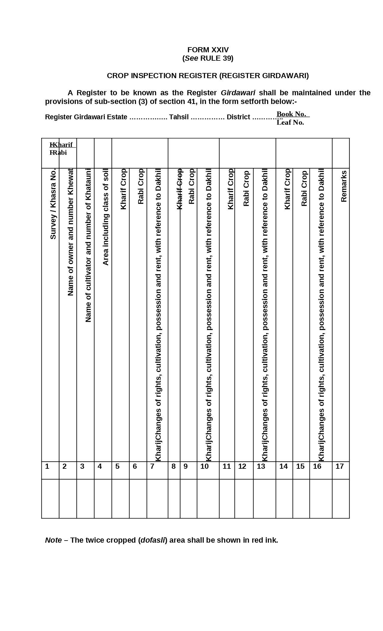

Figure : Crop Inspection Register (Register Girdawari)

**Form XXIV-A:** **Register Taghayyurat-e-Kasht RULE 39(2)**

For each estate, a register of changes in cultivations, possession and rent to be known as the “Register Taghayyurat-e-Kasht” shall also be maintained by the Patwari in Form XXIV-A in which he will enter such harvest-wise changes as are not disputed and will incorporate the same in the Register Girdawari after due checking and attestation thereof by the Field Kanungo and the Circle Revenue Officer].

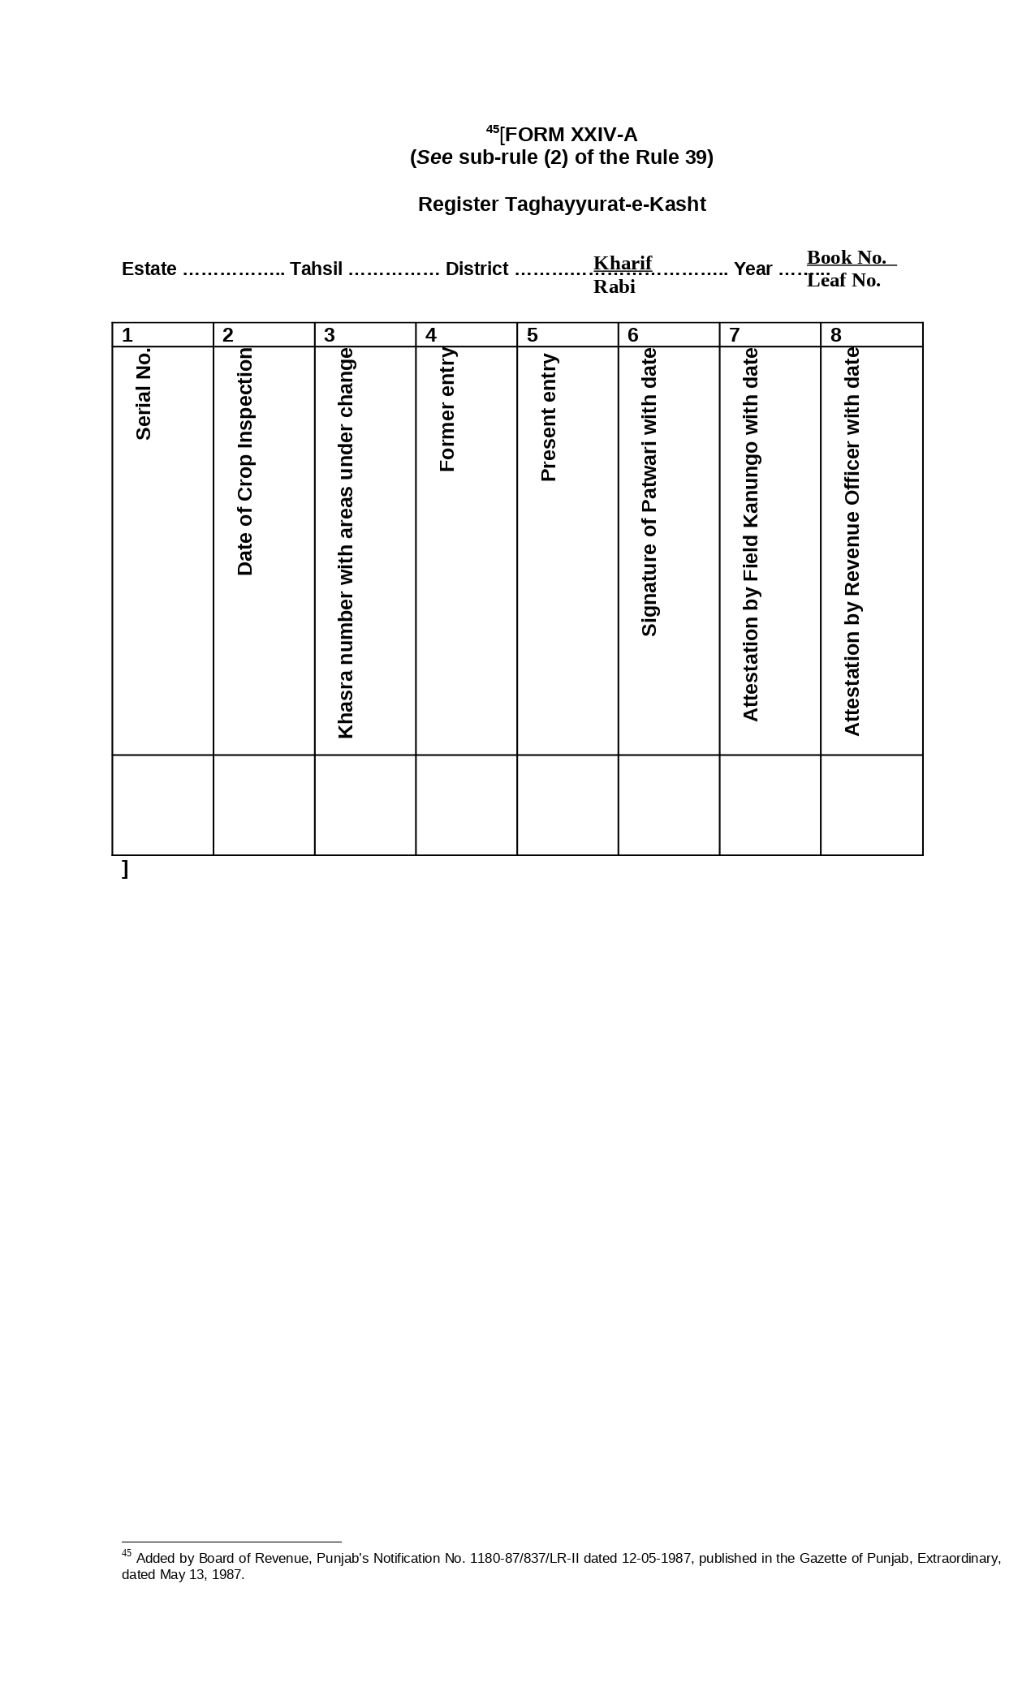

Figure : Register Taghayyurat-e-Kasht

**Form XXV:** **Statement of Kharaba RULE 41**

Failure of crop to be entered in the Register Girdawari.-

1. When a crop fails to germinate or dries up, or is destroyed by calamity of season or the yield falls short of the normal out-turn, a corresponding entry of the failure of crop (Kharaba), shall be made in the Register Girdawari (Form XXIV), at the time of harvest inspections.
2. In areas in which land revenue is assessed in the form of prescribed rates under clause (b) of sub section (3) of section 56 a statement of Kharaba shall be prepared in Form XXV.
3. The entries in the statement of Kharaba shall be checked, on the spot, cent per cent by the Kanungo; 50% by the Naib-Tahsildar/Head Munshi or Tahsildar and 25% by the Assistant Collector of the first Grade.
4. The checking of statement of Kharaba shall be carried out within fifteen days following the day on which the crop inspection by the Patwari is concluded.

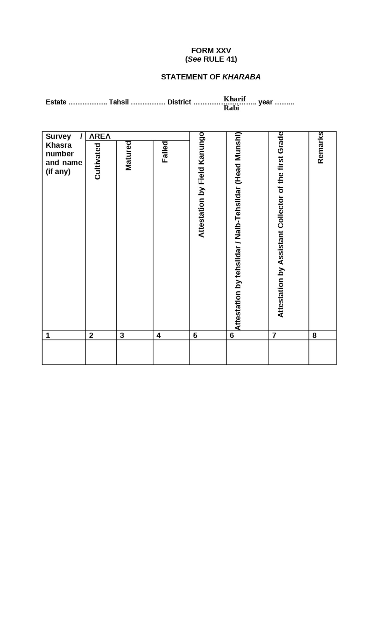

Figure : Statement of Kharaba

**Form XXVI:** **Dhal Bachh Malia Mustaqil (Distribution of fixed revenue over holdings) RULE 44**

Bachh Papers.-

1. In each estate, a distribution of revenue (Dhal Bachh) of fixed (Malia Mustaqil) or in the form of prescribed rates (Ghair Mustaqil), shall be prepared by the Patwari, Khewat-wise, in Form XXVI or Form XXVII, as the case may be.
2. In the areas where collection of revenue is made by Tapedars, the Tapedar (Patwari) shall prepare a bill of assessment, in respect of each land-owner in Form XXVIII and deliver the same to him.
3. In the areas where collection of revenue is made through Headmen (Lambardars), the Patwari shall prepare a copy of Dhal Bachh, headman-wise, showing the particulars of each land-owner and deliver the same to the headman (Lambardar).

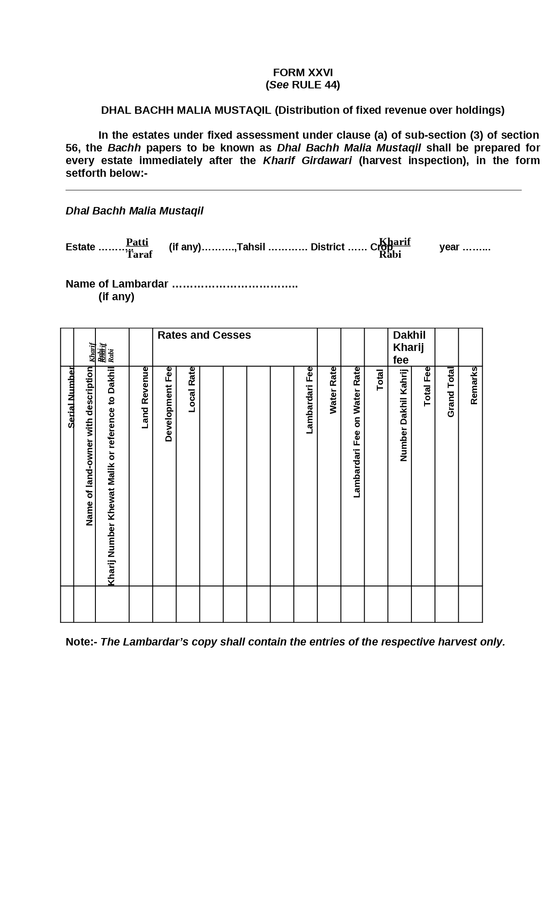

Figure : Dhal Bachh Malia Mustaqil

**Form XXVII: Dhal Bachh Malia Ghair Mustaqil RULE 44**

(Distribution of revenue in the form of prescribed rates over holdings). In the estates in which assessment is levied in the form of prescribed rates under clause (b) of sub-section (3) of section 56, the Bachh papers to be known as Dhal Bachh Malia Ghair Mustaqil shall be prepared after the Girdawari (Harvest inspection) on which the assessment is based, in the form set forth below:

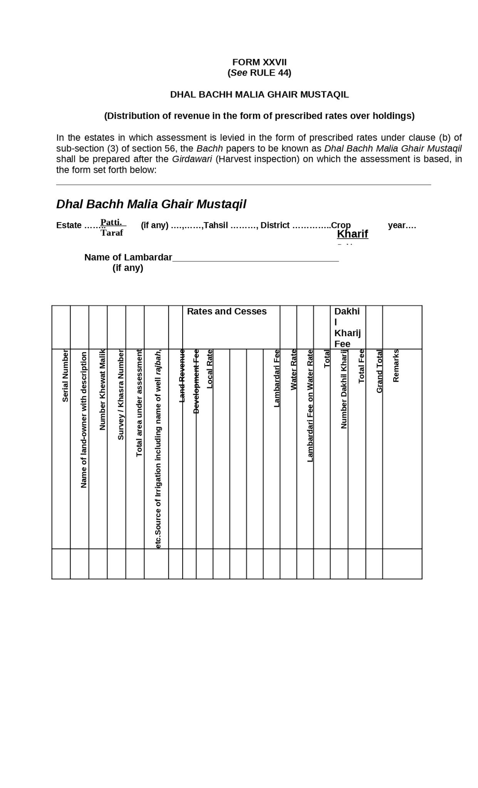

Figure : Dhal Bachh Malia Ghair Mustaqil

**Form XXVIII:** **Bill of Assessment RULE 44**

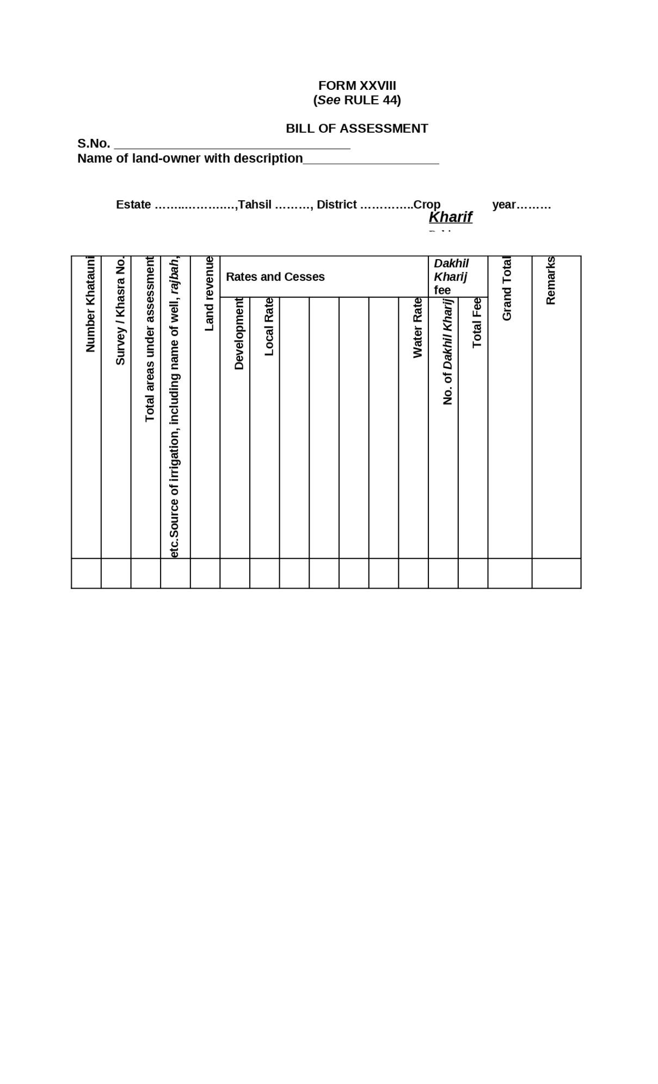

Figure : Bill of Assessment

**Form XXIX: Arz Irsal RULE 45**

Place of payment.- Land revenue shall be paid at the office of the tehsil to which the estate belongs, except in the following cases:- (a) Where the tehsil treasury at the district headquarters has been incorporated with the district treasury, the payment shall be made into the district treasury.

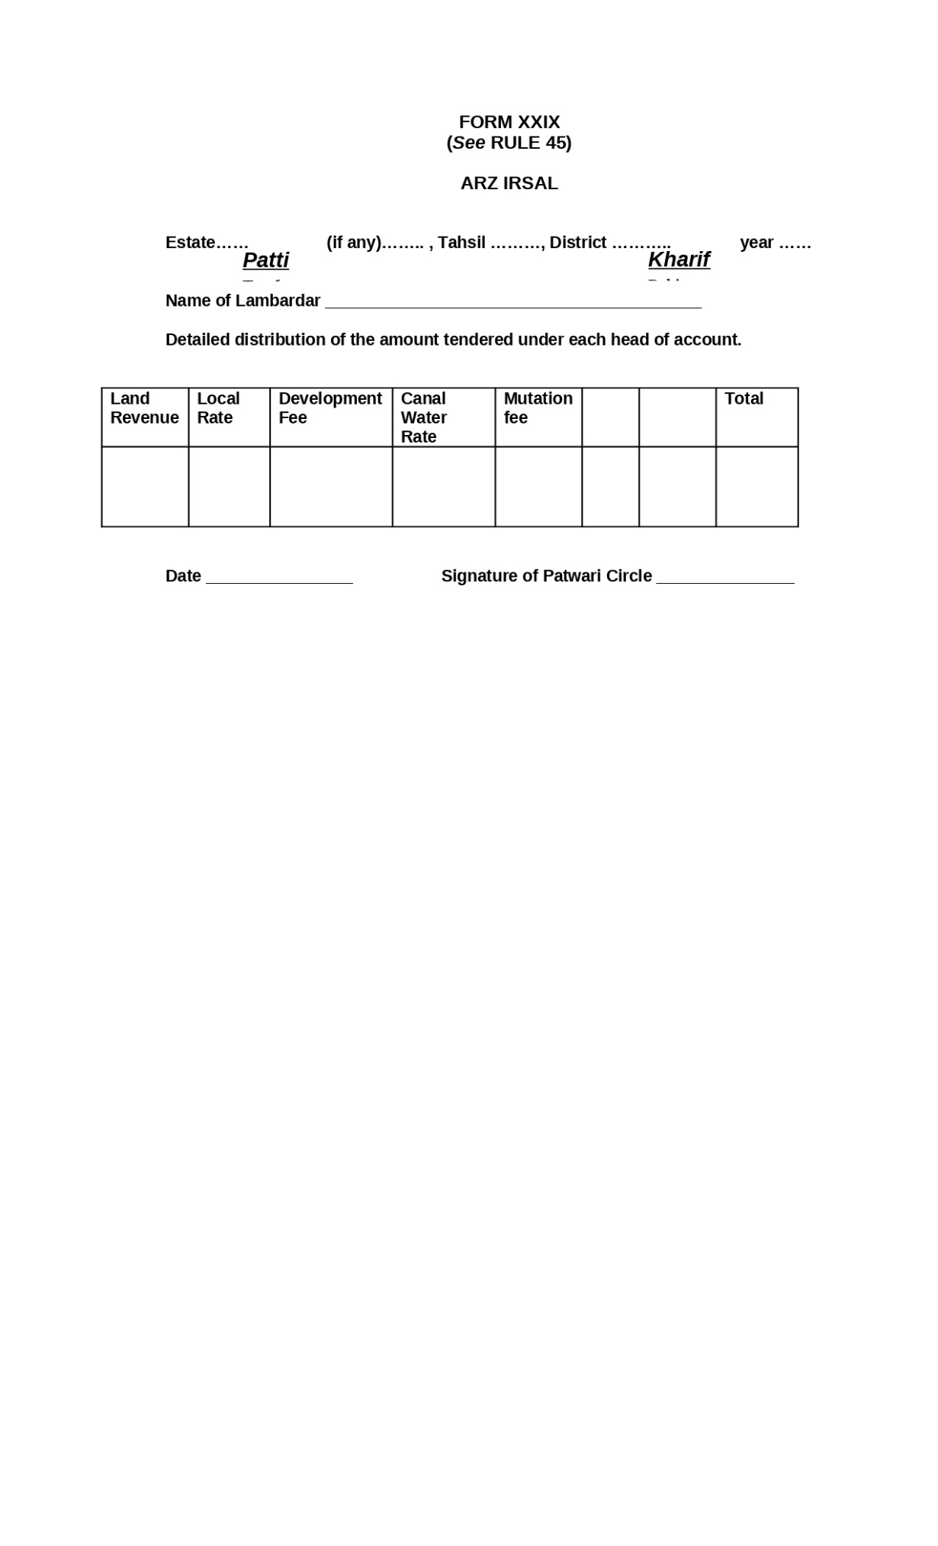

Figure : Arz Irsal

**Form XXX: Payment Receipt (DAKHLA) RULE 45 and 46**

RULE 45-Place of payment.- Land revenue shall be paid at the office of the tehsil to which the estate belongs, except in the following cases:- (a) Where the tehsil treasury at the district headquarters has been incorporated with the district treasury, the payment shall be made into the district treasury.

RULE 46- Payment of land revenue and rates and cesses.-

1. All payments of land revenue, rates and cesses shall be made to the Tapedar concerned, who shall issue receipts in Form I to the land-owners in token of having received the Government dues, from them. The Tapedar shall deposit the amount in the Treasury on Form XXX, which shall be checked and signed by the Revenue Accountant and the Mukhtiarkar, or Head Munshi.
2. Where a special arrangement has been made, with the sanction of the Collector, authorizing any person, to pay land revenue direct into the Government treasury, the payment shall be made in Form XXX which shall be checked and singed by the Revenue Accountant and the Mukhtiarkar or Head Munshi.
3. The land-owner may remit the amount of land revenue or other dues by means of-
4. a crossed cheque in favour of the Mukhtiarkar concerned, alongwith a copy of the bill of assessment; or
5. revenue money-order in favour of the Mukhtiarkar concerned, in which case the entries of bill of assessment shall be copied on the coupon of the money order form. In the aforesaid cases, the Mukhtiarkar concerned shall arrange for the deposit of the amount in the Treasury in Form XXX.

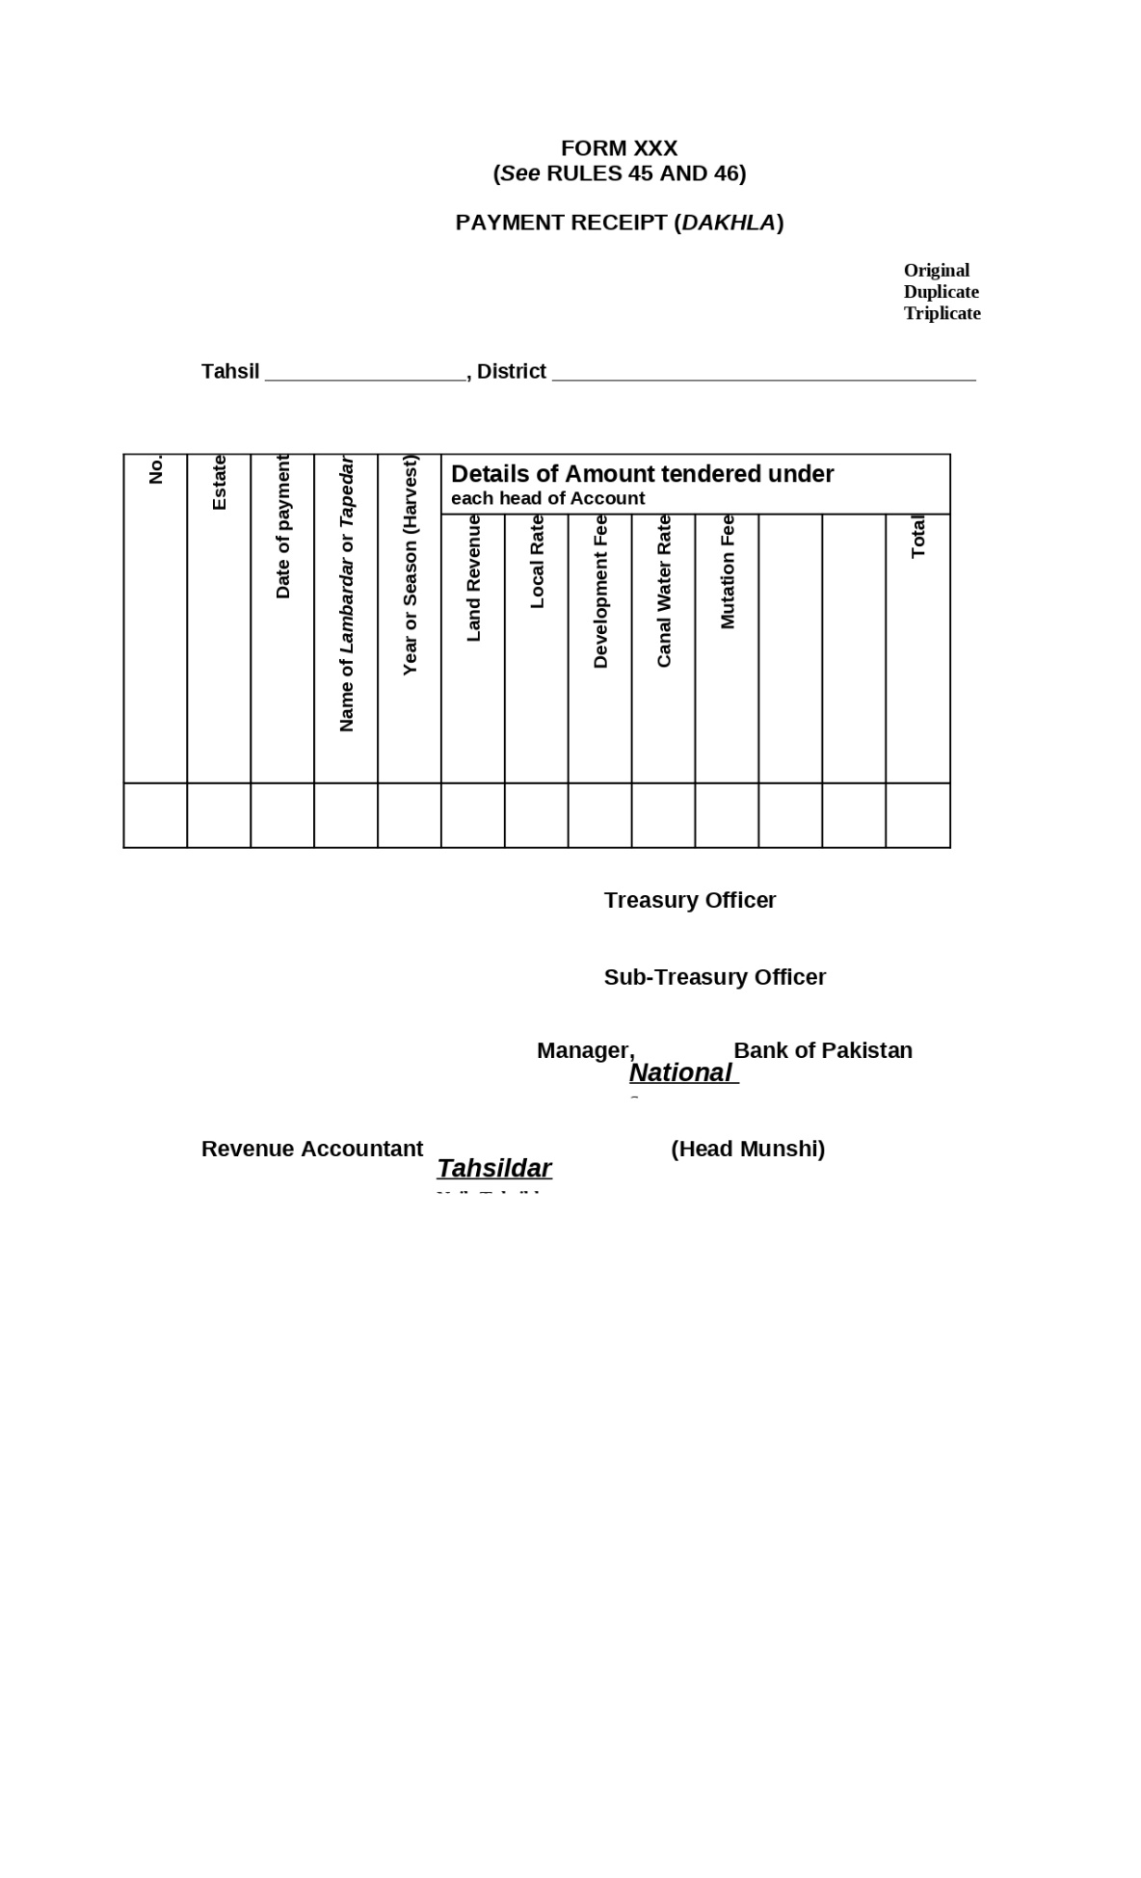

Figure : Payment Receipt

**Form XXXI:** **Security Bond RULE 47**

Security to be furnished by Mukhtiarkar, Head Munshi, Supervising Tapedar and Tapedar.-

1. All Mukhtiarkars, Head Munshis, Supervising Tapedars and Tapedars shall, before entering upon their office, furnish security in the amounts respectively shown hereunder against them, either by deposit of Securities of the Central Government duly endorsed, accompanied by a power to sell or in Form XXXI:-

(i) Mukhtiarkars Rs. ten thousand.

(ii) Head Munshis Rs. five thousand.

(iii) Supervising Tapedars Rs. five thousand.

(iv) Tapedars Rs. five thousand.

1. The securities shall be deposited with the Collector

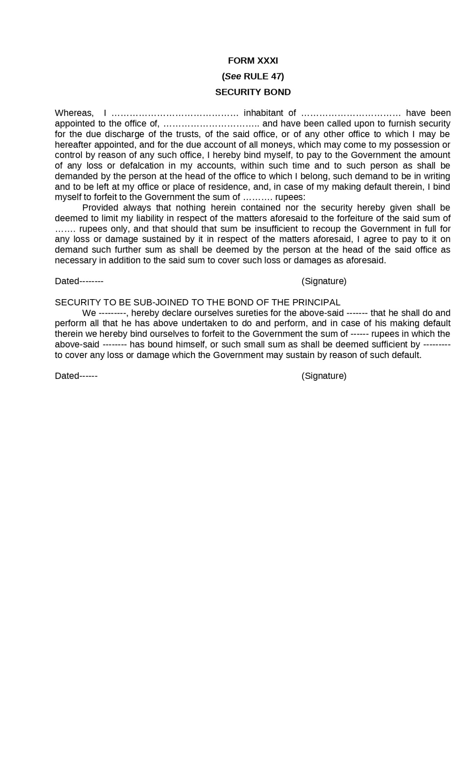

Figure : Security Bond

**Form XXXII: Register of Securities RULE 51**

Register of sureties.- The Collector shall keep a register in Form XXXII of all securities furnished by each officer, in his district.

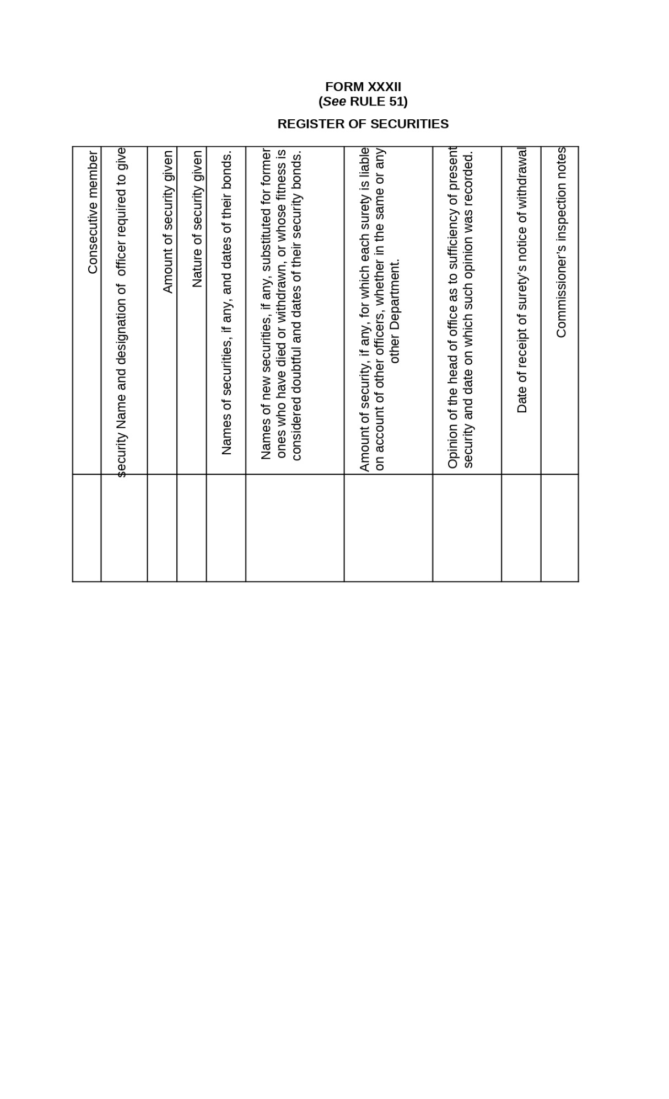

Figure : Register of Securities

**Form XXXIII: Notice of Demand Under Section Of the West Pakistan Land Revenue Act, 1967 RULE 57**

Defaulter to be summoned.-

1. If the application is in proper form and the arrear of which recovery is desired has not been due for more than six months, the Revenue Officer shall fix a date for the hearing of the case and shall serve a notice of demand in Form XXXIII on the defaulter, together with a notice requiring him to appear on the date so fixed, if the demand has not, in the meantime, been paid.
2. If the arrear has been due for more than six months the application shall be rejected, unless the applicant satisfies the Revenue Officer that the delay in realizing the arrear is not due to his neglect, and, if he is so satisfied, the Revenue Officer shall proceed as in sub-rule (1).

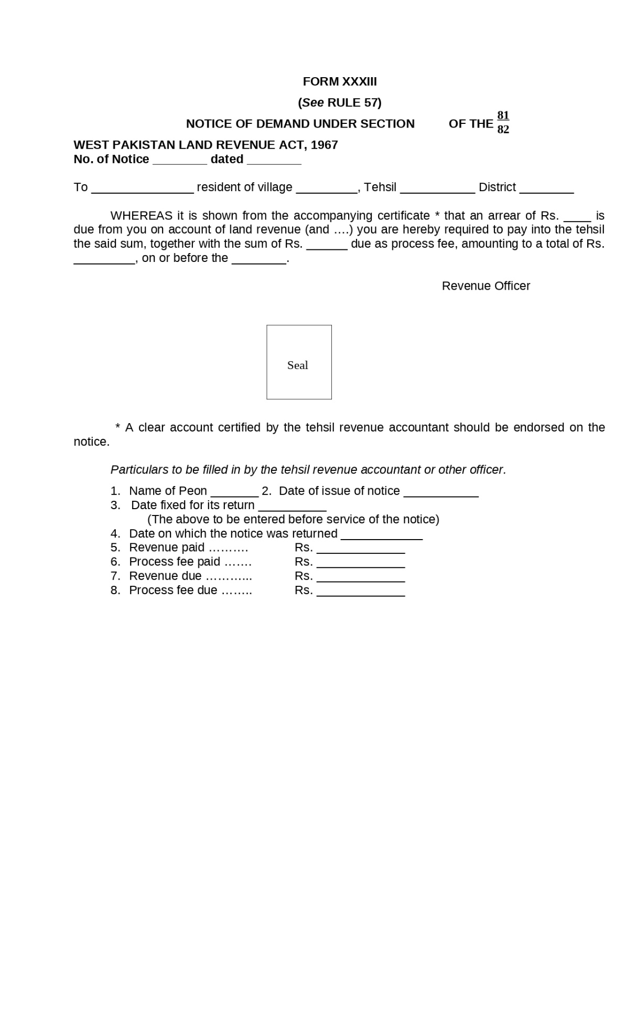

Figure :Notice of Demand Under Section Of the West Pakistan Land Revenue Act, 1967

**Form XXXIII-A:** **Demarcation of land RULE 67-A (4)(a)**

On the receipt of such application duly accompanied by the attested copies mentioned in sub-rule (2), the Revenue Officer concerned shall: - (a) cause the application to be registered in the relevant column of the Register to be maintained in his office in Form XXXIII-A.

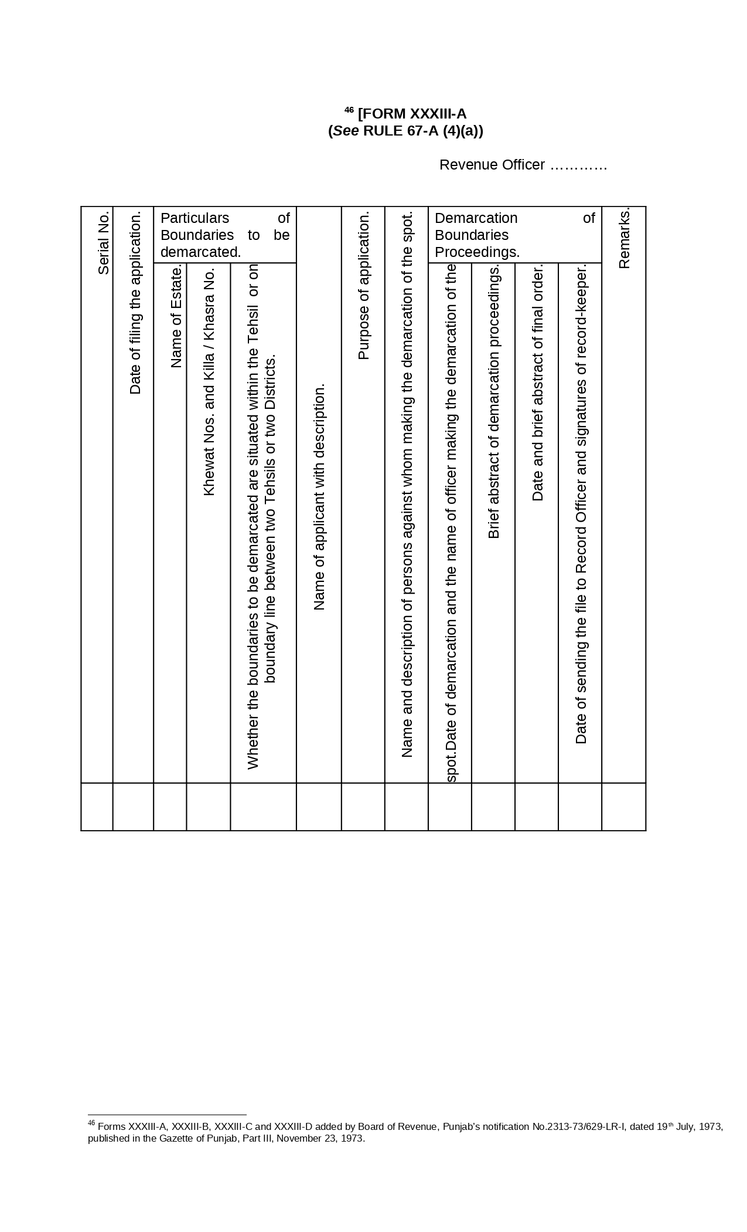

Figure :Demarcation of land RULE 67-A (4)(a)

**Form XXXIII-B:** **Demarcation of land RULE 67-A (4)(c)**

On the receipt of such application duly accompanied by the attested copies mentioned in sub-rule (2), the Revenue Officer concerned shall: -

(c) cause a notice in Form XXXIII-B to be issued in duplicate to-

1. the parties to the application;
2. Lambardar of the village in which the land mentioned in the application is situated;
3. Field Kanungo of the Circle;
4. Revenue Patwari of the village if the notice is not to be served through him; and
5. any other person whose presence at the time of demarcation of boundaries is considered necessary or expedient by the Revenue Officer.

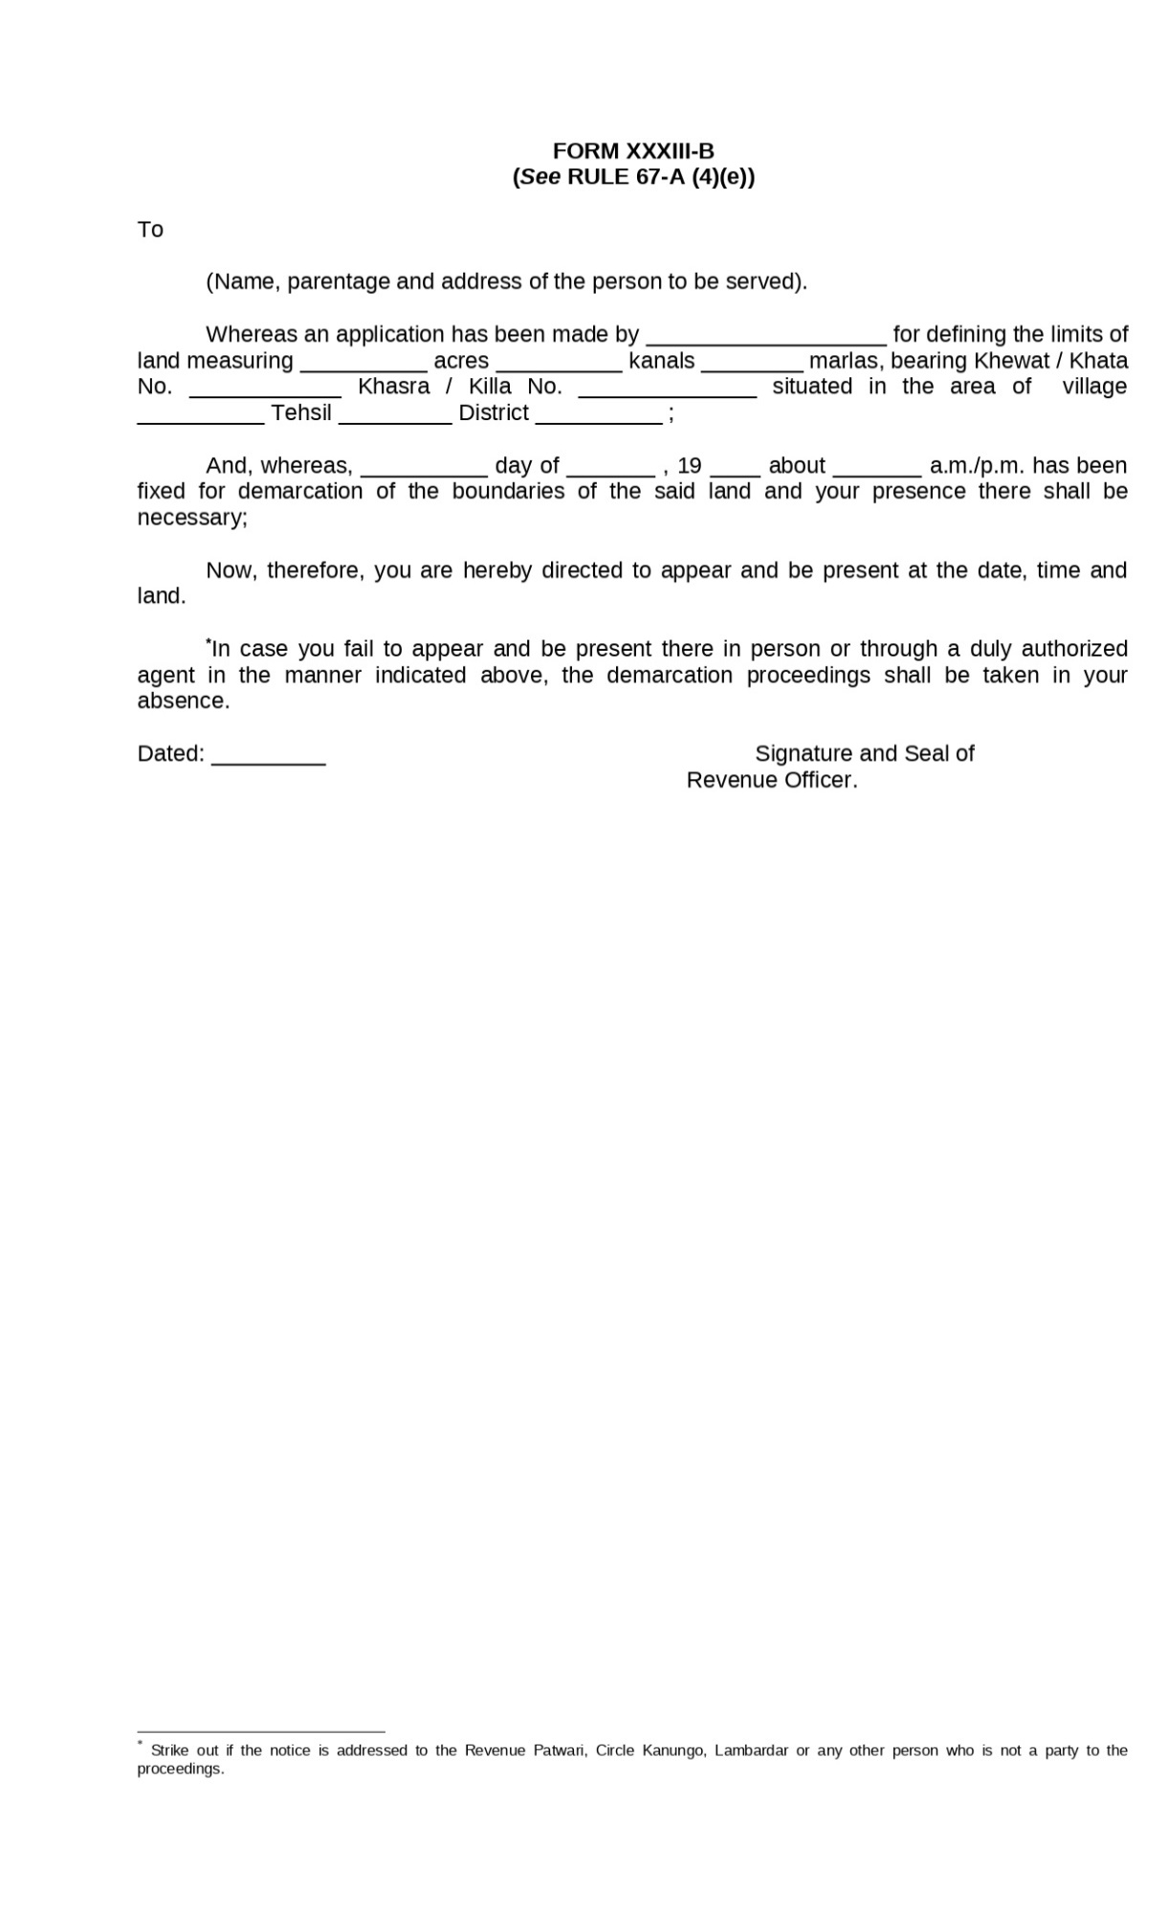

Figure : Demarcation of land RULE 67-A (4)(c)

**Form XXXIII-C: Notice of Eviction Rule 67-B (4))**

On the receipt of the application, the Collector shall fix a date for its hearing and cause its notice in Form XXXIII-C, together with a copy of the application, to be served on the respondent in the manner prescribed in sub-rule (5) of rule 67-A.

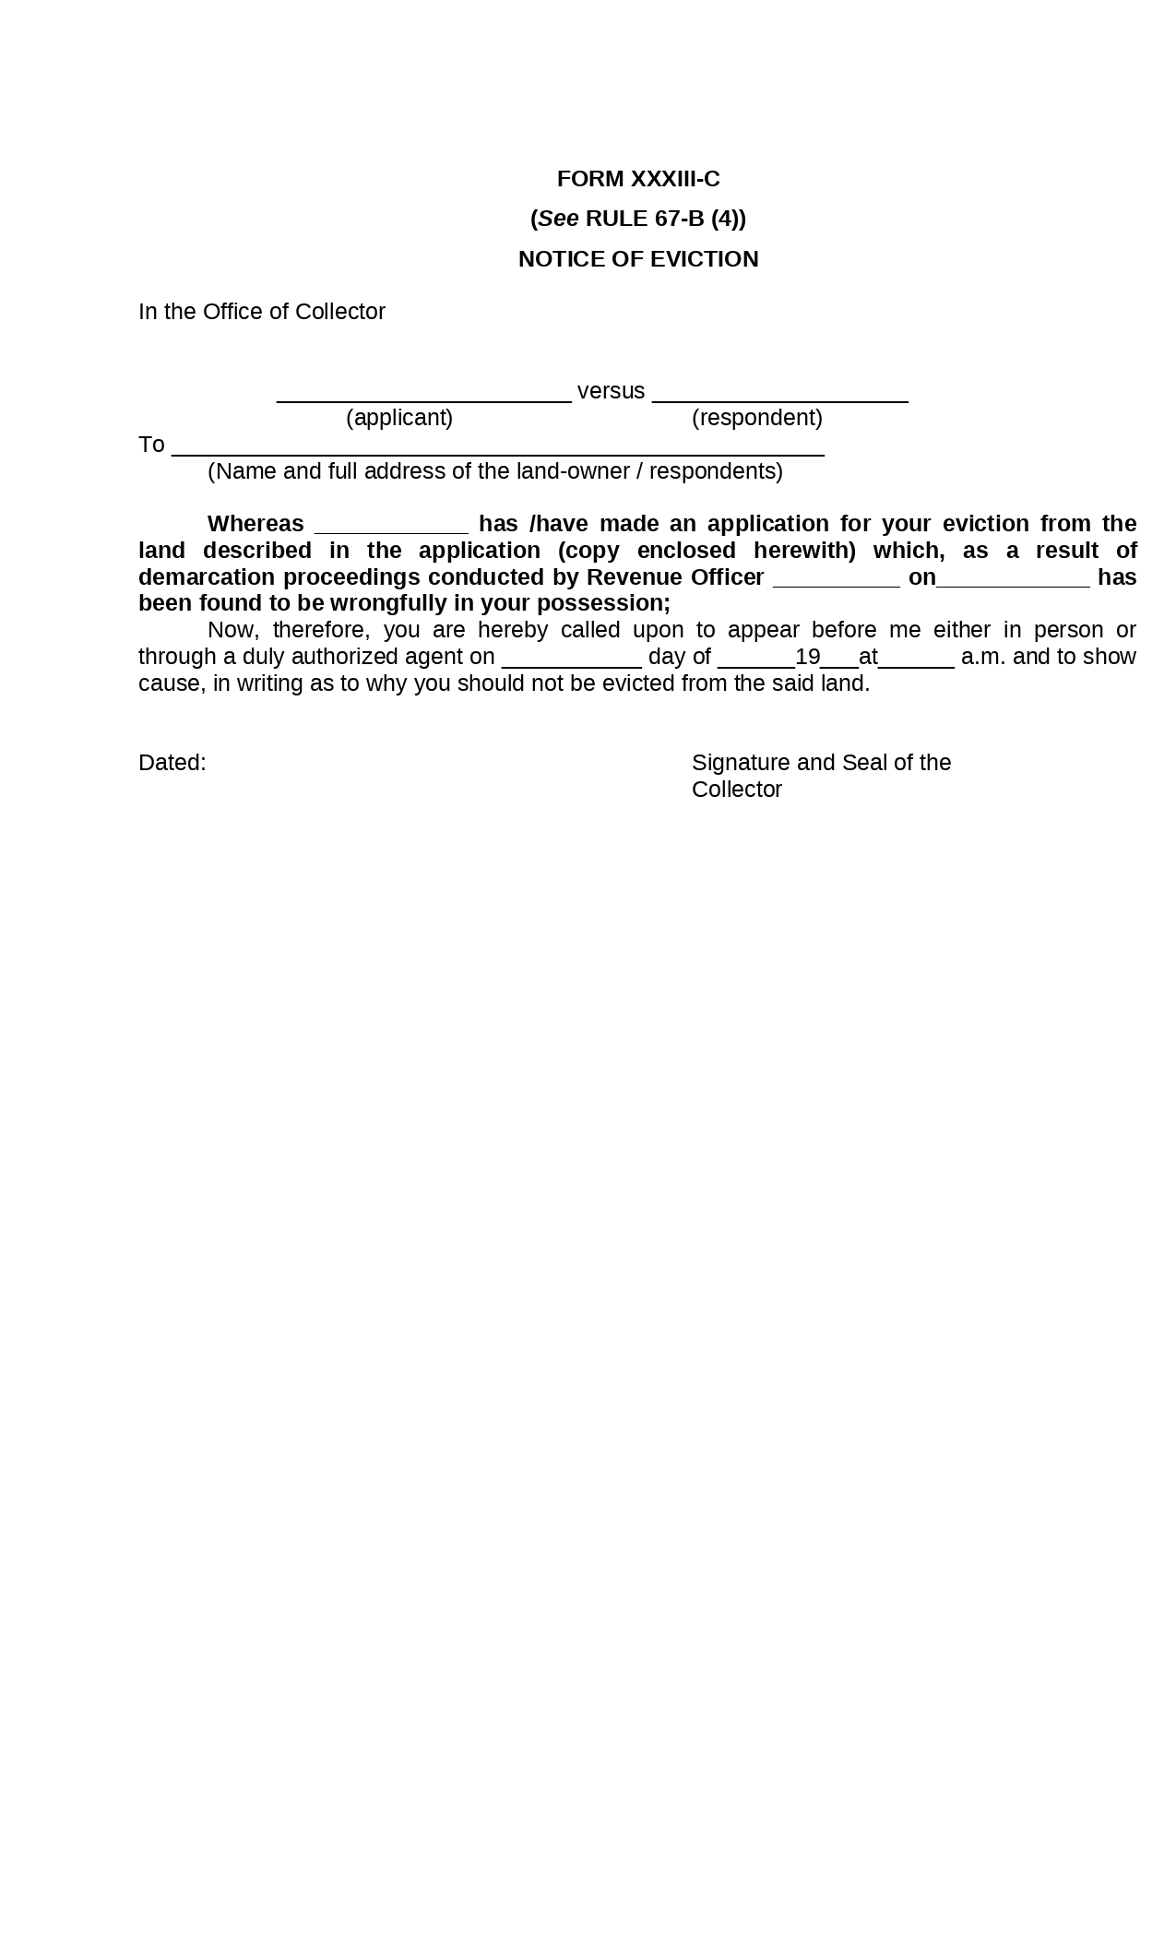

Figure :Notice of Eviction Rule 67-B (4))

**Form XXXIII-D: Warrant of Eviction RULE 67-B (7)**

On the acceptance of the application, the Collector shall afford the respondent an opportunity of delivering possession of the disputed land to the applicant within a period not exceeding one month and if he fails to do so, the Collector, on an application made by the applicant, shall issue a warrant of eviction in Form XXXIII-D which shall be executed by an official not below the rank of a Kanungo, with or without police assistance, according to the circumstances of each case.

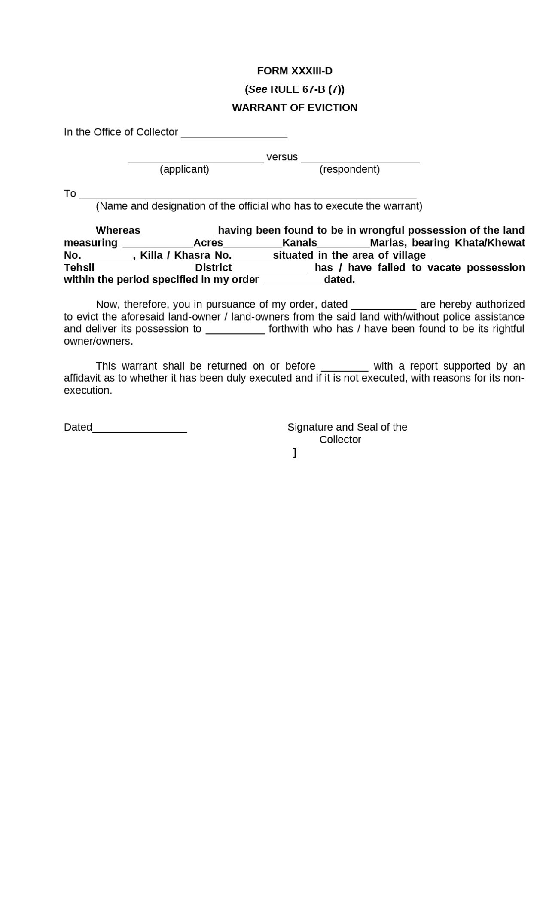

Figure :Warrant of Eviction

**Form XXXIV: Register Haqdaran Zamin (Record of Rights/ Periodical Record)**The statements referred to in clause (a) of sub-section (2) of section 39, shall be recorded in the form set forth below, to be known as the Register Haqdaran Zamin :-

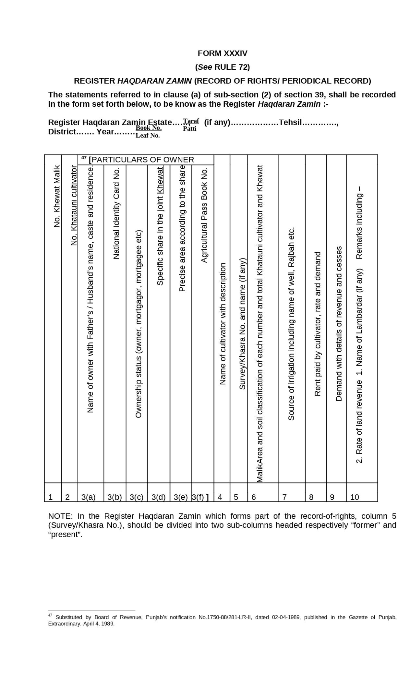

Figure : Register Haqdaran Zamin (Record of Rights/ Periodical Record)

**Form XXXV: Mutation Form (Dakhil Kharij Form**

The mutation register referred to in sub-section (3) of section 41 of the Act shall be maintained in the Form set forth below to be known as the Register Dakhil Kharij.

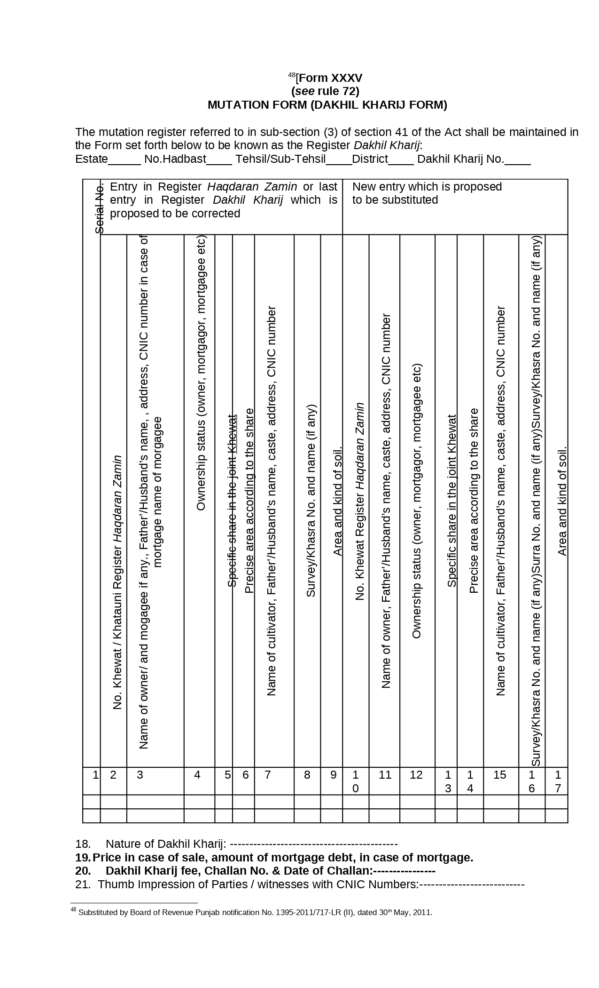

Figure :Mutation Form (Dakhil Kharij Form

**Form XXXV-A: Application for Mutation**

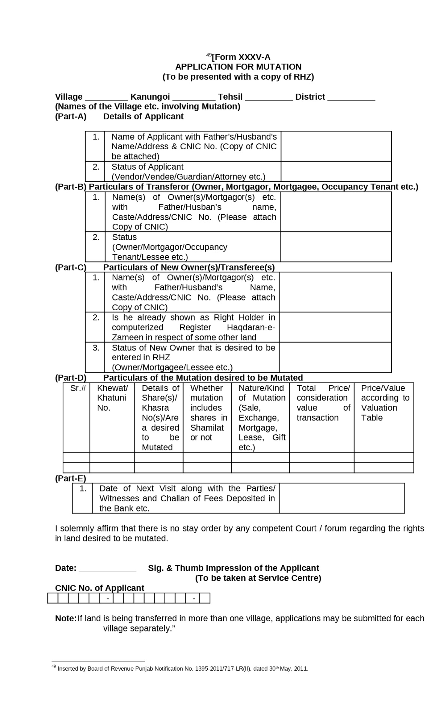

Figure : Application for Mutation

Form XXXVI: Statement of Customs (Wajib-Ul-Arz)

The statement of customs respecting rights and liabilities in the estate referred to in clauseb(b) of sub-section (2) of section 39, shall be recorded in the form set forth below to be known as wajib-ul-arz, which should contain information on so many of the matters given in column 2, as are pertinent to the estate:-

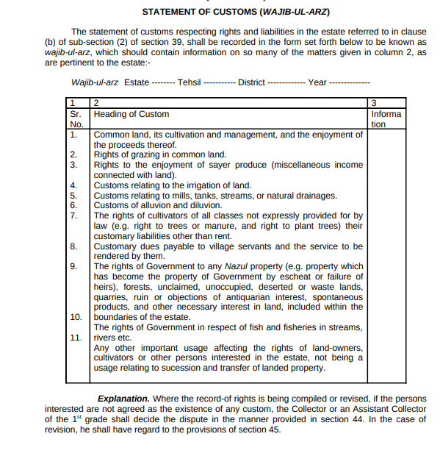

Figure :Statement of Customs (Wajib-Ul-Arz)

Form XXXVII: Requisition for Information or Document Under Section 47(1) of the West Pakistan Land Revenue Act, 1967

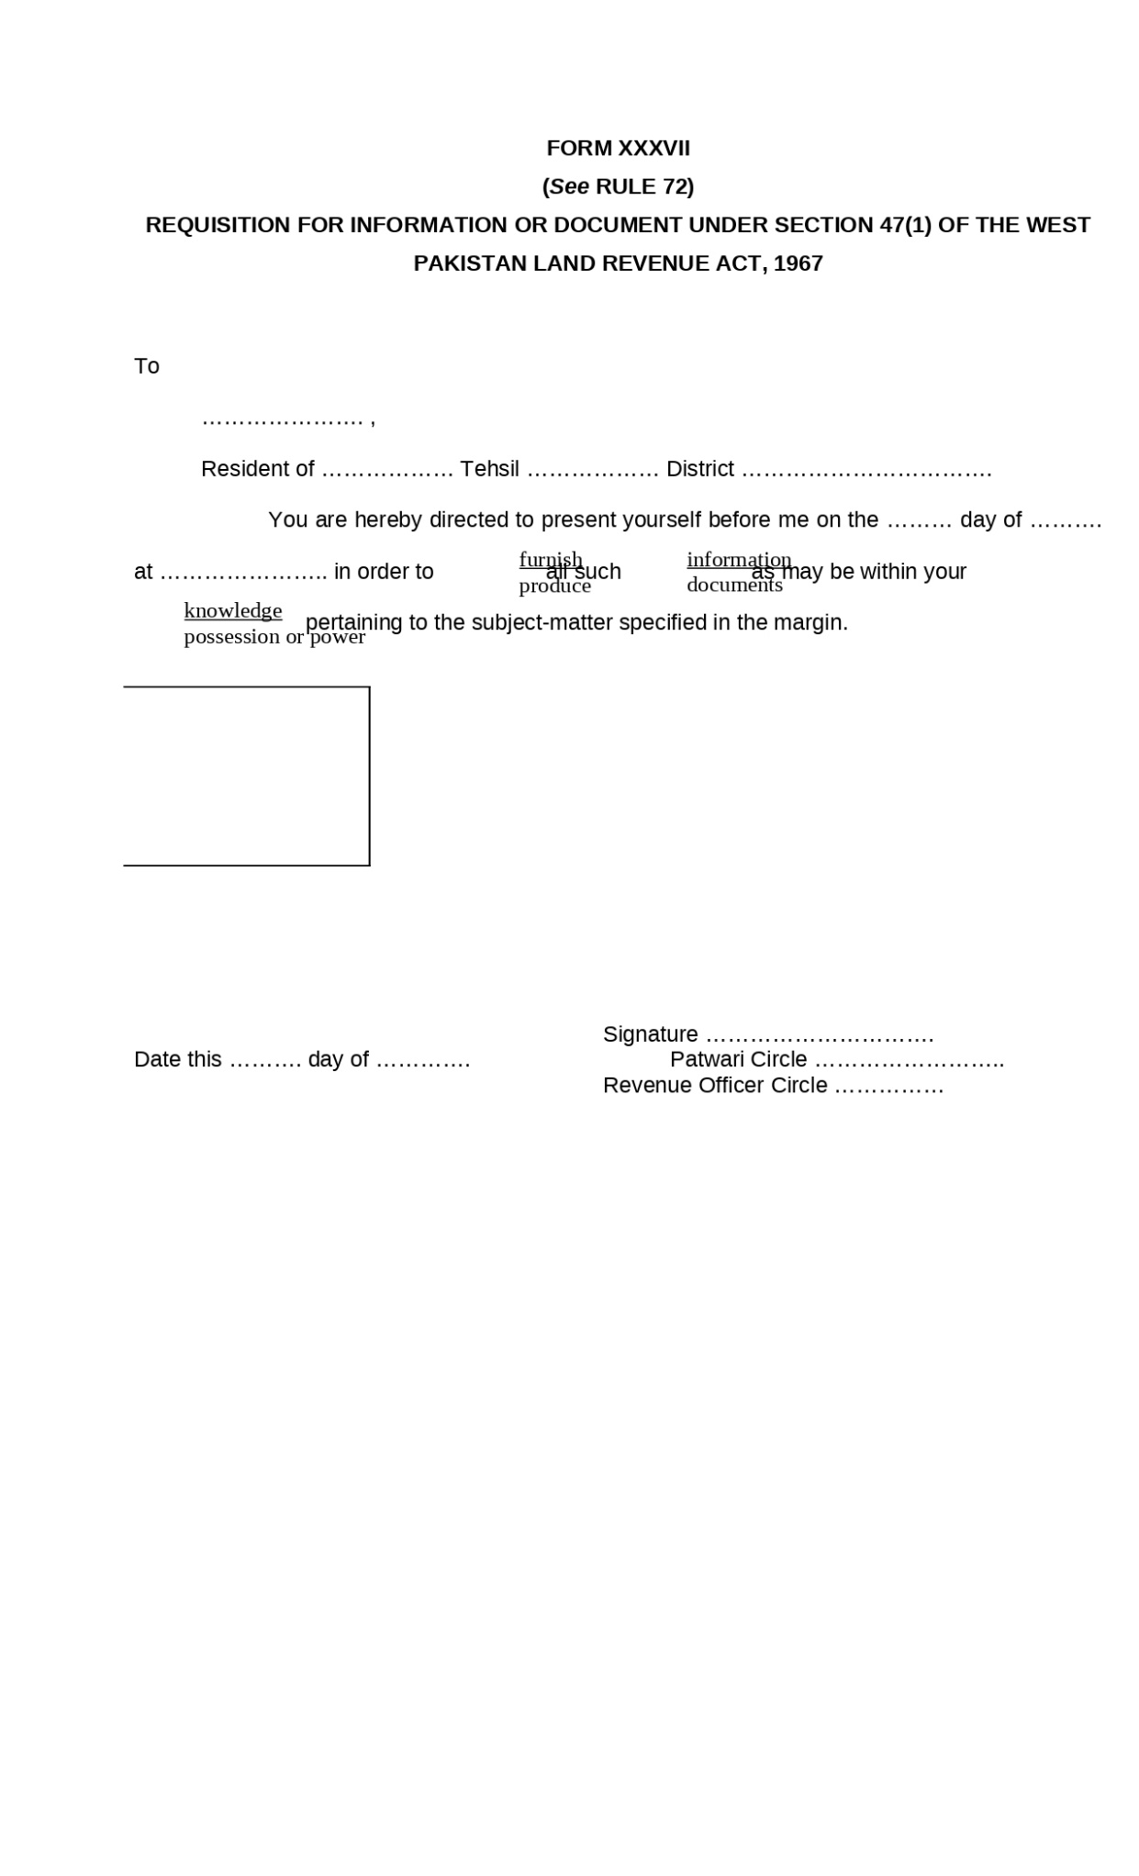

Figure :Requisition for Information or Document Under Section 47(1) of the West Pakistan Land Revenue Act, 1967

Form XXXVIII: Holding Slip (Parcha Khatauni)

At the time of field measurement for the preparation of map of the estate referred to in clause (c) of subsection (2) of section 39, a Holding Slip (Parcha Khatauni) shall be recorded in the form set forth below:-

:

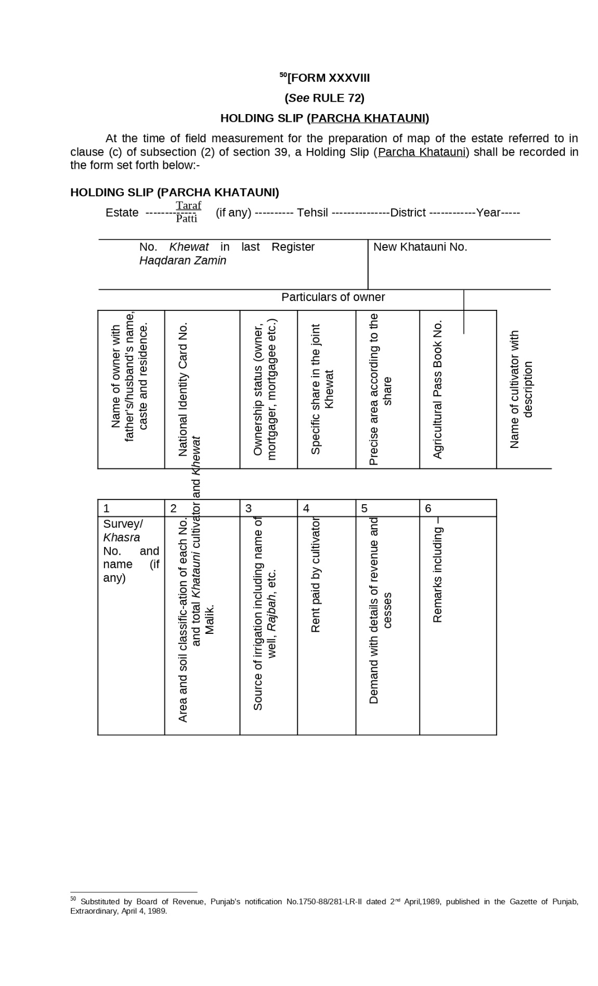

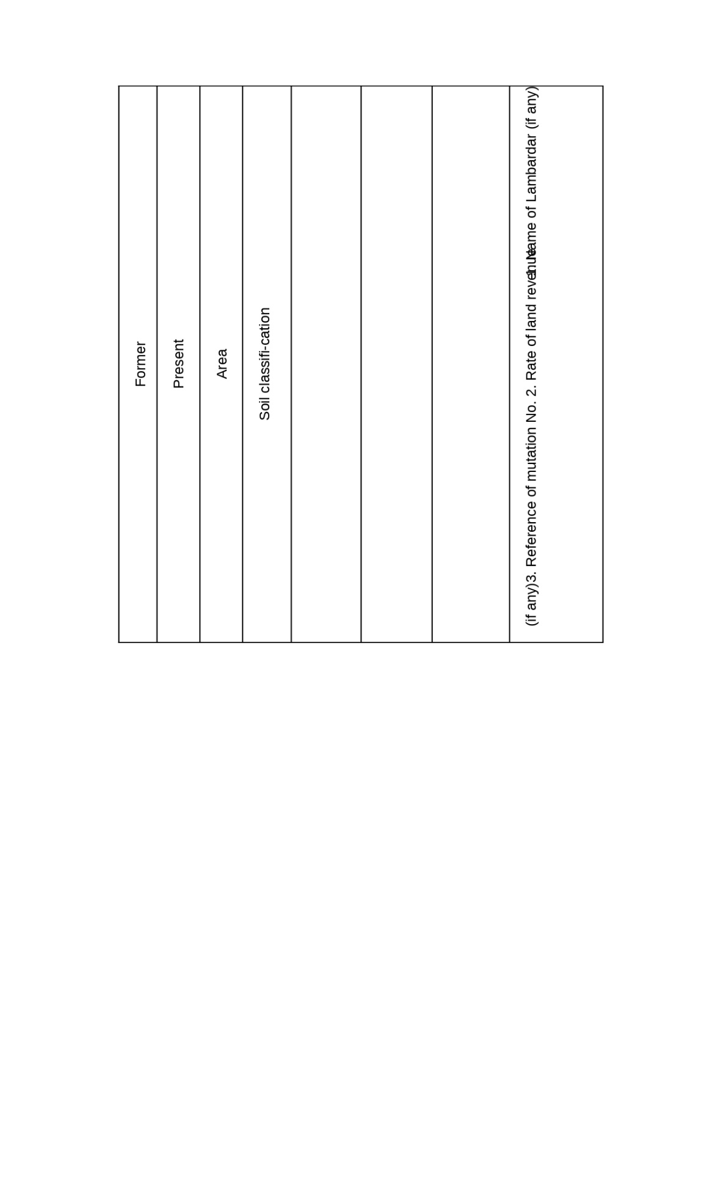

Figure :Holding Slip (Parcha Khatauni)

Form XXXIX: Interrogatory (Band Sawal)

If the Revenue Officer finds that a person whose statement is essential for the disposal of the mutation case, is residing outside the Tehsil an interrogatory be issued in the form set forth below:-

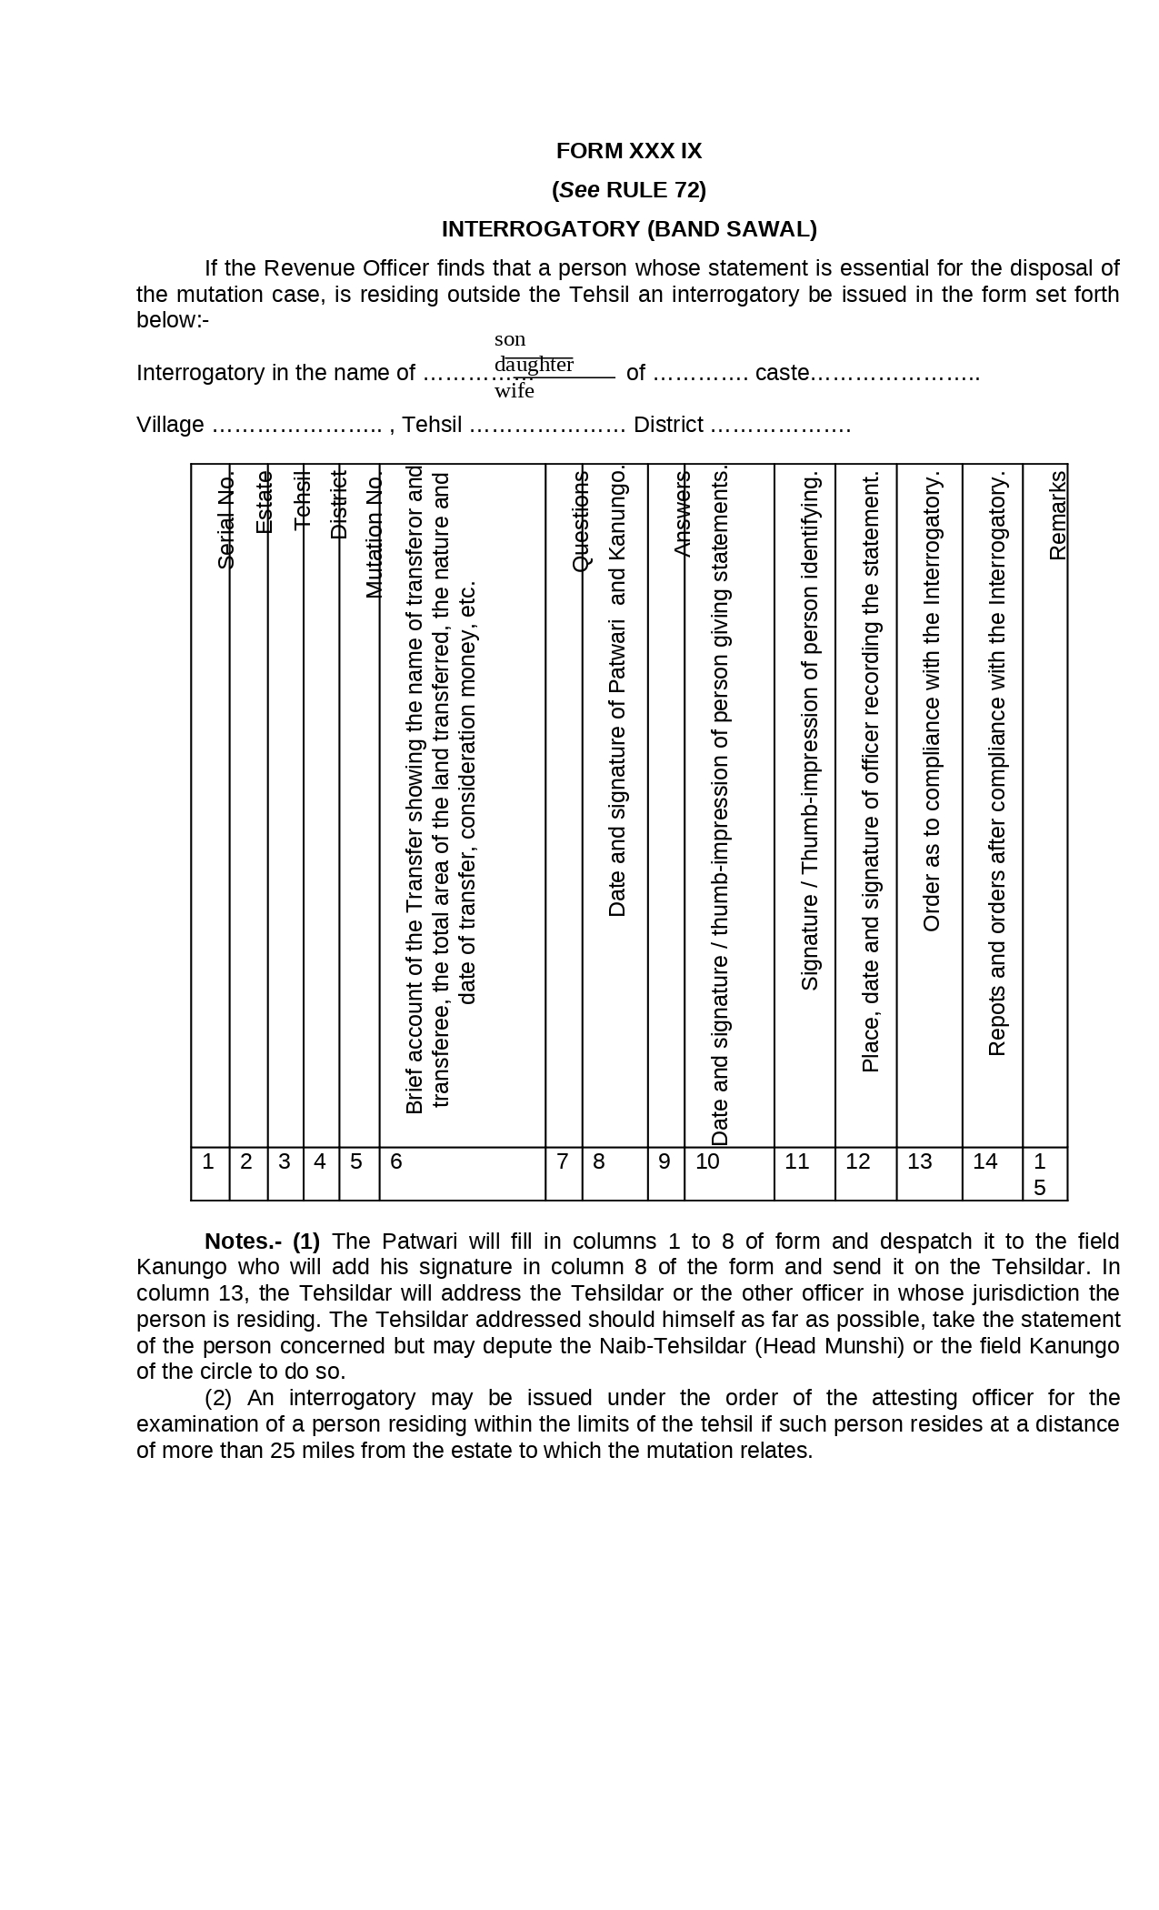

Figure :Interrogatory (Band Sawal)

Form XL: Register of Miscellaneous Land Revenue

In the estates where the land-revenue is collected by Tapedars, a register-miscellaneous land-revenue shall be maintained for each estate, in the form set forth below:-

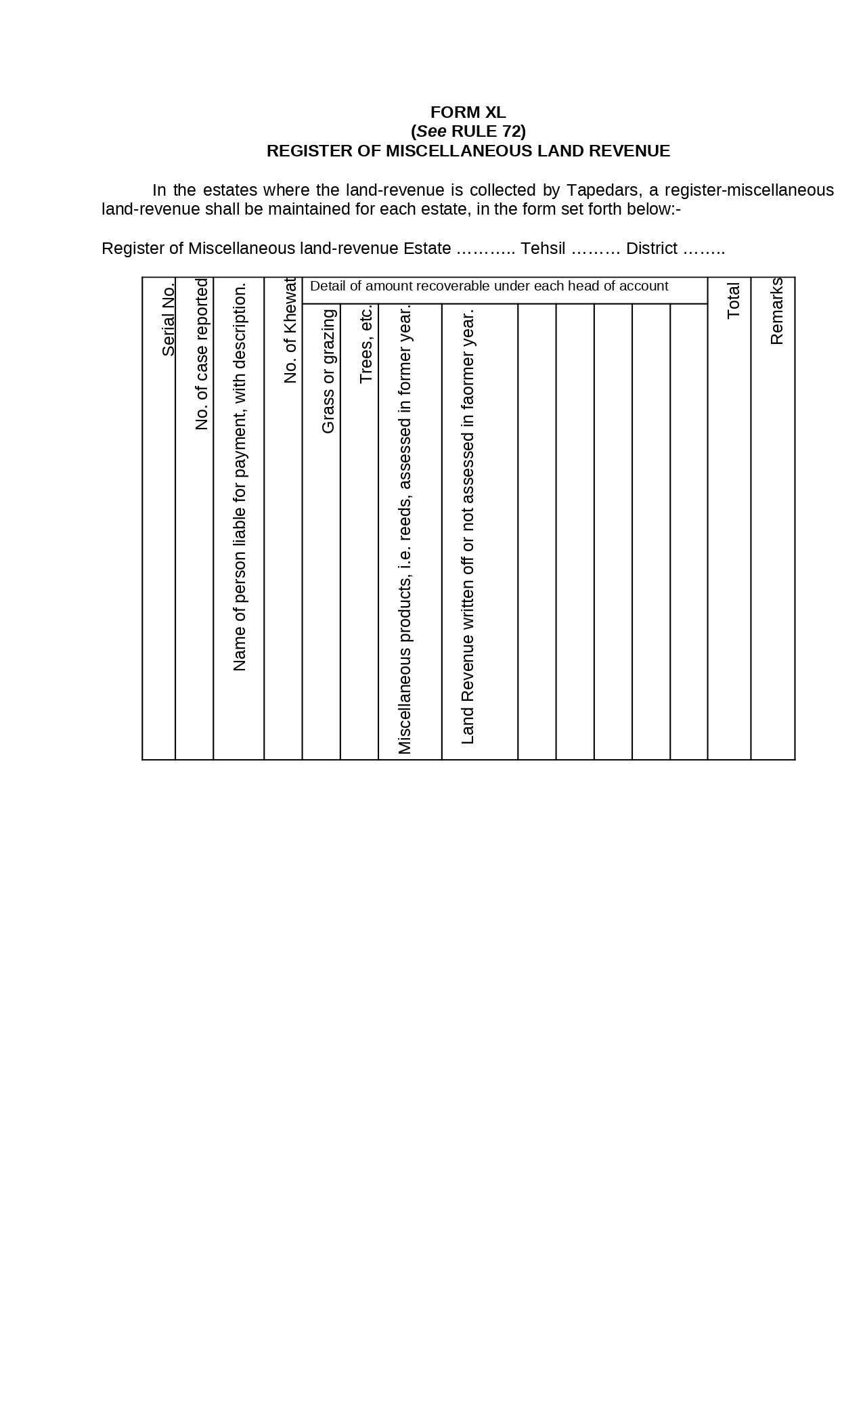

Figure : Register of Miscellaneous Land Revenue

Form XLI: Warrant of Arrest Under Section 82(1) of the West Pakistan Land Revenue Act, 1967

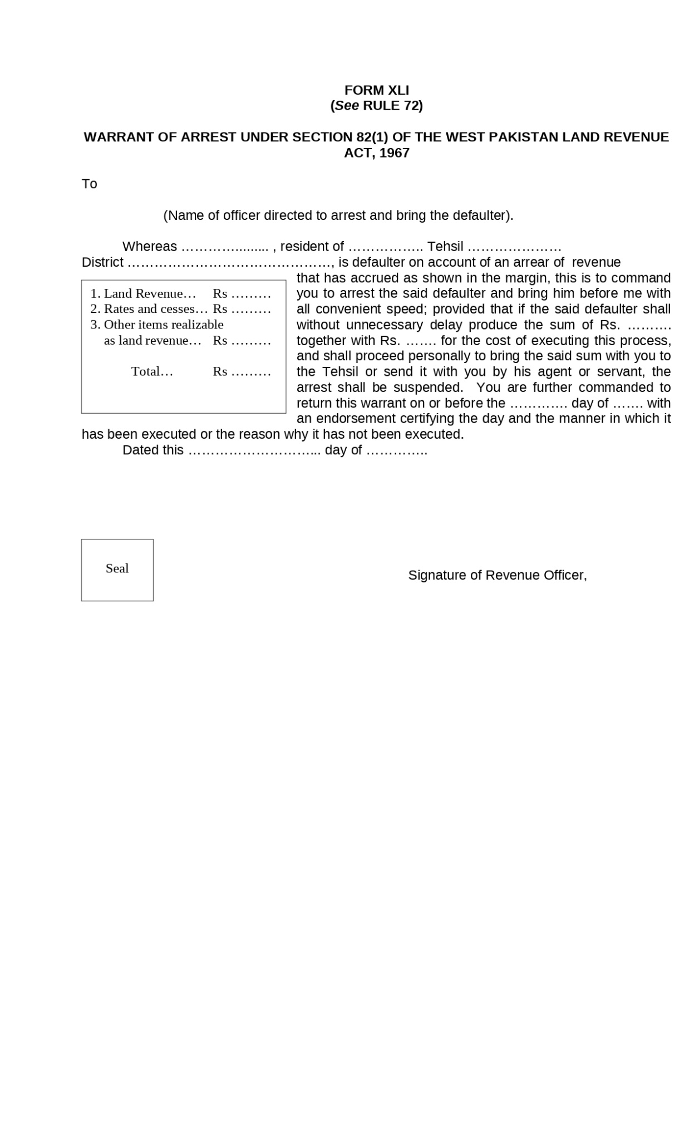

Figure :Warrant of Arrest Under Section 82(1) of the West Pakistan Land Revenue Act, 1967

Form XLII: Warrant of Committal of Defaulter to Civil Jail Under Section 82(5) of the West Pakistan Land Revenue Act, 1967

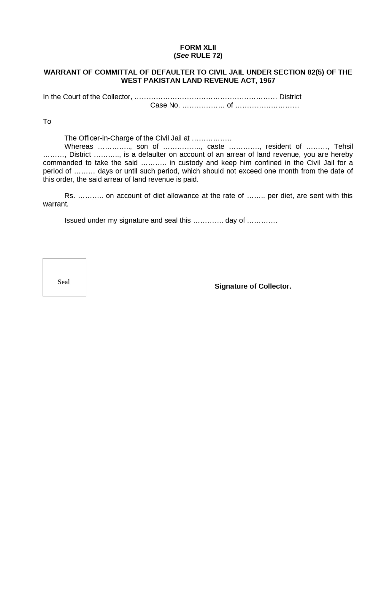

Figure : Warrant of Committal of Defaulter to Civil Jail Under Section 82(5) of the West Pakistan Land Revenue Act, 1967

Form XLIII: Order for the Release of a Defaulter Under Section 82(8) of the West Pakistan Land Revenue Act, 1967

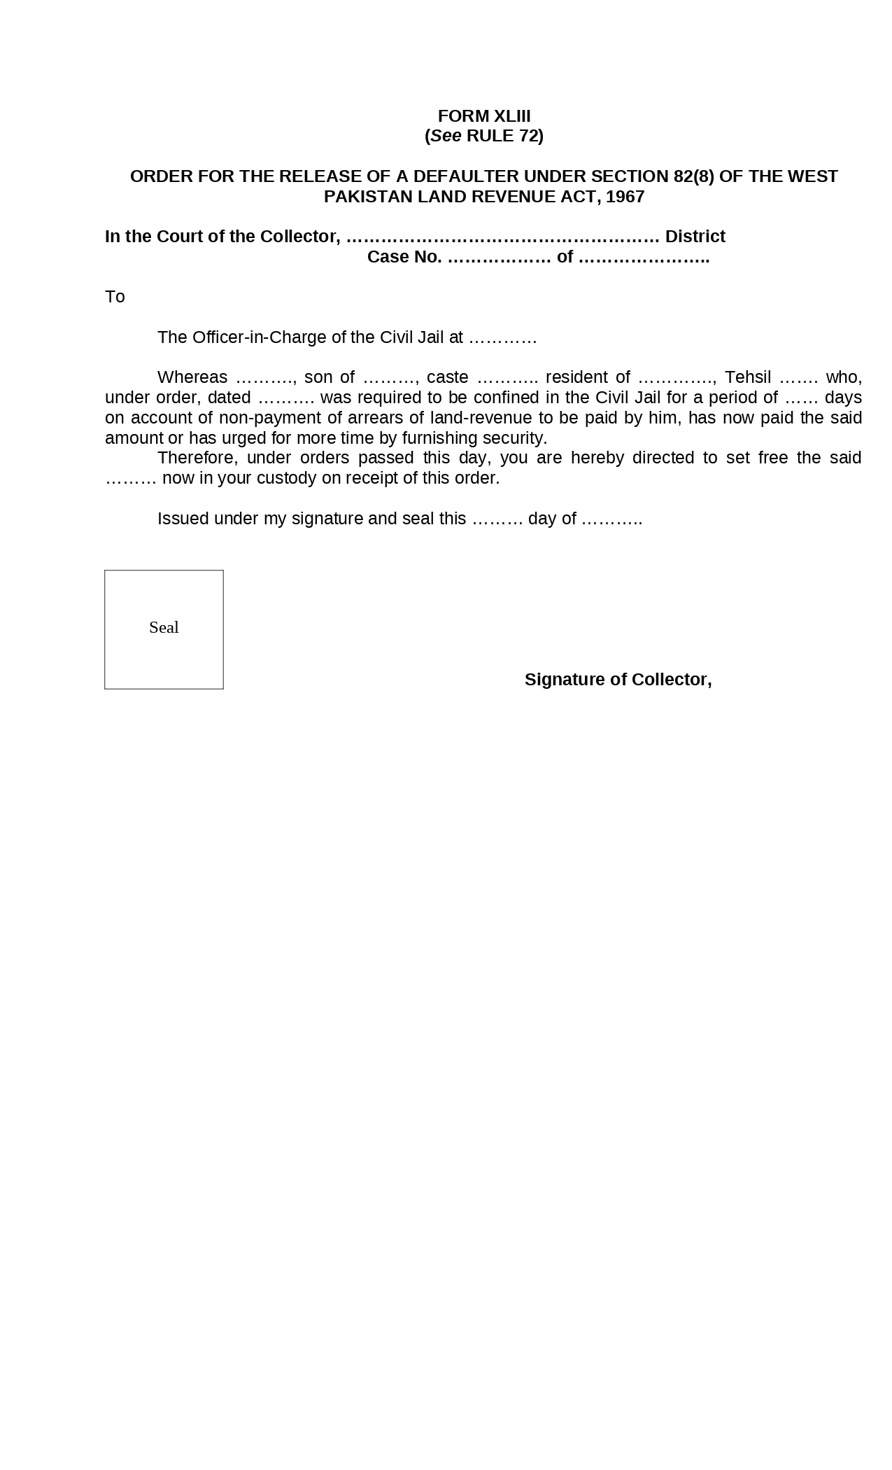

Figure :Order for the Release of a Defaulter Under Section 82(8) of the West Pakistan Land Revenue Act, 1967

Form XLIV: Warrant of Distraint Under Section 83 of the West Pakistan Land Revenue Act, 1967

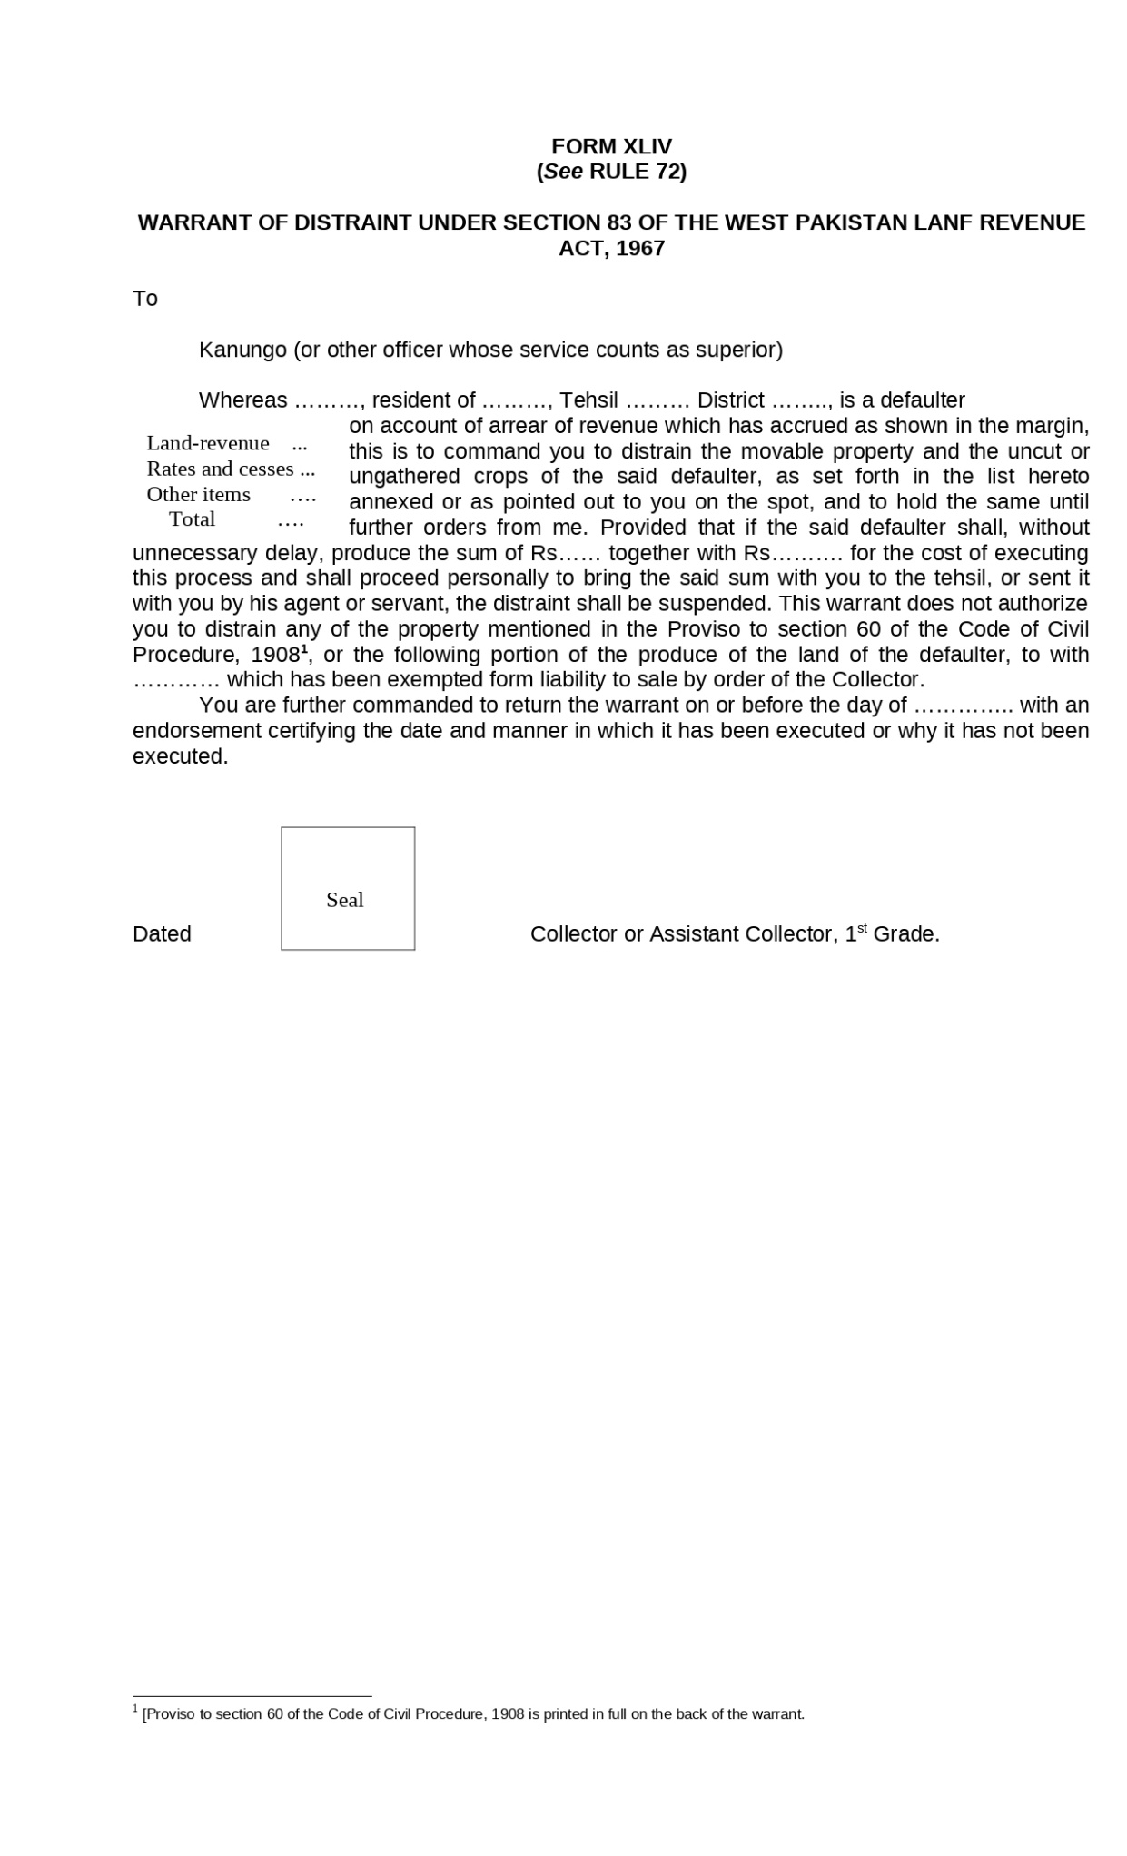

Figure :Warrant of Distraint Under Section 83 of the West Pakistan Land Revenue Act, 1967

Form XLV: Warrant for Sale of Movable Property Under Section 83 of the West Pakistan Land Revenue Act, 1967

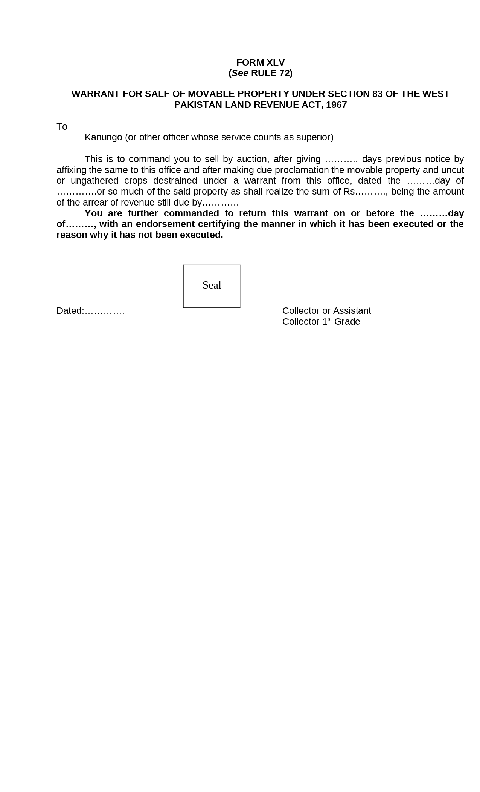

Figure : Warrant for Sale of Movable Property Under Section 83 of the West Pakistan Land Revenue Act, 1967

Form XLVI: Warrant of Transfer of Holding In Respect of Which an Arrear of Revenue Is Due Under Section 84 of the West Pakistan Land Revenue Act, 1967

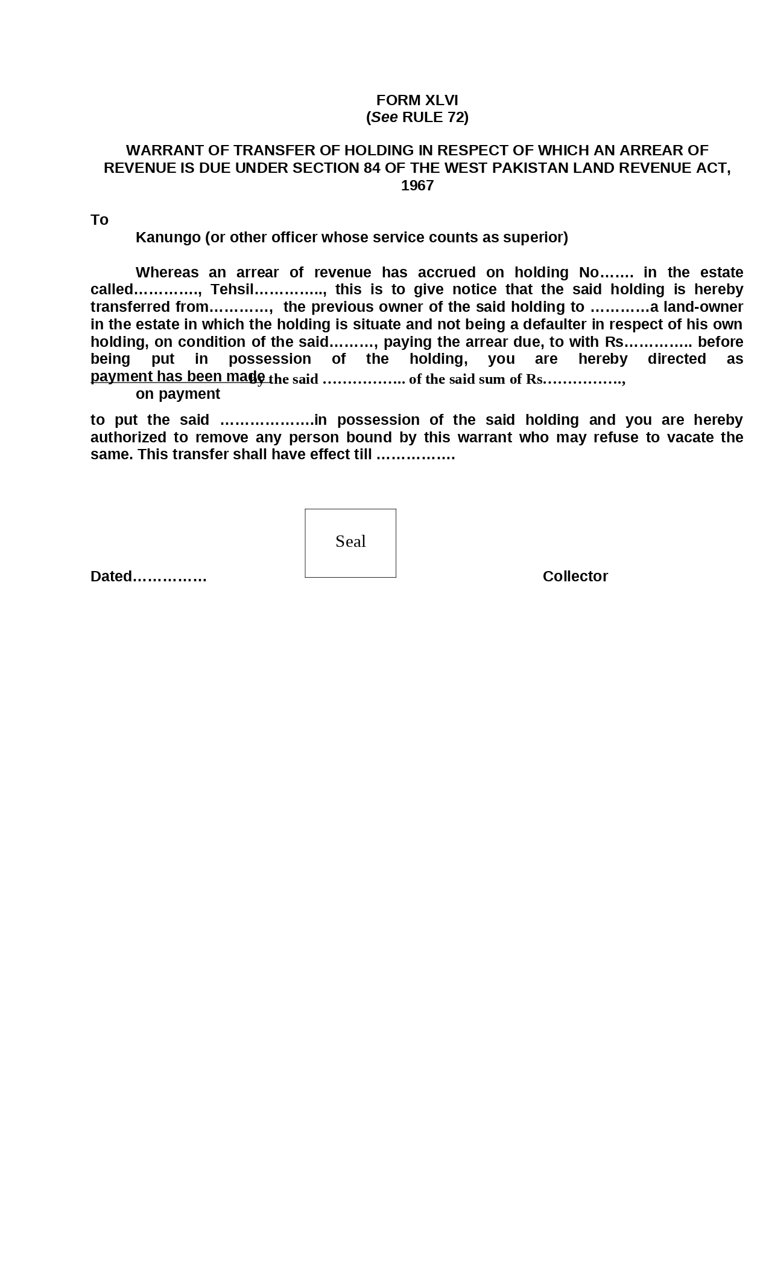

Figure : Warrant of Transfer of Holding In Respect of Which an Arrear of Revenue Is Due Under Section 84 of the West Pakistan Land Revenue Act, 1967

Form XLVII: Warrant for Attachment of an Estate or Holding Under Section 85 of the West Pakistan Land Revenue Act, 1967

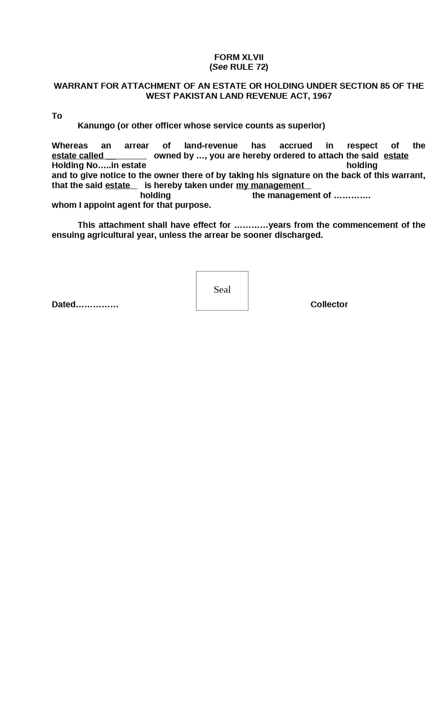

Figure : Warrant for Attachment of an Estate or Holding Under Section 85 of the West Pakistan Land Revenue Act, 1967

Form XLVIII: Proclamation of Sale Under Section 92 of the West Pakistan Land Revenue Act, 1967

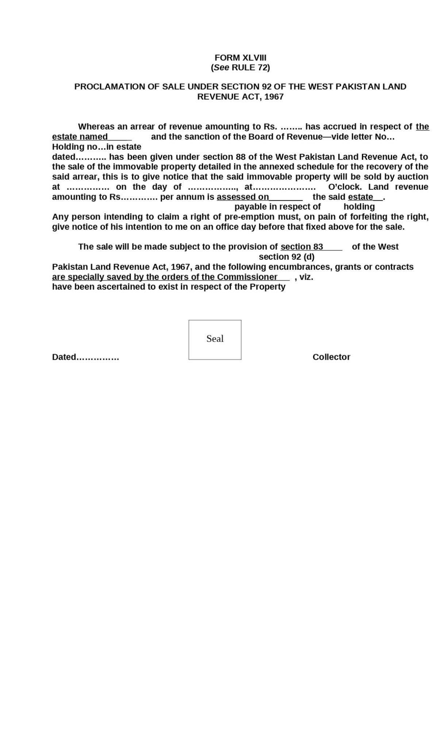

Figure : Proclamation of Sale Under Section 92 of the West Pakistan Land Revenue Act, 1967

Form XLIX: Certificate of Sale Under Section 107 of the West Pakistan Land Revenue Act, 1967

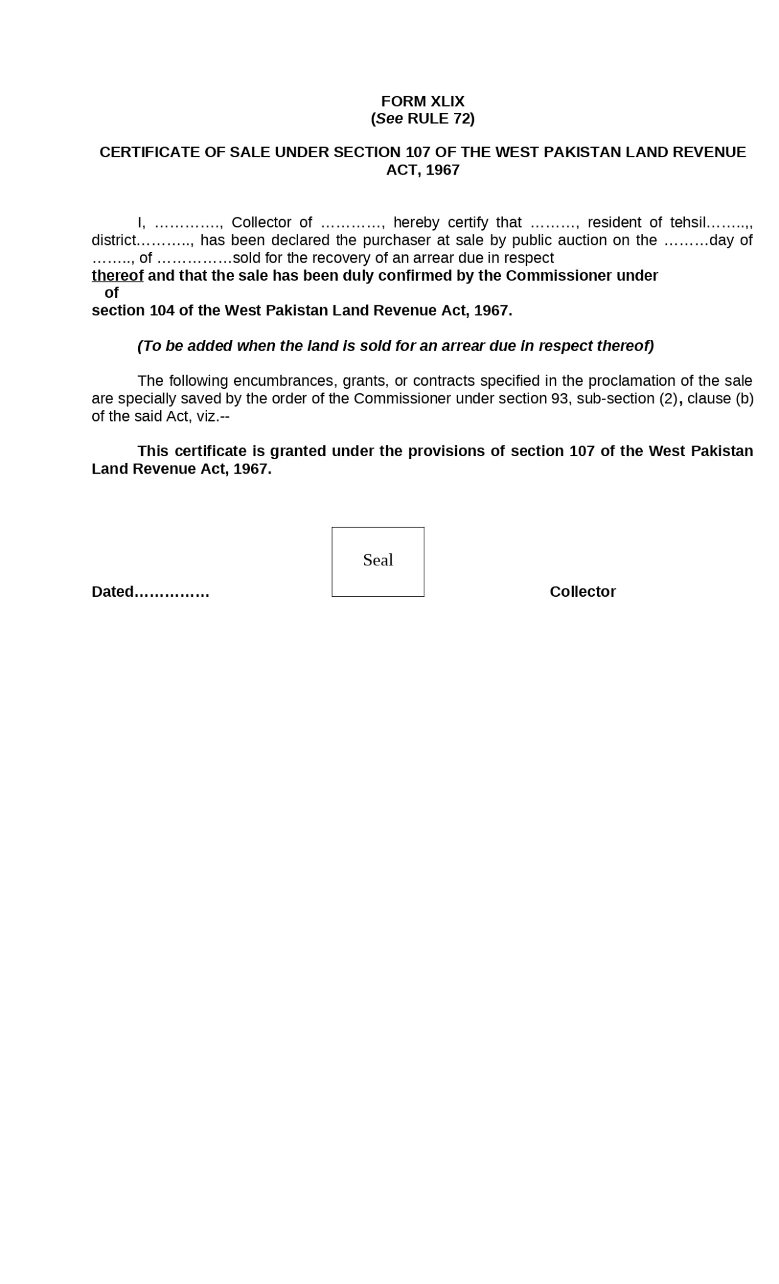

Figure : Certificate of Sale Under Section 107 of the West Pakistan Land Revenue Act, 1967

Form L: Instrument of Partition Under Section 145 of the West Pakistan Land Revenue Act, 1967

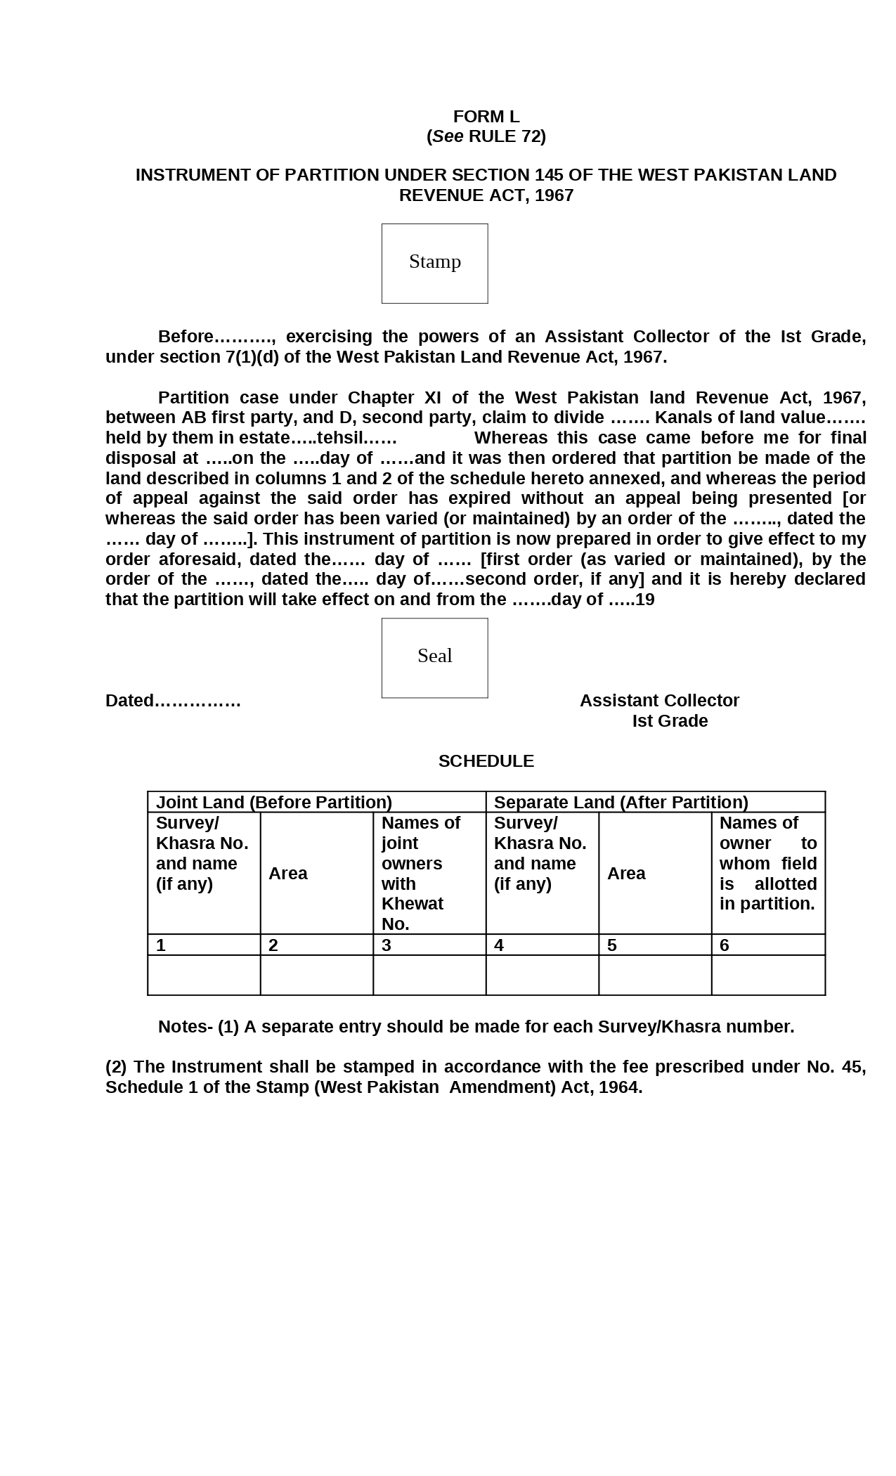

Figure : Instrument of Partition Under Section 145 of the West Pakistan Land Revenue Act, 1967

Form LI: Register Showing the Amount of Fee Realized by Patwari for Inspection of Records and Grant of Certified Copies Therefrom

The accounts of fee realized by Patwari for inspection of records and grant of certified copies therefrom shall be kept in the form set forth below:- Register showing the amount of fee realized for inspection of records and grant of certified copies therefrom.

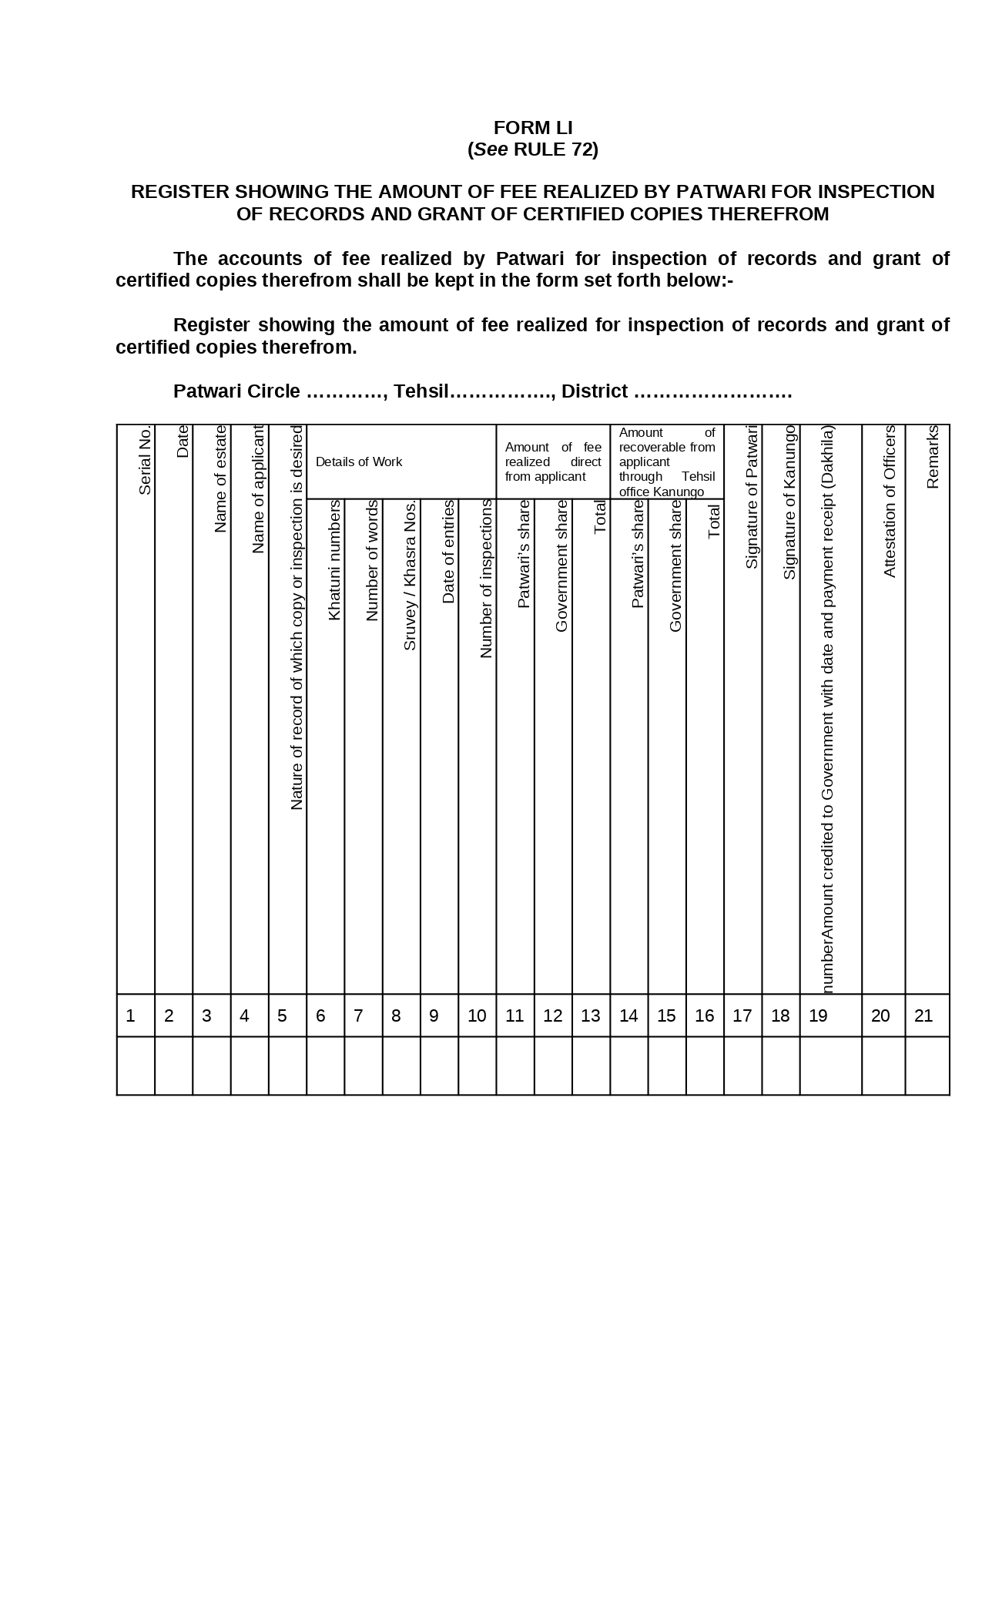

Figure :Register Showing the Amount of Fee Realized by Patwari for Inspection of Records and Grant of Certified Copies Therefrom

Form LII: Register Showing the Amount pf Fee Realized by Patwari for Inspection of Records and Grant of Certified Copies Therefrom

The accounts of fee realized by Patwari for inspection of records and grant of certified copies therefrom shall be kept in the form set forth below:- Register showing the amount of fee realized for inspection of records and grant of certified copies therefrom.

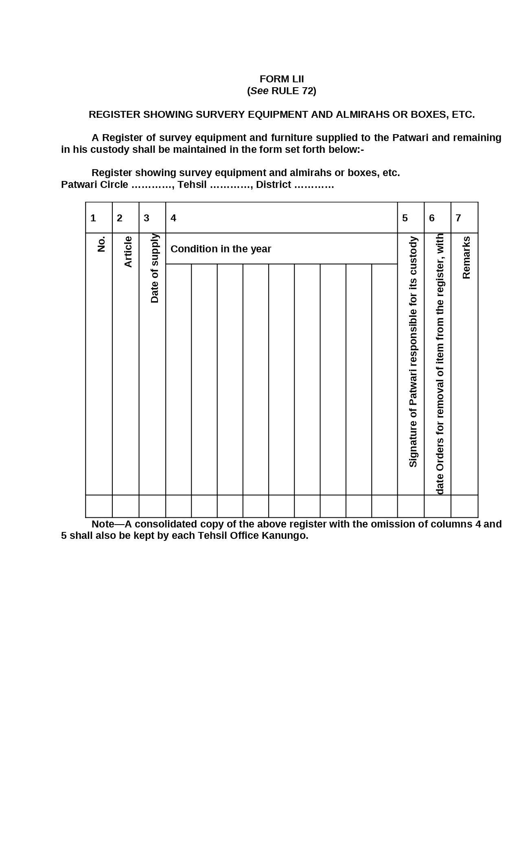

Figure : Register Showing the Amount pf Fee Realized by Patwari for Inspection of Records and Grant of Certified Copies Therefrom

Form LIII: Register of Records in the Custody of Patwari

A register in the following form shall be maintained by each Patwari showing the records in his custody:- Register of records in the custody of Patwari.

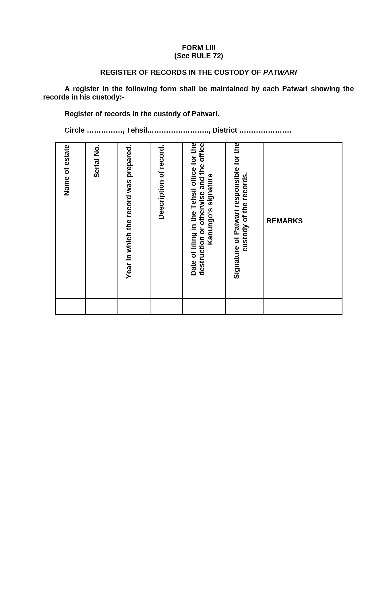

Figure : Register of Records in the Custody of Patwari

Form LIV: Statement Showing the Condition of Survey and Boundary Marks

On the completion of the Kharif harvest inspection each Patwari shall send a report showing the condition of survey and boundary marks in the form set forth below to Tehsil Office Kanungo:-

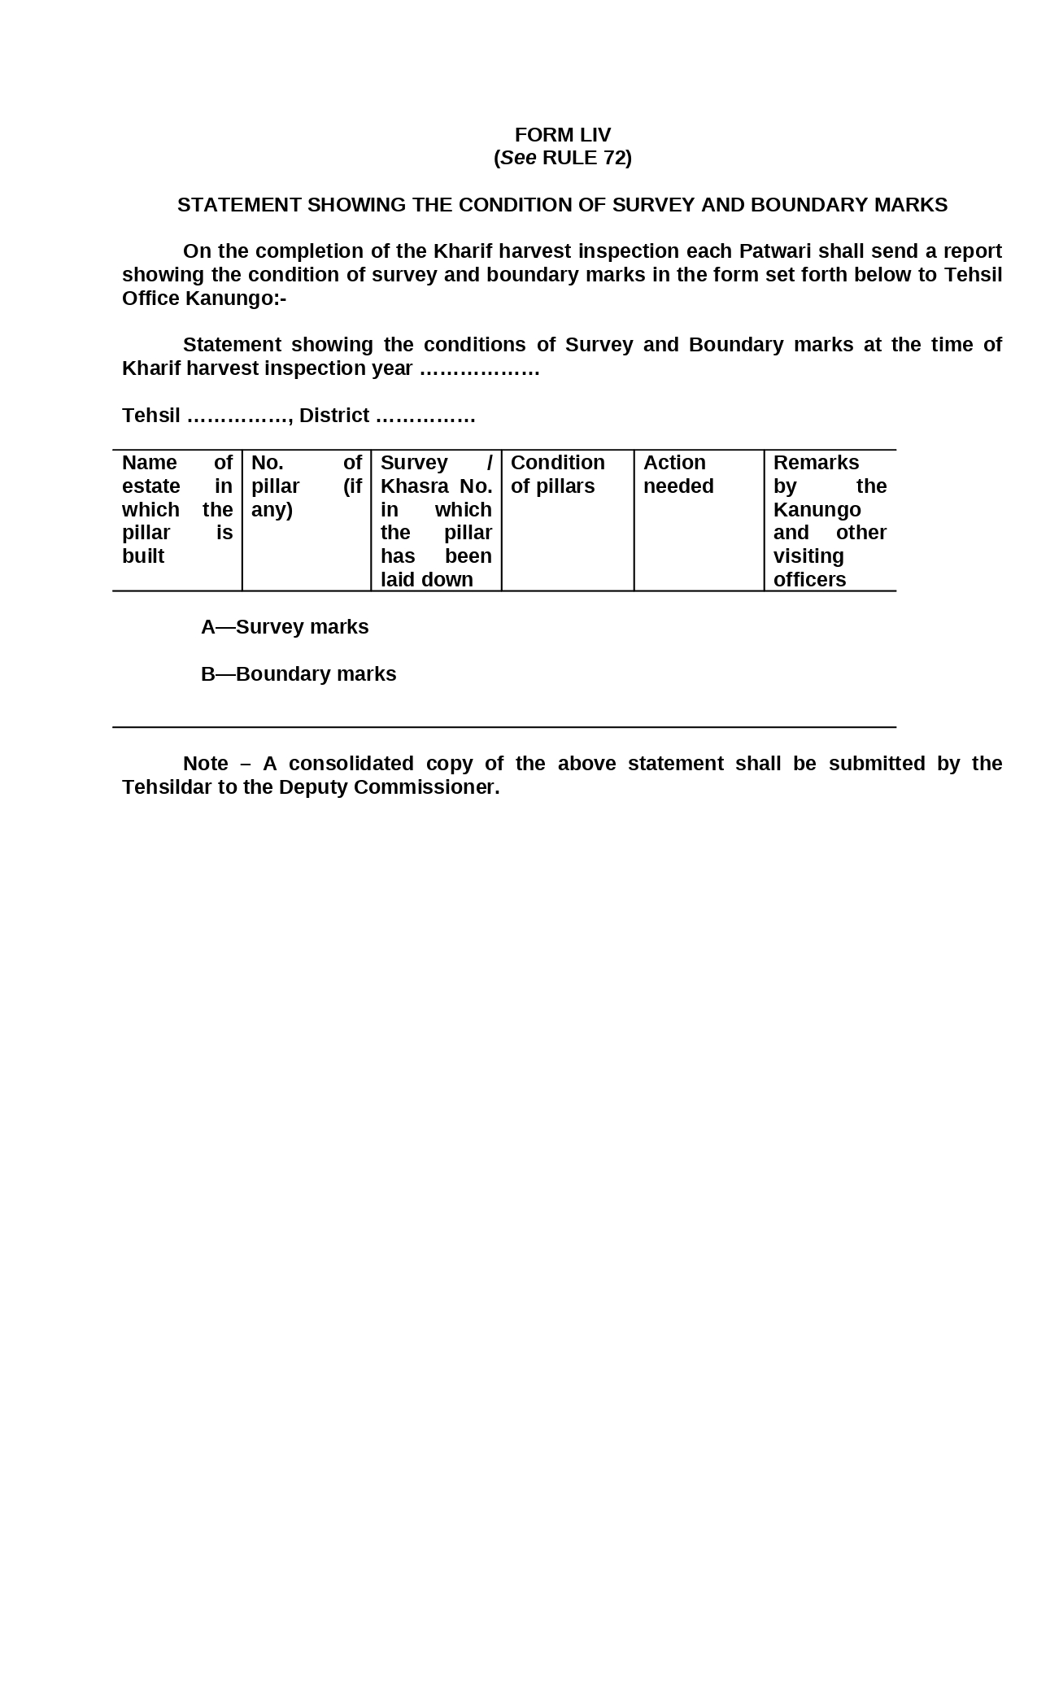

Figure : Statement Showing the Condition of Survey and Boundary Marks

Form LV: Register of Patwari Circles

A register of Patwari Circles of each tehsil shall be maintained by the District Kanungo in the form set forth below:-

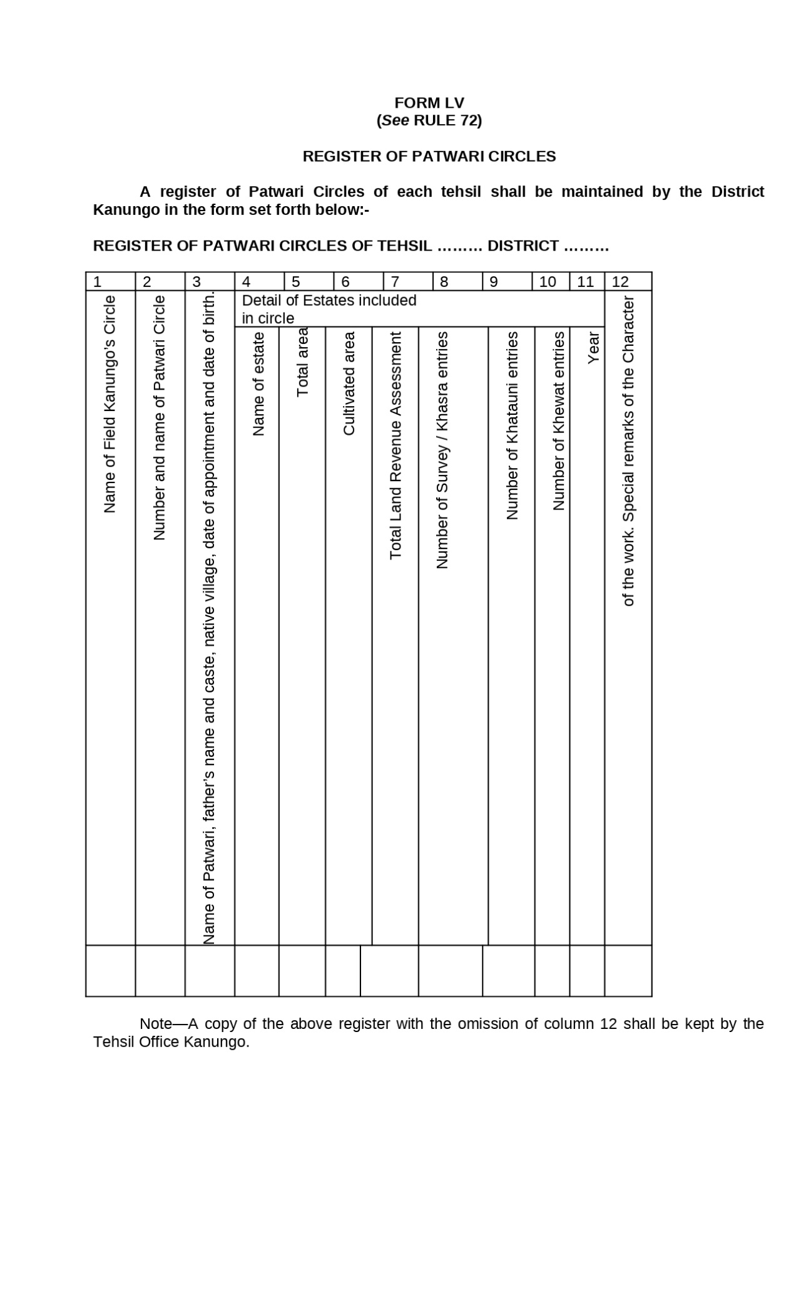

Figure : Register of Patwari Circles

Form LVI: Work-Book (Roznamcha-Karguzari) for Patwaris

Each Patwari shall keep a work-book (Roznamcha-Karguzari) in the form set forth below in which he will enter from day to day the work done by him:-

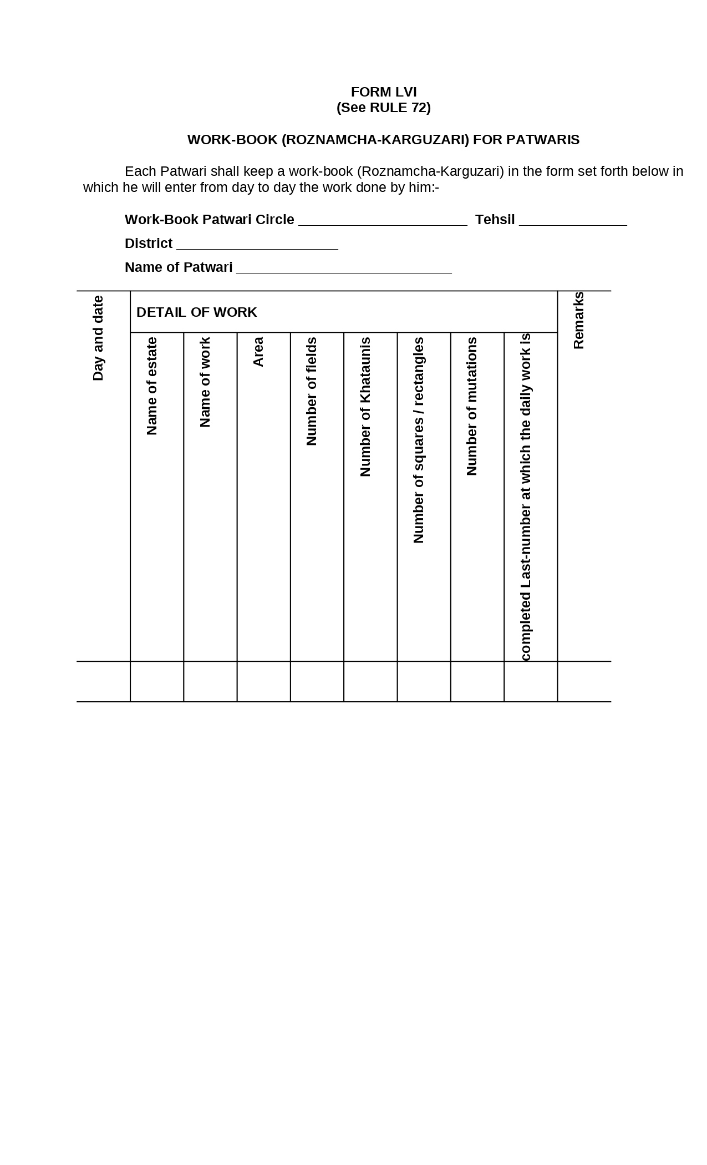

Figure : Work-Book (Roznamcha-Karguzari) for Patwaris

Form LVII: Work-Book (Roznamcha-Karguzari) for Kanungos

Each Kanungo shall keep a work-book (roznamcha-karguzari) in the form set forth below in which he will enter from day to day the work done by him:-

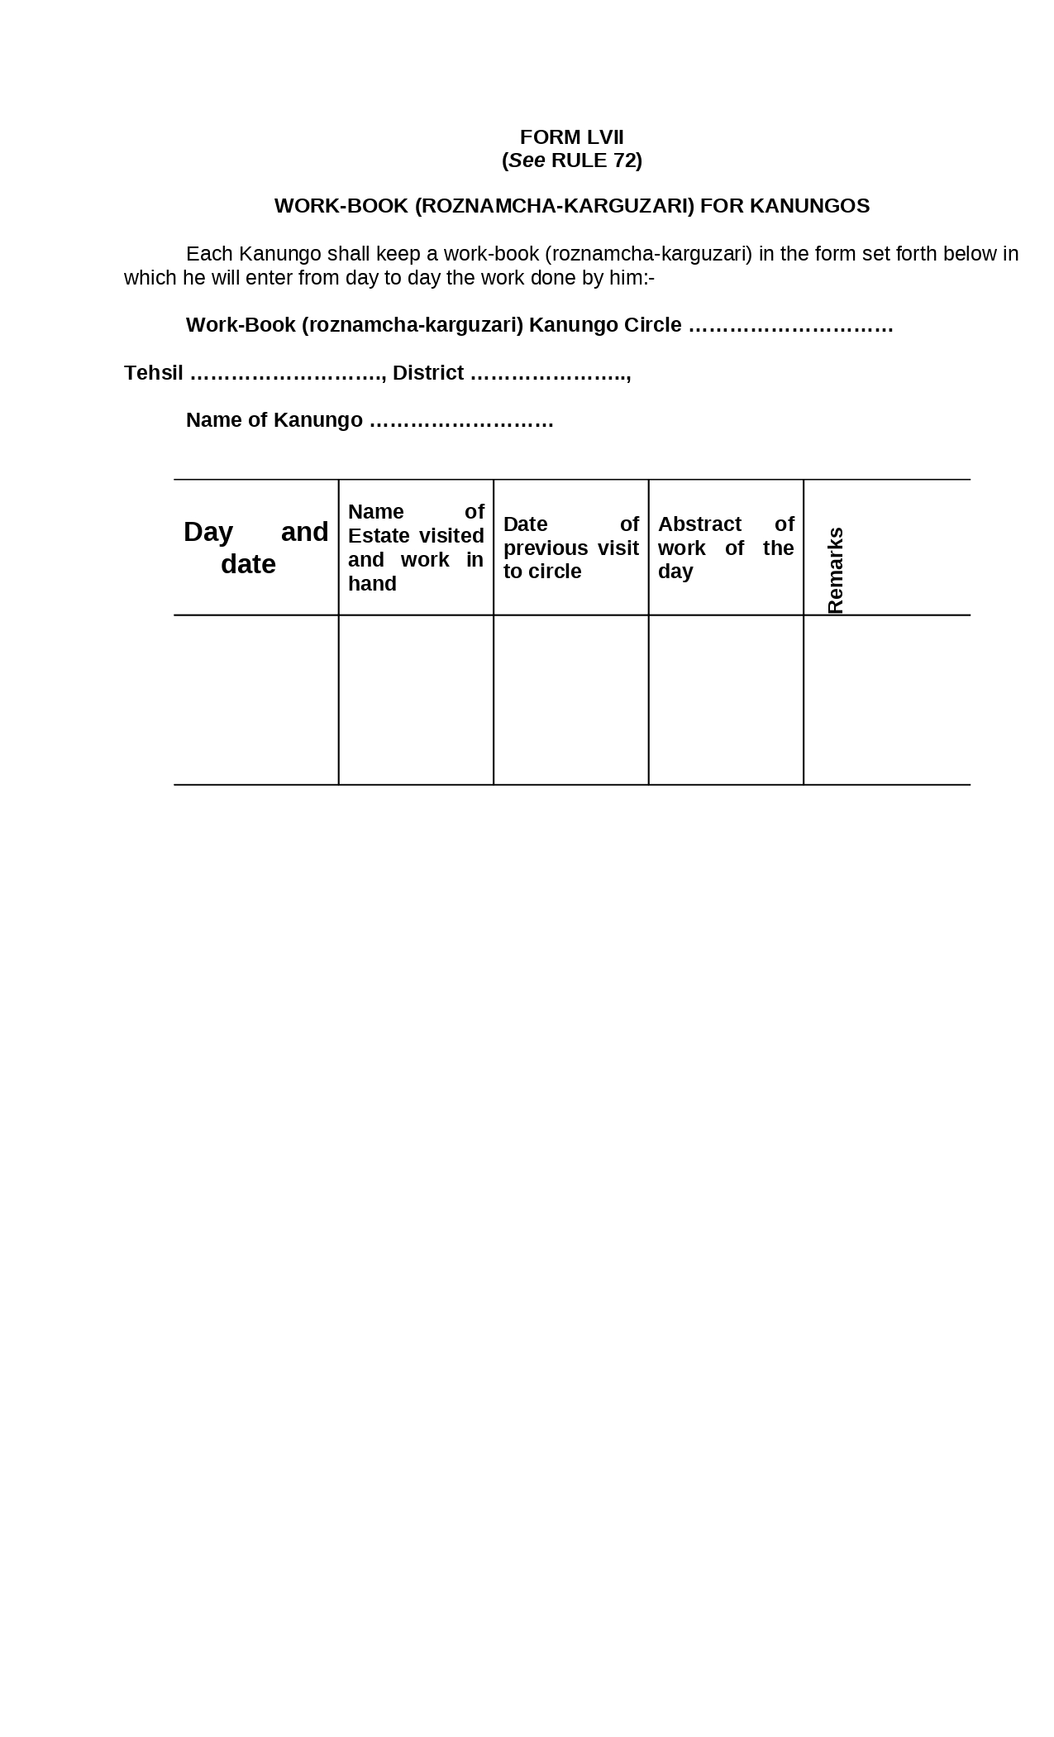

Figure : Work-Book (Roznamcha-Karguzari) for Kanungos

Form LVIII: Work-Book (Roznamcha-Karguzari) For Tehsildars and Naib-Tehsildars / Head Munshis

Each Tehsildar and Naib-Tehsildar (Head Munshi) shall keep a work-book (roznamchakarguzari) in the form set forth below in which he will enter from day to day the work done by him:-



Figure : Work-Book (Roznamcha-Karguzari) For Tehsildars and Naib-Tehsildars / Head Munshis

Form LIX: List of Mortgages with Possession

A list of Mortgages with possession in the form set forth below shall be appended to the holding slip (Form XXXVIII).

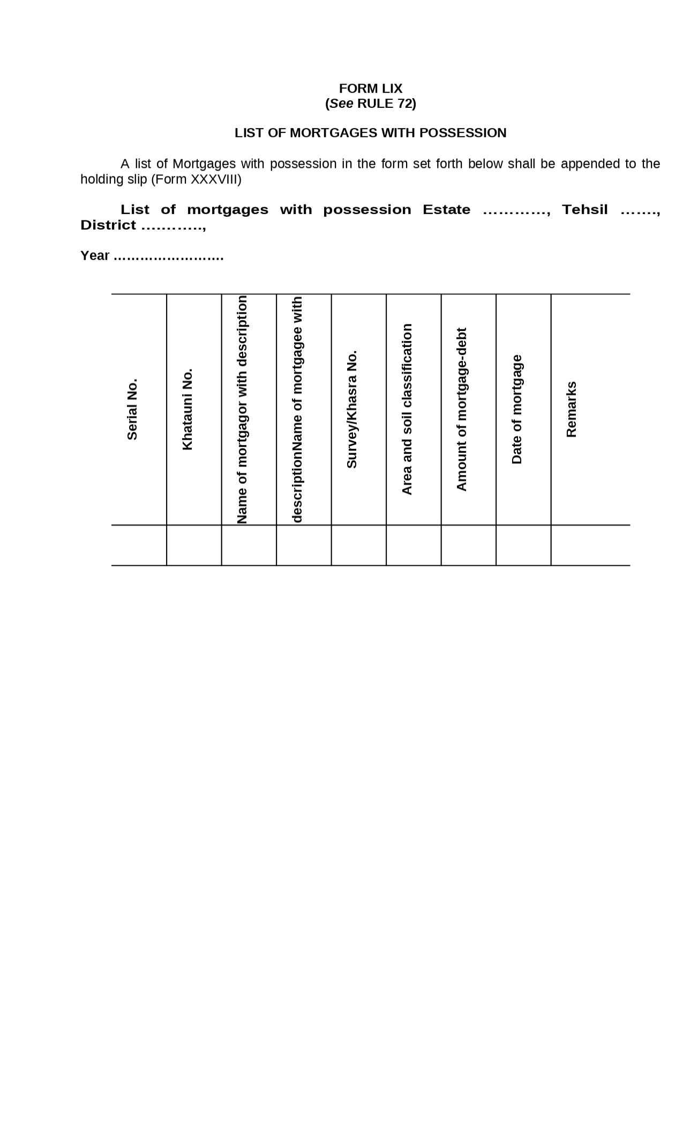

Figure : List of Mortgages with Possession

Form LX: List of Rents

A list of rents in the form set forth below shall be appended to the holding slip (Form XXXVIII).

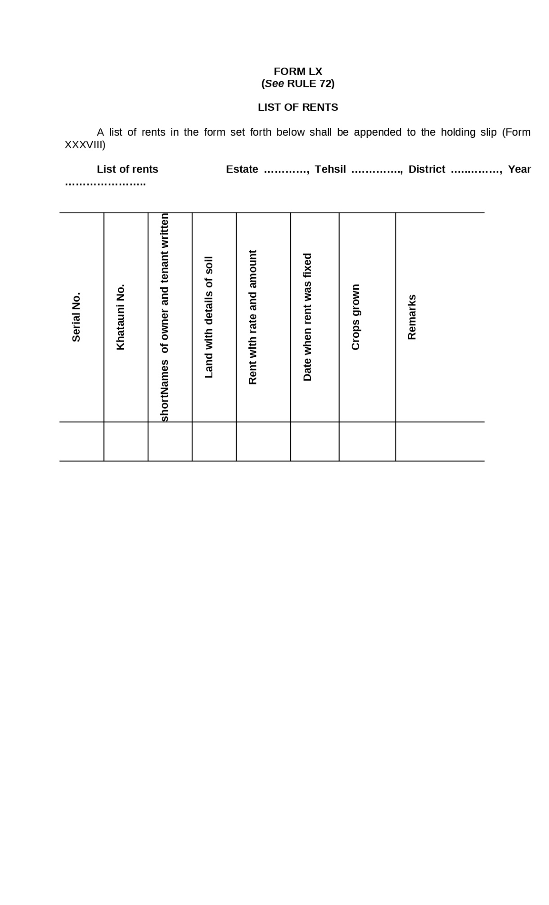

Figure : List of Rents

Form LXI: List of Khatauni Totals

A list of Khatauni totals in the form set forth below shall be appended to the holding slip (Form XXXVIII)

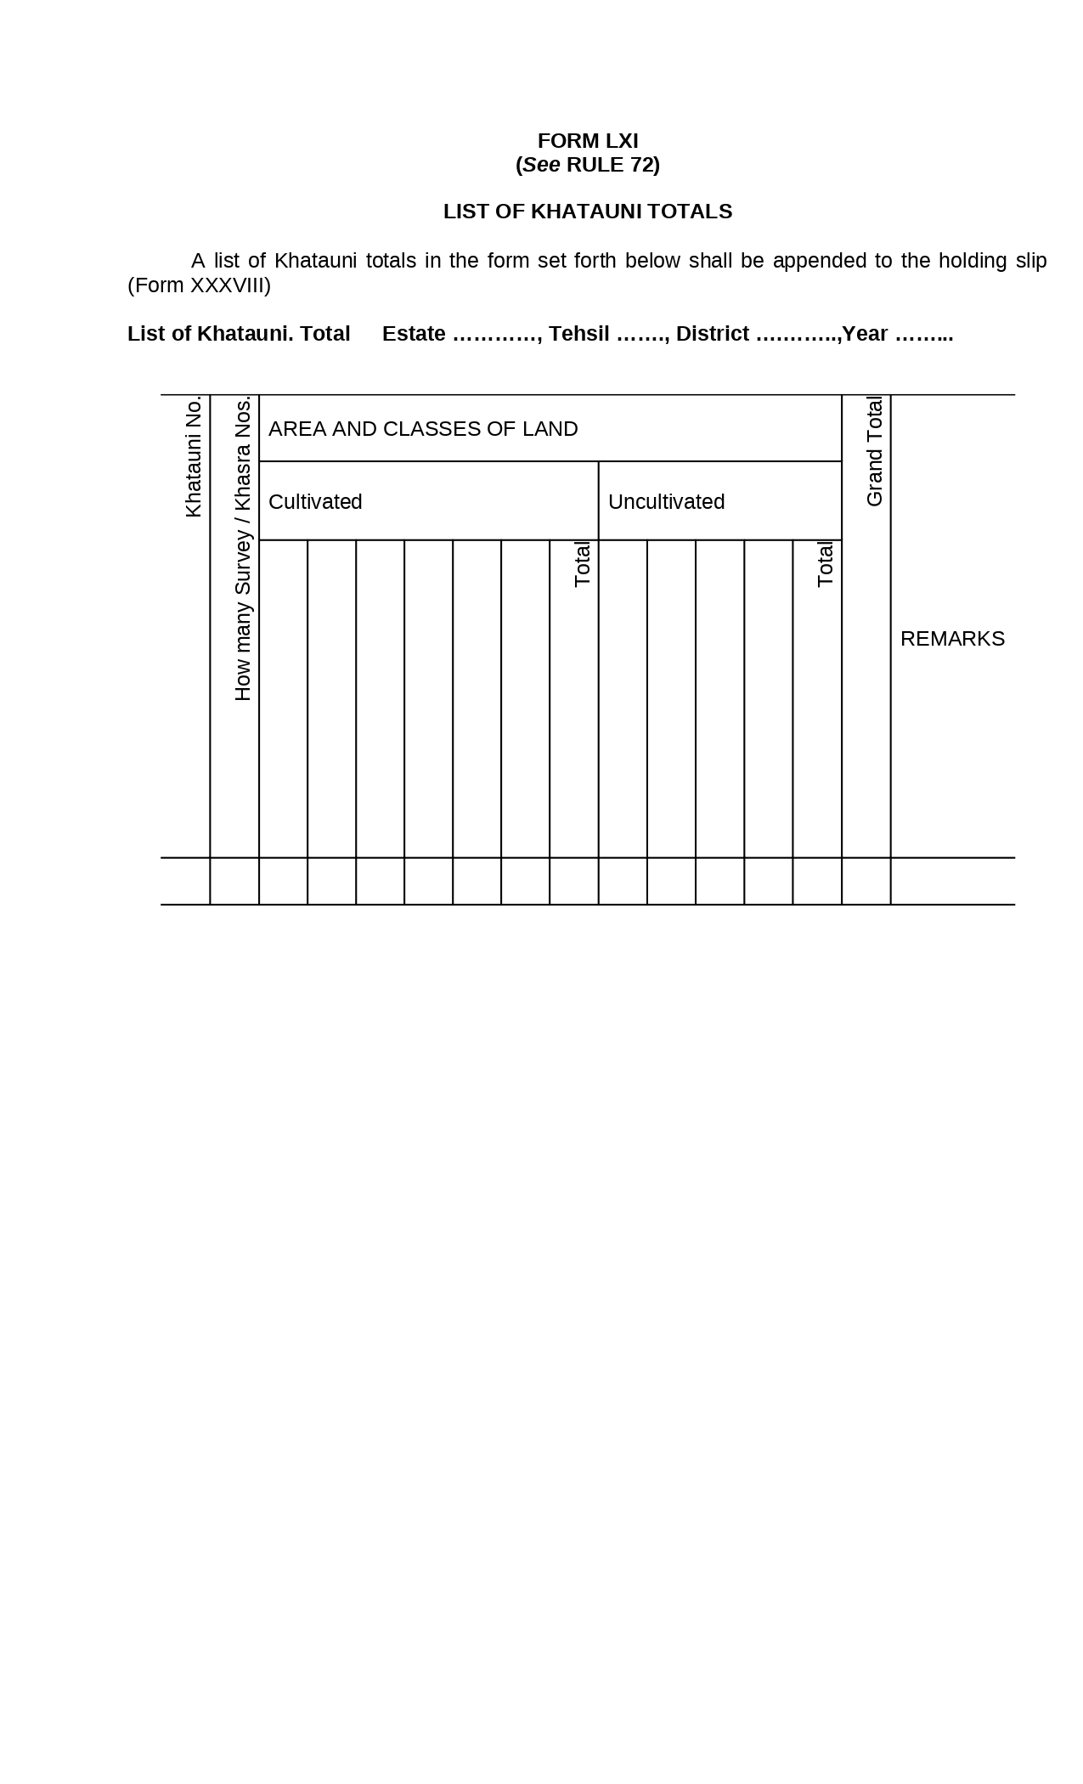

Figure : List of Khatauni Totals

Form LXII: Day Book

In the estates where the land-revenue is collected by Patwaris, a Day Book for each transaction shall be maintained for each estate, in the form set-forth below:-

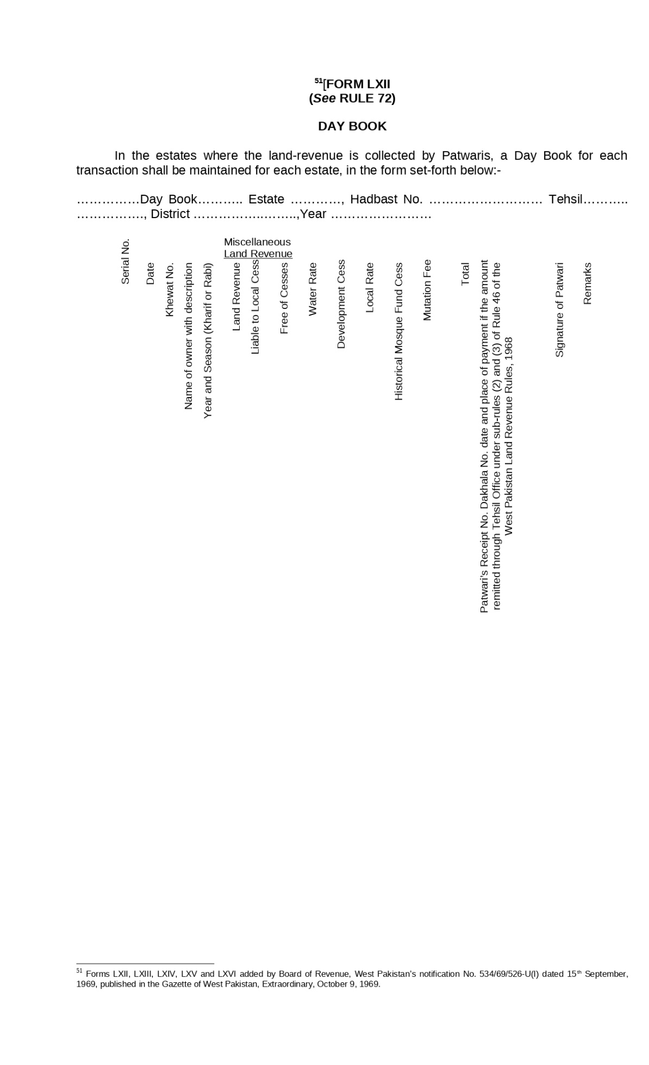

Figure : Day Book

Form LXIII: Ledger of Demands and Collections

In the estates where the Land Revenue is collected by Patwaris, a Ledger of Demands and Collections consisting of holding wise accounts shall be maintained for each estate, in the form set-forth below:-

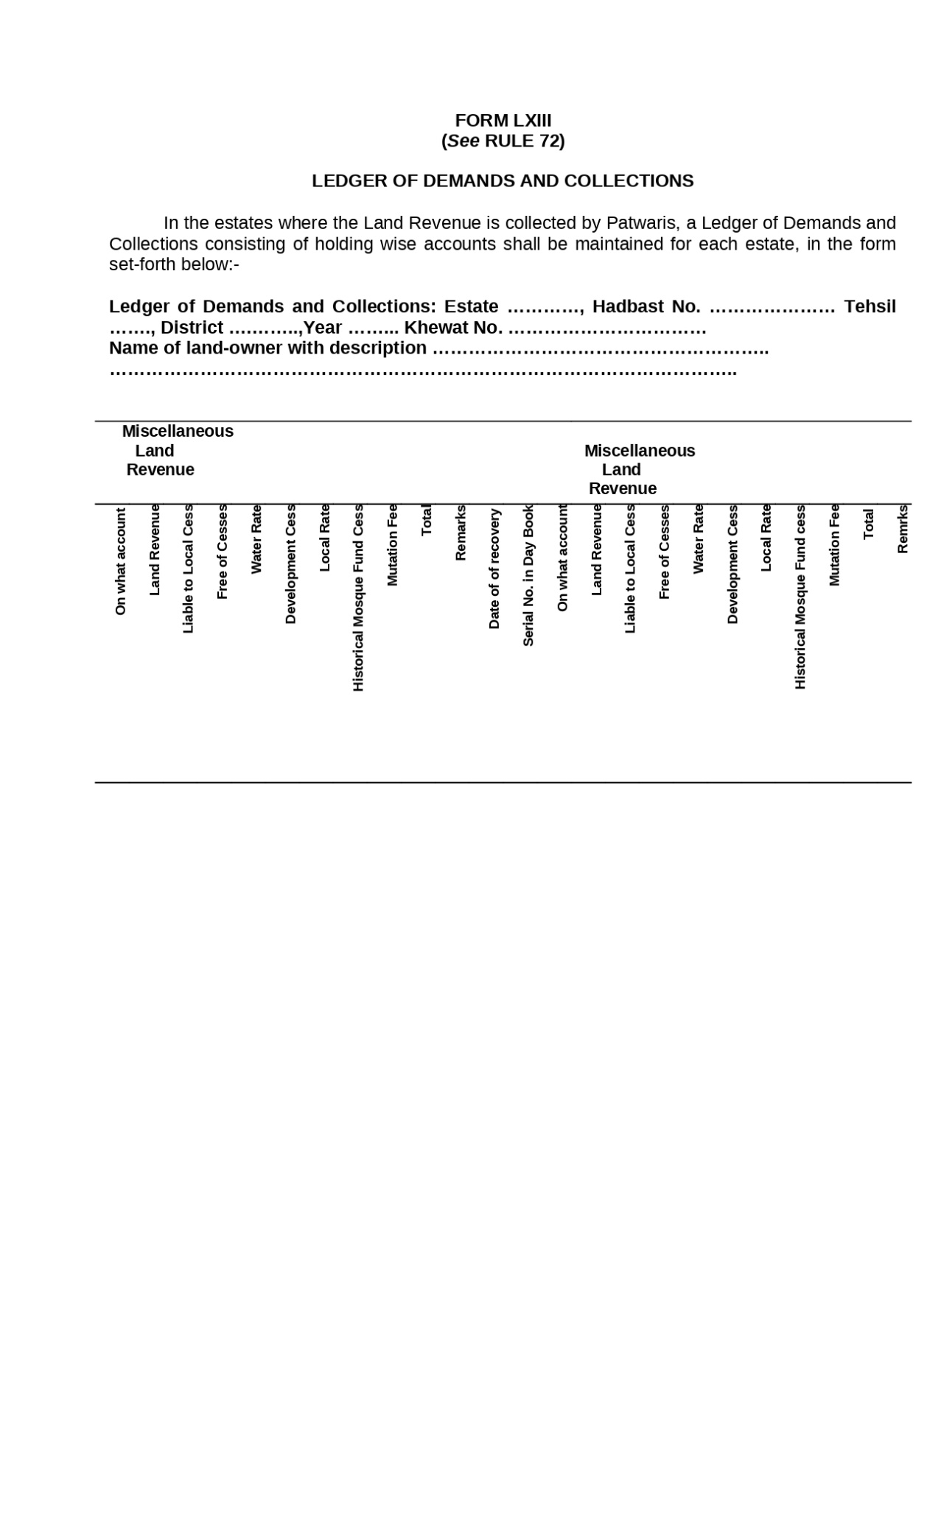

Figure : Ledger of Demands and Collections

Form LXIV: Balance Sheet

In the estates where the land-revenue is collected by Patwaris a Balance Sheet shall be prepared for each estate at the closing of agricultural year in the form set forth below:-

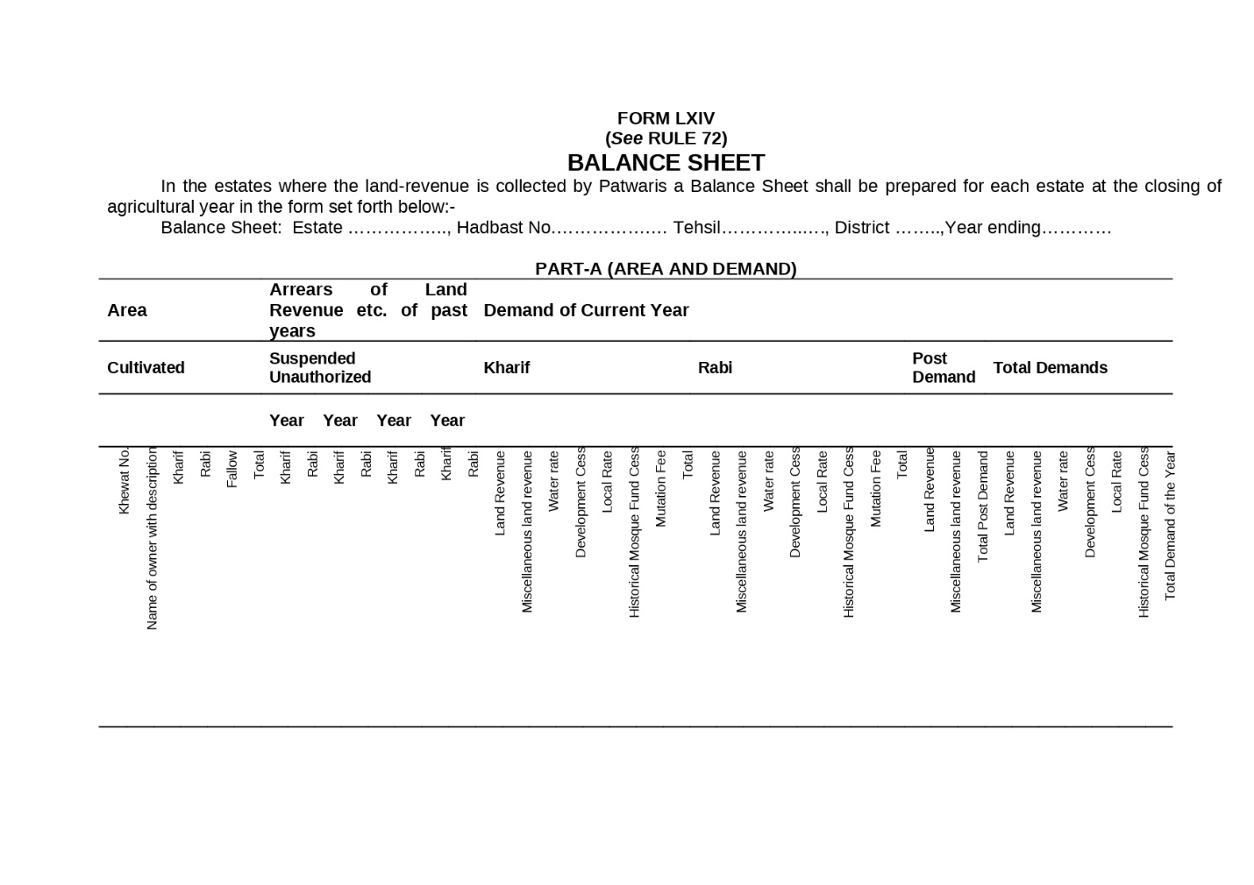

Figure : Balance Sheet

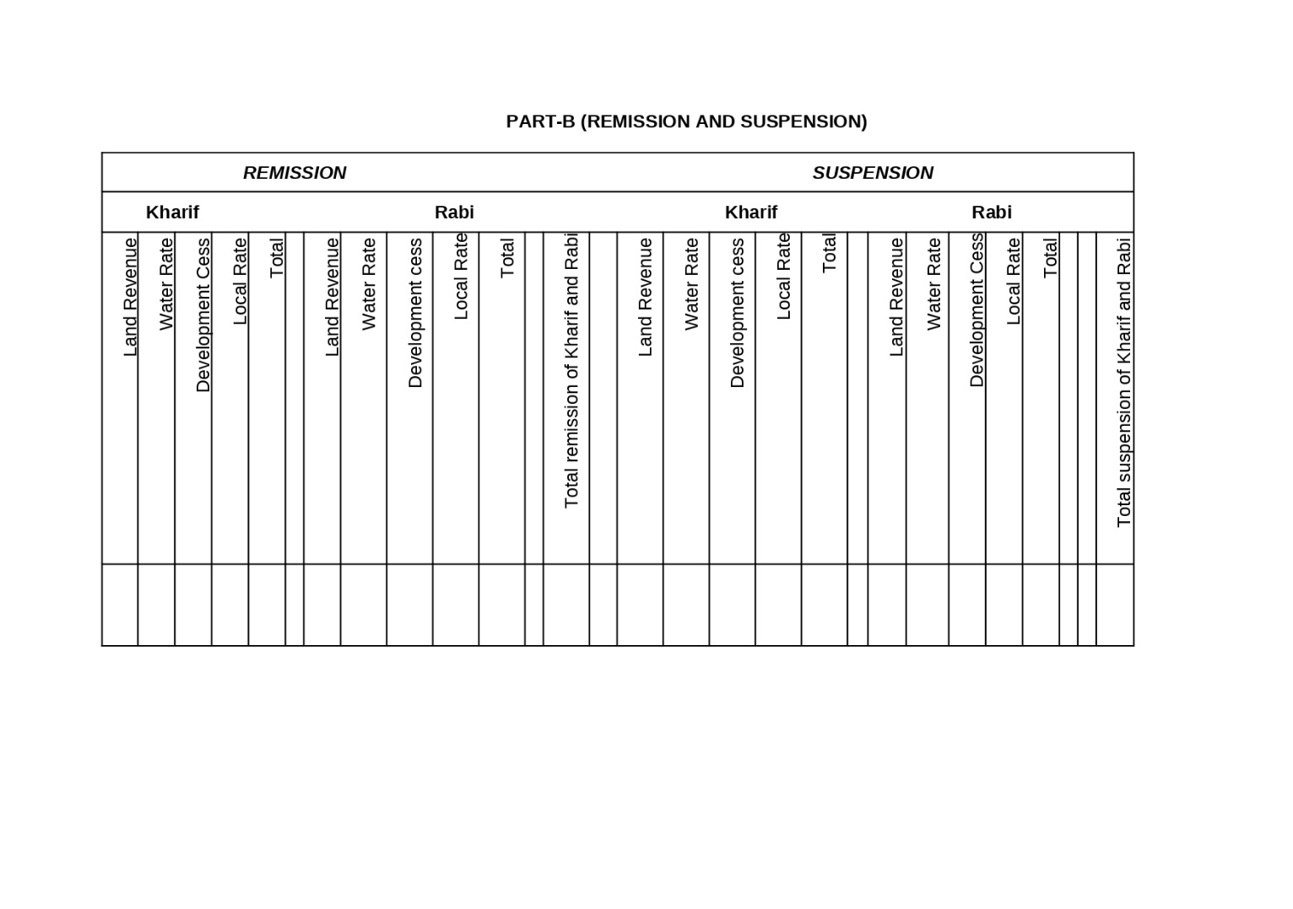

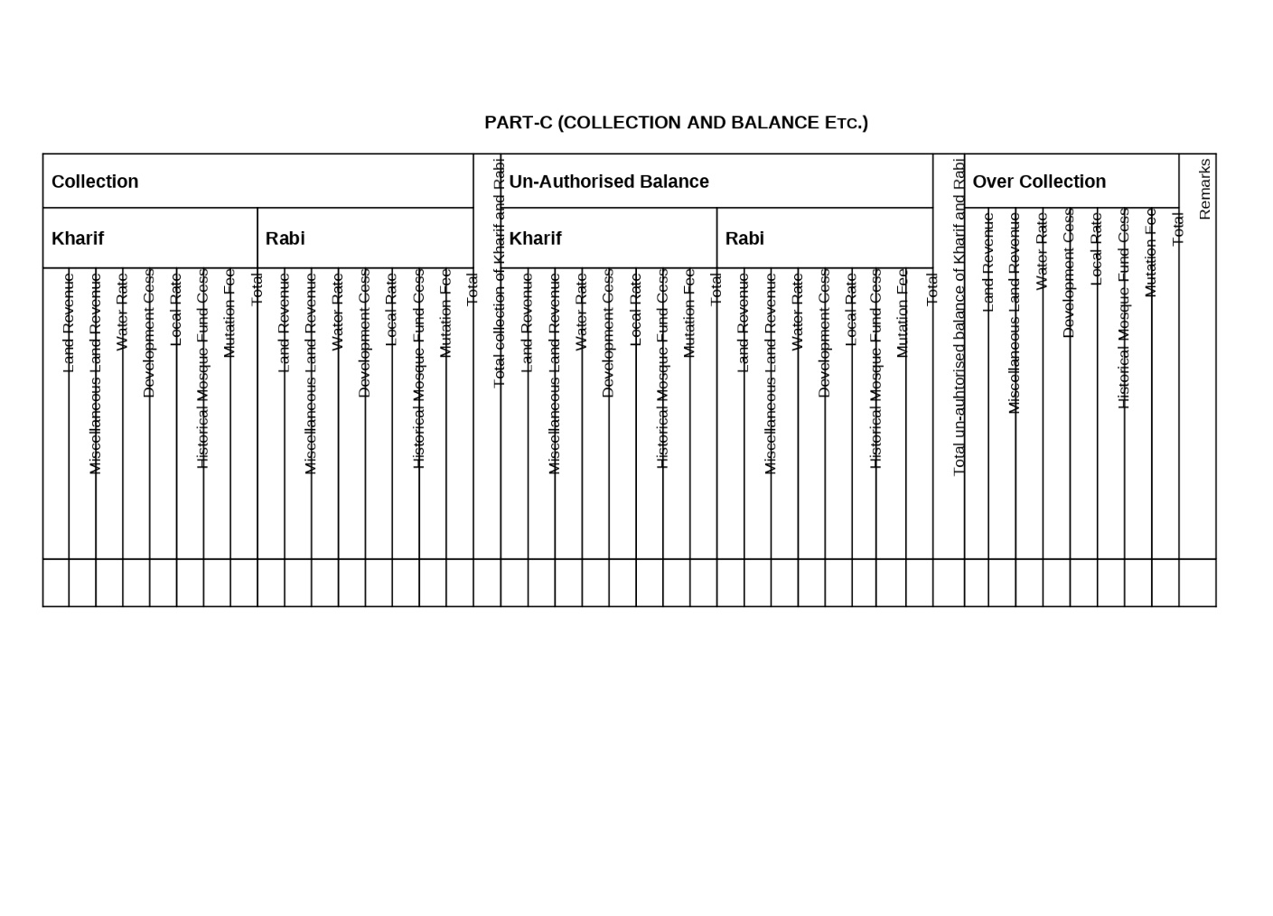

Form LXV: Register of Demands and Recoveries of Water-Course Expenses

In the area where the expenditure incurred by Government on the construction of water-courses is recoverable from the land owners under the law relating to irrigation as in force for the time being a register of demands and recoveries of water-course expenses shall be maintained for each estate, in the form set forth below.

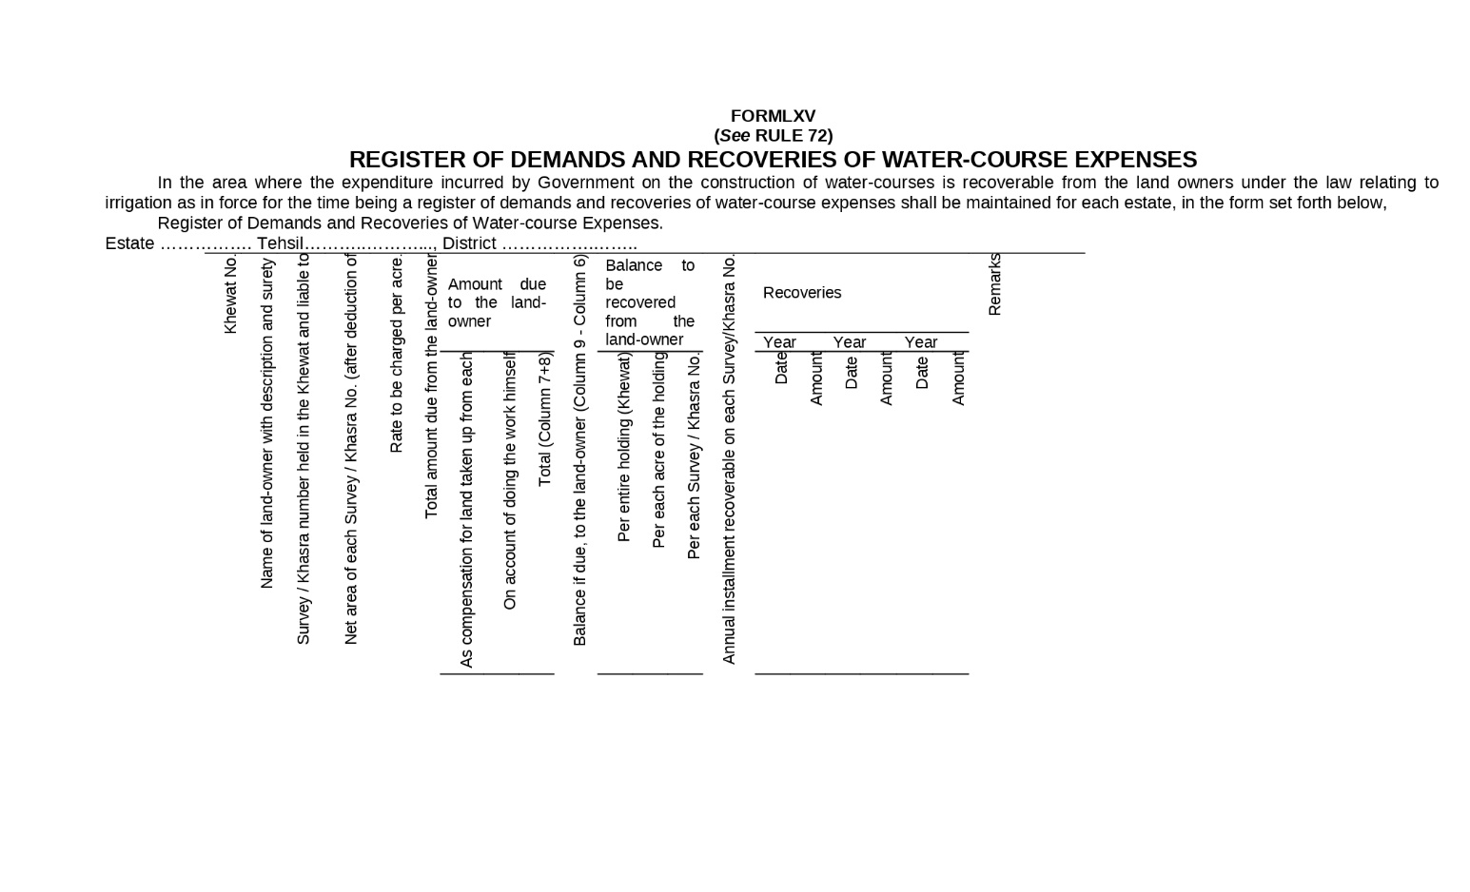

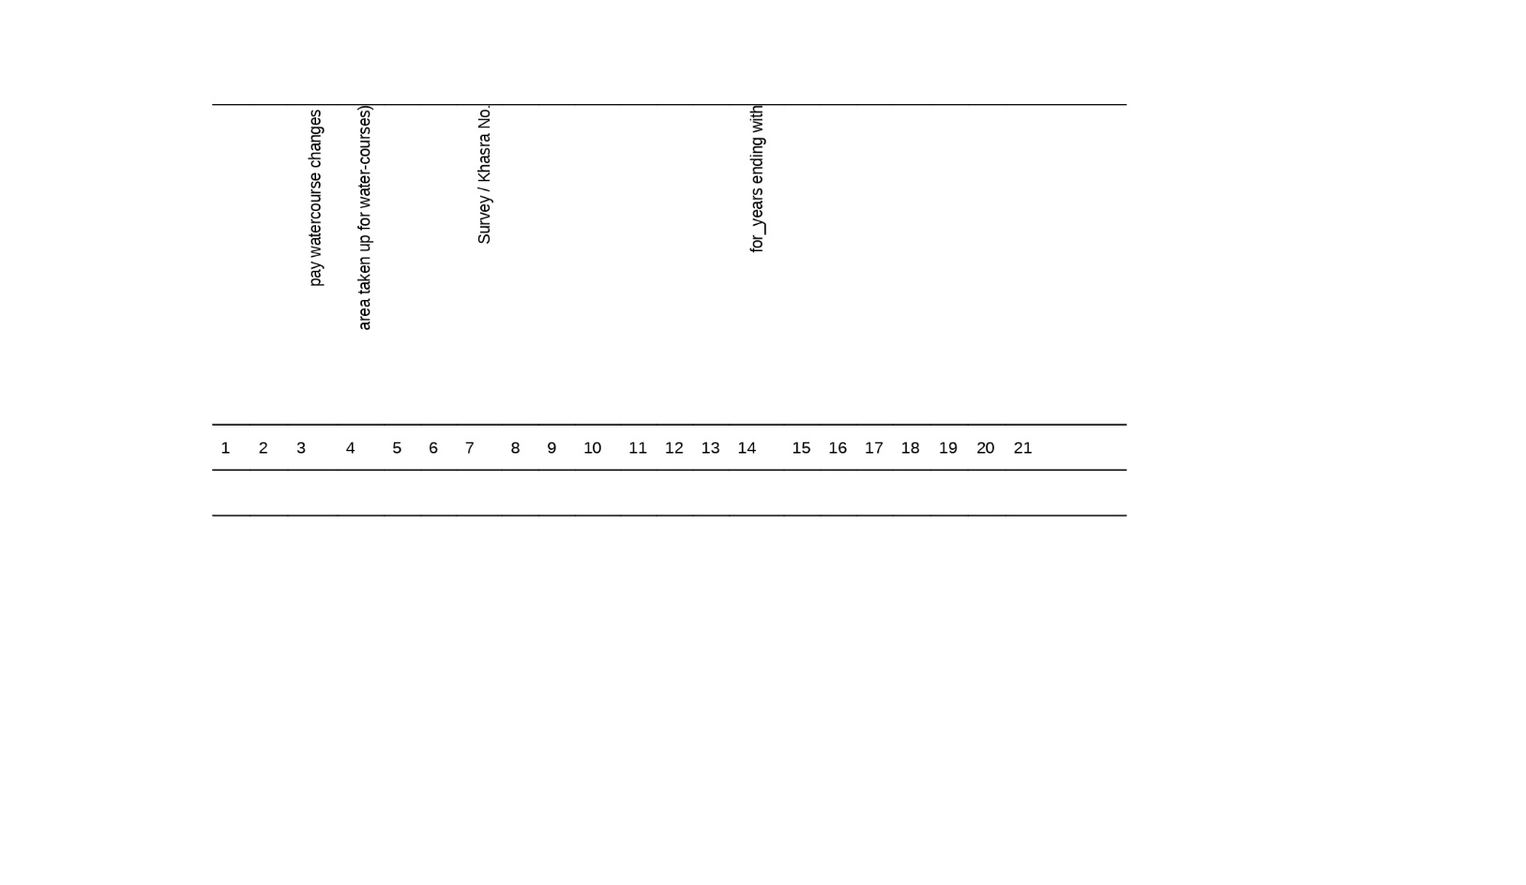

Figure : Register of Demands and Recoveries of Water-Course Expenses

Form LXVI: Register of Area and Assessment of Cultivation in Unsurvey Land

In the areas where assessment is made-on unsurvey land a register of area and assessment shall be maintained in the form set-forth below:-

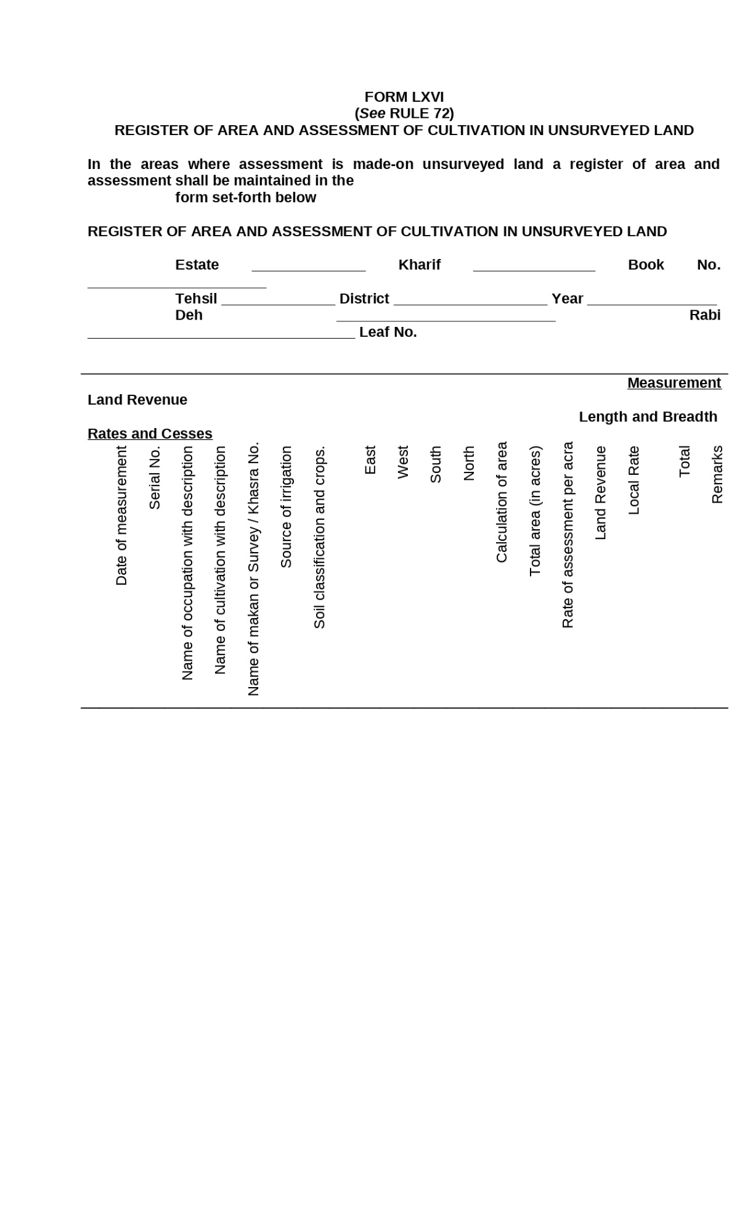

Figure : Register of Area and Assessment of Cultivation in Unsurvey Land

### Cadaster Data Model

Bases on the above-mentioned register and their layout we are purpose a complete data model attached in Annex-I. This data model covers all the important cadaster related information along with the measurement details mentioned in section ‎Chapter 1575083721, Girdawari, and Forest data models. The data dictionary of these tables is as following.

Table : tbl_agriculture_tax

|  |  |  |
| --- | --- | --- |
| **Field** | **Type** | **Extra** |
| **P id** | **int8** |  |
| **parcel_id** | **int4** | **Allow Null** |
| **territory_id** | **int4** | **Allow Null** |
| **area_value** | **numeric(255)** | **Allow Null** |
| **irrgation_source_id** | **int4** | **Allow Null** |
| **crop_type_id** | **int4** | **Allow Null** |
| **crop_area** | **numeric(255)** | **Allow Null** |
| **tax_rate** | **numeric(255)** | **Allow Null** |
| **haboob** | **numeric(255)** | **Allow Null** |
| **lagaan** | **numeric(255)** | **Allow Null** |
| **maalia** | **numeric(255)** | **Allow Null** |
| **tax_period_from** | **date** | **Allow Null** |
| **tax_period_to** | **date** | **Allow Null** |
| **remarks** | **varchar(1000) COLLATE "default"** | **Allow Null** |

Table : tbl_arz_irsal

|  |  |  |
| --- | --- | --- |
| **Field** | **Type** | **Extra** |
| **P id** | **int2** |  |
| **local_revenue** | **float4** | **Allow Null** |
| **local_rate** | **float4** | **Allow Null** |
| **development_fee** | **float4** | **Allow Null** |
| **canal_water_rate** | **float4** | **Allow Null** |
| **mutation_fee** | **float4** | **Allow Null** |
| **total_fee** | **float4** | **Allow Null** |
| **name_of_lambardar** | **varchar(255) COLLATE "default"** | **Allow Null** |
| **attested_by_patwari** | **bool** | **Allow Null** |
| **crop_season** | **int4** | **Allow Null** |
| **year** | **varchar(255) COLLATE "default"** | **Allow Null** |
| **mauza_id** | **int4** | **Allow Null** |

Table : tbl_bill_of_assessments

|  |  |  |
| --- | --- | --- |
| **Field** | **Type** | **Extra** |
| **P id** | **int8** |  |
| **khatuni_no** | **int4** | **Allow Null** |
| **khasra_no** | **int4** | **Allow Null** |
| **area_under_assessment** | **float4** | **Allow Null** |
| **land_revenue** | **float4** | **Allow Null** |
| **development** | **float4** | **Allow Null** |
| **local_rate** | **float4** | **Allow Null** |
| **water_rate** | **float4** | **Allow Null** |
| **dakhil_kharij_no** | **int4** | **Allow Null** |
|  |  |  |
| **total_fee** | **float4** | **Allow Null** |
| **grand_total** | **float4** | **Allow Null** |
| **remarks** | **varchar(255) COLLATE "default"** | **Allow Null** |
| **name_of_lambardar** | **varchar(255) COLLATE "default"** | **Allow Null** |
| **mauza_id** | **int4** | **Allow Null** |
| **crop_season** | **int4** | **Allow Null** |
| **year** | **varchar(255) COLLATE "default"** | **Allow Null** |

Table : tbl_cast

|  |  |  |
| --- | --- | --- |
| **Field** | **Type** | **Extra** |
| **P id** | **int8** |  |
| **cast_name** | **varchar(255) COLLATE "default"** | **Allow Null** |

Table : tbl_crop_inspection

|  |  |  |
| --- | --- | --- |
| **Field** | **Type** | **Extra** |
| **P id** | **int8** |  |
| **khasra_no** | **varchar(50) COLLATE "default"** | **Allow Null** |
| **owner_name** | **varchar(255) COLLATE "default"** | **Allow Null** |
| **khewat_no** | **varchar(50) COLLATE "default"** | **Allow Null** |
| **cultivator_name** | **varchar(255) COLLATE "default"** | **Allow Null** |
| **khatuni_ no** | **varchar(50) COLLATE "default"** | **Allow Null** |
| **area** | **varchar(255) COLLATE "default"** | **Allow Null** |
| **soil_type** | **int8** | **Allow Null** |
| **season_type** | **int8** | **Allow Null** |
| **crop_type** | **int8** | **Allow Null** |
| **inspection_date** | **date** | **Allow Null** |
| **remarks** | **varchar(255) COLLATE "default"** | **Allow Null** |
| **mauza_id** | **int4** | **Allow Null** |

Table : tbl_crop_season

|  |  |  |
| --- | --- | --- |
| **Field** | **Type** | **Extra** |
| **P id** | **int4** |  |
| **crop_season** | **varchar(255) COLLATE "default"** | **Allow Null** |

Table : tbl_crop_types

|  |  |  |
| --- | --- | --- |
| **Field** | **Type** | **Extra** |
| **P id** | **int4** |  |
| **crop_name** | **varchar(255) COLLATE "default"** | **Allow Null** |

Table : tbl_dhal_bachh_malia_ghair_mustaqil

|  |  |  |
| --- | --- | --- |
| **Field** | **Type** | **Extra** |
| **P id** | **int4** |  |
| **owner_name** | **varchar(255) COLLATE "default"** | **Allow Null** |
| **owner_father_name** | **varchar(255) COLLATE "default"** | **Allow Null** |
| **khewat_no** | **int4** | **Allow Null** |
| **khasra_no** | **int4** | **Allow Null** |
| **area_under_assessment** | **float8** | **Allow Null** |
| **source_of_irrigation** | **int4** | **Allow Null** |
| **well_name** | **varchar(255) COLLATE "default"** | **Allow Null** |
| **land_revenue** | **float8** | **Allow Null** |
| **development_fee** | **float8** | **Allow Null** |
| **local_rate** | **float8** | **Allow Null** |
| **lambardari_fee** | **float4** | **Allow Null** |
| **water_rate** | **float4** | **Allow Null** |
| **total** | **float4** | **Allow Null** |
| **dakhil_kharij_no** | **int4** | **Allow Null** |
| **total_fee** | **float4** | **Allow Null** |
| **grand_total** | **float4** | **Allow Null** |
| **remarks** | **varchar(255) COLLATE "default"** | **Allow Null** |
| **crop_season** | **int4** | **Allow Null** |
| **season_year** | **varchar(255) COLLATE "default"** | **Allow Null** |
| **mauza_id** | **int4** | **Allow Null** |
| **name_of_lambardar** | **varchar(255) COLLATE "default"** | **Allow Null** |

Table : tbl_dhal_bachh_malia_mustaqil

|  |  |  |
| --- | --- | --- |
| **Field** | **Type** | **Extra** |
| **P id** | **int4** |  |
| **owner_name** | **varchar(255) COLLATE "default"** | **Allow Null** |
| **owner_father_name** | **varchar(255) COLLATE "default"** | **Allow Null** |
| **khewat_no** | **int4** | **Allow Null** |
| **crop_season** | **int4** | **Allow Null** |
| **crop_season_land_revenue** | **float4** | **Allow Null** |
| **crop_season_development_fee** | **float4** | **Allow Null** |
| **crop_season_local_fee** | **float4** | **Allow Null** |
| **crop_season_lambardari_fee** | **float4** | **Allow Null** |
| **water_rate** | **float4** | **Allow Null** |
| **lambardari_fee_on_water_rate** | **float4** | **Allow Null** |
| **total_amount** | **float4** | **Allow Null** |
| **dakhil_kharij_fee** | **float4** | **Allow Null** |
| **total_fee** | **float4** | **Allow Null** |
| **grand_total** | **float4** | **Allow Null** |
| **remarks** | **varchar(255) COLLATE "default"** | **Allow Null** |
| **name_of_lambardar** | **varchar(255) COLLATE "default"** | **Allow Null** |
| **mauza_id** | **int4** | **Allow Null** |
| **crop_year** | **varchar(255) COLLATE "default"** | **Allow Null** |

Table : tbl_district

|  |  |  |
| --- | --- | --- |
| **Field** | **Type** | **Extra** |
| **P id** | **int8** |  |
| **district_name** | **varchar(255) COLLATE "default"** | **Allow Null** |
| **division_id** | **int4** |  |
| **id_code** | **varchar(25) COLLATE "default"** | **Allow Null** |
| **geom** | **polygon** | **Allow Null** |

Table :tbl_division

|  |  |  |
| --- | --- | --- |
| **Field** | **Type** | **Extra** |
| **P id** | **int8** |  |
| **division_name** | **varchar(255) COLLATE "default"** | **Allow Null** |
| **province_id** | **int4** |  |
| **id_code** | **varchar(25) COLLATE "default"** | **Allow Null** |
| **geom** | **polygon** | **Allow Null** |

Table : tbl_family

|  |  |  |
| --- | --- | --- |
| **Field** | **Type** | **Extra** |
| **P id** | **int8** |  |
| **family_name** | **varchar(255) COLLATE "default"** | **Allow Null** |

Table : tbl_fard_asiab

|  |  |  |
| --- | --- | --- |
| **Field** | **Type** | **Extra** |
| **P id** | **int4** |  |
| **khasra_no** | **int4** | **Allow Null** |
| **khatuni_no** | **int4** | **Allow Null** |
| **source_of_water** | **int4** | **Allow Null** |
| **operationa_date** | **date** | **Allow Null** |
| **operational_expenses** | **varchar(255) COLLATE "default"** | **Allow Null** |
| **owner_of_water** | **varchar(255) COLLATE "default"** | **Allow Null** |
| **owner_of_water_mill** | **varchar(255) COLLATE "default"** | **Allow Null** |
| **name_of_asiaban** | **varchar(255) COLLATE "default"** | **Allow Null** |
| **grindind_day_night** | **varchar(255) COLLATE "default"** | **Allow Null** |
| **income_share_water_owner** | **varchar(255) COLLATE "default"** | **Allow Null** |
| **income_share_watermill_owner** | **varchar(255) COLLATE "default"** | **Allow Null** |
| **income_share_asiaban** | **varchar(255) COLLATE "default"** | **Allow Null** |
| **close_days_per_year** | **int2** | **Allow Null** |
| **government_demand** | **varchar(255) COLLATE "default"** | **Allow Null** |
| **remarks** | **varchar(255) COLLATE "default"** | **Allow Null** |
| **mauza_id** | **int4** | **Allow Null** |
| **year** | **varchar(255) COLLATE "default"** | **Allow Null** |

Table : tbl_fard_badar

|  |  |  |
| --- | --- | --- |
| **Field** | **Type** | **Extra** |
| **P id** | **int8** |  |
| **serial_no** | **varchar(255) COLLATE "default"** | **Allow Null** |
| **khewat_no_previous** | **varchar(255) COLLATE "default"** | **Allow Null** |
| **khewat_no_new** | **varchar(255) COLLATE "default"** | **Allow Null** |
| **patwari_report** | **varchar(255) COLLATE "default"** | **Allow Null** |
| **field_kanungo_report** | **varchar(255) COLLATE "default"** | **Allow Null** |
| **revenue_officer_order** | **varchar(255) COLLATE "default"** | **Allow Null** |
| **mauza_id** | **int8** | **Allow Null** |
| **correction_date** | **date** | **Allow Null** |

Table : tbl_fard_taqseem_ab

|  |  |  |
| --- | --- | --- |
| **Field** | **Type** | **Extra** |
| **P id** | **int4** |  |
| **source_of_lrrigation** | **int4** | **Allow Null** |
| **khewat_no** | **int4** | **Allow Null** |
| **owner_name** | **varchar(255) COLLATE "default"** | **Allow Null** |
| **share** | **varchar(255) COLLATE "default"** | **Allow Null** |
| **remarks** | **varchar(255) COLLATE "default"** | **Allow Null** |
| **mauza_id** | **int4** | **Allow Null** |
| **year** | **varchar(255) COLLATE "default"** | **Allow Null** |

Table : tbl_field_book

|  |  |  |
| --- | --- | --- |
| **Field** | **Type** | **Extra** |
| **P id** | **int8** |  |
| **khasra_no_former** | **varchar(255) COLLATE "default"** | **Allow Null** |
| **khasra_no_present** | **varchar(255) COLLATE "default"** | **Allow Null** |
| **length_east** | **varchar(255) COLLATE "default"** | **Allow Null** |
| **length_west** | **varchar(255) COLLATE "default"** | **Allow Null** |
| **length_south** | **varchar(255) COLLATE "default"** | **Allow Null** |
| **length_north** | **varchar(255) COLLATE "default"** | **Allow Null** |
| **calculation_of_area** | **varchar(255) COLLATE "default"** | **Allow Null** |
| **area_and_soil_classification** | **varchar(255) COLLATE "default"** | **Allow Null** |
| **signature_of_kanungo** | **bytea** | **Allow Null** |
| **remarks** | **varchar(255) COLLATE "default"** | **Allow Null** |
| **mauza_id** | **int8** | **Allow Null** |
| **entry_date** | **date** | **Allow Null** |

Table : tbl_final_attestation_certificate

|  |  |  |
| --- | --- | --- |
| **Field** | **Type** | **Extra** |
| **P id** | **int2** |  |
| **attestation_date** | **date** | **Allow Null** |
| **attestation_place** | **varchar(255) COLLATE "default"** | **Allow Null** |
| **attested_khewat** | **varchar(255) COLLATE "default"** | **Allow Null** |
| **verification_of_mutation_orders** | **varchar(255) COLLATE "default"** | **Allow Null** |
| **khewat_checked_with_previous_register** | **varchar(255) COLLATE "default"** | **Allow Null** |
| **field_khasra_nos_of_supplementary_maps** | **varchar(255) COLLATE "default"** | **Allow Null** |
| **office_khasra_nos_of_supplementary_maps** | **varchar(255) COLLATE "default"** | **Allow Null** |
| **mutation_entered_not_attested_june** | **varchar(255) COLLATE "default"** | **Allow Null** |
| **mauza_id** | **int4** | **Allow Null** |
| **remarks** | **varchar(255) COLLATE "default"** | **Allow Null** |

Table : tbl_forest

|  |  |  |
| --- | --- | --- |
| **Field** | **Type** | **Extra** |
| **P id** | **int8** |  |
| **parcel_id** | **int4** | **Allow Null** |
| **territory_id** | **int4** | **Allow Null** |
| **forest_name** | **varchar(500) COLLATE "default"** | **Allow Null** |
| **forest_type_id** | **int4** | **Allow Null** |
| **forest_category_id** | **int4** | **Allow Null** |
| **compartment_name** | **varchar(500) COLLATE "default"** | **Allow Null** |
| **sub_comparment** | **varchar(500) COLLATE "default"** | **Allow Null** |
| **forest_zone_id** | **int4** | **Allow Null** |
| **working_circle** | **varchar(255) COLLATE "default"** | **Allow Null** |
| **working_pan** | **varchar(255) COLLATE "default"** | **Allow Null** |
| **notification** | **varchar(255) COLLATE "default"** | **Allow Null** |
| **source_document** | **varchar(255) COLLATE "default"** | **Allow Null** |
| **source_image** | **varchar(255) COLLATE "default"** | **Allow Null** |
| **source_map** | **varchar(255) COLLATE "default"** | **Allow Null** |
| **from_date** | **date** | **Allow Null** |
| **to_date** | **date** | **Allow Null** |
| **remarks** | **varchar(1000) COLLATE "default"** | **Allow Null** |

Table : tbl_forest_category

|  |  |  |
| --- | --- | --- |
| **Field** | **Type** | **Extra** |
| **P id** | **int8** |  |
| **forest_category** | **varchar(500) COLLATE "default"** | **Allow Null** |

Table : tbl_forest_type

|  |  |  |
| --- | --- | --- |
| **Field** | **Type** | **Extra** |
| **P id** | **int8** |  |
| **forest_type** | **varchar(500) COLLATE "default"** | **Allow Null** |

**tbl_forest_zone**

|  |  |  |
| --- | --- | --- |
| **Field** | **Type** | **Extra** |
| **P id** | **int8** |  |
| **forest_zone** | **varchar(500) COLLATE "default"** | **Allow Null** |

Table : tbl_gcps

|  |  |  |
| --- | --- | --- |
| **Field** | **Type** | **Extra** |
| **P id** | **int8** |  |
| **gcp_name** | **varchar(255) COLLATE "default"** | **Allow Null** |
| **gcp_type_id** | **int4** |  |
| **elevation** | **numeric(255)** | **Allow Null** |
| **remarks** | **varchar(1000) COLLATE "default"** | **Allow Null** |
| **geom** | **point** | **Allow Null** |

Table : tbl_gcps_type

|  |  |  |
| --- | --- | --- |
| **Field** | **Type** | **Extra** |
| **P id** | **int8** |  |
| **gcp_type** | **varchar(500) COLLATE "default"** | **Allow Null** |

Table : tbl_gender

|  |  |  |
| --- | --- | --- |
| **Field** | **Type** | **Extra** |
| **P id** | **int8** |  |
| **gender** | **varchar(255) COLLATE "default"** | **Allow Null** |

Table : tbl_haqdaran_nakhlistan

|  |  |  |
| --- | --- | --- |
| **Field** | **Type** | **Extra** |
| **P id** | **int8** |  |
| **khewat_no** | **varchar(255) COLLATE "default"** | **Allow Null** |
| **khatuni_no** | **varchar(255) COLLATE "default"** | **Allow Null** |
| **owner_name** | **varchar(255) COLLATE "default"** | **Allow Null** |
| **khasra_no** | **varchar(255) COLLATE "default"** | **Allow Null** |
| **source_of_irrigation** | **varchar(255) COLLATE "default"** | **Allow Null** |
| **date_trees_female** | **varchar(255) COLLATE "default"** | **Allow Null** |
| **date_trees_eunuch** | **varchar(255) COLLATE "default"** | **Allow Null** |
| **date_trees_male** | **varchar(255) COLLATE "default"** | **Allow Null** |
| **date_trees_total** | **varchar(255) COLLATE "default"** | **Allow Null** |
| **govt_demand_revenue** | **varchar(255) COLLATE "default"** | **Allow Null** |
| **govt_demand_cesses** | **varchar(255) COLLATE "default"** | **Allow Null** |
| **mauza_id** | **int8** |  |
| **inspection_date** | **date** | **Allow Null** |

Table : tbl_index_khasra_no

|  |  |  |
| --- | --- | --- |
| **Field** | **Type** | **Extra** |
| **P id** | **int8** |  |
| **khasra_no** | **varchar(255) COLLATE "default"** | **Allow Null** |
| **khatuni_no** | **varchar(255) COLLATE "default"** | **Allow Null** |
| **mauza_id** | **int4** | **Allow Null** |

Table : tbl_inteqal_type

|  |  |  |
| --- | --- | --- |
| **Field** | **Type** | **Extra** |
| **P id** | **int8** |  |
| **inteqal_type** | **varchar(500) COLLATE "default"** | **Allow Null** |

Table : tbl_interrogatory_band_sawal

|  |  |  |
| --- | --- | --- |
| **Field** | **Type** | **Extra** |
| **P id** | **int4** |  |
| **interrogatory_on_the_name** | **varchar(255) COLLATE "default"** | **Allow Null** |
| **father_name** | **varchar(255) COLLATE "default"** | **Allow Null** |
| **cast** | **int2** | **Allow Null** |
| **village_name** | **varchar(255) COLLATE "default"** | **Allow Null** |
| **mauza_id** | **int4** | **Allow Null** |
| **tehsil_id** | **int4** | **Allow Null** |
| **district_id** | **int4** | **Allow Null** |
| **mutation_no** | **int4** | **Allow Null** |
| **transferred_to** | **varchar(255) COLLATE "default"** | **Allow Null** |
| **area_transferred** | **float4** | **Allow Null** |
| **nature_of_transfer** | **varchar(255) COLLATE "default"** | **Allow Null** |
| **date_of_transfer** | **date** | **Allow Null** |
| **consideration_amount** | **float4** | **Allow Null** |
| **questions** | **varchar(255) COLLATE "default"** | **Allow Null** |
| **attested_by_patwari** | **bool** | **Allow Null** |
| **attested_by_kanungo** | **bool** | **Allow Null** |
| **answers** | **varchar(255) COLLATE "default"** | **Allow Null** |
| **interrogatory_thumb_expression** | **bytea** | **Allow Null** |
| **identifying_person_thumb_expression** | **bytea** | **Allow Null** |
| **place_of_statement_recording** | **varchar(255) COLLATE "default"** | **Allow Null** |
| **signature_of_officer_statement_recording** | **varchar(255) COLLATE "default"** | **Allow Null** |
| **date_of_statement_recording** | **date** | **Allow Null** |
| **order_to_interrogatory** | **varchar(255) COLLATE "default"** | **Allow Null** |
| **reports_of_interrogatory** | **varchar(255) COLLATE "default"** | **Allow Null** |
| **orders_of_interrogatory** | **varchar(255) COLLATE "default"** | **Allow Null** |
| **remarks** | **varchar(255) COLLATE "default"** | **Allow Null** |

Table : tbl_irrigation_source

|  |  |  |
| --- | --- | --- |
| **Field** | **Type** | **Extra** |
| **P id** | **int8** |  |
| **source_name** | **varchar(255) COLLATE "default"** | **Allow Null** |

Table : tbl_kharaba_statement

|  |  |  |
| --- | --- | --- |
| **Field** | **Type** | **Extra** |
| **P id** | **int4** |  |
| **khasra_no** | **int4** | **Allow Null** |
| **cultivated_area** | **float8** | **Allow Null** |
| **matured_area** | **float8** | **Allow Null** |
| **failed_area** | **float8** | **Allow Null** |
| **attested_bu_qanungo** | **bool** | **Allow Null** |
| **attested_by_teshildar** | **bool** | **Allow Null** |
| **attested_by_assistant_collector** | **bool** | **Allow Null** |
| **crop_season** | **int4** | **Allow Null** |
| **season_year** | **varchar(255) COLLATE "default"** | **Allow Null** |
| **mauza_id** | **int4** | **Allow Null** |

Table : tbl_khasra_numbers

|  |  |  |
| --- | --- | --- |
| **Field** | **Type** | **Extra** |
| **P id** | **int8** |  |
| **khasra_no** | **varchar(255) COLLATE "default"** | **Allow Null** |
| **khatuni_no** | **varchar(255) COLLATE "default"** | **Allow Null** |
| **mauza_id** | **int4** |  |
| **id_code** | **varchar(25) COLLATE "default"** | **Allow Null** |
| **geom** | **polygon** | **Allow Null** |

Table : tbl_khatuni

|  |  |  |
| --- | --- | --- |
| **Field** | **Type** | **Extra** |
| **P id** | **int4** |  |
| **khatuni_id** | **varchar COLLATE "default"** | **Allow Null** |
| **person_name** | **varchar(255) COLLATE "default"** | **Allow Null** |
| **person_cnic** | **varchar(255) COLLATE "default"** | **Allow Null** |
| **father_name** | **varchar(255) COLLATE "default"** | **Allow Null** |
| **address** | **varchar(255) COLLATE "default"** | **Allow Null** |
| **cast** | **varchar(255) COLLATE "default"** | **Allow Null** |
| **mauza_id** | **int4** | **Allow Null** |

Table : tbl_khewat

|  |  |  |
| --- | --- | --- |
| **Field** | **Type** | **Extra** |
| **P id** | **int4** |  |
| **khewat_no** | **varchar(255) COLLATE "default"** | **Allow Null** |
| **person_name** | **varchar(255) COLLATE "default"** | **Allow Null** |
| **father_name** | **varchar(255) COLLATE "default"** | **Allow Null** |
| **cast** | **varchar(255) COLLATE "default"** | **Allow Null** |
| **adrees** | **varchar(255) COLLATE "default"** | **Allow Null** |
| **cnic** | **varchar(255) COLLATE "default"** | **Allow Null** |
| **mauza_id** | **int4** | **Allow Null** |

Table : tbl_land_type

|  |  |  |
| --- | --- | --- |
| **Field** | **Type** | **Extra** |
| **P id** | **int8** |  |
| **land_type** | **varchar(255) COLLATE "default"** | **Allow Null** |
| **description** | **varchar(1000) COLLATE "default"** | **Allow Null** |

Table : tbl_landuse_subtype

|  |  |  |
| --- | --- | --- |
| **Field** | **Type** | **Extra** |
| **P id** | **int8** |  |
| **sub_type** | **varchar(500) COLLATE "default"** | **Allow Null** |
| **type_id** | **int4** | **Allow Null** |

Table : tbl_landuse_type

|  |  |  |
| --- | --- | --- |
| **Field** | **Type** | **Extra** |
| **P id** | **int8** |  |
| **landuse_type** | **varchar(255) COLLATE "default"** | **Allow Null** |

Table : tbl_mauza

|  |  |  |
| --- | --- | --- |
| **Field** | **Type** | **Extra** |
| **P id** | **int8** |  |
| **mauza_name** | **varchar(255) COLLATE "default"** | **Allow Null** |
| **tehsil_id** | **int4** | **Allow Null** |
| **qanoongo_halqa_id** | **int4** | **Allow Null** |
| **patwar_circle_id** | **int4** | **Allow Null** |
| **id_code** | **varchar(25) COLLATE "default"** | **Allow Null** |
| **geom** | **polygon** | **Allow Null** |

Table : tbl_measurement_type

|  |  |  |
| --- | --- | --- |
| **Field** | **Type** | **Extra** |
| **P id** | **int8** |  |
| **measurement_type** | **varchar(255) COLLATE "default"** | **Allow Null** |

Table : tbl_measurement_units

|  |  |  |
| --- | --- | --- |
| **Field** | **Type** | **Extra** |
| **P id** | **int8** |  |
| **measurement_unit** | **varchar(255) COLLATE "default"** | **Allow Null** |
| **measurment_type_id** | **int4** |  |

Table : tbl_mutations

|  |  |  |
| --- | --- | --- |
| **Field** | **Type** | **Extra** |
| **P id** | **int8** |  |
| **last_khewat** | **int8** | **Allow Null** |
| **last_khatuni** | **int8** | **Allow Null** |
| **last_owner** | **varchar(255) COLLATE "default"** | **Allow Null** |
| **last_owner_father_husband** | **varchar(255) COLLATE "default"** | **Allow Null** |
| **last_owner_address** | **varchar(255) COLLATE "default"** | **Allow Null** |
| **last_owner_cnic** | **varchar(255) COLLATE "default"** | **Allow Null** |
| **last_owner_cast** | **int8** | **Allow Null** |
| **last_mortgagee** | **varchar(255) COLLATE "default"** | **Allow Null** |
| **last_ownership_status** | **varchar(255) COLLATE "default"** | **Allow Null** |
| **last_cultivator_name** | **varchar(255) COLLATE "default"** | **Allow Null** |
| **last_cultivator_cast** | **int8** | **Allow Null** |
| **last_cultivator_address** | **varchar(255) COLLATE "default"** | **Allow Null** |
| **last_cultivator_cnic** | **varchar(255) COLLATE "default"** | **Allow Null** |
| **last_khasra_no** | **int8** | **Allow Null** |
| **last_soil_type** | **int8** | **Allow Null** |
| **new_khewat** | **int8** | **Allow Null** |
| **new_khatuni** | **int8** | **Allow Null** |
| **last_share_in_joint_khewat** | **varchar(255) COLLATE "default"** | **Allow Null** |
| **last_area_according_to_share** | **varchar(255) COLLATE "default"** | **Allow Null** |
| **last_cultivator_father_husband_name** | **varchar(255) COLLATE "default"** | **Allow Null** |
| **new_owner_name** | **varchar(255) COLLATE "default"** | **Allow Null** |
| **new_owner_father_husband_name** | **varchar(255) COLLATE "default"** | **Allow Null** |
| **mutation_id** | **varchar(255) COLLATE "default"** | **Allow Null** |
| **new_owner_cast** | **int8** | **Allow Null** |
| **new_owner_address** | **varchar(255) COLLATE "default"** | **Allow Null** |
| **new_owner_cnic** | **varchar(255) COLLATE "default"** | **Allow Null** |
| **new_ownership_status** | **varchar(255) COLLATE "default"** | **Allow Null** |
| **new_share_in_joint_khewat** | **varchar(255) COLLATE "default"** | **Allow Null** |
| **new_area_according_to_share** | **varchar(255) COLLATE "default"** | **Allow Null** |
| **new_cultivator_name** | **varchar(255) COLLATE "default"** | **Allow Null** |
| **new_cultivator_father_husband_name** | **varchar(255) COLLATE "default"** | **Allow Null** |
| **new_cultivator_address** | **varchar(255) COLLATE "default"** | **Allow Null** |
| **new_cultivator_cast** | **int8** | **Allow Null** |
| **new_cultivator_cnic** | **varchar(255) COLLATE "default"** | **Allow Null** |
| **new_khasra_no** | **int4** | **Allow Null** |
| **new_soil_type** | **int4** | **Allow Null** |
| **mauza_id** | **int4** | **Allow Null** |
| **hadbast_no** | **int4** | **Allow Null** |
| **dakhil_kharij_no** | **int4** | **Allow Null** |
| **nature_of_dakhil_kharij** | **varchar(255) COLLATE "default"** | **Allow Null** |
| **price_of_sale** | **varchar(255) COLLATE "default"** | **Allow Null** |
| **amount_of_mortgage** | **varchar(255) COLLATE "default"** | **Allow Null** |
| **dakhil_kharij_fee** | **varchar(255) COLLATE "default"** | **Allow Null** |
| **dakhil_kharij_fee_chalan_no** | **int4** | **Allow Null** |
| **dakhil_kharij_chalan_no** | **int4** | **Allow Null** |
| **thumb_expression_of_old_party** | **varchar(255) COLLATE "default"** | **Allow Null** |
| **thumb_expression_of_new_party** | **varchar(255) COLLATE "default"** | **Allow Null** |
| **witness_of_old_party** | **varchar(255) COLLATE "default"** | **Allow Null** |
| **witness_of_new_party** | **varchar(255) COLLATE "default"** | **Allow Null** |
| **cnic_of_old_party** | **varchar(255) COLLATE "default"** | **Allow Null** |
| **cnic_of_new_party** | **varchar(255) COLLATE "default"** | **Allow Null** |
| **order_of_revenue_officer** | **varchar(255) COLLATE "default"** | **Allow Null** |
| **attachments** | **varchar(255) COLLATE "default"** | **Allow Null** |

Table : tbl_naqsha_haquq_chahat_wa_nul_chahat

|  |  |  |
| --- | --- | --- |
| **Field** | **Type** | **Extra** |
| **P id** | **int4** |  |
| **khasra_no** | **int4** | **Allow Null** |
| **khatuni_no** | **int4** | **Allow Null** |
| **name_of_well** | **varchar(255) COLLATE "default"** | **Allow Null** |
| **wells_depth_to_water** | **varchar(255) COLLATE "default"** | **Allow Null** |
| **depth_on_water** | **varchar(255) COLLATE "default"** | **Allow Null** |
| **well_condition** | **varchar(255) COLLATE "default"** | **Allow Null** |
| **length_of_tube** | **varchar(255) COLLATE "default"** | **Allow Null** |
| **length_of_filter** | **varchar(255) COLLATE "default"** | **Allow Null** |
| **depth_of_water** | **varchar(255) COLLATE "default"** | **Allow Null** |
| **mouth_of_tube** | **varchar(255) COLLATE "default"** | **Allow Null** |
| **working_oil_eiectricity** | **varchar(255) COLLATE "default"** | **Allow Null** |
| **working_condition** | **varchar(255) COLLATE "default"** | **Allow Null** |
| **usage_start_on** | **date** | **Allow Null** |
| **owner_name** | **varchar(255) COLLATE "default"** | **Allow Null** |
| **owner_share** | **varchar(255) COLLATE "default"** | **Allow Null** |
| **user_name** | **varchar(255) COLLATE "default"** | **Allow Null** |
| **user_share** | **varchar(255) COLLATE "default"** | **Allow Null** |
| **remarks** | **varchar(255) COLLATE "default"** | **Allow Null** |
| **mauza_id** | **int4** | **Allow Null** |
| **year** | **varchar(255) COLLATE "default"** | **Allow Null** |

Table : tbl_ownership_type

|  |  |  |
| --- | --- | --- |
| **Field** | **Type** | **Extra** |
| **P id** | **int8** |  |
| **ownership_type** | **varchar(255) COLLATE "default"** | **Allow Null** |

Table : tbl_parcel_landuse

|  |  |  |
| --- | --- | --- |
| **Field** | **Type** | **Extra** |
| **P id** | **int8** |  |
| **parcel_id** | **int4** | **Allow Null** |
| **territory_id** | **int4** | **Allow Null** |
| **landuse_type_id** | **int4** | **Allow Null** |
| **landuse_subtype_id** | **int4** | **Allow Null** |
| **effective_from** | **date** | **Allow Null** |
| **effective_to** | **date** | **Allow Null** |
| **remarks** | **varchar(1000) COLLATE "default"** | **Allow Null** |

Table : tbl_parcels

|  |  |  |
| --- | --- | --- |
| **Field** | **Type** | **Extra** |
| **P id** | **int8** |  |
| **parcel_id** | **varchar(50) COLLATE "default"** | **Allow Null** |
| **territory_id** | **varchar(50) COLLATE "default"** | **Allow Null** |
| **khasra_id** | **varchar(50) COLLATE "default"** | **Allow Null** |
| **sub_khasra_id** | **varchar(50) COLLATE "default"** | **Allow Null** |
| **square_no** | **varchar(50) COLLATE "default"** | **Allow Null** |
| **masavi_no** | **varchar(50) COLLATE "default"** | **Allow Null** |
| **dimensions** | **varchar(255) COLLATE "default"** | **Allow Null** |
| **feet_per_marla** | **varchar(255) COLLATE "default"** | **Allow Null** |
| **mauza_id** | **int4** |  |
| **id_code** | **varchar(50) COLLATE "default"** | **Allow Null** |
| **landusetype_id** | **int4** | **Allow Null** |
| **geom** | **polygon** | **Allow Null** |

Table : tbl_parcels_info

|  |  |  |
| --- | --- | --- |
| **Field** | **Type** | **Extra** |
| **P id** | **int8** |  |
| **parcel_id** | **int4** | **Allow Null** |
| **territory_id** | **int4** | **Allow Null** |
| **floor_no** | **varchar COLLATE "default"** | **Allow Null** |
| **house_no** | **varchar COLLATE "default"** | **Allow Null** |
| **flat_no** | **varchar COLLATE "default"** | **Allow Null** |
| **shop_no** | **varchar COLLATE "default"** | **Allow Null** |
| **office_no** | **varchar COLLATE "default"** | **Allow Null** |
| **property_no** | **varchar COLLATE "default"** | **Allow Null** |
| **property_name** | **varchar(255) COLLATE "default"** | **Allow Null** |
| **street_no** | **varchar COLLATE "default"** | **Allow Null** |
| **sector** | **varchar(255) COLLATE "default"** | **Allow Null** |
| **sub_sector** | **varchar(255) COLLATE "default"** | **Allow Null** |
| **housing_society** | **varchar(255) COLLATE "default"** | **Allow Null** |
| **block** | **varchar(255) COLLATE "default"** | **Allow Null** |
| **zone** | **varchar(255) COLLATE "default"** | **Allow Null** |
| **remarks** | **varchar(255) COLLATE "default"** | **Allow Null** |

Table : tbl_patwar_circle

|  |  |  |
| --- | --- | --- |
| **Field** | **Type** | **Extra** |
| **P id** | **int8** |  |
| **patwar_circle_name** | **varchar(255) COLLATE "default"** | **Allow Null** |
| **qanoongo_halqa_id** | **int4** |  |
| **id_code** | **varchar(25) COLLATE "default"** | **Allow Null** |
| **geom** | **polygon** | **Allow Null** |

Table : tbl_pending_muations

|  |  |  |
| --- | --- | --- |
| **Field** | **Type** | **Extra** |
| **P id** | **int2** |  |
| **mutation_no** | **int4** | **Allow Null** |
| **entry_date** | **date** | **Allow Null** |
| **nature_of_mutation** | **varchar(255) COLLATE "default"** | **Allow Null** |
| **reasons_of_non_attestation** | **varchar(255) COLLATE "default"** | **Allow Null** |
| **disposal_measures** | **varchar(255) COLLATE "default"** | **Allow Null** |
| **remarks** | **varchar(255) COLLATE "default"** | **Allow Null** |
| **mauza_id** | **int4** | **Allow Null** |

Table : tbl_possession

|  |  |  |
| --- | --- | --- |
| **Field** | **Type** | **Extra** |
| **P id** | **int8** |  |
| **parcel_id** | **int4** | **Allow Null** |
| **territory_id** | **int4** | **Allow Null** |
| **possession_type_id** | **int4** | **Allow Null** |
| **remarks** | **varchar(255) COLLATE "default"** | **Allow Null** |

Table : tbl_possession_type

|  |  |  |
| --- | --- | --- |
| **Field** | **Type** | **Extra** |
| **P id** | **int8** |  |
| **possession_type** | **varchar(255) COLLATE "default"** | **Allow Null** |

Table :tbl_province

|  |  |  |
| --- | --- | --- |
| **Field** | **Type** | **Extra** |
| **P id** | **int8** |  |
| **province_name** | **varchar(255) COLLATE "default"** | **Allow Null** |
| **id_code** | **varchar(25) COLLATE "default"** | **Allow Null** |
| **geom** | **polygon** | **Allow Null** |

Table : tbl_qanoongo_halqa

|  |  |  |
| --- | --- | --- |
| **Field** | **Type** | **Extra** |
| **P id** | **int8** |  |
| **qanoongo_halqa_name** | **varchar(255) COLLATE "default"** | **Allow Null** |
| **tehsil_id** | **int4** |  |
| **id_code** | **varchar(25) COLLATE "default"** | **Allow Null** |
| **geom** | **polygon** | **Allow Null** |

Table : tbl_radeefwar_malikan

|  |  |  |
| --- | --- | --- |
| **Field** | **Type** | **Extra** |
| **P id** | **int8** |  |
| **alphabatical_letters** | **varchar(50) COLLATE "default"** | **Allow Null** |
| **owner_name** | **varchar(255) COLLATE "default"** | **Allow Null** |
| **father_husband_name** | **varchar(255) COLLATE "default"** | **Allow Null** |
| **khewat_no** | **varchar(100) COLLATE "default"** | **Allow Null** |
| **mauza_id** | **int8** | **Allow Null** |

Table : tbl_radeefwar_murtahinan

|  |  |  |
| --- | --- | --- |
| **Field** | **Type** | **Extra** |
| **alphabetical_letters** | **varchar(255) COLLATE "default"** | **Allow Null** |
| **mortgagee_name** | **varchar(255) COLLATE "default"** | **Allow Null** |
| **father_husband_name** | **varchar(255) COLLATE "default"** | **Allow Null** |
| **khewat_no** | **int4** | **Allow Null** |
| **mauza_id** | **int4** | **Allow Null** |
| **book_no** | **varchar(255) COLLATE "default"** | **Allow Null** |
| **leaf_no** | **varchar(255) COLLATE "default"** | **Allow Null** |
| **P id** | **int8** |  |

Table : tbl_record_of_rights

|  |  |  |
| --- | --- | --- |
| **Field** | **Type** | **Extra** |
| **P id** | **int8** |  |
| **khewat_no** | **varchar(255) COLLATE "default"** | **Allow Null** |
| **khatuni_no** | **varchar(255) COLLATE "default"** | **Allow Null** |
| **owner_name** | **varchar(255) COLLATE "default"** | **Allow Null** |
| **owner_father_husband_name** | **varchar(255) COLLATE "default"** | **Allow Null** |
| **owner_cast_id** | **int4** | **Allow Null** |
| **owner_address** | **varchar(255) COLLATE "default"** | **Allow Null** |
| **owner_cnic_no** | **varchar(15) COLLATE "default"** | **Allow Null** |
| **ownership_type_id** | **int4** | **Allow Null** |
| **share_in_joint_khewat** | **varchar(255) COLLATE "default"** | **Allow Null** |
| **share_area** | **varchar(255) COLLATE "default"** | **Allow Null** |
| **agri_pass_book_no** | **varchar(100) COLLATE "default"** | **Allow Null** |
| **cultivator_name** | **varchar(255) COLLATE "default"** | **Allow Null** |
| **cultivator_father_name** | **varchar(255) COLLATE "default"** | **Allow Null** |
| **cultivator_cast_id** | **int4** | **Allow Null** |
| **cultivator_cnic_no** | **varchar(15) COLLATE "default"** | **Allow Null** |
| **cultivator_address** | **varchar(255) COLLATE "default"** | **Allow Null** |
| **khasra_no** | **varchar(100) COLLATE "default"** | **Allow Null** |
| **malik_area_khasra_no** | **varchar(255) COLLATE "default"** | **Allow Null** |
| **irrigation_source_id** | **int4** | **Allow Null** |
| **rent_paid_by_cultivator** | **varchar(255) COLLATE "default"** | **Allow Null** |
| **rent_rate** | **varchar(255) COLLATE "default"** | **Allow Null** |
| **rent_demand** | **varchar(255) COLLATE "default"** | **Allow Null** |
| **detail_revenue_ceasses** | **varchar(255) COLLATE "default"** | **Allow Null** |
| **remakrs** | **varchar(1000) COLLATE "default"** | **Allow Null** |
| **mauza_id** | **int4** | **Allow Null** |

Table : tbl_religion

|  |  |  |
| --- | --- | --- |
| **Field** | **Type** | **Extra** |
| **P id** | **int8** |  |
| **religion** | **varchar(255) COLLATE "default"** | **Allow Null** |

Table : tbl_revenue_terminology

|  |  |  |
| --- | --- | --- |
| **Field** | **Type** | **Extra** |
| **P id** | **int8** |  |
| **terminology** | **varchar(255) COLLATE "default"** | **Allow Null** |
| **description** | **varchar(1000) COLLATE "default"** | **Allow Null** |

Table : tbl_robkar_ibtdai

|  |  |  |
| --- | --- | --- |
| **Field** | **Type** | **Extra** |
| **P id** | **int4** |  |
| **robkar_ibtdai_mauza** | **varchar(255) COLLATE "default"** | **Allow Null** |
| **shajrah_nasab** | **varchar(255) COLLATE "default"** | **Allow Null** |
| **khasra_no** | **int4** | **Allow Null** |
| **index_of_owners** | **varchar(255) COLLATE "default"** | **Allow Null** |
| **index_of_mortgagees** | **varchar(255) COLLATE "default"** | **Allow Null** |
| **register_haqdaran_zamin** | **varchar(255) COLLATE "default"** | **Allow Null** |
| **note_of_changes_of_soil_type** | **varchar(255) COLLATE "default"** | **Allow Null** |
| **register_haqdaran_nakhlistan** | **varchar(255) COLLATE "default"** | **Allow Null** |
| **statement_of_customs** | **varchar(255) COLLATE "default"** | **Allow Null** |
| **orders_of_assessments** | **varchar(255) COLLATE "default"** | **Allow Null** |
| **orders_of_assessments_over_holdings** | **varchar(255) COLLATE "default"** | **Allow Null** |
| **sheets_of_accepted_mutations** | **varchar(255) COLLATE "default"** | **Allow Null** |
| **field_book** | **varchar(255) COLLATE "default"** | **Allow Null** |
| **remarks** | **varchar(255) COLLATE "default"** | **Allow Null** |

Table : tbl_roznamcha_karguzari_patwari

|  |  |  |
| --- | --- | --- |
| **Field** | **Type** | **Extra** |
| **P id** | **int4** |  |
| **karquzari_date** | **date** | **Allow Null** |
| **mauza_id** | **int8** | **Allow Null** |
| **work_name** | **varchar(255) COLLATE "default"** | **Allow Null** |
| **area_name** | **varchar(255) COLLATE "default"** | **Allow Null** |
| **no_of_fields** | **varchar(255) COLLATE "default"** | **Allow Null** |
| **no_of_khatunis** | **varchar(255) COLLATE "default"** | **Allow Null** |
| **no_of_squares** | **varchar(255) COLLATE "default"** | **Allow Null** |
| **no_of_mutations** | **varchar(255) COLLATE "default"** | **Allow Null** |
| **previous_day_work_index** | **varchar(255) COLLATE "default"** | **Allow Null** |
| **remarks** | **varchar(255) COLLATE "default"** | **Allow Null** |

Table : tbl_roznamcha_karguzari_qanoongo

|  |  |  |
| --- | --- | --- |
| **Field** | **Type** | **Extra** |
| **P id** | **int4** |  |
| **karguzari_date** | **date** | **Allow Null** |
| **mauza_id** | **int4** | **Allow Null** |
| **previous_visit_date** | **date** | **Allow Null** |
| **abstract_of_work** | **varchar(255) COLLATE "default"** | **Allow Null** |
| **remarks** | **varchar(255) COLLATE "default"** | **Allow Null** |
| **work_in_hand** | **varchar(500) COLLATE "default"** | **Allow Null** |

Table : tbl_roznamcha_karguzari_thesildar

|  |  |  |
| --- | --- | --- |
| **Field** | **Type** | **Extra** |
| **P id** | **int4** |  |
| **karguzari_date** | **date** | **Allow Null** |
| **work_details** | **varchar(500) COLLATE "default"** | **Allow Null** |
| **remarks** | **varchar(500) COLLATE "default"** | **Allow Null** |

Table : tbl_roznamcha_waqiati

|  |  |  |
| --- | --- | --- |
| **Field** | **Type** | **Extra** |
| **P id** | **int4** |  |
| **roznamcha_date** | **date** | **Allow Null** |
| **heading_of_entry** | **varchar(255) COLLATE "default"** | **Allow Null** |
| **occurance** | **varchar(255) COLLATE "default"** | **Allow Null** |
| **mauza_id** | **int4** | **Allow Null** |
| **remarks** | **varchar(255) COLLATE "default"** | **Allow Null** |

Table : tbl_sect

|  |  |  |
| --- | --- | --- |
| **Field** | **Type** | **Extra** |
| **P id** | **int8** |  |
| **sect** | **varchar(255) COLLATE "default"** | **Allow Null** |

Table : tbl_shajrah_nasab

|  |  |  |
| --- | --- | --- |
| **Field** | **Type** | **Extra** |
| **P id** | **int8** |  |
| **person_id** | **int4** | **Allow Null** |
| **person_name** | **varchar(255) COLLATE "default"** | **Allow Null** |
| **person_cnic** | **varchar(15) COLLATE "default"** | **Allow Null** |
| **gender_id** | **int4** | **Allow Null** |
| **father_husband_name** | **int4** | **Allow Null** |
| **mother_name** | **int4** | **Allow Null** |
| **finger_impression** | **bytea** | **Allow Null** |
| **alive** | **bool** | **Allow Null** |
| **contact_no** | **varchar(15) COLLATE "default"** | **Allow Null** |
| **family_id** | **int4** | **Allow Null** |
| **sub_cast_id** | **int4** | **Allow Null** |
| **cast_id** | **int4** | **Allow Null** |
| **sect_id** | **int4** | **Allow Null** |
| **religion_id** | **int4** | **Allow Null** |
| **profession_id** | **int4** | **Allow Null** |
| **remarks** | **varchar(1000) COLLATE "default"** | **Allow Null** |
| **mauza_id** | **int4** | **Allow Null** |

Table : tbl_soil_type

|  |  |  |
| --- | --- | --- |
| **Field** | **Type** | **Extra** |
|  |  |  |
| **P id** | **int4** |  |
| **soil_type** | **varchar(255) COLLATE "default"** | **Allow Null** |

Table : tbl_source_of_irrigation

|  |  |  |
| --- | --- | --- |
| **Field** | **Type** | **Extra** |
| **P id** | **int4** |  |
| **source_of_irrigation** | **varchar(255) COLLATE "default"** | **Allow Null** |

Table : tbl_sub_cast

|  |  |  |
| --- | --- | --- |
| **Field** | **Type** | **Extra** |
|  |  |  |
| **P id** | **int8** |  |
| **sub_cast** | **varchar(255) COLLATE "default"** | **Allow Null** |



Table : tbl_tatimma_shajrah

|  |  |  |
| --- | --- | --- |
| **Field** | **Type** | **Extra** |
| **P id** | **int8** |  |
| **khasra_no_former** | **varchar(255) COLLATE "default"** | **Allow Null** |
| **khasra_no_present** | **varchar(255) COLLATE "default"** | **Allow Null** |
| **no_khatuni_no** | **varchar(255) COLLATE "default"** | **Allow Null** |
| **khasra_no_east** | **varchar(255) COLLATE "default"** | **Allow Null** |
| **khasra_no_west** | **varchar(255) COLLATE "default"** | **Allow Null** |
| **khasra_no_south** | **varchar(255) COLLATE "default"** | **Allow Null** |
| **khasra_no-north** | **varchar(255) COLLATE "default"** | **Allow Null** |
| **calculation_of_area** | **varchar(255) COLLATE "default"** | **Allow Null** |
| **area_and_soil_classification** | **varchar(255) COLLATE "default"** | **Allow Null** |
| **remarks** | **varchar(255) COLLATE "default"** | **Allow Null** |
| **geom** | **polygon** | **Allow Null** |
| **verified_by_patwari** | **varchar(255) COLLATE "default"** | **Allow Null** |
| **verified_by_kanungo** | **varchar(255) COLLATE "default"** | **Allow Null** |
| **verified_by_revenue** | **varchar(255) COLLATE "default"** | **Allow Null** |
| **mauza_id** | **int8** | **Allow Null** |
| **entry_date** | **date** | **Allow Null** |
| **field_book_no** | **varchar(255) COLLATE "default"** | **Allow Null** |
| **leaf_no** | **varchar(255) COLLATE "default"** | **Allow Null** |

Table : tbl_tax

|  |  |  |
| --- | --- | --- |
| **Field** | **Type** | **Extra** |
| **P id** | **int8** |  |
| **parcel_id** | **int4** | **Allow Null** |
| **territory_id** | **int4** | **Allow Null** |
| **area_value** | **numeric(255)** | **Allow Null** |
| **tax_rate** | **numeric(255)** | **Allow Null** |
| **tax_amount** | **numeric(255)** | **Allow Null** |
| **tax_period_from** | **date** | **Allow Null** |
| **tax_period_to** | **date** | **Allow Null** |
| **remarks** | **varchar(1000) COLLATE "default"** | **Allow Null** |

Table : tbl_tehsil

|  |  |  |
| --- | --- | --- |
| **Field** | **Type** | **Extra** |
| **P id** | **int8** |  |
| **tehsil_name** | **varchar(255) COLLATE "default"** | **Allow Null** |
| **district_id** | **int4** |  |
| **id_code** | **varchar(25) COLLATE "default"** | **Allow Null** |
| **geom** | **polygon** | **Allow Null** |

Table : tbl_territory

|  |  |  |
| --- | --- | --- |
| **Field** | **Type** | **Extra** |
| **P id** | **int8** |  |
|  |  |  |
| **territory_name** | **varchar(255) COLLATE "default"** | **Allow Null** |
| **id_code** | **varchar(50) COLLATE "default"** | **Allow Null** |

Table : tbl_unit_conversion

|  |  |  |
| --- | --- | --- |
| **Field** | **Type** | **Extra** |
| **P id** | **int8** |  |
| **from_unit** | **int4** |  |
| **to_unit** | **int4** |  |
| **conversion_value** | **numeric(255)** | **Allow Null** |

### Territory ID Structure

The following territory table is used for recording administrative units’ information like name of a village, its tehsil, district, province name etc. Territory ID segregates the administrative area unit. The main attributes in territory table are shown in below Figure.

|  |  |  |  |  |  |  |  |
| --- | --- | --- | --- | --- | --- | --- | --- |
| **Province** | **Division** | **District** | **Tehsil** | **Urban/Rural** | **Patwar Circle** | **Mouza** | **UC (Optional)** |
| 1 | 2 | 3 | 4 | 5 | 6 | 7 | 8 |
| 01 | 05 | 012 | 23 | 0 | 05 | 03 | 00 |

|  |  |  |  |  |  |  |  |
| --- | --- | --- | --- | --- | --- | --- | --- |
| **Province** | **Division** | **District** | **Tehsil** | **Urban/Rural** | **Patwar Circle** | **Mouza** | **Town/Cantt.,**  **Cooperative, Authority** |
| 1 | 2 | 3 | 4 | 5 | 6 | 7 | 8 |
| 01 | 05 | 012 | 23 | 0 | 05 | 03 | 00 |

### Measurements of land

### Measure of length and areas

The simplest way or measuring land is by pacing. When a man in walking steps out first with his left foot, the pace or kadam is the distance between the heel of the right foot in its original position and the heel of the same foot after it has been advanced in from of the left foot to make the second step. A kadam is the usual unit of measures of length and a square kadam the unit of measures of area. In the east of the Punjab, where the bigha is the local measure, the square kadam is known as the biswani; in the west, where the ghumao is employed, it is known as the sarsahi. Twenty biswanis make a biswa, and twenty biswas a bigha. Nine sarsahis make a Marla, Twenty merlas a kanal, and eight kanals a ghumao. The bigha of the Western Punjab is one half of a ghumao. As the average height of a man, in different localities varies greatly, it is not surprising that the local measures in use were found to be far from uniform. The variations have been reduced, but not abolished, in our settlement surveys. Following few diagrams has been used to represent and calculate basic area measurements.

#### MEASUREMENT OF AREA

* Area Calculation based on Euclidean geometry

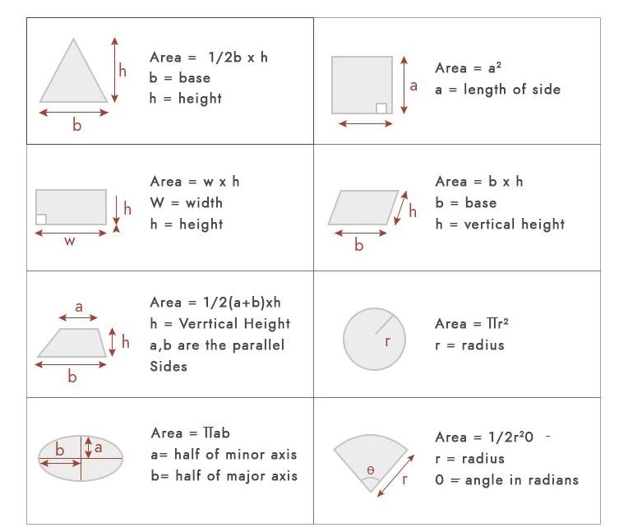

Figure : Area Calculation based on Euclidean geometry

* Polygon area Calculation based on Analytical geometry

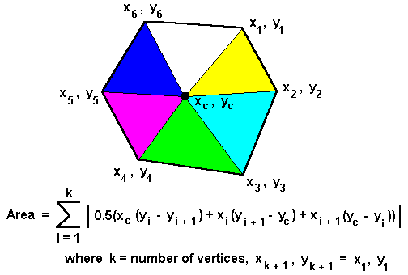

Figure : Polygon area Calculation based on Analytical geometry

#### Calculation of field areas

The calculation of field areas depends on the simple fact that the numbers of kadams on two sides of a rectangular figure, one of which is perpendicular to the other, multiplied together will give the number of square kadams. Area of any triangle can be found by multiplying the number of kadams in its base by the number contained in a perpendicular dropped on to the base from the opposite angle and having the result. However irregular the shape of the field may be, so long as its sides are straight or only slightly curved, there is no difficulty in finding its areas, for any figure on this sort can be divided into triangles.

#### Topographical and cadastral surveys

There are two surveys with which a Settlement Officer has to concern himself, the topographical survey made by the Survey Department and the cadastral or field survey made by the patwaris. The second is indispensable for his work, the first is chiefly useful to him as a means to testing the accuracy of the second. The methods used in both cases are scientific. The processes followed in the second are, of course, much simpler than those employed in the former, but experience has proved, that properly applied, they are sufficient to secure a degree of accuracy sufficient for all the purposes for which revenue officials employ village maps. The Imperial Survey deals with village as a whole, mapping their boundaries and showing the main topographical features, such as the homestead or abadi, roads, canals and large sheets of water. The limits of the cultivated culturable, and barren land have also sometimes been indicated. The cadastral survey marks on the village map the boundaries of every field, and by means of it the areas shown in the Jamabandi are calculated.

The field measurements are based on a somewhat elaborate traverse made by the Survey Department, but this plan has not been followed in other plain districts, except in the case of riverain tracts as noticed in the last paragraph, as it is found that the squares laid down by the patwaris furnish an accurate framework for cadastral surveys. But in hilly tracts the square system is impossible. Recourse has therefore, to be had to a modification of the plane-table system, and no great accuracy can perhaps be looked for unless the patwari is supplied with mapping sheets on which the positioning of several conspicuous points been marked by the Survey Department. In the tracts under reference, and possibly in others, an increasing amount of assistance of this kind will, it is anticipated, be required as time 9.

For hill measurement, plotted sheets showing survey marks fixed and traversed by the Department for the purpose the facilitating settlement measurement and mapping. In all settlements for which such plotted sheets are supplied, three traverse points in each estate should be marked with stone pillars under the orders of the Settlement Officer. It may be possible to utilize tri-junctions as traverse points and thus to reduce the expense of laying pillars. Usually manual method is used by patwaries and gardawars , in which they use “Jhandi” and Jareb.

#### REVENUE TERMINOLOGIES

|  |  |
| --- | --- |
| Khewat number | The number of owners of the land |
| Khatoni Number | The number of possessor/ cultivators of land |
| Khasra number | The number of measurements of area in jamabandi |
| Kita number | The Number mentioning the khasra number in jamabandi |
| Mutation/rapat | Any entry regarding sale purchase or transfer of land |
| Vassiat | transfer of land through will |
| Hiba | transfer of land through gift |
| Billa | Devoid of/without |
| Hadbast number | Number of revenue village boundary |
| Mushqueel/ Murrabha/ rectangle | comprise of 25 Acres/bighas |
| Lal Dora | The boundary of inhabited village, within which ownership of land is generally through possession only. |

#### Scale and Tolerance used in Mussavies:

|  |  |  |  |
| --- | --- | --- | --- |
|  | **Scale** | **Distance Tolerance** | **Area Accuracy** |
| Rural Areas | 1:500 up to 1:1000 | 8cm to 16cm | 0.5 m2 |
| Urban Area | 1:500 | 8cm | 0.2 m2 |

#### Spatial reference system /Coordinate System:

The UTM projection coordinate system should be used for unified cadaster system. The UTM zones for Pakistan are 41N, 42N and 43N as Pakistan lie to the north of the equator.

There are certain measurements which are being used in different areas of Pakistan in accordance with vernacular versions of respective areas. Measurements being observed in each province are mentioned below.

#### Land Measurement used in Punjab

|  |  |
| --- | --- |
| 1 Karam | 5.5 Feet |
| 1 Marla | 9 Sq Karams (272.25 sq. ft) |
| 1 Kanal | 20 Marla (5,445 sq. ft) |
| 4 Kanal | 1 Bigha |
| 1 *1Kila | 8 Kanals (43,560 sq. ft = 1 acre) |
| 1 Murabba | 25 kilas (1,089,000 sq. ft = 25 acres) |

*1A Kila is measured rectangularly, reckoned as an area 36 Karams x 40 Karams, or 198 feet x 220 feet = 43,560 square feet.

A couple of older measures:

|  |  |
| --- | --- |
| 1 Karam or Kuru or kuroon | ( 5.5 feet ) |
| 1 Sq Karam or Kuru or Kuroon | 1 Sarsai |
| 9 Sarsai | 1 Marla |
| 1 Biswa | 15 Sq karams |
| 12 Biswas | 1 Kanal |
| 1 Bigha | 20 Biswas - 1008 Sq Yards - 842.68 Sq Meter |
| 2 Bigha | 1 Ghumaoon |
| 8 Kanal | 1 Kila |

*In land transaction the acre is often used to express areas of land. Land records are written in metric system. An acre is approximately 40% of a hectare.

#### Land Measurement used in Baluchistan

The following are the measurement units used in Baluchistan Province.

|  |  |
| --- | --- |
| 1 Karam | 2 ft. steps = 5.5 ft. = 1.67 m |
| 1 sq. Karam | 5.5 x 5.5 ft. = 30.25 Sq. ft. ( at some places it is equal to 1 Sarsai) |
| 1 Pole | 9 Sq Karam = 272.25 Sq. ft. |
| 40 poles | 1 Rod = 10890 Sq. ft. |
| 4 Rod | 1 Acre = 43560 Sq. ft. |

#### Land Measurement used in Sindh

Following are the current units of measurement in Sindh residential as well as open / agricultural land.

|  |  |
| --- | --- |
| 1 Athaas | 4 Acres |
| 1 Acre | 2 Jarebs = 43,560 Sq. Ft = 4,840 Sq. Yd |
| 1 Jareb | 20 Wiswa = 21,780 Sq. Ft = 2,420 Sq. Yd |
| 1 Wiswa | 1089 Sq. Ft = 121 Sq. Yd = 33 x 33 feet |

#### Land Measurement used in Khyber Pakhtoon Kha( KPK)

|  |  |
| --- | --- |
| 1 Karam | 5.5 Feet |
| 1 Marla | 9 Sq Karams (272.25 sq. ft) |
| 1 Kanal | 20 Marla (5,445 sq. ft) |
| 4 Kanal | 1 Bigha |
| 1 Murabba | 25 kilas (1,089,000 sq. ft = 25 acres) |

## Land Business process Model

### Land Process

Different land processes are carried out by the BOR in the provincial at local level (Patwar Circle). The most common processes include as follows:

#### Fard Malkiyat (Ownership Document) Process

The document showing ownership of land is called the "Fard Malkiyat". It is prepared by the Patwari concerned or district office on payment of fee as prescribed in schedule of ‘copies of extract charges. It is created from the Haqdaran Zamin (Jammabandi) Register and the incorporations made through any mutation (Intiqal). It is essentially just a copy of a particular part of the Haqdaran Zamin Register. The different registration process is shown in Annexure A,B and C.

#### Register Haqdaran Zamin (Land Registration) Process

Haqdaran Zamin formerly known as the Jammabandi Register is one of the most important documents of the record-of rights as well as the periodic record in the rural areas. It primarily shows the right holders of land including details on owner, cultivator, land, soil, and rent. It is created every four years for incorporating recent mutations (Intiqal) that have taken place since the last document was created from the previous Haqdaran Zamin (land owners) register.

#### Fard Badar (Error Correction) Process

Whenever a clerical mistake is detected in current Jammabandi after it has been finally attested and filed, whether that mistake was originally made in that or any previous Jammabandi, the Patwari makes the necessary entries about it in the columns of the Fard Badar. The Fard Badar process is used for the purpose of avoiding the entry of a further mutation of inheritance in cases where in entering the original mutation some of the holdings of the deceased were inadvertently omitted.

#### Mutation Process

A mutation is a change in the agricultural land records. There are various types of mutations with different transaction characteristics. The mutation process is a process with many checks and balances. In mutation process, an oral report or application for mutation in writing is made to the Patwari. The key persons involved in mutation process are Patwari, Gardawar / Kanungo, and Teshildar or Naib Tehsildar (Revenue Officer). Changes in the recorded rights and interest are managed at the Patwar level. There are various types of mutations such as sale, gift, mortgaging, lease, and subdivision, and devolution of land.

## Process Modelling

### As-Is of Land processes

As-is process analysis or current state analysis is a process management strategy that identifies and evaluates a business’s current processes. For evaluating current process of Land record management system, a thorough study has been done for the preparation of As-Is land process. Current state analysis is focus on LRMS more specific processes. Each process has been defined by As-Is diagrams which describes the present state of the work flow of process. The main process As-Is are as follow:

#### Consolidation procedure

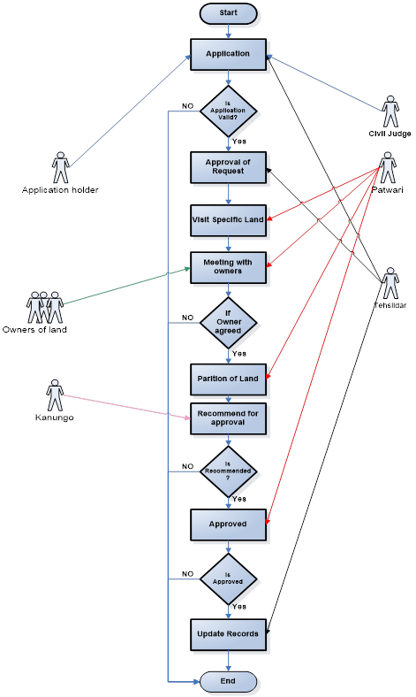

Figure : Consolidation Procedure

Application

|  |  |
| --- | --- |
| ID | 1 |
| Name | Application |
| Element | Procedure |
| Actor | Tehsildar |
| Actor | Application Holder |
| Actor | Civil judge |
| Actor | Civil Court/Registrar |
| Description | Application holder writes an application for consolidation and goes to Tehsildar to submit application. Application holder can also go to civil judge and order through court for consolidation. |
| Execution Time | 2 day |
| Register | NA |

Is application valid

|  |  |
| --- | --- |
| ID | 2 |
| Name | Application Valid |
| Element | Condition |
| Description | If the application is valid and there is no issue, then proceed for further process. |
| Execution Time | 1 day |
| Register | NA |

Approved of request

|  |  |
| --- | --- |
| ID | 3 |
| Name | Approved of request |
| Element | Procedure |
| Actor | Tehsildar |
| Actor | Civil Court/Registrar |
| Description | The user can pass the order for further study from Tehsildar or Civil court. |
| Execution Time | 7 days |
| Register | NA |

Visit Specific Land

|  |  |
| --- | --- |
| ID | 4 |
| Name | Visit Specific Land |
| Element | Procedure |
| Actor | Patwari |
| Description | Patwari goes to specific mozza and records required information about land. |
| Execution Time | 1 day |
| Register | NA |

Meeting with Owners

|  |  |
| --- | --- |
| ID | 5 |
| Name | Meeting with Owners |
| Element | Procedure |
| Actor | Patwari |
| Description | Patwari meet with all owners of the land of particular mozza and says for their opinion about consolidation of the land. |
| Execution Time | 1 day |
| Register | NA |

If Owner agreed

|  |  |
| --- | --- |
| ID | 6 |
| Name | Owner agreed |
| Element | Condition |
| Actor | Patwari |
| Actor | Owners of lands |
| Description | If 51% owner of that’s mozza are agreed for consolidation, then Patwari continue consolidation procedure otherwise nothing happened. |
| Execution Time | 1 day |
| Register | NA |

Partition of land

|  |  |
| --- | --- |
| ID | 7 |
| Name | Partition of land |
| Element | Procedure |
| Actor | Patwari |
| Description | Patwari prepared all records and data about land. And then he assigns new plot number and his owners name known as portion of land (Plot bandi).and Patwari also records in his Rozanamcha. |
| Execution Time | 1 day |
| Register | Rozanamcha is a dairy in which Patwari records his daily activities date by date. |

Recommend for approval

|  |  |
| --- | --- |
| ID | 8 |
| Name | Recommend for approval |
| Element | Procedure |
| Actor | Patwari |
| Actor | Kanungo |
| Description | Kanungo visit his tour toward Patwari after every fifteen days. Patwari discuss the consolidation procedure with Kanungo and briefly explain about the situation. After that Kanungo recommend this procedure. |
| Execution Time | 15 days |
| Register | NA |

Approved

|  |  |
| --- | --- |
| ID | 9 |
| Name | Recommend for approval |
| Element | Procedure |
| Actor | Patwari |
| Actor | Tehsildar |
| Description | Tehsildar or Patwari visit toward Tehsildar or Patwari. Patwari discuss the consolidation procedure with Tehsildar and briefly explain about the situation also inform the recommendation of Kanungo. After that Patwari approved this procedure. |
| Execution Time | 15 day |
| Register | NA |

Update

|  |  |
| --- | --- |
| ID | 10 |
| Name | update |
| Element | Procedure |
| Actor | Patwari |
| Description | Patwari update this all consolidation procedure in the register known as Register Haqdaran Zameen. |
| Execution Time | 7 day |
| Register | Register Haqdaran Zameen have following type of records.   |  |  | | --- | --- | | 1 | Kehot Number | | 2 | Khatoni number | | 3 | Owner name with father/husband. Caste and address | | 4 | Type of ownership | | 5 | Shared land | | 6 | Total land | | 7 | Agriculture land | | 8 | Name of former with reference to khatoni number | | 9 | Name of former | | 10 | Khasra number | | 11 | Interest rate and demand and paid from former | | 12 | Area and type of land | | 13 | Demand of mamla | | 14 | Land prize and name of numberdar | |

#### MUTATION PROCEDURE

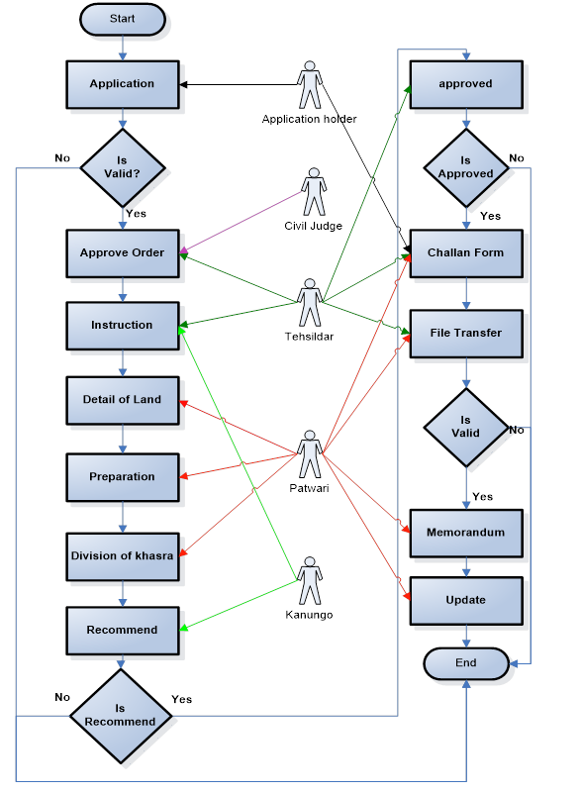

Figure : Mutation Procedure

Application

|  |  |
| --- | --- |
| ID | 1 |
| Name | Application |
| Element | Procedure |
| Description | User goes to his lawyer/himself and writes an application for Mutation process. |
| Execution Time | 1 day |
| Register | NA |

Valid

|  |  |
| --- | --- |
| ID | 2 |
| Name | Valid |
| Element | Condition |
| Description | If the application is valid and there is no issue, then proceed for further process. |
| Execution Time | 1 day |
| Register | NA |

Approved Order

|  |  |
| --- | --- |
| ID | 3 |
| Name | Approved order |
| Element | Procedure |
| Actor | Tehsildar |
| Actor | Civil Judge/Registrar |
| Description | The user can pass the order for further study from Tehsildar or Civil court. |
| Execution Time | 7 days |
| Register | NA |

Instruction

|  |  |
| --- | --- |
| ID | 4 |
| Name | Instruction about Mutation. |
| Element | Procedure |
| Actor | Kanungo |
| Actor | Patwari |
| Description | Kanungo deliver following kind of instructions to Patwari.   1. Kanungo give the application of mutation of the land. 2. Kanungo also delivered registration document relating to the transition. 3. Order to Patwari for mutation and also told him how to enter these mutation records in register. 4. Kanungo also instruction to Patwari to prepare all the data which is updated by Kanungo with red ink for the updatation of register Haqdaran Zameen after four year on 30th June. |
| Execution Time | 15 day for mutation |
| Register update time | 4 year( 30 June) |
| Modification time | 25 year |
| Register | Register Haqdaran Zameen have following type of records.   |  |  | | --- | --- | | 1 | Kehot Number | | 2 | Khatoni number | | 3 | Owner name with father/husband. Caste and address | | 4 | Type of ownership | | 5 | Shared land | | 6 | Total land | | 7 | Agriculture land | | 8 | Name of former with reference to khatoni number | | 9 | Name of former | | 10 | Khasra number | | 11 | Interest rate and demand and paid from former | | 12 | Area and type of land | | 13 | Demand of mamla | | 14 | Land prize and name of numberdar | | 15 | Remarks | |

Detail of Land

|  |  |
| --- | --- |
| ID | 5 |
| Name | Detail of land |
| Element | Procedure |
| Actor | Patwari |
| Description | In this procedure Patwari records all detail about mutation of land record in his register known as Rozanamcha Waqiti. |
| Execution Time | 3 day |
| Register | Rozanamcha Waqiti  Patwari records his daily base activities in this register. |

Preparation

|  |  |
| --- | --- |
| ID | 6 |
| Name | Preparation |
| Element | Procedure |
| Actor | Patwari |
| Description | 1. Inheritance case Patwari Prepared Shajra Nasab on behave of foil and counter foil which are showing name of all person who are involved in dead. 2. Patwari also Prepares Tatima Shajra in case of transaction on back of mutation sheet (counter foil and foil) of sub Khasra. |
| Execution Time | 3 day |
| Register | NA |

Division of Khasra

|  |  |
| --- | --- |
| ID | 7 |
| Name | Division of Khasra |
| Element | Procedure |
| Actor | Patwari |
| Description | Patwari writes with lead pencil against the relevant khata / khatoni number in register Haqdaran Zameen. If both parties agreed the mutation process and division of land otherwise Patwari put some condition on it. |
| Execution Time | 3 day |
| Register | Register Haqdaran Zameen have following type of records.   |  |  | | --- | --- | | 1 | Kehot Number | | 2 | Khatoni number | | 3 | Owner name with father/husband. Caste and address | | 4 | Type of ownership | | 5 | Shared land | | 6 | Total land | | 7 | Agriculture land | | 8 | Name of former with reference to khatoni number | | 9 | Name of former | | 10 | Khasra number | | 11 | Interest rate and demand and paid from former | | 12 | Area and type of land | | 13 | Demand of mamla | | 14 | Land prize and name of numberdar | | 15 | Remarks | |

Recommend for approval

|  |  |
| --- | --- |
| ID | 8 |
| Name | Recommend for approval |
| Element | Procedure |
| Actor | Patwari |
| Actor | Kanungo |
| Description | * Kanungo visit after two week and he should inform the Patwari of his tour. * Kanungo look the register of Haqdaran Zameen and also verifies the mutation entries in Memorandum. Detailed view on Tatima process and other transfer of rights. * Kanungo reports in Rozanamcha Waqiti for his tour and also records mutation verified in his daily diary. * Kanungo recommend the procedure of division of Khasra is completed. |
| Execution Time | 15 days |
| Register | Rozanamcha Waqiti  Patwari records his daily base activities in this register. |
| Register | Register Haqdaran Zameen have following type of records.   |  |  | | --- | --- | | 1 | Kehot Number | | 2 | Khatoni number | | 3 | Owner name with father/husband. Caste and address | | 4 | Type of ownership | | 5 | Shared land | | 6 | Total land | | 7 | Agriculture land | | 8 | Name of former with reference to khatoni number | | 9 | Name of former | | 10 | Khasra number | | 11 | Interest rate and demand and paid from former | | 12 | Area and type of land | | 13 | Demand of mamla | | 14 | Land prize and name of numberdar | | 15 | Remarks | |

Approved

|  |  |
| --- | --- |
| ID | 9 |
| Name | Recommend for approval |
| Element | Procedure |
| Actor | Patwari |
| Actor | Tehsildar |
| Description | * Tehsildar inform Patwari about his tour visit. * Patwari records report of Tehsildar visit in his Rozanamcha Waqiti and also inform the involved parties about the visit of Tehsildar so the both parties can solve their issue (if any). * Tehsildar approved the mutation process about the particular sub Khasra. |
| Execution Time | 15 days |
| Register | Rozanamcha Waqiti  Patwari records his daily base activities in this register. |
| Register | Register Haqdaran Zameen have following type of records.   |  |  | | --- | --- | | 1 | Kehot Number | | 2 | Khatoni number | | 3 | Owner name with father/husband. Caste and address | | 4 | Type of ownership | | 5 | Shared land | | 6 | Total land | | 7 | Agriculture land | | 8 | Name of former with reference to khatoni number | | 9 | Name of former | | 10 | Khasra number | | 11 | Interest rate and demand and paid from former | | 12 | Area and type of land | | 13 | Demand of mamla | | 14 | Land prize and name of numberdar | | 15 | Remarks | |

Chillan Form

|  |  |
| --- | --- |
| ID | 10 |
| Name | Chillan Form |
| Element | Procedure |
| Actor | Patwari |
| Actor | Tehsildar |
| Actor | Application Holder |
| Description | * Revenue officer (Tehsildar) Guides to the user for payment of fee for mutation. In some cases where mutation fees are not chargeable in this case user only pay necessary charges. * User can get filled Chillan from Patwari for the submission of fees to the specific bank to continue procedure. * User (Application Holder) goes in specific bank and submit fees and after that he submit this reception copy to Patwari.   Tehsildar passed orders of mutation and also writes this order on mutation form. |
| Execution Time | 10 days |
| Register | NA |

File Transfer

|  |  |
| --- | --- |
| ID | 12 |
| Name | File Transfer |
| Element | Procedure |
| Actor | Patwari |
| Actor | Tehsildar |
| Description | Patwari transfer the file of mutation to Tehsildar office. Tehsildar received finally the updated mutation file and if the file fulfils the entire requirement which he demand then he approved the file else he should ask to Patwari for further change. |
| Execution Time | 20 days |
| Register | NA |

Memorandum

|  |  |
| --- | --- |
| ID | 14 |
| Name | Memorandum |
| Element | Procedure |
| Actor | Patwari |
| Description | When Patwari received the finally documents of mutation he delivered one copies to Tehsildar office and also given to involved parties. |
| Execution Time | 2 day |
| Register | NA |

Update

|  |  |
| --- | --- |
| ID | 15 |
| Name | update |
| Element | Procedure |
| Actor | Patwari |
| Description | Patwari update this all Mutation procedure in the register known as Register Haqdaran Zameen. |
| Execution Time | 7 day |
| Register | Register Haqdaran Zameen have following type of records.   |  |  | | --- | --- | | 1 | Kehot Number | | 2 | Khatoni number | | 3 | Owner name with father/husband. Caste and address | | 4 | Type of ownership | | 5 | Shared land | | 6 | Total land | | 7 | Agriculture land | | 8 | Name of former with reference to khatoni number | | 9 | Name of former | | 10 | Khasra number | | 11 | Interest rate and demand and paid from former | | 12 | Area and type of land | | 13 | Demand of mamla | | 14 | Land prize and name of numberdar | |

#### Error Correction Procedure

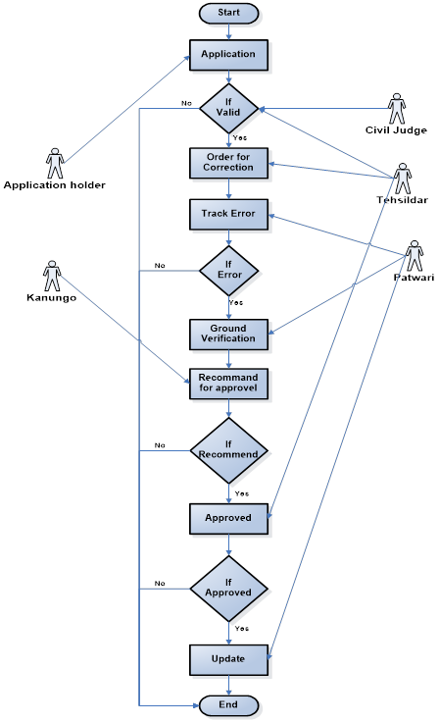

Figure : Error Correction Procedure

Application

|  |  |
| --- | --- |
| ID | 1 |
| Name | Application |
| Element | Procedure |
| Description | User goes to his lawyer/himself and writes an application for error correction process. |
| Execution Time | 1 day |
| Register | NA |

Valid

|  |  |
| --- | --- |
| ID | 2 |
| Name | Valid |
| Element | Condition |
| Description | If the application is valid and there is no issue, then proceed for further process. |
| Execution Time | 1 day |
| Register | NA |

Order for correction

|  |  |
| --- | --- |
| ID | 3 |
| Name | Approved order |
| Element | Procedure |
| Actor | Tehsildar |
| Actor | Civil Judge/Registrar |
| Description | The user can pass the order for further study from Tehsildar or Civil court. |
| Execution Time | 7 days |
| Register | NA |

Trace Error

|  |  |
| --- | --- |
| ID | 4 |
| Name | Trace Error |
| Element | Procedure |
| Actor | Kanungo |
| Actor | Patwari |
| Description | Patwari check the error from registers (Register Haqdaran Zameen). |
| Execution Time | 7 day |
| Register | Register Haqdaran Zameen have following type of records.   |  |  | | --- | --- | | 1 | Kehot Number | | 2 | Khatoni number | | 3 | Owner name with father/husband. Caste and address | | 4 | Type of ownership | | 5 | Shared land | | 6 | Total land | | 7 | Agriculture land | | 8 | Name of former with reference to khatoni number | | 9 | Name of former | | 10 | Khasra number | | 11 | Interest rate and demand and paid from former | | 12 | Area and type of land | | 13 | Demand of mamla | | 14 | Land prize and name of numberdar | | 15 | Remarks | |

IS Error

|  |  |
| --- | --- |
| ID | 5 |
| Name | IS Error |
| Element | Procedure |
| Actor | Patwari |
| Description | In this procedure if Patwari identify the error and identify this error in Rozanamcha also with lead pencil in register Haqdaran Zameen else procedure end. |
| Execution Time | 1 day |
| Register | Rozanamcha Waqiti  Patwari records his daily base activities in this register. |

Ground Verification

|  |  |
| --- | --- |
| ID | 5 |
| Name | Ground Verification |
| Element | Procedure |
| Actor | Patwari |
| Description | In this procedure if Patwari identify the error and go into the field and note down the ground values about the error in his Rozanamcha Waqiti. |
| Execution Time | 1 day |
| Register | Rozanamcha Waqiti  Patwari records his daily base activities in this register. |

Recommend for approval

|  |  |
| --- | --- |
| ID | 8 |
| Name | Recommend for approval |
| Element | Procedure |
| Actor | Patwari |
| Actor | Kanungo |
| Description | * Kanungo visit after two week and he should inform the Patwari of his tour. * Kanungo look the register of Haqdaran Zameen and also verifies the error correction. * Kanungo recommend the procedure of error correction. |
| Execution Time | 15 days |
| Register | Rozanamcha Waqiti  Patwari records his daily base activities in this register. |
| Register | Register Haqdaran Zameen have following type of records.   |  |  | | --- | --- | | 1 | Kehot Number | | 2 | Khatoni number | | 3 | Owner name with father/husband. Caste and address | | 4 | Type of ownership | | 5 | Shared land | | 6 | Total land | | 7 | Agriculture land | | 8 | Name of former with reference to khatoni number | | 9 | Name of former | | 10 | Khasra number | | 11 | Interest rate and demand and paid from former | | 12 | Area and type of land | | 13 | Demand of mamla | | 14 | Land prize and name of numberdar | | 15 | Remarks | |

Approved

|  |  |
| --- | --- |
| ID | 9 |
| Name | Recommend for approval |
| Element | Procedure |
| Actor | Patwari |
| Actor | Tehsildar |
| Description | * Tehsildar inform Patwari about his tour visit. * Patwari records report of Tehsildar visit in his Rozanamcha Waqiti * Tehsildar approved the error correction process about the particular Khasra. |
| Execution Time | 15 days |
| Register | Rozanamcha Waqiti  Patwari records his daily base activities in this register. |
| Register | Register Haqdaran Zameen have following type of records.   |  |  | | --- | --- | | 1 | Kehot Number | | 2 | Khatoni number | | 3 | Owner name with father/husband. Caste and address | | 4 | Type of ownership | | 5 | Shared land | | 6 | Total land | | 7 | Agriculture land | | 8 | Name of former with reference to khatoni number | | 9 | Name of former | | 10 | Khasra number | | 11 | Interest rate and demand and paid from former | | 12 | Area and type of land | | 13 | Demand of mamla | | 14 | Land prize and name of numberdar | | 15 | Remarks | |

Update

|  |  |
| --- | --- |
| ID | 15 |
| Name | update |
| Element | Procedure |
| Actor | Patwari |
| Description | Patwari update this all error correction procedure in the register known as Register Haqdaran Zameen. |
| Execution Time | 2 day |
| Register | Register Haqdaran Zameen have following type of records.   |  |  | | --- | --- | | 1 | Kehot Number | | 2 | Khatoni number | | 3 | Owner name with father/husband. Caste and address | | 4 | Type of ownership | | 5 | Shared land | | 6 | Total land | | 7 | Agriculture land | | 8 | Name of former with reference to khatoni number | | 9 | Name of former | | 10 | Khasra number | | 11 | Interest rate and demand and paid from former | | 12 | Area and type of land | | 13 | Demand of mamla | | 14 | Land prize and name of numberdar | |

#### OWNERSHIP PROCEDURE

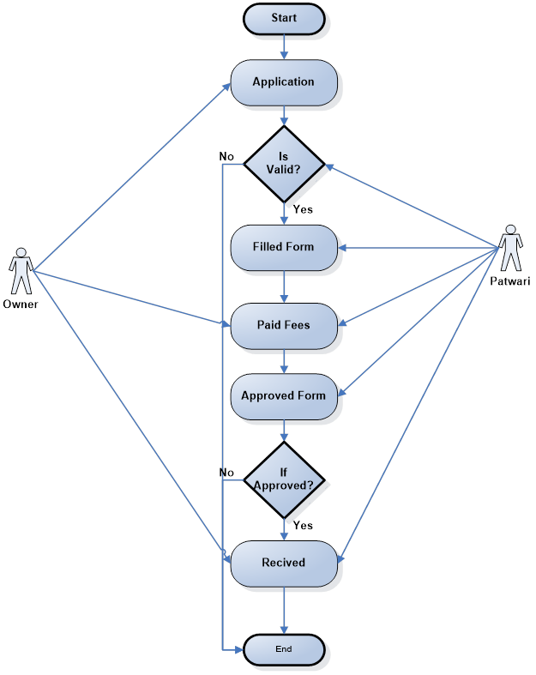

Figure : Ownership Procedure

Application

|  |  |
| --- | --- |
| ID | 1 |
| Name | Application |
| Element | Procedure |
| Description | User goes to his lawyer/himself and writes an application for Ownership process. |
| Execution Time | 1 day |
| Register | NA |

Valid

|  |  |
| --- | --- |
| ID | 2 |
| Name | Valid |
| Element | Condition |
| Actor | Patwari |
| Description | Patwar check If the application is valid and there is no issue then proceed for further process. Else procedure end. |
| Execution Time | 1 day |
| Register | NA |

Filled Form

|  |  |
| --- | --- |
| ID | 3 |
| Name | Filled Form |
| Element | Procedure |
| Actor | Patwari |
| Actor | Owner |
| Description | Patwari records all details about the owners from his register Haqdaran Zameen and filled the form of ownership and delivered this form to owners. |
| Execution Time | 2 days |
| Register | Register Haqdaran Zameen have following type of records.   |  |  | | --- | --- | | 1 | Kehot Number | | 2 | Khatoni number | | 3 | Owner name with father/husband. Caste and address | | 4 | Type of ownership | | 5 | Shared land | | 6 | Total land | | 7 | Agriculture land | | 8 | Name of former with reference to khatoni number | | 9 | Name of former | | 10 | Khasra number | | 11 | Interest rate and demand and paid from former | | 12 | Area and type of land | | 13 | Demand of mamla | | 14 | Land prize and name of numberdar | | 15 | Remarks | |

Paid Fees

|  |  |
| --- | --- |
| ID | 4 |
| Name | Paid Fees |
| Element | Procedure |
| Actor | Owner |
| Actor | Patwari |
| Description | After receiving the ownership form he paid fees in specific bank. |
| Execution Time | 2 day |
| Register | NA |

Approved Form

|  |  |
| --- | --- |
| ID | 5 |
| Name | Approved form |
| Element | Procedure |
| Actor | Patwari |
| Description | In this procedure Patwari approved the ownership form and signature on it also with stamps. |
| Execution Time | 1 day |
| Register | NA |

Received Form

|  |  |
| --- | --- |
| ID | 8 |
| Name | Received form |
| Element | Procedure |
| Actor | Owner |
| Description | Owner (Application holder) received ownership (Fard) form from Patwari. |
| Execution Time | 1 days |
| Register | NA |

#### Existing Land Settlement Process

Settlement work based on accurate field survey. It is the framing of a record of rights or the making of a fair assessment. Settlement Officer must have an accurate map of each village showing the position and boundaries of every field. Such a map is known as the shajra Kishtwar or mussavi. The current process of land settlement has been defined below in detail.

#### Existing Method

There are two surveys which has concern to settlement Officer:

* The topographical survey map made by Pakistan Survey Department
* The Cadastral or field survey made by patwari.

Note: The field surveys in Punjab are not supervised by the officers of Survey Department

In the early field surveys i.e. first regular settlements, the survey of the village consisted of two stages:

* The preparation of boundary map naksha thakbast
* Field map or Shajra Kishtwar and a khasra number i.e. a register showing in respect of each field its number in the map, the names of its owners and of its cultivators, its dimensions and area, its soil and crops growing in it at the time of measurement.

#### Systems for Surveying

##### The Plane Table System of field Survey

The plan was devised by Mr. Blyth in 1852 and first put in practice in the settlement of the central districts of the Punjab.  The area is cut up into triangles

##### Killabandi

This system was introduced in the west Punjab, In this method each square is divided into 25 small squares known as kilas, each occupying a fraction over an acre.  Each Kila forms a field or survey number.  First Kila bandi was introduced in Crown lands irrigated by perennial canals due to difficulties in assessment of water rates and large and irregular shape of fields. In the areas of the newest canals the small squares are now replaced by rectangle containing 25 acres

Before the arrival of the British colonists, the land in the sub-continent was state property. It was East India Company which introduced the permanent settlement system. Under the new system the land was sold to moneyed classes mainly Hindus and the Muslims who were without any property rights were deprived of the economic benefits

The Britishers are pioneers towards documenting land record and revenue surveys based on the system adopted in England and Western Europe.

### To-Be Land Processes

Through the analysis of As-is and To-be process results in identifying the difference between the current and target process for the gap analysis and achieve optimization. We will need an integrated model of Cadastre module and registry module for the optimization of workflows between these two main modules. These integrated modules should also be accessible to the public.

The land information system will consist of following module

* Registry Module
* Cadastre Module
* Public access module

The Following diagram representing the complete work flow and integration of involved processes.

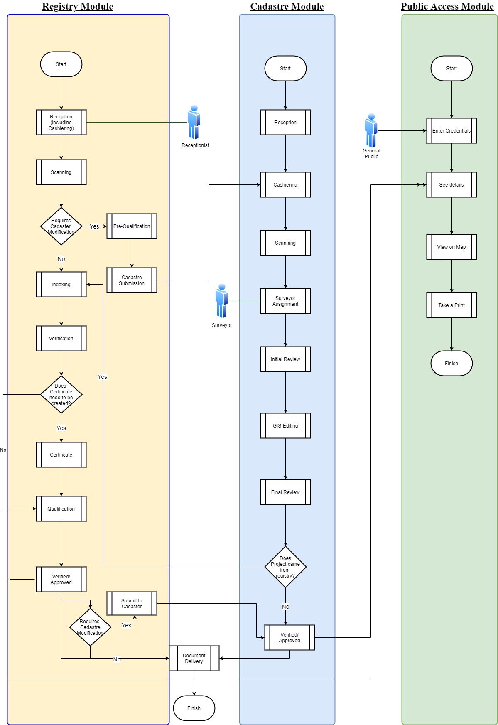

Figure : TO-BE LAND PROCESSES

#### Registry Module:

The land registry records are the legal basis to prevent and/or settle property disputes by serving as the official record of ownership related to real property interests.   A land registry module should be responsible for recording, indexing and archiving large volumes of land administration and transaction records.  This module should provide a complete automated land registry solution. It should be designed and developed as integrated component of land information system with Cadaster and Public access module, but it should also capable of operating as a standalone solution.

The registry component should provide the following functions:

* Automation of land registration system.
* Re-engineering and re-designing of existing system.
* Designing and development of ETL for migration of existing data.
* Content management system including data entry module.
* Rule based identification and removal of anomalies.
* Designing development of workflow of BOR processes
  + Ownership recording and transfer process
  + Error correction process
  + Job tracking through unique ID and parcel ID
* Enables archiving and indexing of document.
* Mining of information based on rules.

This module should benefit users by expediting the processing of the request and will create an accurate, auditable, and transparent records.

#### Cadastre Module:

The basis for property boundary identification, ownership determination on ground and transfer is the parcel which mapped on a Cadaster map. In the era of modern technology GIS is used for recording such maps in the form of digital parcels. GIS plays a backbone of such module and help in digitizing, visualizing and analyzing parcel data in spatial domain.

The Cadaster module will use to record, index and archive ground information in the form of geometries and map.  It should enable more timely, accurate and informed decision making and mutation of land. The module should provide a unified and standardized project management workflow of mutation of parcel. It should provide a user-friendly wizard which guide the inexperienced user through parcel management activities that include splitting, merging, creating and adjusting parcel boundaries.

Cadaster module should be developed utilizing the following criteria

* Bidirectional integration with registry module.
* Content management system with parcel editing and creation module.
* Open architecture in compliance with open GIS requirements
* Business model driven application and work flow integrations, i.e.,
* Controlled user access levels
* Wizard driven parcel map mutation and maintenance.
* Job tracking through unique project ID.

#### Public access Module

An online public access module will be developed to access land information data including map-based queries. Such information and queries can be as open or controlled as required by BOR personals. The system should provide two types of online access of both spatial and a spatial data. The first type of access is a full featured search facility which should be made available to designated government users and on secured intranet or internet. The second type of access is subscription-based service for interested public users over the web portal or on their mobile phone (only textual information). The web portal should permit properly authenticated subscribers to perform queries linking the spatial and a spatial database.

Cadaster Module is the major and important aspect of land Management System and the following four To-Be models work flows must be incorporated and integrated with this module.

#### Consolidation procedure

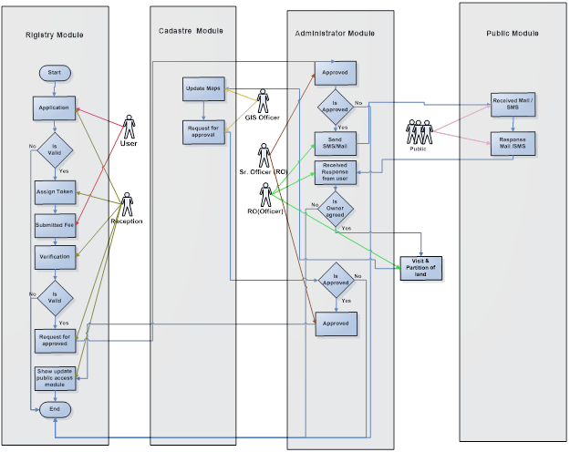

Figure : Consolidation Procedure To Be

Application

|  |  |
| --- | --- |
| ID | 1 |
| Name | Application |
| Element | Procedure |
| Actor | User |
| Description | User goes Receptionist and writes an application for Consolidation process. |
| Execution Time | 1 day |
| Table | NA |

Valid

|  |  |
| --- | --- |
| ID | 2 |
| Name | Valid |
| Element | Condition |
| Actor | Receptionist |
| Description | If the application is valid and there is no issue, then proceed for further process. |
| Execution Time | 2 hours |
| Table | NA |

Assign Token

|  |  |
| --- | --- |
| ID | 3 |
| Name | Assign Token |
| Element | Procedure |
| Actor | Receptionist |
| Description | Receptionist assigns a token number to the user and provides the Chillan form then asked to user to submit fees for consolidation procedure. |
| Execution Time | 2 hours |
| Table | Tbl_rigistration_user |

Submit Fees

|  |  |
| --- | --- |
| ID | 4 |
| Name | Submit fees |
| Element | Procedure |
| Actor | User |
| Description | User submit fee for the consolidation procedure. |
| Execution Time | 1 day |
| Table | NA |

Verification

|  |  |
| --- | --- |
| ID | 5 |
| Name | Verification |
| Element | Procedure |
| Actor | Receptionist |
| Description | Receptionist received deposit copy of bank and then verified this procedure. Now actually procedure starts for consolidation. |
| Execution Time | 1 hours |
| Table | Tbl_verified_status |

Request for Approved

|  |  |
| --- | --- |
| ID | 6 |
| Name | Approved |
| Element | Procedure |
| Actor | RO |
| Description | RO checked this mozza from maps and generate and email/SMS and attached maps which highlighted this mozza for basic approval of consolidation. |
| Execution Time | 1 day |
| Table | Tbl_verified_status |

Approved

|  |  |
| --- | --- |
| ID | 6 |
| Name | Approved |
| Element | Procedure |
| Actor | Sr. Officer |
| Description | Sr. Officer checked this mozza from maps and generate and email/SMS and attached maps which highlighted this mozza for basic approval of consolidation. |
| Execution Time | 1 day |
| Table | Tbl_verified_status |

Mail/SMS

|  |  |
| --- | --- |
| ID | 7 |
| Name | Partition of land |
| Element | Procedure |
| Actor | RO |
| Description | RO officer generates an email or SMS to all the owners which are involved this particular mozza and asked them for their opinion about consolidation(Yes/No) within 3 days otherwise consider their answer as Yes |
| Execution Time | 1 hours |
| Table | Tbl_ownership_right |

Received

|  |  |
| --- | --- |
| ID | 8 |
| Name | Received |
| Element | Procedure |
| Actor | Public |
| Description | All the owners of the particular Khasra received an SMS/Email from Board of Revenue department about the consolidation of particular Khasra. |
| Execution Time | 1 hours |
| Table | NA |

Response

|  |  |
| --- | --- |
| ID | 9 |
| Name | Response |
| Element | Procedure |
| Actor | Public |
| Description | All the owners that’s involves in consolidation procedure will give their views in form of (Yes/No) to the RO Officer within 3 days. |
| Execution Time | 3 day |
| Table | Tbl_verified_status |

Owner agreed

|  |  |
| --- | --- |
| ID | 10 |
| Name | Owner agreed |
| Element | Condition |
| Actor | RO |
| Description | RO received email/SMS from all the owners. If 51 % owners say the answer is Yes, then consolidation procedure continue. |
| Execution Time | 2 hours |
| Table | Tbl_verified_status |

Partition of Land

|  |  |
| --- | --- |
| ID | 11 |
| Name | Partition of Land |
| Element | Procedure |
| Actor | GIS Officer |
| Description | RO officer designs the ways of partition of land also visit to that specific land and records all disadvantage and advantage of that land. |
| Execution Time | 2 hours |
| Table | Tbl_spatial_land_record_ |

Create Temporary maps

|  |  |
| --- | --- |
| ID | 12 |
| Name | Create maps |
| Element | Procedure |
| Actor | RO |
| Description | RO create the partitions (Plot bandi) maps of that Khasra. And then generate and email with attached maps for the approval of senior RO. |
| Execution Time | 2 hours |
| Table | Tbl_slave_land |

Approved

|  |  |
| --- | --- |
| ID | 13 |
| Name | Approved |
| Element | Procedure |
| Actor | Senior officer |
| Description | RO officer also generates an email for the approval of that consolidation procedure. |
| Execution Time | 1 day |
| Table | Tbl_verified_status |

Update Maps

|  |  |
| --- | --- |
| ID | 14 |
| Name | Response |
| Element | Procedure |
| Actor | GIS officer |
| Description | GIS officer receiving the approval mail from his senior officer then he updates maps. When maps are updated an email/SMS generated to all the owners and application holder. And also end the procedure of consolidation. |
| Execution Time | 2 hours |
| Table | Tbl _spatial land_ |

#### Mutation procedure

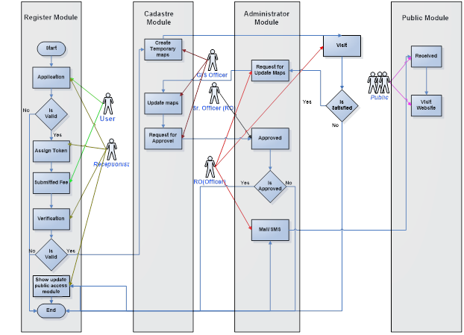

Figure : Mutation Procedure To Be

Application

|  |  |
| --- | --- |
| ID | 1 |
| Name | Application |
| Element | Procedure |
| Actor | User |
| Description | User goes to receptionist and writes an application for Mutation process. |
| Execution Time | 1 day |
| Table | NA |

Valid

|  |  |
| --- | --- |
| ID | 2 |
| Name | Valid |
| Element | Condition |
| Actor | RO |
| Description | If the application is valid and there is no issue, then proceed for further process. |
| Execution Time | 2 hours |
| Table | Tbl _verified_status |

Give Token

|  |  |
| --- | --- |
| ID | 3 |
| Name | Give Token |
| Element | Procedure |
| Actor | RO (Officer) |
| Description | RO (Revenue office) assign a token number to the user and provide the Chillan form then asked to user to submit fees for Mutation procedure. |
| Execution Time | 2 hours |
| Table | Tbl_user_rigistration |

Submit Fees

|  |  |
| --- | --- |
| ID | 4 |
| Name | Submit fees |
| Element | Procedure |
| Actor | User |
| Description | User submit fee for the Mutation procedure. |
| Execution Time | 1 day |
| Table | NA |

Verification

|  |  |
| --- | --- |
| ID | 5 |
| Name | Verification |
| Element | Procedure |
| Actor | RO |
| Description | Receptionist received deposit copy of bank and then verified this procedure. Now actually procedure starts for Mutation. |
| Execution Time | 1 hours |
| Table | Tbl _verified_status |

Create temporary map

|  |  |
| --- | --- |
| ID | 6 |
| Name | Create temporary map |
| Element | Procedure |
| Actor | GIS Officer |
| Description | GIS Officer checked this particular Khasra from maps and build new temporary maps on the basis of new division of that Khasra. Generate and email/SMS and attached maps which highlighted this Khasra to Senior RO for basic approval of Mutation. |
| Execution Time | 1 day |
| Table | Tbl _spatial_land_ , tbl_land_slae |

Visit

|  |  |
| --- | --- |
| ID | 7 |
| Name | Visit |
| Element | Procedure |
| Actor | RO |
| Description | RO officer visit on that specific land for the judgment of that’s land and divides the land into Sub Khasra in the appearance of two parties. |
| Execution Time | 2 days |
| Table | Tbl_field_book |

Approved

|  |  |
| --- | --- |
| ID | 13 |
| Name | Approved |
| Element | Procedure |
| Actor | Senior Officer |
| Description | Senior Officer also generates an email/SMS for the approval of that mutation procedure. |
| Execution Time | 1 day |
| Table | Tbl _verified_status |

Update Maps

|  |  |
| --- | --- |
| ID | 14 |
| Name | Response |
| Element | Procedure |
| Actor | RO |
| Description | RO receiving the approval mail from his senior officer then he updates maps. When maps are updated an email/SMS generated to all the owners which are involved. They can see the updating on map through website. And also end the procedure of consolidation. |
| Execution Time | 2 hours |
| Table | Tbl _spatial_land_ |

#### Error Correction Procedure

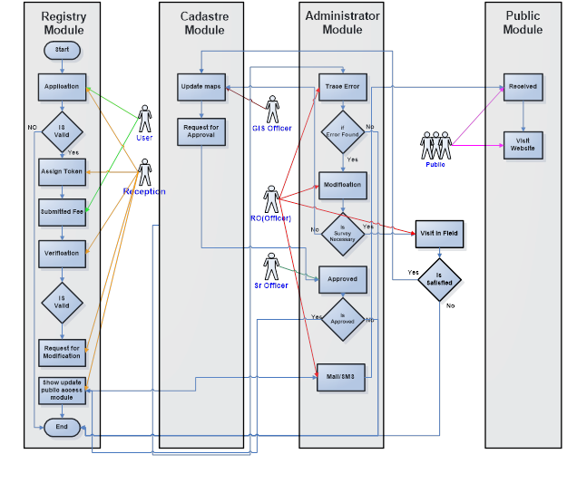

Figure : Error Correction Procedure To Be

Application

|  |  |
| --- | --- |
| ID | 1 |
| Name | Application |
| Element | Procedure |
| Actor | User |
| Description | User goes Receptionist and writes an application for Error correction process. |
| Execution Time | 1 day |
| Table | NA |

Valid

|  |  |
| --- | --- |
| ID | 2 |
| Name | Valid |
| Element | Condition |
| Actor | Receptionist |
| Description | If the application is valid and there is no issue, then proceed for further process. |
| Execution Time | 2 hours |
| Register | NA |
| Table | Tbl_verified_status |

Give Token

|  |  |
| --- | --- |
| ID | 3 |
| Name | Give Token |
| Element | Procedure |
| Actor | Receptionist |
| Description | Receptionist assigns a token number to the user and provides the Chillan form then asked to user to submit fees for error correction procedure. |
| Execution Time | 2 hours |
| Table | Tbl_user_registration |

Submit Fees

|  |  |
| --- | --- |
| ID | 4 |
| Name | Submit fees |
| Element | Procedure |
| Actor | User |
| Description | User submit fee for the Error Correction procedure. |
| Execution Time | 1 day |
| Table | NA |

Verification

|  |  |
| --- | --- |
| ID | 5 |
| Name | Verification |
| Element | Procedure |
| Actor | Receptionist |
| Description | Receptionist received deposit copy of bank and then verified this procedure. Now actually procedure starts for error correction. RO identify the error which is wanted to be correct by the user. |
| Execution Time | 1 hours |
| Table | Tbl_verified_status |

Trace Error

|  |  |
| --- | --- |
| ID | 5 |
| Name | Trace error |
| Element | Procedure |
| Actor | Ro |
| Description | RO trace the error from maps. And send this specific error to another RO officer for modification. |
| Execution Time | 1 hours |
| Table | Tbl_verified_status |

Error Found

|  |  |
| --- | --- |
| ID | 6 |
| Name | Error Found |
| Element | Condition |
| Actor | Receptionist |
| Description | Receptionist checked the error if the error found from records then he highlighted the error and generate an email to another RO for correction this error. Else procedure end. |
| Execution Time | 2 hours |
| Table | Tbl_spatia_land_ , tbl_ownership_records |

Modification

|  |  |
| --- | --- |
| ID | 7 |
| Name | Partition of land |
| Actor | RO |
| Description | RO officer received an email for correction. He modified this error and updates this as per user requirement. And now he generates an email to his senior RO for the approval of this modification. |
| Execution Time | 4 hours |
| Table | Tbl_spatial_land_ , tbl_ownership |

Survey Necessary

|  |  |
| --- | --- |
| ID | 7 |
| Name | Survey Necessary |
| Actor | RO |
| Description | On behave of error found. If error is area length etc. then RO goes in the field and get ground value otherwise request goes for approval. |
| Execution Time | 4 hours |
| Table | Tbl_spatial_land_ , tbl_ownership |

Approved

|  |  |
| --- | --- |
| ID | 13 |
| Name | Approved |
| Element | Procedure |
| Actor | Senior Officer |
| Description | Senior Officer also generates an email/SMS for the approval of that mutation procedure. |
| Execution Time | 1 day |
| Table | Tbl _verified_status |

**Update Maps**

|  |  |
| --- | --- |
| ID | 14 |
| Name | Response |
| Element | Procedure |
| Actor | RO |
| Description | RO receiving the approval mail from his senior officer then he updates maps and also update records from registry module. When maps are updated an email/SMS generated to the owner of land for the correction of Error that he identifies. Then he can go to web link and see the error correction. |
| Execution Time | 2 hours |
| Table | Tbl_spatial_land_ , tbl_ownership_records |

#### Ownership Procedure

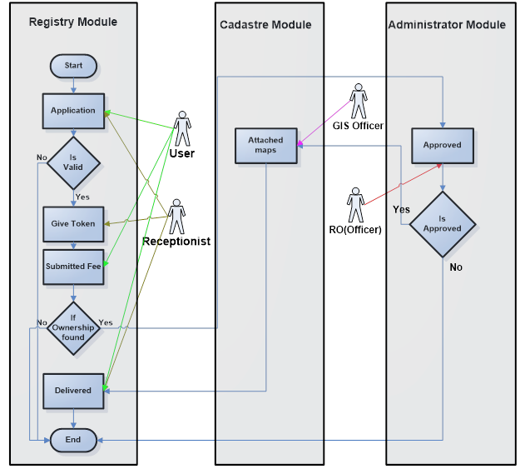

Figure : Ownership Procedure To Be

**Application**

|  |  |
| --- | --- |
| ID | 1 |
| Name | Application |
| Element | Procedure |
| Actor | User |
| Description | User goes Receptionist and writes an application for Ownership (Fard) process. |
| Execution Time | 1 day |
| Table | NA |

**Valid**

|  |  |
| --- | --- |
| ID | 2 |
| Name | Valid |
| Element | Condition |
| Actor | Receptionist |
| Description | If the application is valid and there is no issue, then proceed for further process. |
| Execution Time | 2 hours |
| Table | tbl_verified_status |

**Give Token**

|  |  |
| --- | --- |
| ID | 3 |
| Name | Give Token |
| Element | Procedure |
| Actor | Receptionist |
| Description | Receptionist assigns a token number to the user and provides the Chillan form then asked to user to submit fees for error correction procedure. |
| Execution Time | 2 hours |
| Table | tbl_user_rigistration |

**Submit Fees**

|  |  |
| --- | --- |
| ID | 4 |
| Name | Submit fees |
| Element | Procedure |
| Actor | User |
| Description | User submit fee for the Ownership procedure. |
| Execution Time | 1 day |
| Table | NA |

**Ownership Found**

|  |  |
| --- | --- |
| ID | 5 |
| Name | Verification |
| Element | Condition |
| Actor | RO |
| Description | RO find the records from database. If ownership found in name of that person, then procedure start and generate an ownership document/form and generate an email to senior RO for the verification and approval for that’s documents else process end. |
| Execution Time | 1 hours |
| Table | tbl_ownership_records |

**Attached Map**

|  |  |
| --- | --- |
| ID | 6 |
| Name | Attached map |
| Element | Procedure |
| Actor | GIS Officer |
| Description | Ro attached the maps of that’s Mussavis with the document of the ownership. |
| Execution Time | 2 hours |
| Table | tbl_ownership_records , tbl_spatial_land_ |

**Delivered**

|  |  |
| --- | --- |
| ID | 7 |
| Name | Delivered |
| Element | Modification |
| Actor | RO |
| Description | RO officer delivered the ownership document to the user. |
| Execution Time | 4 hours |
| Table | NA |

#### Proposed Land Settlement Process

The following workflow has been designed to propose an efficient land settlement Process.

* Digitization of Land parcel and feature from Mausavies, Field Book, Satellite imagery and other datasets.
* Computerization of Land records from different Patwari Registers.
* Development of Geo-ERP solution of work flow and processes.

##### Digitization of Land parcels and features

Following steps must be involved during digitization

* Data procurement
* DGPS survey of Deh/Mouza
* Ortho rectification of Cadastre image and Satellite Image
* Feature extraction from field book and base dataset
* Layout of Deh/Mouza

The Figure bbelow is showing the process of digitization of land parcel and feature extraction.

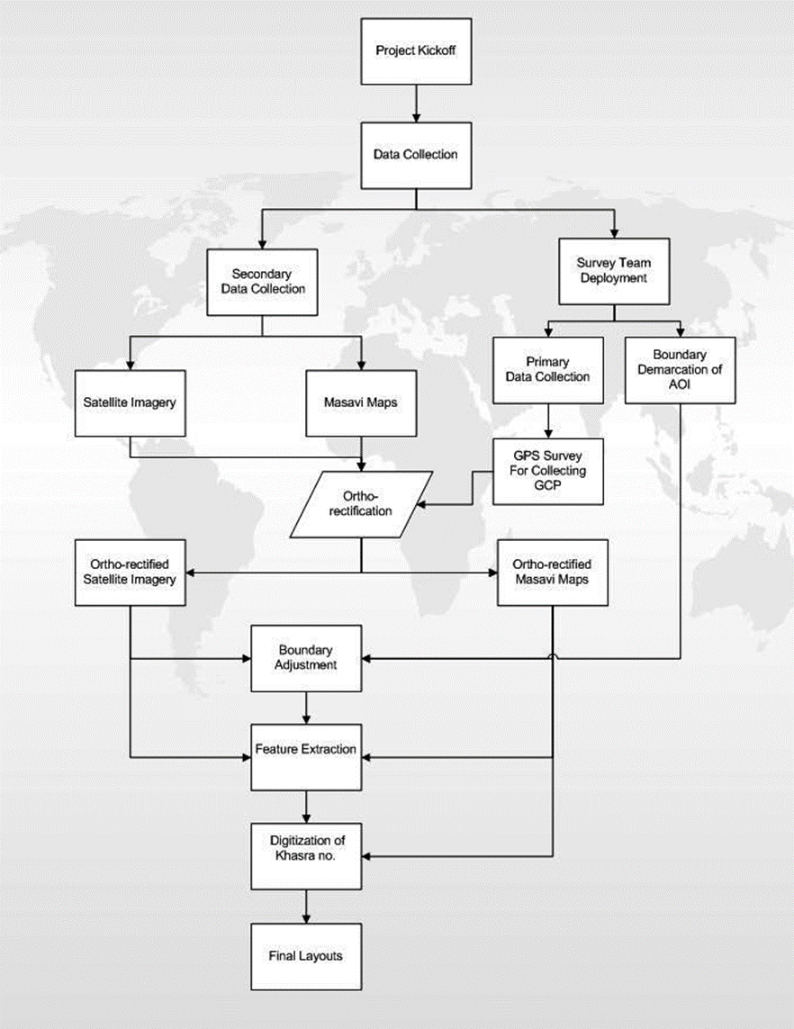

Figure : Digitization of Land Parcels and Features Process

##### Data procurement

Satellite imagery, Digital elevation model (DEM) and Cadastre maps (“Masawees”) are the basic data set required for the execution of the project. Satellite imagery and DEM will be procured at the start of the project and processed to enhance the feature on it. The processing of satellite imagery will include geo-referencing, ortho-rectification, mosaicking, indexing and colour enhancement.  Cadastre sheet will be acquired from BOR in scanned form. They will process, mosaic (according to the index provided on sheet), geo-referenced and ortho-rectified. The processed output along with process satellite imagery will use as a source for digitization.

##### DGPS Survey of mauza

The ground control points (GCPs) in each Mauza should be established. Survey monument and other natural and manmade feature like road features, crossing, water bodies etc must use to establish these ground control points.

##### Ortho Rectification of Datasets

GCP collected through survey will use to ortho-rectify the satellite imagery and Cadaster map (“Massawees”).   This process is required to removes the distortion in the image which in turn help in making direct and accurate measurement of distance, angle, position and area.

##### Boundary Adjustment

After ortho-rectification of dataset the boundary of Mauza should properly adjust on top to these datasets. The adjusted boundary will help in defining the AOI (Area of interest) in extracting feature.

##### Feature Extraction From Field Book And Base Dataset

After ortho-rectification of base data set, features will extract from these datasets and field book. Following feature will extract from these datasets

* Mauza boundary
* Land parcels (Khasra)
* Roads
* Water bodies
* Other prominent land marks.

Initially all these features will extract from the Cadaster maps. The missing feature and landmarks will delineate from satellite imagery. Mauza boundary will properly adjust without distorting its shape and area. Missing or distorted parcels will develop from field book which will in the form of polar coordinates, i.e., direction and length. An excel file will prepare to calculate and convert the direction and length into ground coordinates.

## Proposed Land Architecture

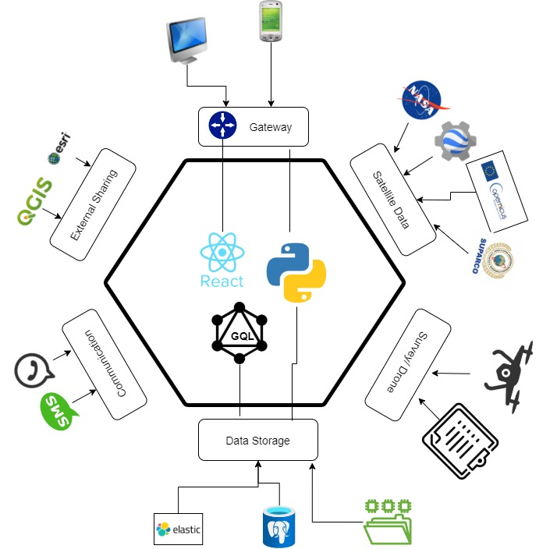

Figure : Proposed Land Architecture

### Spatial Databases:

Since this will be a data centric application, so as a first step we will develop Cadaster database which will store the Land record data explained in the ‎Chapter 1575083721 and shown in Annex-I. This Data model will use Territory ID explain in section ‎Chapter 1575083721 along with Khasra number as its key for uniquely identifying and integrate with already existing registry Module.

Major information of Cadaster Database is in spatial domain, so Spatial Database is required that can cover all of the major themes of the field representation, spatial queries, computational geometry, spatial indexing etc. We will use Postgres with PostGIS as spatial database for storing Vector data and its related attributes. The Raster data images will be stored as Cloud Optimized GeoTiff (COG) which can be accessed through Tile Mapping Services (TMS).

### Development of work flow Engine

A Microservices based workflow engine will be established to integrate all the To-be workflow explained in section ‎Chapter 1575083721. These workflows will play the heart of the application and will developed in Python using Django Framework which provide strong Administration Module and ORM models to extract information from databased in optimized and efficient way. The work engine will develop in a dynamic way (Entity based) so if there is any change in the proposed flow It can adapt those changes easily.

### Development of COGO and Spatial Data Pipeline

As proposed in section ‎Chapter 1575083721, Surveyors (Patwari) will perform their field job based on Coordinate Geometry mostly in the form of angle and distance. The application. Must provide a Coordinate Geometry (COGO) interface based on measurements given in section ‎Chapter 1575083721 which help to draw shape based on the field information and save those shape spatial database based on proposed model. Furthermore, we will develop spatial data pipeline to collect imagery from different sources. The Data pipeline will be developed in such a way it can continuously extract data and update database as per user request. Moreover, DGPS/GPS/ Drone survey data will be integrated for adding ground information assessment which will increase the potential of system.

### Application interface and Information Dissemination

For the application interface and dissemination of information, we have proposed 4 different categories. Each category is listed below.

#### Web Mapping Application

With a key focus on flexibility and ease of operation, the application will be developed using Component based state-of-the-art technologies/libraries like React. While maintaining the fundamental functionality using industry best practices and design patterns, that allow for quick, easy and seamless system implementation. Additionally, user friendly ‘Wizards’ will also be developed to guide the inexperienced user through various functions and activities of workflow explained above. The application will consist of the following modules:

#### Basic Interactive Map Module

This module will be used for map visualization and navigation, where it will provide the base maps and overlay layers including

* Administrative Boundaries
* Province, Division, District, UC, and/or Mauza
* Irrigation Boundaries
  + **Zones Boundaries, Circle Boundaries, Division Boundaries**
* Land Revenue Boundaries
  + **Khasra Boundary**
  + **Mauza Boundary**
  + **Patwar Circle Boundary**
  + **Qanungoi Boundary**
  + **Tehsil Boundary**
  + **District Boundary**
* Scanned Images
  + **Georeferenced Mauza Map**
  + **Scanned Fabric (Latha)**

##### Workflow wizards and query module

The primary role of this module will provide interface in the form of wizards so user can perform task based on its flow. Furthermore, it will allow user to perform spatial query and identify layers features based on its attributes.

##### Analysis Module and Reporting Module

The analysis module will allow user (Data Analyst) to analyze information based on spatial data. It will be capable of showing revenue information and statistical reports in the form of pie charts and other graphical representations.

##### 3D MODULE

This module will help in visualize and analyse data in 3D. All the data with height attribute will be extruded to view in 3D.

##### Mobile Application.

A mobile application will be developing to help general public access the registry and Cadastre Module. Including all the information related to transfer, sale and other legal process of land deeds.

### Communication through Email & SMS

Email communication is important, especially when formal means are necessary to convey important information. Texting, being more informal, is a great option for reminders, due dates, and quick relays of useful info. This functionality will be provided to all register users.

### Information Sharing on Different Platforms For Future Research

The spatial data services will be developed in a standard way like TMS or WMTS. These services can be consumed on number of softwires like QGIS, R Statistics, ArcGIS. This will help researchers to do research and contribute in improving the land Management System.

## Prototype Application for Spatial data mangmaent

### Home Page

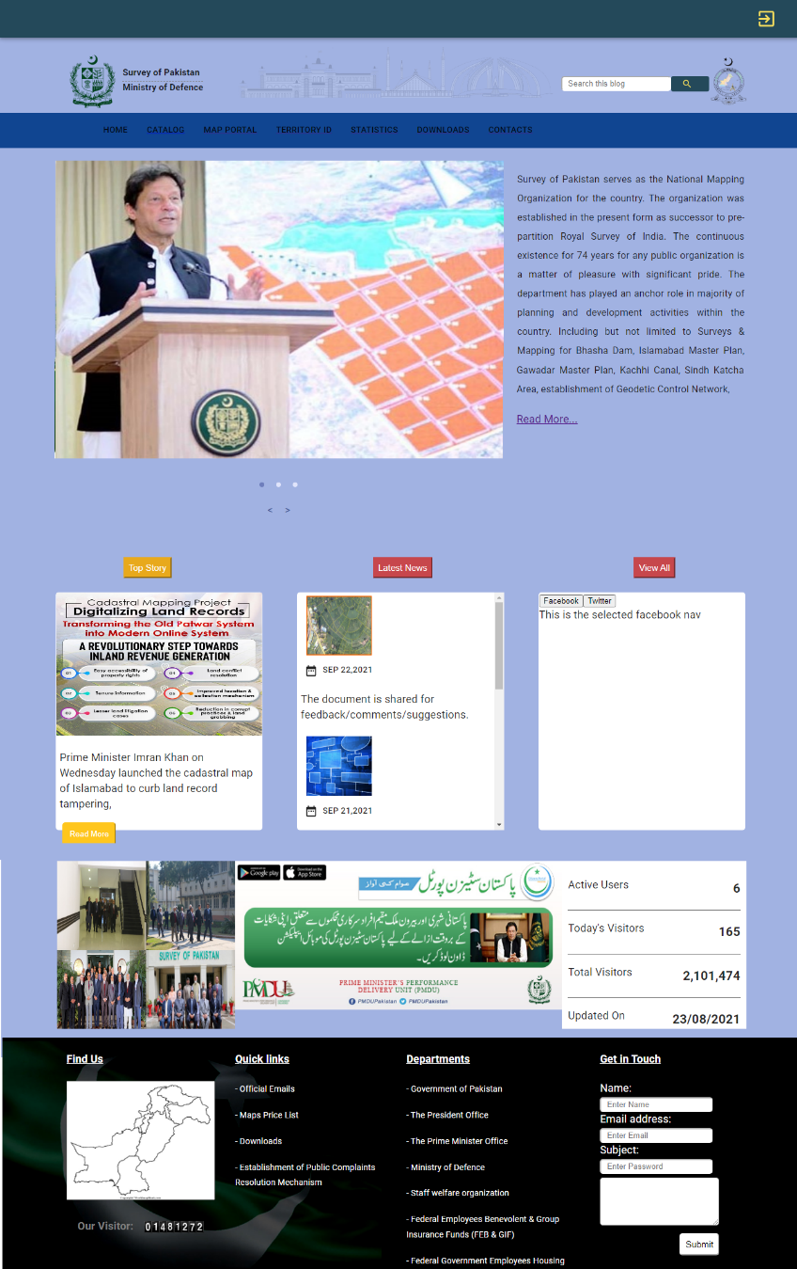

Figure : Application homepage

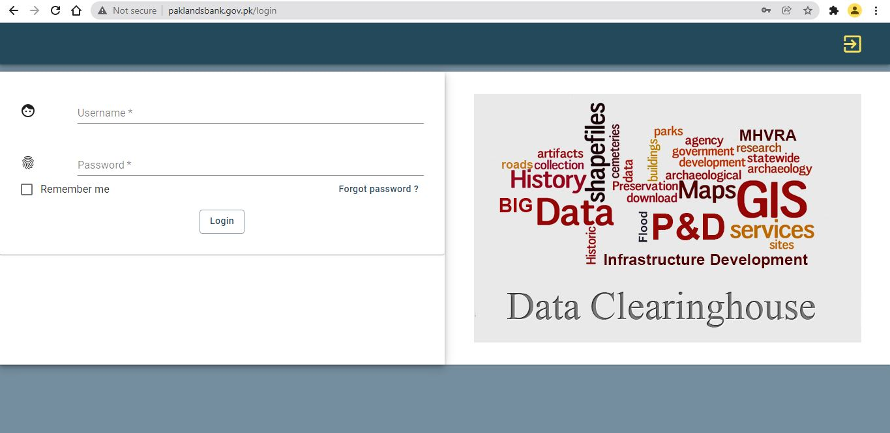

Figure : Application Login Page

### Companies Data Management

In company Data management module, all the company which are working on any part of Cadaster development project (Figure 92: Company Data Management). This module will provide an interface for those companies to upload and share their data. The application has specifies the each company login which allows the companies to share and data uploaded. There are two mode of data sharing , Spatial data sharing (Figure 93: Spatial data upload) which include the shapefiles of relevant data and Non-spatial data sharing (Figure 94: Non- Spatial Data upload) which can be of any relevant document. The user is also able to modify the display for the data uploaded according to need, thus making the application adaptable (Figure 95: Data View).

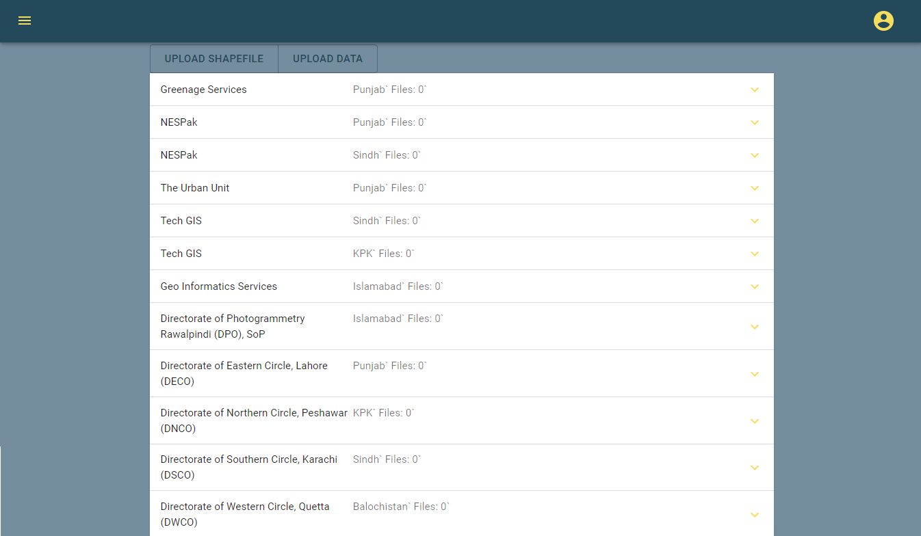

Figure : Company Data Management

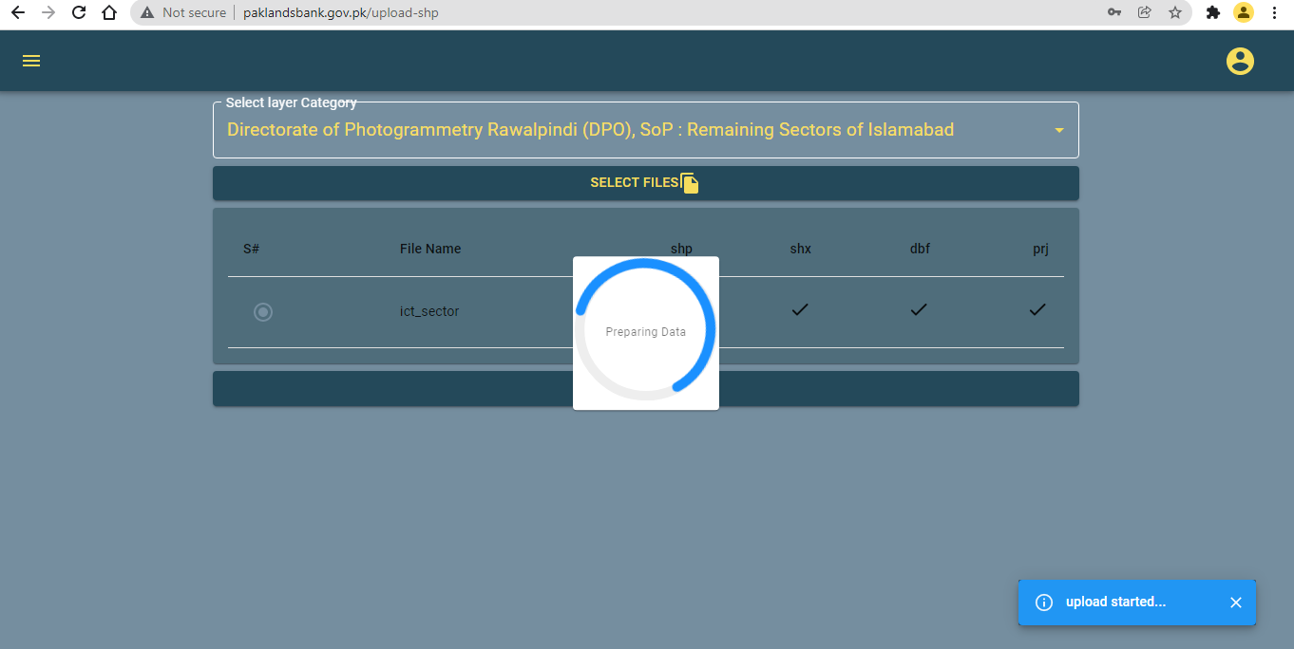

Figure : Spatial data upload

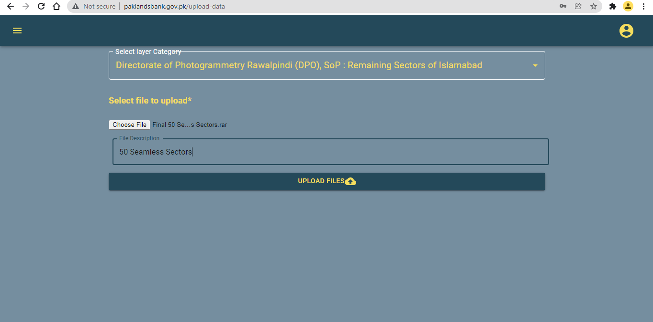

Figure : Non- Spatial Data upload

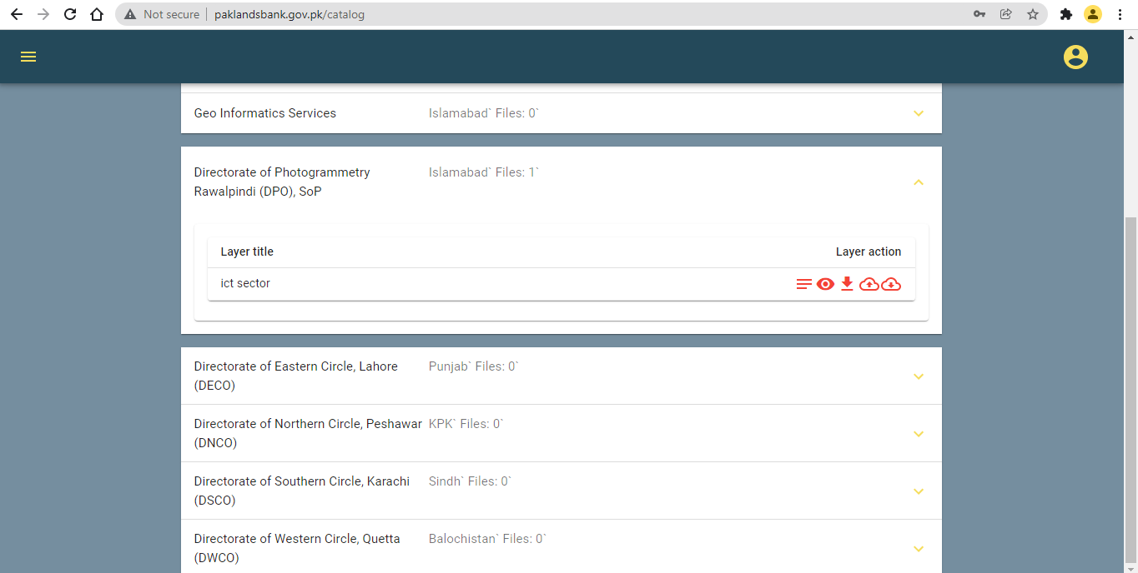

Figure : Data View

### 2. Map Module

Layers are the mechanism used to display geographical data sets. Each layer references a dataset and specifies how that dataset is portrayed using symbols and text labels i.e and data sharing using polygon symbology. When a layer add to a map, we ca specify its dataset and set its map symbols and labeling properties. The Application allows the user to create and design their own layers by uploading the data (Figure 96: Layer Designer). Furthermore layer meta data (Figure 97: Meta data) can be preserve and layer styling functionality is also provided(Figure 98: Layer Styling).

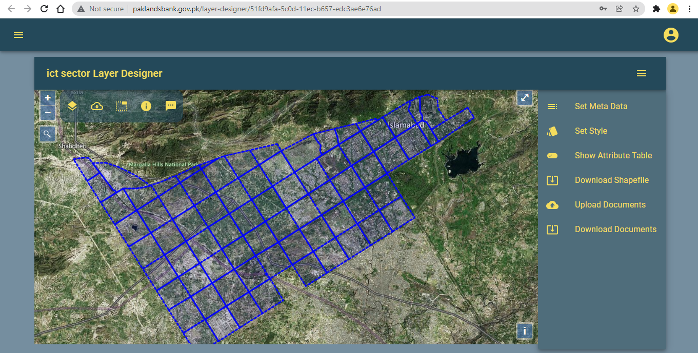

Figure : Layer Designer

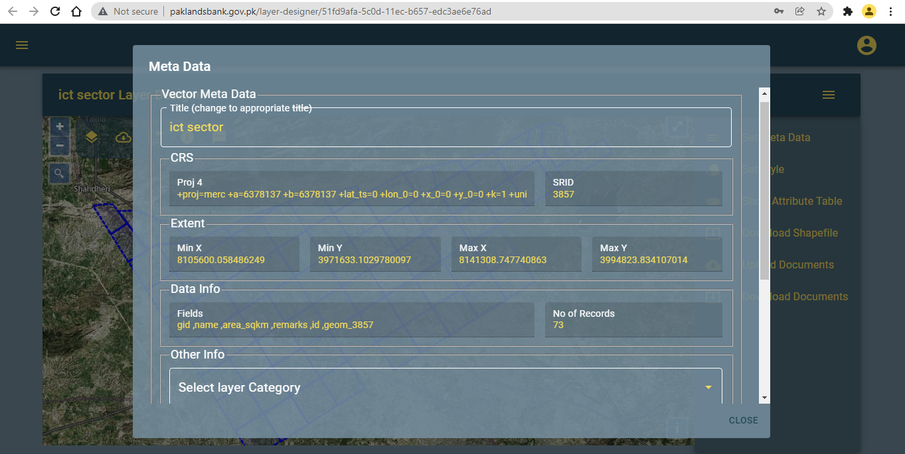

Figure : Meta data

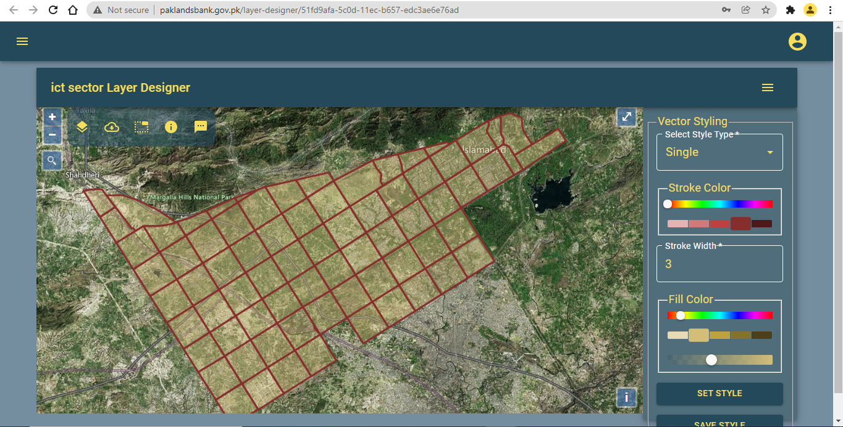

Figure : Layer Styling

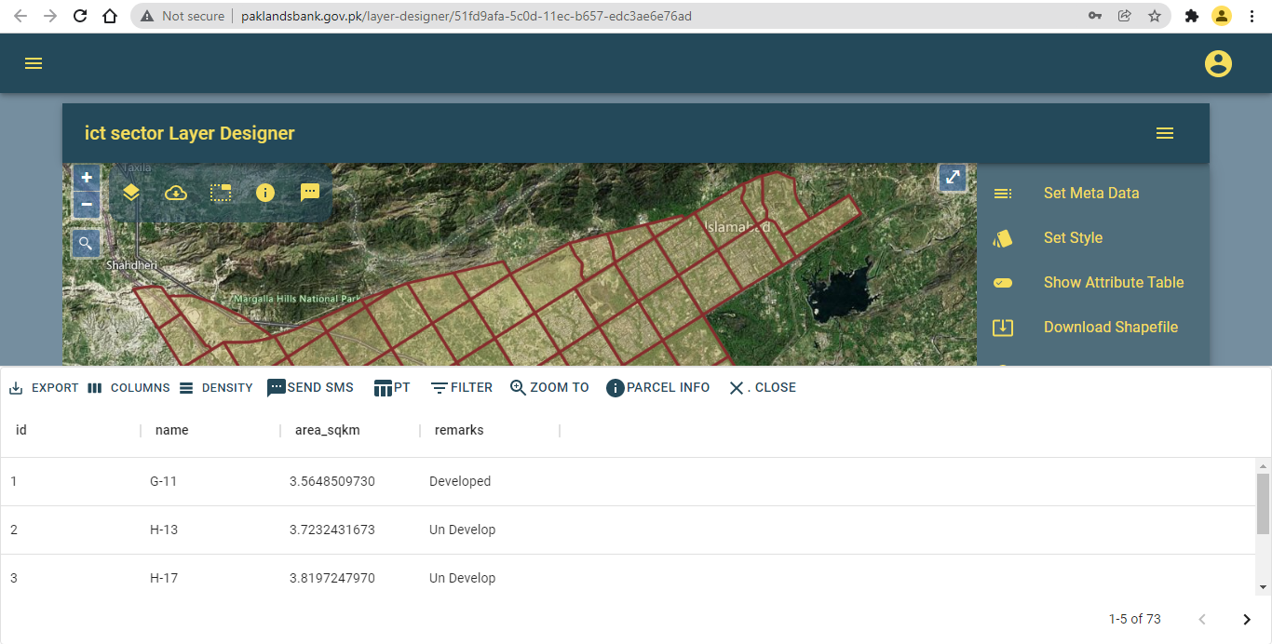

Figure : Attribute Table

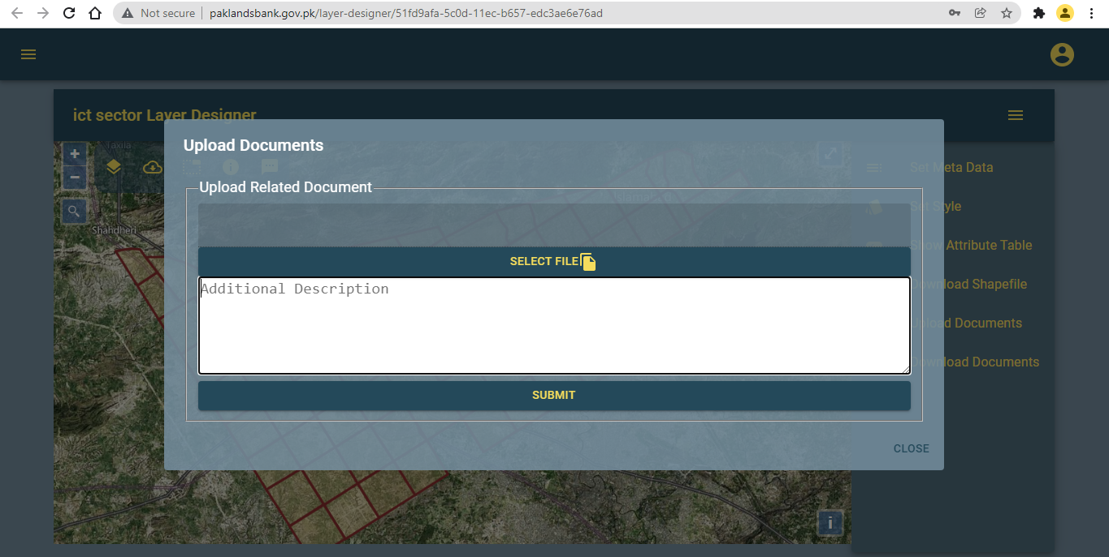

Figure : Upload Document

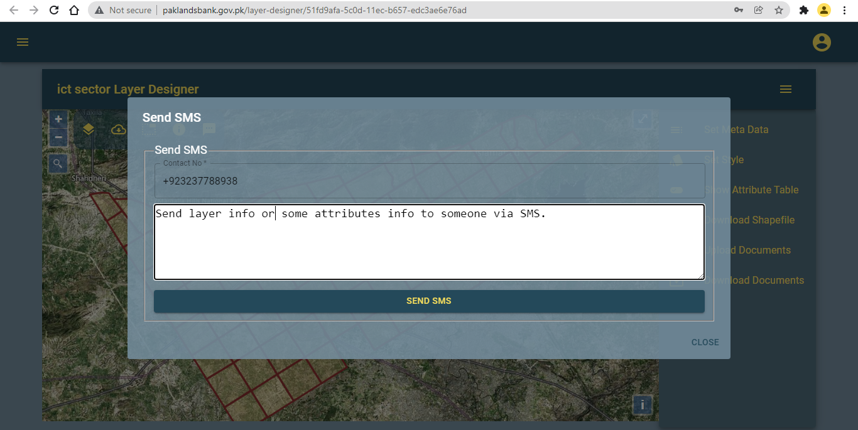

Figure : Share Layer Info Through SMS

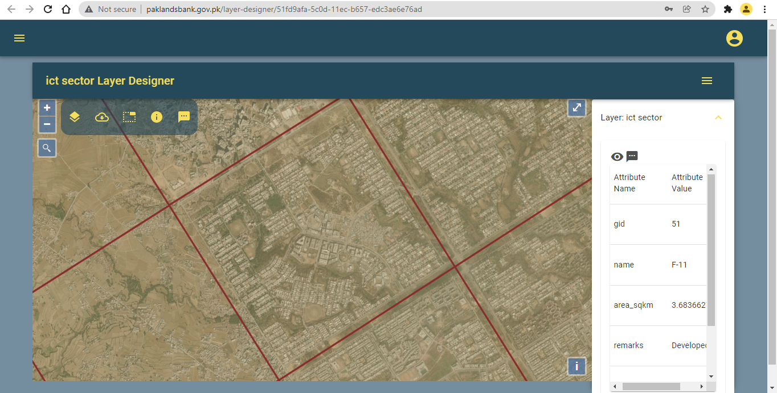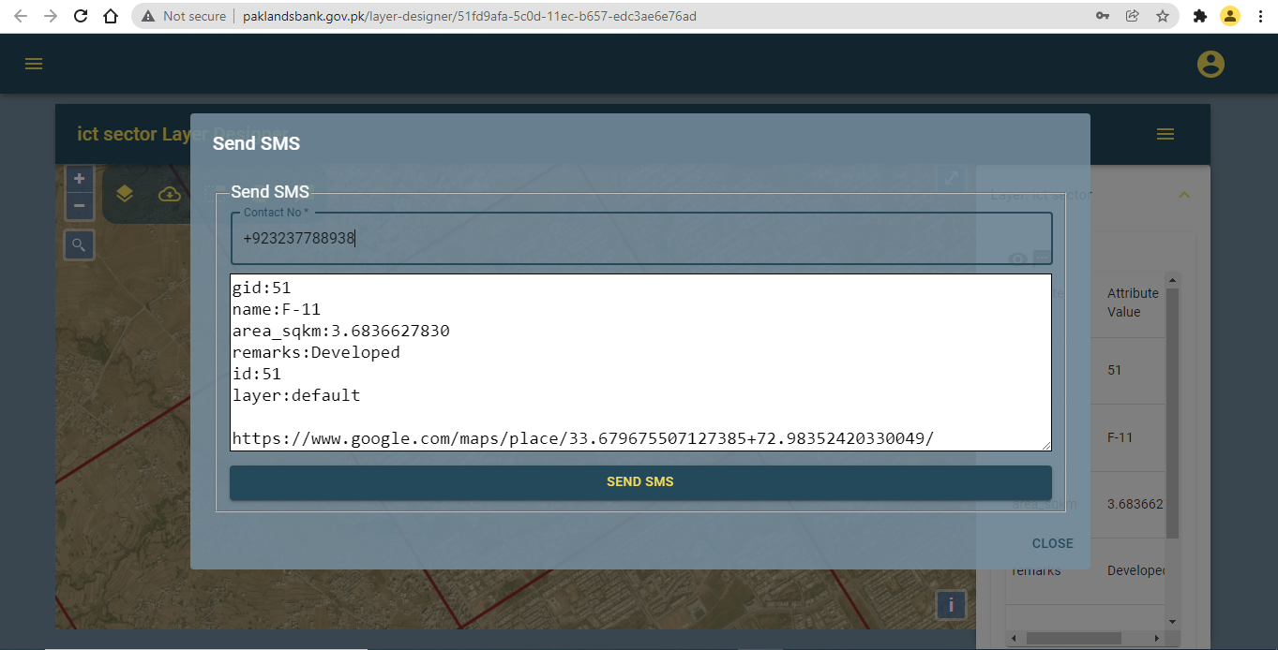

The application is provided with overlay layers that can provide visual information pertinent to different requirements on a signal map(Figure 102: Layer Switcher), (Figure 103: Layers Data).

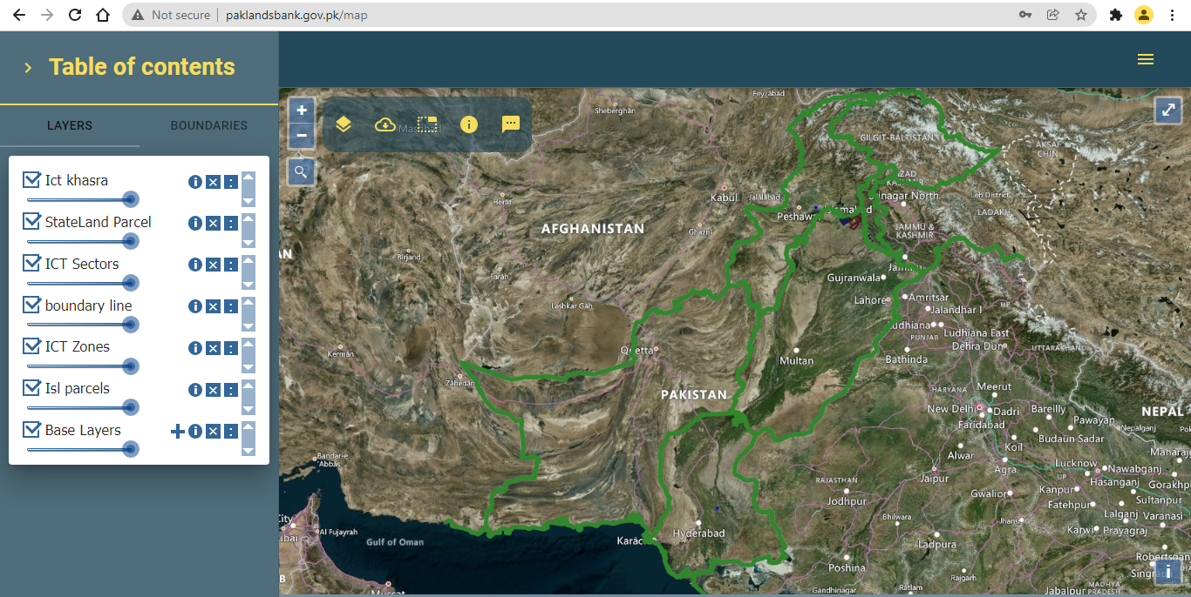

Figure : Layer Switcher

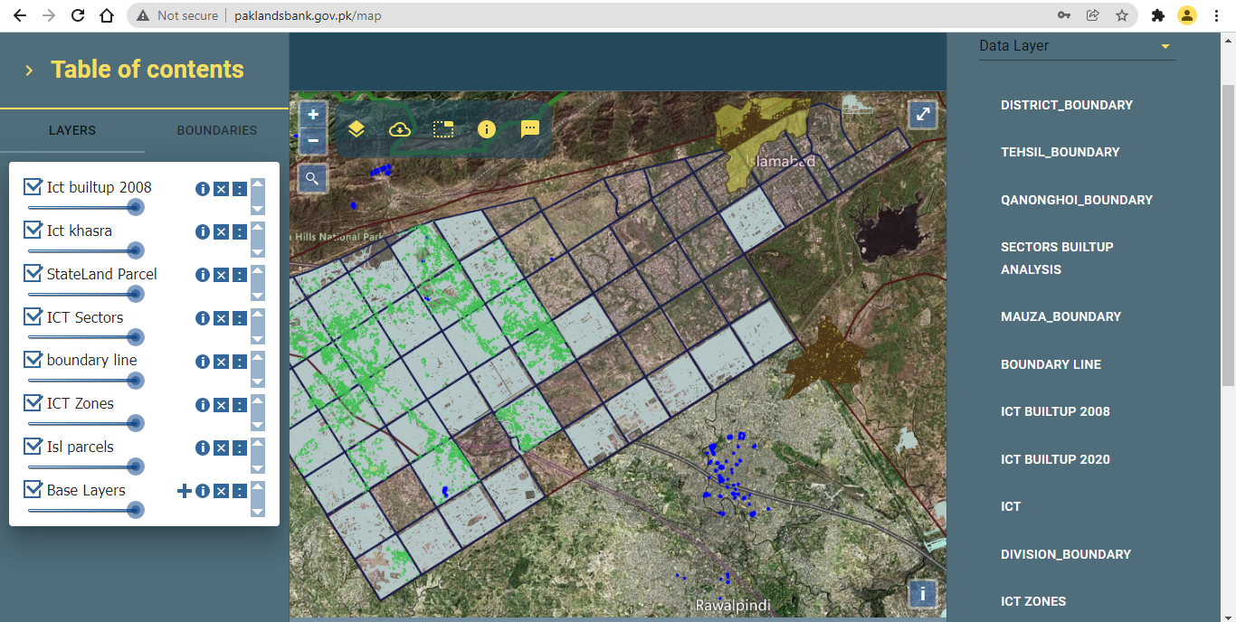

Figure : Layers Data

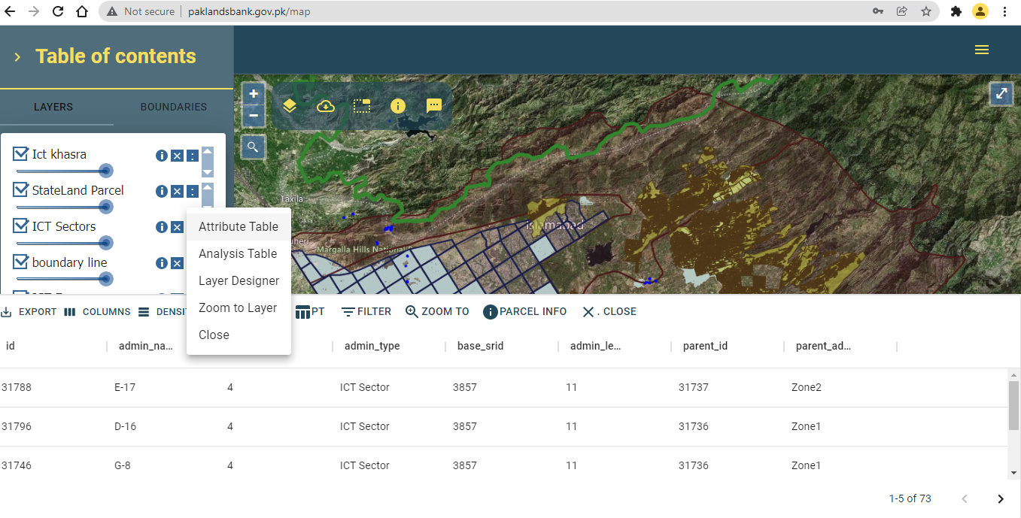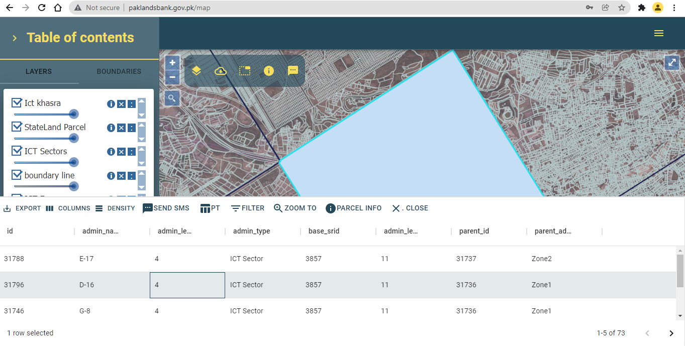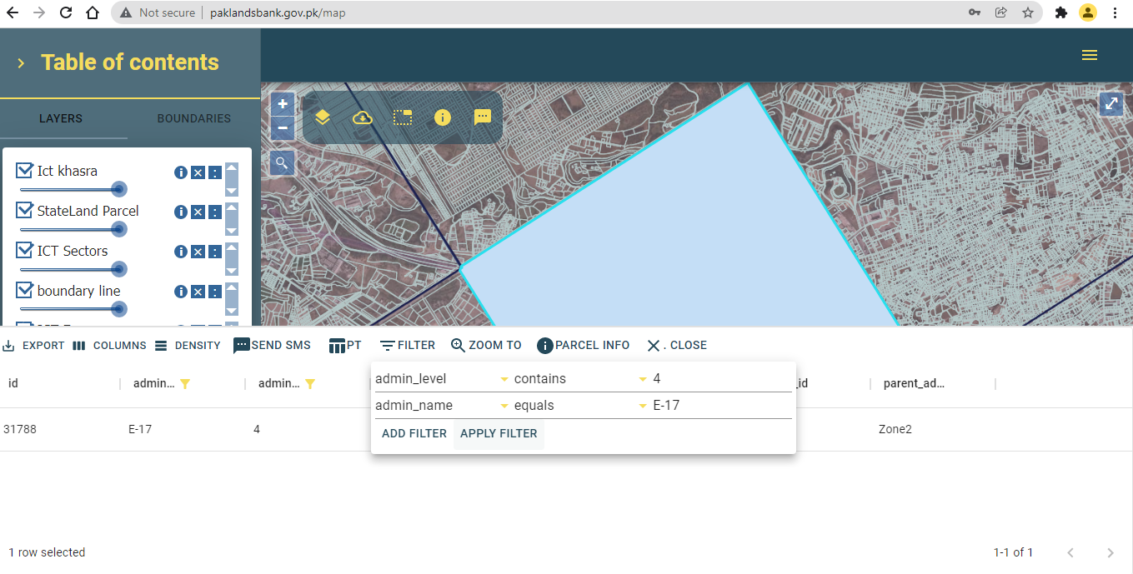

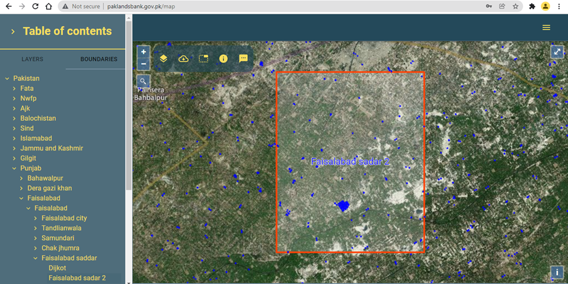

### 3. Pivot Table analysis

With the Pivot Table module , user can analyses and present the data efficiently. User can type in a new selection of columns, or click on the arrow to re-select which columns and rows to include your data.

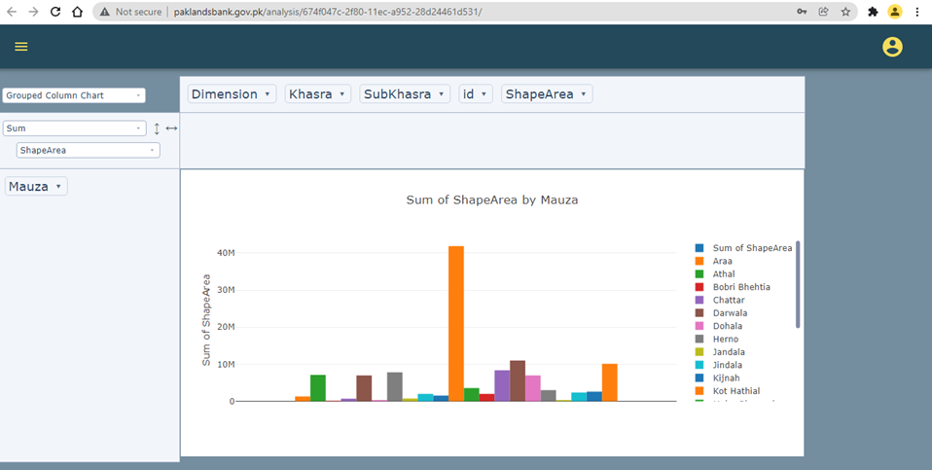

Figure :Graph Functionality